Comparative analysis of model phonon spectra of the A₃B family with the A-15 crystal structure
  - Nebola¹, A.F. Katanytsia¹, D.I. Kaynts, A.V. Korneichuk
¹Uzhhorod National University, Faculty of Physics, 3, Narodna Sq., 88000 Uzhhorod, Ukraine

E-mail: ivan.nebola@uzhnu.edu.ua

A number of practically valuable crystals, among them, for example, NaTl, BiF3, CaF2, ZnS, Ge, Cu2O, Nb3Sn (A-15) and some others, can be described as (4a×4a×4a) superlattices. To describe the motif of the elementary cell, you can use a combination of ideas of superspatial symmetry and the lattice model. Let us define a lattice model for the 4a×4a×4a superlattice with the minimum possible order n in the metric of a convenient protocrystal, which will provide setting the all the atomic positions [1-5].
Representatives of the A-15 family are interesting as the most high-temperature superconductors. The progenitor of this family is aluminum niobium Nb3Al [1], typical superconductor with the A-15 structure (β-W type cubic structure with the space group Pm3n №200). The simple cubic unit cell (SC) contains 8 atoms in the Wyckoff
positions (1 a m 3 . [0,0,0] , 1, b m 3 . [1/2,1/2,1/2] 2 and 6 g mm2. [x,1/2,0], [-x,1/2,0], [0,x,1/2], [0.-x,1/2], [1/2, 0,x], [1/2,0,-x]) where x = 1/4. It is convenient to set all these positions in the lattice model of order 64. Let us illustrate the comparative analysis of the model phonon spectra of this family by using the methodology [5-8].
Let’s consider the most general case of describing the structure of crystals with the (4a×4a×4a) superlattice, the lattice model of order n = 64 with the metric of a simple cubic protocrystal with the parameter a. To generate all the possible positions, we will use (3+3)-dimensional direct and inverse bases [3, 4]:
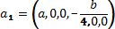
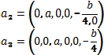
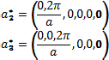
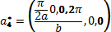
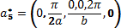
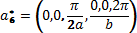

For (VE + Vd), we conveniently chose the bases of a simple cubic lattice (SCL), the first three components a1, a2, a3 for VE, and the 4-th, 5-th and 6-th components a4, a5, a6, respectively, for Vd.
4
5
a
6

All 64 modulation vectors were generated from the first three components of vectors
a∗ ,
a∗ ,
- [3]. They

can be separated into 10 stars, namely: two single-beam stars {q000} (q000 = 0,0,0), {q222}(q222 = π/a,π/a,π/a); two three-beam ones {q200} (q200 = π/a,0,0, q020= 0,π/a,0, q002= 0,0,π/a) and {q220} (q220 = π/a,π/a,0, q202 = π/a,0,π/a, q022 = 0,π/a,π/a); two six-ray ones {q100} (q100 = π/2a,0,0, q010 = 0,π/2a,0, etc.) and {q122} (q122 = π/2a,π/a,π/a etc.); one eight-beam star {q111} (q111 = π/2a,π/2a,π/2а etc.) and three twelve-beam stars {q110} (q110 = π/2a,π/2a,0 etc.), {q112} (q112 = π/2a,π/2a,π/а etc.), {q120} (q120 = π/2a,π/a,0 etc.). Similarly, all 64 positions of the n lattice model can be distributed over ten orbits. Note that for describing the other mentioned structures, for the protocrystal the face- centered or volume-centered metric can be chosen, which results in decreasing the order of the lattice model [5-9].
The use of a complete set of modulation vectors [4-9] makes it possible to determine the amplitudes of mass modulation functions and, based on them, to generate a generalized dynamic matrix of a real crystal and a matrix of mass perturbation [6-10]. The first one is given in the form of a superposition of the protocrystal dynamic matrices determined at different points of the Brillouin zone (ZB), which were connected by modulation vectors. The second one is described by the amplitudes of mass modulation functions [5-9].
In the concept of superspatial symmetry, the dispersion curves of the phonon spectrum of crystal formation are defined as solutions of the matrix equation under the condition that the determinant of the form is equal to zero [5,7,9]:

[Dβγ (k + qi )−ω2δβγδij −ω2ρ(i− j )δβγ ]

= 0 , (1)

where Dβγ (k + qi ) are the dynamic matrices of the single atomic protocrystal, which were determined at the points
of the Brillouin zone (k + q_{i} ) , ρ(qi − qj )= ρ(qs ) are the amplitudes of the mass modulation function, which were set for the modulation vector (q_{i} − q _{j} ), k – wave vector, qi – modulation vectors, β, γ are coordinates x, y, z.

The dynamic matrices relation [11]:
Dβγ (k + qi )
of the protocrystal in the first approximation are determined by the

Dβγ
(k + qi ) =
∑αn
l ≠0
lβ lγ (1− ei(k +qi )l ), (2)
l 2

where αn is the force constant of interaction of atom in the 0-th position with atom in the l-th position, lβ, lγ are the projection of the vector l on the axis β, γ.
Solving the matrix equation (1) with respect to ω²(k) allows one to determine the dispersion dependences of the phonon spectrum taking into account various options for compositional filling and combinations of force constant values [5-9].
In the first (equidistant) approximation, for the dynamic matrix of the protocrystal (2), the force characteristic depends only on the distance between the atoms, and, therefore, the interaction of various combinations of atoms of different types, which are in equidistant positions, is the same. We note that in this structure (A-15) such a situation is realized only at a distance of multiples of 4a, when the interaction of different atoms of the same kind occurs (Nb-Nb and Sn-Sn). This allows us to consider the equidistant approximation sufficiently correct for model studies of crystals with the A-15 structure, and therefore to form a dynamic matrix in a quasi-diagonal form.
In the non-equidistant approximation αl is determined by both the distance between the positions and the difference between the physical characteristics of atoms that occupy these positions (this situation is not considered in this work).

The values of the amplitudes of the mass characteristics equations
i
ρ(q j )
are obtained by solving the system of

m(rj )=
∑
i =1
n
ρ(q )eiqi rj
(2)

relative to the amplitudes of the mass modulation functions
ρ(qi ) = ρ_{i} , n is the number of possible positions of

atoms in the lattice model, where m(rj) – mass characteristics in these positions, qj – array of modulation vectors, the number of which coincides with the number of positions in the lattice model.
Therefore, the solutions of the generalized dynamic matrix (1), dimensionality (3n×3n) allow to plot the model dispersion dependences and densities of phonon states, depending on the values of its elements and combinations of the force constants αl [3-5, 8] (Fig. 1).

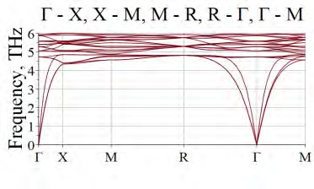 | 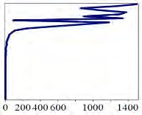 | 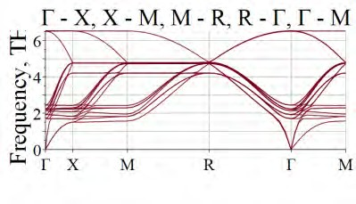 | 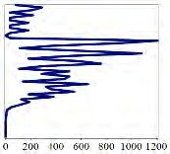
Nb6Sn2 (92,9 ,118,7) powerConstants: =  Vector[row](10, [0, 0, 0, 10.9.10,01.10, 9, 0, 0, 0, 0]) |  | Nb6Sn2 (92,9 ,118,7) powerConstants: =  Vector[row](10, [0, 0, 0, 10.9.10,01.10, 9, 0, 0, 0, 0])
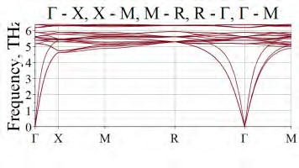 | 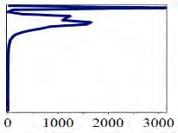 | 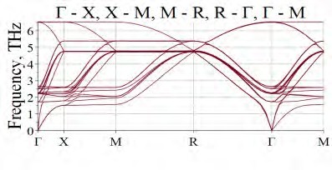 | 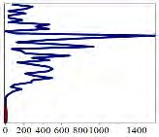
Nb6Ge2 (92,9,72.6) powerConstants: = Vector[row](10, [0, 0, 0, 10.9.10,01.10, 9, 0, 0, 0, 0]) |  | Nb6Ge2 (92,9,72.6) powerConstants: = Vector[row](10, [0, 0, 0, 10.9.10,01.10, 9, 0, 0, 0, 0])

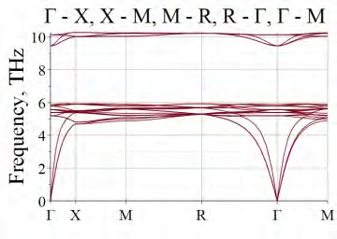 | 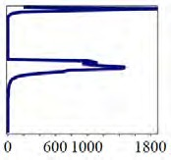 | 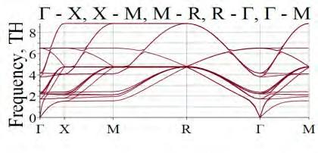 | 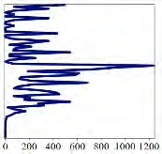
Nb6Al2 (92,9,26.9) powerConstants: = Vector[row](10, [0, 0, 0, 10.9.10,01.10, 9, 0, 0, 0, 0]) |  | Nb6Al2 (92,9,26.9) powerConstants: = Vector[row](10, [0, 0, 0, 60.9.1,0.1,05, 0, 0, 0, 0])
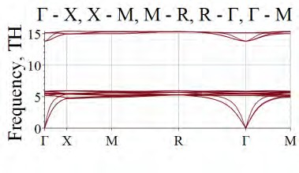 | 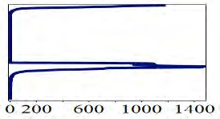 | 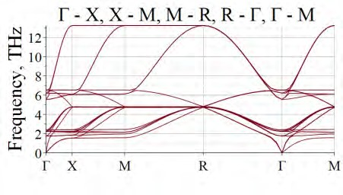 | 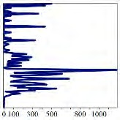
Nb6C6 (92.9,12.01) powerConstants: = Vector[row](10, [0, 0, 0, 10.9.10,01.10, 9, 0, 0, 0, 0]) |  | Nb6C6 (92.9,12.01) powerConstants: = Vector[row](10, [0, 0, 0, 60.9.1,0.1,05, 0, 0, 0, 0])
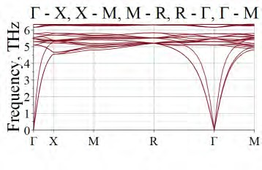 | 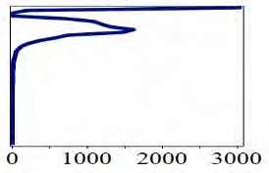 | 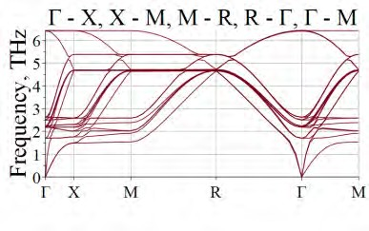 | 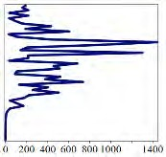
Mo6Ge2 (95.94,72.6) powerConstants: = Vector[row](10, [0, 0, 0, 10.9.10,01.10, 9, 0, 0, 0, 0]) |  | Mo6Ge2 (95.94,72.6) powerConstants: = Vector[row](10, [0, 0, 0, 60.9.1,0.1,05, 0, 0, 0, 0])
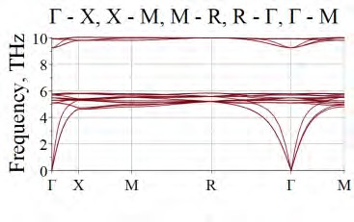 | 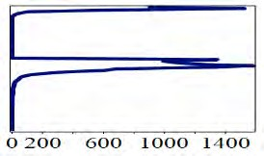 | 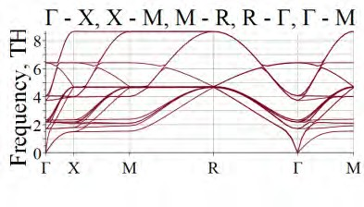 | 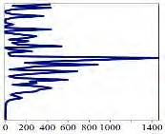
Mo6Si2 (95.94,28.1) powerConstants: = Vector[row](10, [0, 0, 0, 10.9.10,01.10, 9, 0, 0, 0, 0]) |  | Mo6Si2 (95.94,28.1) powerConstants: = Vector[row](10, [0, 0, 0, 60.9.1,0.1,05, 0, 0, 0, 0])
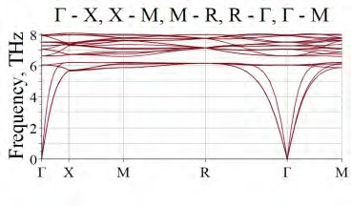 | 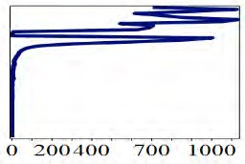 | 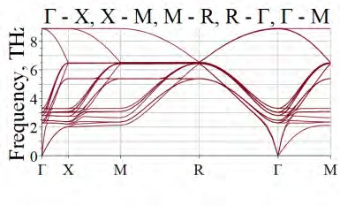 | 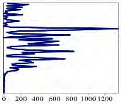
V6Ge2 (50.9,72.6) powerConstants: = Vector[row](10, [0, 0, 0, 10.9.10,01.10, 9, 0, 0, 0, 0]) |  | V6Ge2 (50.9,72.6) powerConstants: = Vector[row](10, [0, 0, 0, 60.9.1,0.1,05, 0, 0, 0, 0])
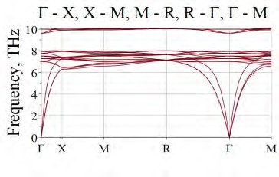 | 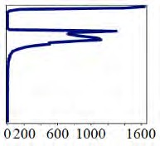 | 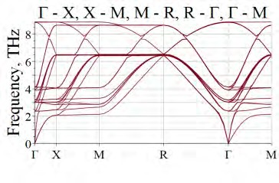 | 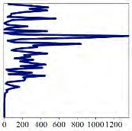
V6Si2 (50.9,28.1) powerConstants: = Vector[row](10, [0, 0, 0, 10.9.10,01.10, 9, 0, 0, 0, 0]) |  | V6Si2 (50.9,28.1) )powerConstants: = Vector[row](10, [0, 0, 0, 60.9.1,0.1,05, 0, 0, 0, 0])

Figure 1. Model phonon dispersion dependences and densities of phonon states of some crystals of the A3B family (with the structure A-15) calculated for highly symmetric directions of the Brillouin zone with two different combinations of the force constant values.

The values of the force constants αl are given in order of increasing the distance between the positions of the orbits 1(0,0,0) and l + 1, while all the possible variants of distances between the pairs of positions occupied by atoms were taken into account. The force constants were chosen in the equidistant approximation. For example, for the Nb3Sn structure, the force constant α4, describing the interaction at a distance 2a, is equal to 10.9 n/m, and all the others are equal, respectively, to (powerConstants: = Vector[row](10, [0, 0, 0, 10.9.10,01.10, 9, 0, 0, 0, 0]). Two identical combinations of force constants were chosen for all the studied crystals.
The obtained model calculations reflect the modification of phonon spectra exclusively depending on the mass characteristics. It is shown that by choosing the certain combinations of values of force constants, mainly α4, α5 and α6, it is possible to obtain phonon spectra with optical frequencies within the range of 150 to 240 cm^{–1} for Nb3Sn crystals, which correlates with the experimental data [1]. At the same time, the distribution of densities of phonon states is significantly different. We note the proximity of the ranges of high-frequency optical branches for a number of crystals and significant difference in the values for low-frequency and especially acoustic branches.

  - F. Weiss, O. Demolliens, R. Madar, J. P. Senateur and R. Fruchart, On the stabilization of A-15 Nb3Ge with high Tc’s, J. Phys. France, vol. 45, pp. 1137–1141 (1984).
  - S.A. Andersson and M.D. Perlman, Lattice models for conditional independence in a multivariate normal distribution, The Annals of Statistics, vol. 21, No 3. P. 1318–1358 (1993).
  - S. van Smaalen, An elementary introduction to superspace crystallography, Zeitschrift für Kristallographie, vol. 219, pp. 681–691 (2004).
  - P. M. de Wolff, T. Janssen, J.Aloysio, The superspace groups for incommensurate crystal structures with a one-dimensional modulation, Acta crystallographica. Section A, vol. 37, No 5, pp. 625–636 (1981).
  - T. Janssen, On the lattice dynamics of incommensurate crystal phases, J. Phys. C: Solid State Phys., vol. 12, No 24, pp. 5381–5392 (1979).
  - I.I. Nebola, I.M. Shkirta, A.F. Katanytsia, A.K.V. Dolynai. 3+D dimensional bases for the complex crystals lattice dynamics modeling. The 19th Small triangle meeting on theoretical physics, Slovakia, Medzilaborce, 2017. P. 141–148.
  - I.I. Nebola, A.Ya. Shteyfan, V.I. Sidey, A.F. Katanytsia, I.P. Studenyak, I.M. Shkyrta. Model research of phonon spectra of argyrodites family, SPQEO, vol. 21, pp. 134–138 (2018).
  - I.I. Nebola, O.F. Ivanyas, V.Y. Kindrat, The genesis of the structure and vibrational spectra of crystals with the (Sa×Sa×Sa) superlattice, Physics of the Solid State, 1993, vol. 35, pp. 1852–1866 (in Russian).
  - I.I. Nebola, A.F. Katanytsia, I.M. Shkyrta, J.M. Pozho, Yu.O. Pal, Modification of phonon spectra of Ag7GeSe5I and Cu7GeSe5I crystals with different partial population of crystallographic orbits, International Journal of Science and Engineering Investigations, vol. 10, issue 112, pp. 56– 60 (2021).
  - https://maple.cloud/app/5753562177994752/Modeling+of+dispersions+of+phonon+spectra
  - A.I. Anselm, Introduction to the Theory of Semiconductors, Moscow, Nauka, 1978 (in Russian).

