MINISTRY OF EDUCATION AND SCIENCE OF UKRAINE
STATE HIGHER EDUCATIONAL INSTITUTION
UZHHOROD NATIONAL UNIVERSITY
MEDICAL FACULTY
DEPARTMENT OF GENERAL SURGERY

Stoika Vasyl, Kanziuba Anatolii, Filip Stepan, Pushkash Ivan, Kochmar Vitalii

DAMAGE TO THE SHOULDER GIRDLE, SHOULDER JOINT AND SHOULDER

Educational and methodical instructions for independent work
5th year students, medical faculty
in the specialty "Medicine"

UZhHOROD - 2021

Methodical developments have prepared:
Stoika Vasyl Volodymyrovych - PhD, Assistant of the Department of General Surgery of Uzhhorod National University.
Kanziuba Anatolii Ivanovych - Doctor of Medical Sciences, Professor of the Department of General Surgery.
Filip Stepan Stepanovych – Doctor of Medical Sciences, Professor, Head of the Department of General Surgery.
Pushkash Ivan Ivanovych - PhD, Docent of the Department of General Surgery of Uzhhorod National University.
Kochmar Vitalii Mykhailovych - Assistant of the Department of General Surgery of Uzhhorod National University.

Reviewers:
PhD, Docent of the Department of General Surgery, Uzhhorod National University Sheregii Andrii Andriiovych
PhD, Docent of the Department of General Surgery, Uzhhorod National University Lytvak Vasyl Vasyliovych

Methodical recommendations are approved
at the Academic Council of the Medical Faculty
of “SNEI” Uzhhorod National University
protocol № 5 from " 15 " 02 2021.

Responsible for the issue:
Dean of the Medical Faculty, Uzhhorod National University
Doctor of medical sciences, Professor Boldizhar Oleksandr Oleksandrovych

DAMAGE TO THE SHOULDER GIRDLE, SHOULDER JOINT AND SHOULDER

Actuality of theme
Movements of the shoulder are shared between the shoulder joint proper, i.e. between the humerus and glenoid part of the scapula, and movement of the scapula on the chest wall.
Normally, during abduction there is a smooth integration between these movements, but in pathological conditions, one may predominate over the other, e.g. stiffness at the shoulder joint may mean that the only possibility for abduction is at the scapulothoracic joint. On the other hand, stiffness or ankylosis of the sternoclavicular joint may virtually eliminate scapular movements.
The rotator cuff muscles surrounding the upper end of the humerus and the capsule of the shoulder are important for stabilizing the shoulder and producing rotation, while the deltoid provides most of the power of abduction.

The purpose of the lesson
To study the method of examination of the shoulder and shoulder joint. To study the classification, clinical symptoms, and methods of treatment of fractures of the shoulder girdle and shoulder, dislocations of the clavicle and shoulder joint, ruptures of ligaments and muscles in the shoulder and shoulder girdle.

To solve this problem, the student must know before class:
- Anatomy of the shoulder and shoulder joint.
- Methods of examination of the shoulder and shoulder joint.
- Classification of fractures of the clavicle, scapula and humerus.
- Classification of clavicle and shoulder dislocations.
- Clinical symptoms of fractures, dislocations, muscle and ligaments damage in the area of the shoulder.
- Basic methods of treating fractures, dislocations, muscle and ligaments damage in the area of the shoulder.
- Indications for surgical treatment.

By the end of the practical lesson, each student should be able to:
- Collect a history and identify clinical symptoms of damage to the structures of the shoulder girdle and shoulder.
- Identify and describe the radiographic features of fractures and dislocations in the shoulder area.
- Master the techniques of repositioning dislocations of the shoulder joint and clavicle.
- Make a plan for conservative treatment of fractures, dislocations, ruptures of muscles, tendons and ligaments.
- Determine the indications for surgical treatment.

The main theoretical provisions of the topic.

Examination
1 Inspection. The patient should be observed standing or sitting in a comfortable position and the levels of the shoulders noted, together with the presence or absence of swellings or wasting. Deltoid wasting accompanies many shoulder conditions, as does wasting of the posterior scapular muscles (supra- and infra-spinatus).
2 Palpation. The landmarks are the tip of the acromion, the sternoclavicular joint, the coracoid process and the spine of the scapula. The greater tuberosity of the humerus is also normally palpable. Tenderness is commonly found over the trapezius area, and in capsulitis may be localized to the greater tuberosity. Increase in temperature and boggy swelling may accompany infective conditions or rheumatoid arthritis.
3 Movements. Abduction, flexion, internal and external rotation should be tested (Fig. 1). Abduction should be observed from behind to distinguish the various components of this movement. External rotation is tested with the elbow pressed into the side of the body. A useful rapid test is to ask the patient to put his/her hand behind his/her neck and behind his/her back. The patient may avoid attempting external rotation when the joint is unstable, e.g. in recurrent dislocation. The shoulder can sometimes be ‘telescoped’ upwards and downwards, usually following a paralytic condition such as a stroke.
4 Measurement. The girth of the upper arm may be an index of deltoid or biceps and triceps wasting.
5 Neurology. Damage to the axillary nerve may produce a patch of anaesthesia over the belly of the deltoid. Other shoulder conditions may be associated with brachial plexus injury. Many shoulder conditions cause pain indistinguishable from that due to cervical pathology, so a full neurological examination of the arm is always indicated.
6 Circulation. The blood supply in the arm may be impaired in certain shoulder conditions which cause pressure on the axilla. Axillary vein thrombosis is an uncommon condition, usually affecting young men and causing swelling and discoloration of the whole arm.
7 Lymphatics. The lymphatic glands in the axilla or supraclavicular fossa may be enlarged from shoulder disease, particularly infective conditions.

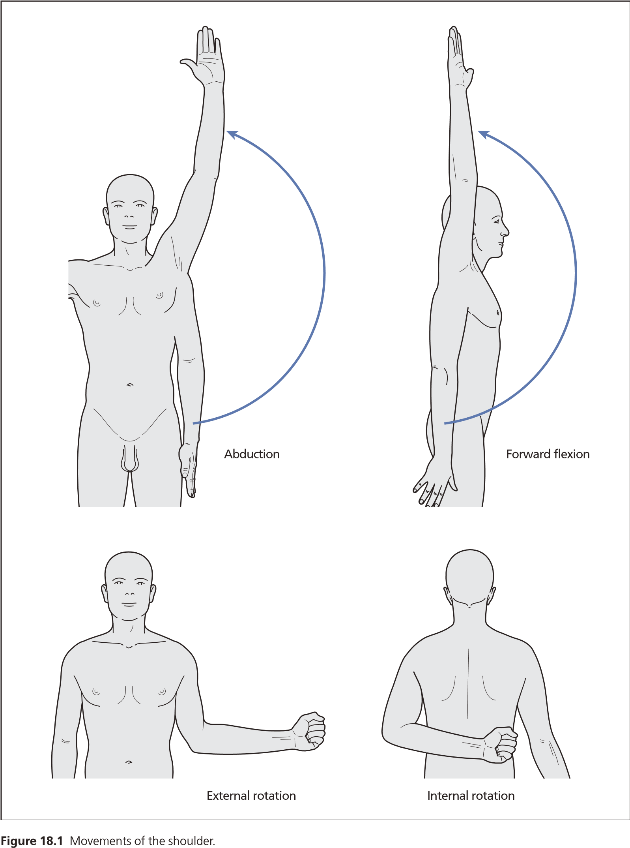
Figure 1. Movements of the shoulder.

Fracture of the clavicle.
This is one of the commonest fractures in childhood and early adult life, and is usually caused by a fall onto the shoulder or the outstretched hand.
Fractures of the clavicle often arise owing to direct strike, less often - at falling on the extended hand or on the lateral surface of the shoulder. Fractures are usually located in the middle one-third of the clavicle or on border of the external and middle one-third. Depending on the mechanism of the trauma there are transverse, oblique and splintered fractures observed at adults, and at children the clavicle breaks more often according to the type of the "green branch". At the fractures of the clavicle with the dislocation the internal fragment dislocates upwards and backwards because of the sternocleidomastoid muscle pull, and external - downwards, forward and inside under extremity weight influence and traction of pectoral muscles. The traction of the subclavian muscle leads to the displacement of the fragments along the length. Hence, the fragments are displaced along the length, width and at the angle. The fracture is rarely open. In a child the fracture is usually of the greenstick type.
Clinical features. One can define the deformation and shortening of the clavicle, the ptosis of the shoulder downwards and forward, dysfunction of the upper extremity functions at the side of the fracture with the displacement of the fragments. The injured supports the elbow and the forearm of the injured extremity by the intact hand and presses it to the body. There are the swelling and the hemorrhage visible at the area of the fracture. The tenderness can be defined at the palpation and one can palpate the ends of the fragments.
The diagnosis of clavicle fracture is ascertained on the basis of the clinical symptoms and radiography data. (Fig. 2).
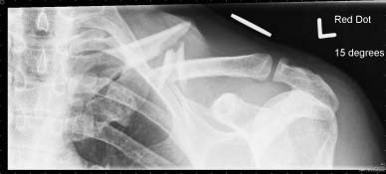
Figure 2. Fracture of the clavicle — typical displacement.

Complications. These are rare, but the brachial plexus may be injured, as may the subclavian artery or vein. Occasionally the dome of the pleura may be penetrated by a bony fragment, producing a pneumothorax. Non-union is very rare and is more likely after internal fixation.
Treatment. Reposition is made under the local anesthesia (10-15 ml of 2 % Novocain solution). After the beginning of the anesthesia effect the patient is seated on the stool. The assistant, standing behind, sets a knee between the scapulas and pulls back the humeral articulations. The person who repositions, standing sideways from the patient at the side of the injury, brings the fist in the axillary crease, raises the shoulder, rotates it outwards, and then leads the elbow to the body. Very often the fragments are repositioned easily, but it is difficult to keep them in this position up to the union of the fracture, in spite of the great number of offered ways.
The greatest recognition from the modern bandages and splints have the figure-of eight bandage of Sharashenidze, splints of Kuzminsky, Kaplan, Titova's oval, etc. The figure of-eight bandage is a simple method and gives good results at careful performance (fig. 3). The patient sits at edge of the chair, and the bandaging person stands behind. First of all, a piece of cotton is placed on each of the humeral articulations in front for it to get into the axillary region. Then with the help of several bandages 13-15 cm in width the figure-of-eight bandage is imposed. The bandages go in front of the humeral articulations, under the armpit and are crossed behind between the scapulas. With each turn of the bandage the shoulders are pulled upwards and back. Bandaging should not be hard for not to cause the vascular embarrassment. Rounds of bandages are kept by sewing one to another. After imposing the bandage the control radiography is made. In the first week the extremity is placed on the kerchief and the active exercises for the fingers, radiocarpal and cubital articulations are prescribed. The figure-of-eight bandage and the splinters are removed in 2 weeks at clinical visible union of the fractures. The working capacity of the patients is recovered in 3-6 weeks after the fracture.
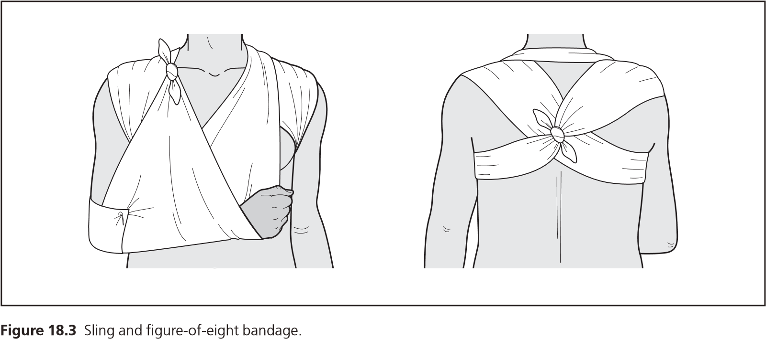
Figure 3. Sling and figure-of-eight bandage.

Subperiosteal and incomplete fractures, observed at children, do not require the fixation. From the first days the children are prescribed the gymnastics and massage. At children's age function of the upper extremity recovers completely in 2-3 weeks after the fracture.
Operative treatment. At the fractures, complicated by the injury of the brachial plexus and vessels, the closed one-stage reposition is contra-indicated. The operation is carried in cases when it is not possible to make the approximation and to keep the fragments of the clavicle by the conservative methods. Operation is also indicated because in many cases the unsuccessful reposition depends on the interposition of the soft tissues.
The opened reposition of the fragments is carried out under the local or general anesthesia. The incision of the skin is made lengthwise above the place of the clavicle fracture. Bone fragments are often defined and fixed by the thick Kirschner's wires, thin Bogdanov's nails, metal plates, etc. Free bone fragments are not removed but are placed on their places and are kept by the catgut or lavsan seams. For the immobilization for 5-6 weeks the Desault's bandage. Figure-of-eight bandage at is imposed, strengthened by the plaster bandages. the fracture of the clavicle.
The osteoplastic operations are applied at theunhealed fractures and false joints. In these cases intraosseous osteosynthesis by the metal nails is made, and auto - or allografts are used outside for the improvement of the reparative regeneration. The term of fixation is extended up to 8-10 weeks.
Dislocations of the clavicle.
Dislocations of the clavicle are observed in some times seldom than the fractures and make up to 5% of all dislocations. There are acromial or external extremity of clavicle, and dislocations and sternal or internal extremity of clavicle are distinguished. The dislocations of the acromial extremity of clavicle occur more often.
Dislocations of the acromial extremity of clavicle. Dislocations of this kind occur basically at falling on the turned aside hand or shoulder. When the acting force is directed from outside inwards and from up downwards (the direct mechanism of the trauma), the scapula turns around the front axis in such a manner that its lower angle displaces outwards and downwards. At this moment there is the contact between the clavicle and the rib, and as the result the incomplete fracture of the clavicle upwards. If the acting force continues then the coracoclavicular ligaments are tearing additionally and the it leads to the complete dislocation of the clavicle upwards.
Clinical symptoms. The sharp pain is characteristic for an incomplete dislocation which has arisen at the moment of the trauma, and formation of a little swelling or protrusion of the round form in the area of the acromioclavicular joint. At a raising of the hand the protrusion can disappear and appear again at lowering. At pressing on the distal end of the clavicle the symptom of “springiness" arises.. Function of the extremity is not violated, but there is the painfulness at the movement and rotation of shoulder. It can be seen from the radiograph that lower edge of the clavicle is at a level of the upper edge of the acromial end.
At a full dislocation of the acromial end of the clavicle upwards there appears the protuberance as a step. The superarm is little bit shorter and lowered. The subclavicular fossa is smoothed owing to the tension pectoral fascia. The scapula is displaced to the inside and comes nearer to the spine column. There is the painfulness and the mobility of the dislocated end of the clavicle in all directions at the palpation. The clavicle can be easily repositioned and easily dislocated; this phenomenon refers to as symptom of "key". Movements in the humeral articulation are limited, painful. The radiography confirms the clinical diagnosis. The radiography film of the acromioclavicular joint should be carried out at vertical position of the patient with a shoulder hanging downwards and a load of 3-4 kg on the injured side. In horizontal position of the patient the dislocation is spontaneously repositioned, and it will not be seen in the film.
It is recommended to carry out the differential diagnostics at the bruise of the shoulder, fractures of the acromion, acromial end of the clavicle, dislocation of the shoulder, arthritis deformans, arthrosis deformans and tumors.
Treatment. If the dislocation can be repositioned easily and there are no soft tissues between the articular ends, then the treatment is conservative -- with plaster bandages and splints. Preliminary, the 20-30 ml 1 % Novocaine solution are introduced into the acromioclavicular joint and surrounding soft tissues. After that the hand in the abducted position is gradually rejected backwards. Simultaneously the finger is pressed on the dislocated clavicle end downwards and a little forward. After the reposition the hand is fixed with the plaster bandage by B. K. Babich or splinters of Kuzminsky, Kozhuhov, etc. The plaster bandage and splinters are imposed for the period of 4 weeks. In 2 weeks after the reposition the medical exercises are prescribed. Work capacity is restored in 5 6 weeks.
Use of the splinters with bandages is prescribed at the incomplete dislocations of the acromial clavicle end. However the data of some authors and our supervision testify that results of conservative treatment frequently appear unsuccessful. It is recommended that fresh full, stale incomplete and chronic dislocations should be operated not losing time. Conservative treatment in these cases only extends terms of invalidity and does not give positive results.
Operative treatment. Many ways of fixing the acromial clavicle end with the help of a wire, pins, metal nails, silk, capron and lavsan threads are offered. Strengthening of the repositioned clavicle with the coracoid and acromial processes by Bennel is considered to be a good method (fig. 3). Under local anesthesia and arc-shaped anterolateral incision opens the access to the acromioclavicular joint. The dislocated clavicle end and acromion are released from the cicatricial tissue and are mobilized enough. Three apertures are drill bored: one – in the acromion and two - in the clavicle. A thick silk string polished with paraffin is put through these apertures which connects the clavicle ends with the acromion and recreates the coracoclavicular ligament. The soft tissues are sewn above the joint.
At an operative method of Watkinson-Kaplan the same access is applied. Hold of the articulate ends is reached by means of two pins and formation of the ligament between the external part of the clavicle and coracoid process with lavsan tape. A wound is sewn in layers. Thoracobrachial plaster bandage is imposed with the abducted hand for the period of 4 weeks. The pins are removed in 4-6 weeks. After the removal of the plaster bandage the patient is prescribed the medical gymnastics,
An effective method of operative treatment of fresh full and chronic dislocations of the acromial clavicle end is the figure-of-eight implanted suture, developed by A. P. Mizin. The lavsan thread with the 0,9-1 mm section is put through two channels in the clavicle from down upwards, intersected above its upper edge, and then directed downwards under the acromion where it is taken out through two channels from down upwards (fig. 4). A hand of the patient is abducted up to the right angle. The clavicle is repositioned, threads are tightened and are fastened with double hitch. A wound is sewn in layers. The hand is fixed on the abducted TSITO splint with pressing bandage. After the removal of the sutures the thoracobrachial plaster bandage is imposed for 4 weeks. From the first days the physiotherapy exercises are prescribed.
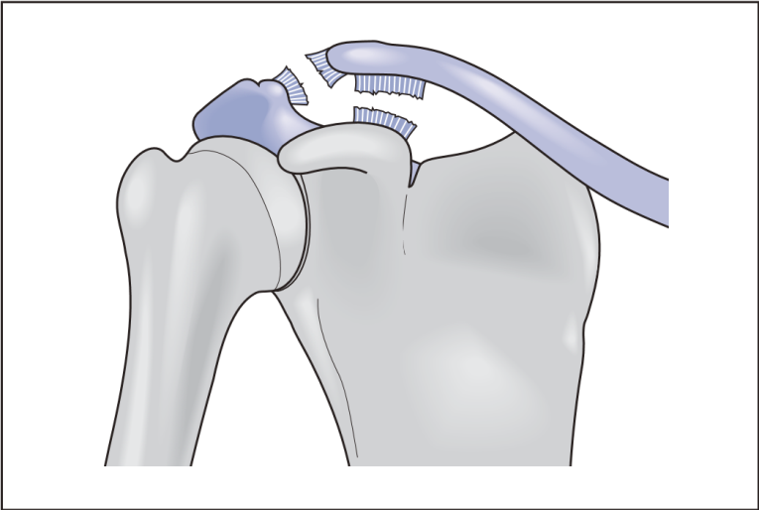
Figure 4 Acromioclavicular dislocation.
Dislocations of the sternal extremity of clavicle. The dislocation of this kind occurs as the result of the indirect trauma at falling on the shoulder abducted and displaced backwards. Thus the sternal extremity of the clavicle can be displaced forward, backwards and upwards. The dislocations forward (antesternal) occur more often – and backwards (retrosternal) are significantly seldom. Dislocations of the sternal extremity of the clavicle are divided on full and incomplete, or subluxations. At incomplete the lavsan thread at the dislocations clavicular ligaments. At full dislocations, except for the of the acromial end of the clavicle rupture of the sternal clavicular ligaments, there is also by Mizin. the costoclavicular ligament rupture. At the dislocation the intraarticular disk in one cases avulses and displaces together with the articular clavicle end, and in other cases - is trapped between articular surfaces.
Clinical symptoms. There is the protrusion which arise in the area of the sternal extremity of the clavicle, and as the result the supraclavicular and subclavicular fosses become deep. The superarm becomes little bit shortened. The dislocated clavicle end becomes mobile. This area is painful at the palpation. Movements in the humeral joint are restricted. At subluxations all these phenomena are apparent in a lesser degree. Fresh dislocations are sometimes combined with fractures. It is possible to specify the diagnosis only with the help of radiography. B. K. Babich recommends to make films with both clavicles on an identical extent. It allows to compare the upper contour of the clavicle in relation to the notch manubrium of sternum at the injured and healthy sides.
Conservative and operative treatment. Bloodless reposition is easily removed, if the soft tissues are not trapped between the articular ends, but it is sometimes very diffi cult to keep the repositioned end. The patient is sitting on a chair. After local anesthesia by 1-2 % Novocain solution, introduced into the joint, the assistant stands behind the pa tient and tries to put both humeral joints to the spine column. At this time the repositioning person, pressing on the dislocated clavicle end, repositions it. After the reposition the superarms are abducted to the sternum which provides the holding. This position is fixed with the thoracobrachial plaster bandage at the abduction and displacement of the ex tremity forward up to 90°. The cotton-gauze bandage is imposed on the area of the repo sitioned dislocation. Immobilization up to 4 weeks. If there is the recurrence of disloca tions then the operative treatment is prescribed.
In cases of dislocation of the acrominal-clavicle end we also recommended special antimigration device of Serdyuk - Yurkov – Popov.
The most simple and one of the best is the method of Markser. Under local anesthesia opens the access to the sternum clav icular joint by the semicircular incision going along the upper edge of the clavicle to the sternum. The end of the clavicle is released from the shreds of the capsular clavicular apparatus, and the chronic dislocations the cartilaginous disk is also removed. Through the apertures in the sternum and clavicle two in each made with the drill the lavsan thread is put and is fastened with a firm knot after the reposition of the clavicular end. The soft tissues are low ered above the knot. The extremity is fixed with the thoracobrachial plaster bandage in the same position, as at the conservative treatment. The cotton gauze bandage is imposed on the area of the joint. In three weeks the patient is prescribed the functional therapy. Work capacity is restored by the end of the second week.
Fractures of the scapula
Fractures of the scapula are rather rare, and make 1,2 % of the closed fractures. They usually arise at falling on the back (a direct trauma) or less often - on the adducted shoulder (an indirect trauma). More often fractures are of the anatomic and surgical necks of the scapula, less often the body of the scapula, the coracoid process and the acromion are injured.
Clinical symptoms. At the fracture of the scapula neck the peripheral fragment is displaced from downwards and inside and it is often accompanied by the injury of the axillary nerve and the ar artery of the scapula. It leads to the paresis of the deltoid muscle. The shoulder hangs down, and there is the painfulness at the palpation of the scapula neck. The post-external area of the scapula is thickened. The acromion is as protruded word at the sick side, and the coracoid process goes deeper. In the axillary region the protruding edge of the broken scapula can be defined.
The swelling is characteristic for the fracture of the scapula body with a hypodermic hemorrhage and local painfulness. The same changes arise at the fractures of the acro mion, but thus painfulness is more expressed during the movement in the humeral joint and the phenomena of crepitation at pressing on the acromion. The diagno sis is specified by the radiography.
Treatment. If the fragments of the scapula body are not displaced, then the Desault's bandage with the swab is im posed in the axillary area for the period of 2 weeks. The muscles surrounding the scapula create favorable conditions for healing the fractures of the scapula body. Work capacity is restored in 3-5 weeks. At the fractures of the scapula neck without the displacement of the bone fragments the abducting splint is imposed for the period of 25-30 days and the movements by the upper extrem ity are allowed. Work capacity is restored by the end of the second month.
At the fractures of the scapula neck with displacement the constant extension with the elbow process with the abduction of the shoulder up to 90 is applied. A load – from 2 up to 4 kg up to one month. Active movements in fingers are prescribed as soon as possible, then in radiocarpal articulation and in the elbow joint, and movements in the humeral joint are pre scribed after 3 weeks. Work capacity is restored by the end of 8-10 week. At the fractures of the acromion with displacement the abduction splint is applied. The shoulder is fixed at 10 backwards from the frontal plane for 3-4 weeks.
Dislocation of the shoulder.
Dislocations in the humeral joint occur very often and make 58-60 % of all disloca S. Significant frequency of dislocations in the humeral joint is explained by its anatomy physiological features: discrepancy between the head and glenoid cavity; insufficient thening of the humeral joint bursa, especially in the anteroinferior segment; big amDislocations in a humeral joint more often occur at falling on the extended for ward and abducted hand and less often at falling on back area of the humeral joint.

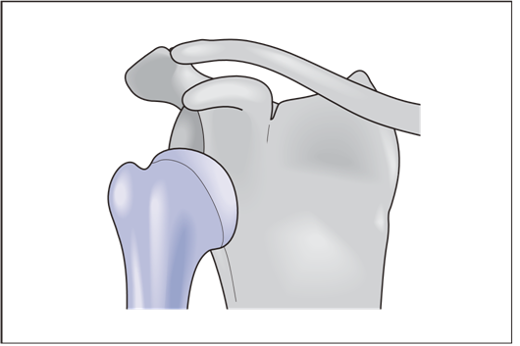 |  | Figure 5 Anterior glenohumeral (subcoracoid) shoulder dislocation.
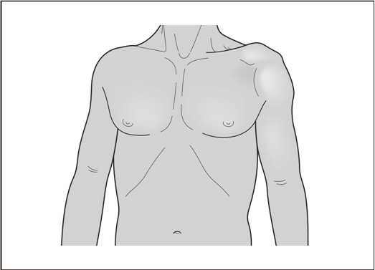 | Figure 6 Clinical appearance of an anterior dislocation.
Depending on the mechanism of the trauma the following kinds are distinguished: frontal (subcoracoid and subclavicular), in ferior and posterior dislocations. The frontal (subcoracoid) dislocations (fig. 5) occur more often. They make 75 % of all disloca tions of the shoulder. On the second place (23 %) the inferior dislocations when the head is displaced into the axillary crease. Much seldom are the posterior dislocations (2 %). They are divided on subacromial and subspinous.
Dislocations of the shoulder are always accompanied by the rupture of the bursa and ligaments and quite often by the avulsion of the greater tubercle with the attached muscles. In addition the sinews of the muscles (supraspinous, infraspinatus), participating in abduction and rotation of the shoulder to the outside, can also be ruptured. Sometimes happens the rupture of the long head sinew of the biceps and injury of the neurovascular fascicle.
Clinical symptoms. The deformation of the humeral joint (fig. 6) and sharp painfulness are characteristic for the anterior dislocation. The head can be palpated to the front from the glenoid cavity. Acromion protrudes excessively, and under it the retraction can be defined. All movements in the joint are sharply restricted because of the painfulness. The axis of the shoulder is displaced inwards, and at the measurement of the humeral bone from acromion up to the elbow process it is shortened. The patient keeps the injured hand in position of abduction. The muscles surrounding the humeral joint, they are sharply tensed. The dislocated head can squeeze the neurovascular fascicle, therefore it is nec essary to check the condition of skin sensitivity, movement in fingers and presence of pulse at the radial artery.
If the head of the shoulder can be defined under the clavicle to the inside from the coracoid process then we have the subclavicular dislocation. At this dislocation the ex tremity is abducted to the body and the head is palpated directly under the clavicle.
Inferior dislocation of the shoulder (axillary). The head of the humeral bone is displaced downwards and is placed under the glenoid cavity. Symptoms are the as at the anterior dislocation except that the shoulder is more sharply abducted, its palpated in the axillary fossula and at the measurement of the extremity the head can be palpated in the axillar last appears relatively longer than healthy.
Posterior dislocation of the shoulder. The posterior dislocations of the shoulder occur seldom. The mechanism of the trauma is more often the direct one. The victim behand occluded to the body and supports it with the healthy hand. The shoulder tated to the outside. The expansion of deltoid area contour backwards and flattening front is defined at people with the moderately developed hypodermic basis. The subclavicular fossula is smoothed, the contour of the coracoid process and the frontal tap of the acromion is boldly pro truded. Significant tension of the medium and posterior portions of deltoid muscles are defined at the palpation, retraction under acromion. The axis of the shoulder is displaced backwards. The head of the humeral bone is placed backwards from the glenoid cavity which at insignifi cant movements synchronously moves with the shoulder (fig. 7). Active movements in the humeral joint are impossible, at pas sive — the symptom of elastic mobility is expressed. Radiological research shows displacement of the head backwards. Especially persuasively it can be seen on the roentgenogram in the lateral projection. On the radiography film in the anteroposterior projection the displacement of the head backwards conceals the projective thickening which is the reason of the diagnostic mistakes.
Treatment. Reposition of dislocation is necessarily carried out under local or general anesthesia, proceeding from strong-willed qualities of the patient and development of the muscular system.
At local anesthesia 25-30 ml of 1% Novocain or trimecaine solution which are administered into the cavity of the humeral joint. The puncture is made under the outwardly menor edge of the acromion. The direction of the needle is from outside - inwards, from above - downwards and from the front - backwards. Sometimes the muscle relaxants are applied, especially to the persons with well developed muscles.
At the anterior dislocation the best ways of reposition are the methods of Dzhanelidze, Kokher.
The inferior dislocations are repositioned by the Mukhin-Mot and Hypocrite-Cooper. The posterior dislocations of the shoulder are repositioned by Kokher with the simultaneous pressing on the head of the shoulder.
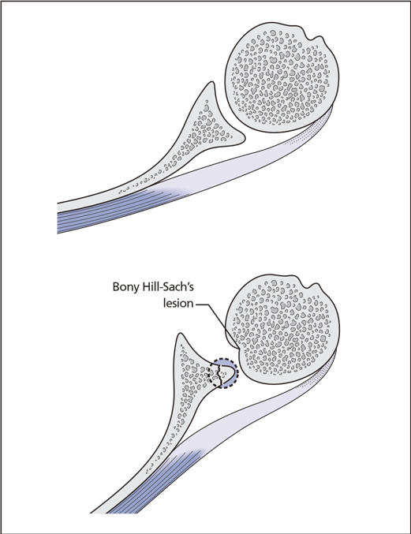  Figure 7 Lateral appearance of a recurrent dislocation showing a Hill Sachs lesion. | 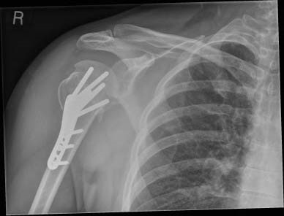  Figure 8 Internal fixation of a fracture dislocation of the shoulder.
Reposition by Dzhanelidze (fig. 9) – after anesthesia the patient is laid on the side of the injured extremity. The hand hangs across the edge of the dressing table. Thus the scapula should be necessarily fixed by edge of the table plane. A little table is put under the head, which should correspond to the level of the table. In such position the patient stays for 15-20 minutes. Under weight of the lowered extremity the muscles of the shoulder girdle gradually relax.
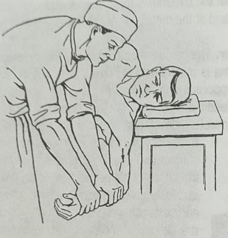
Figure 9. Method of reposition shoulder joint by Dzhanelidze.
The assistant stands in front of the patient and bends his hanging down hand in the elbow joint under the right angle and the result the tensed muscles relax, then puts his hands on the palmar surface of the forearm and makes pressure downwards on the forearm, along the longitudinal axis of the shoulder, simultaneously making the rotational movement outwards and inside. Usually at this the reposition is made.
Method of Kokher (fig. 10). After the preliminary anesthesia the patient is laid on the table. Reposition will consist of four consecutive stages.
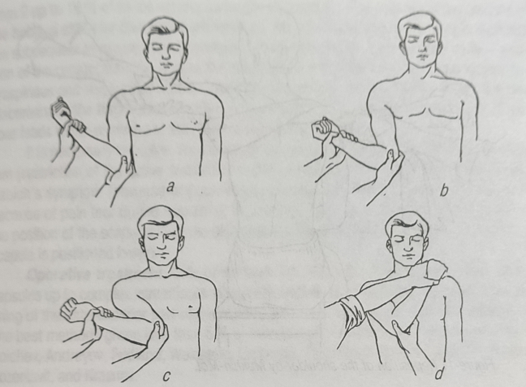
Figure 10. Method of reposition shoulder joint by Kokher
The first stage: the repositioning person stands at the side of the patient and takes his elbow bent under the right angle with one hand and the area of the radiocarpal joint with the other hand. At this time the assistant fixes the shoulder girdle of the injured, and the repositioning person presses on the forearm, pulling it downwards, and presses the elbow to the body. At this time the head turns outwards.
The second stage: the brought down shoulder downwards is rotated outwards, taking the bent forearm to the frontal plane. At this time the head of a shoulder retreats outwards and stands against the glenoid cavity. Very often the head repositions at this moment. If it has not happened, then the third stage is on.
The third stage: traction, outwards rotation of the shoulder and reduction are kept, but in addition the elbow of the injured hand is taken to the anterior surface of the thorax. During this moment the head of the shoulder stands against the rupture place of the capsule.
The fourth stage: the forearm is turned inside and put on the breast of the patient, and the wrist is on the healthy shoulder. The head of the shoulder is usually comes to its place at this.
Mukhin-Mot's method. The patient lays or sits on a stool. With the sheet laid along the length, the axillary region is covered, and the ends of the sheet are taken to the healthy joint. They are kept strong by the assistant standing at the healthy side. The surgeon takes the shoulder above the elbow joint with one hand, and the forearm with the other hand, bends the hand in the elbow under the right angle and pulls the hand from the thorax. Having given the hand the mentioned position, the surgeon makes the traction with the shoulder outwards and a little upwards. Lifting and lowering the forearm, he makes the rotary movements of the shoulder (fig. 11). The head of the shoulder is usually comes to its place at this.
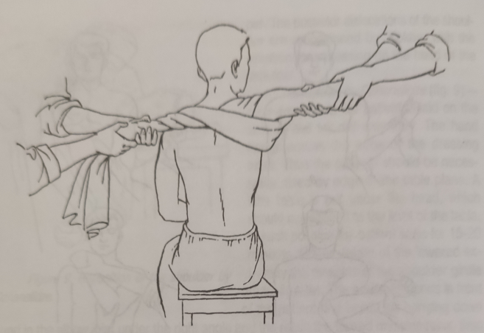
Figure 11. Mukhin-Mot's method of reposition shoulder joint.
Hypocrite-Cooper's method (fig. 12). After anesthesia the patient is laid on the flat couch, the repositioning person removes the footwear from one leg, puts on pure sock and takes a seat at the side with his face to the patient. Then with the same leg, corre sponding to the dislocated head of the shoulder, presses with the heel on the axillary crease and simultaneously pulls to himself the extended hand by the wrist. By means of this method the head displaces outwards and upwards, penetrating into the joint through the aperture.
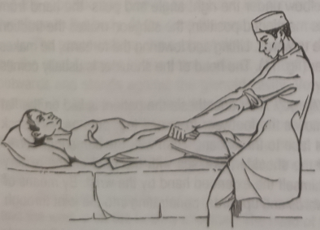
Figure 12. Hypocrite-Cooper's method of reposition shoulder joint.
After the reposition of the dislocation by one of the described methods it is neces sary to carry out the control x-ray films for the confirmation of reposition. The hand is fixed with the plaster splint in the medium physiological position for not less than 3 weeks with the subsequent functional method of treatment. It is better to put the hand on the wedge-shaped pillow in a combination with the posterior plaster splint. This term of immo bilization is necessary for the recovery of the injured tissues during the dislocation and warns development of the habitual shoulder dislocation. Work capacity is restored in 30 45 days. During 3 months one should not go in for sports and heavy physical work.
Dislocations of the head with the fractures of the shoulder neck are seldom observed. Conservative treatment with preliminary imposed skeletal traction and the subse quent one-stage reposition under the narcosis is not always success ful. Open reposition in a combina tion with intraosseous osteosynthe sis leads to good anatomic and functional results.
Habitual shoulder dislocations.
Habitual dislocations shoulder occur often enough from 2 up to 16 % of cases among traumatic dislocations. The reasons of occurrence of the habitual shoulder dislocation are basically the errors made at the first reposition and the subsequent treatment. The accompanying injuries contribute to this especially - avul sion of the greater tubercle and as the result there is the insufficiency infraspinatus, su praspinous and teres minor muscle, marginal fractures of the articular fossa with the dis placement of the fragments, etc. Observance of all rules of treatment of fresh disloca tions leads to the decrease of the habitual dislocations quantity.
It is necessary to outline the following from the objective factors: Weinstein's symp tom (restriction of the active supination at the abduction of the hand to the right angle) Babich's symptom (absence of passive movements in the humeral joint of a sick hand because of pain fear during research), Drobotun's symptom (presence of asymmetry in the position of the scapulas - at the side of the habitual dislocation - the inferior angle of scapula is positioned lower).
Operative treatment. Lots of methods are offered – from simple suture of the capsules up to complex intraarticular plastic operations. All of them are based on strength ening of the anteroinferior part of the capsule and restoration of the muscular synergism. The best methods giving less than 5 % of relapses are considered to be the methods of Boichev, Andreyev, Fridland, Weinstein, Drobotun, Putti-Plyatt, Bankart, Shtutin, Ruppa Rozentsvit, and Krasnov.
Tendon rupture of the supraspinous muscle.
Full rupture of the supraspinous muscle tendon is usually connected with falling. Injuries can be caused by sudden abduction of the shoulder at the holding of weight in a hand or sharp ejection of a hand forward for protection at falling. Besides, sometimes traumatic dislocations of a shoulder are complicated by the rupture of the supraspinous muscle tendon.
Clinical symptoms. There is the pain felt in the middle of the shoulder and above the greater tubercle, and also the painfulness at the movement in the humeral joint. Full rupture of the tendons is accompanied by the restriction of active shoulder abduction.
Conservative treatment. The ruptured tendons are pulled together by means of abduction, bending forward and external rotation of extremity with the immobilization up to 8-10 weeks. Faster restoration of the shoulder function to the abduction side can be reached by an earl operation
Tendon rupture of the biceps.
The Long head of the shoulder biceps muscle is exposed to the degenerate changes, especially at osteoarthritis and arthrosis of the humeral joint. It sometimes leads to the rupture of the tendon after the muscular tension. The proximal end of the biceps long head ruptures or avulses more often (fig. 13); avulsion of the short head of this muscle from coracoid process or avulsion of the distal end of its tendon occurs seldom.
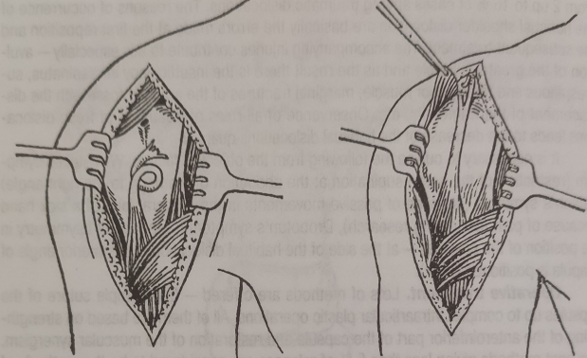
Figure 13. Avulsion of long head of biceps brachial muscle tendom and fixation to the acromion by Smirnova.
Clinical symptoms. There is the sharp pain at the moment of the trauma which is accompanied by the swelling below the deltoid muscles. At bending of the forearm the biceps increases in volume and is condensed. The electroexcitability of the muscle at the injury side is reduced. Restoration of the function disturbance of the injured muscle is possible after the operative treatment only. Sewing of the ruptured tendon to the rough ness of the scapula supraglenoid cavity complicates the operation considerably as it makes necessary to open the humeral joint. Attachment of the tendon to the proximal end of the humeral bone makes it a monoarticular muscle and reduces its function. L. A. Smirnova offered more simplified attachment modification of the avulsed tendon of the shoulder biceps long head to the acromion. Thus, the muscle keeps the two-articular character and there is no necessity to open the cavity of the joint.
Fractures of the humeral bone.
Fractures of the humeral bone superior end are divided into extraarticular and intraarticular. Fractures of the humeral bone head and anatomic cervix are referred to the intraarticular fractures, and transtubercle and fractures of the surgical neck are re ferred to the extraarticular fractures. In addition, quite often there are isolated fractures of the greater tubercle rarely- of the lesser tubercle.
Three types of fractures are differentiated among the fractures of the shoulder surgical neck: 1) fractures without displacement; 2) adducting and 3) abducting.
Fractures without displacement arise because of the direct impact on the external part of the shoulder or at falling on the elbow. Last two types of fractures are the conse quence of falling on the hand or on the elbow in position of adduction (adducting frac ture) and on the abducted elbow or hand (abducting fracture).
If at the moment of the trauma the hand was in “neutral" position, then depending on the force level acting along the axis of the humeral bone, there is an introduction of the inferior fragment into the upper and arises the impacted fracture of the shoulder surgical cervix.
At the adducting fracture the central fragment is abducted and rotated outwards, the peripheral – is displaced outwards and upwards (fig. 14.a). An angle is formed which is opened inwards and backwards between both fragments. There is often the introduction of the distal end edge of the humeral bone into the head.
At the abducting fracture of the shoulder surgical cervix the central fragment is adducted and is rotated inwards, and the peripheral – inwards and forward and is lifted up (fig. 14.b). Both fragments form the angle opened outwards and backwards. The most often are the abducting fractures of the shoulder surgical cervix.
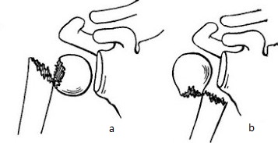
Figure 13. Fractures of the shoulder surgical neck: a) adducting and b) abducting.

Epiphysiolysis and fractures with displacement are often present at children in area of the shoulder surgical cervix.
Clinical symptoms. Patients complain of the pain in the humeral joint, there is a swelling and a hemorrhage in it. Active movements in the humeral joint are almost impossible. At the adducting fracture with the significant displacement the central end of the peripheral fragment is defined along the external surface of the humeral joint. At the ab ducting fracture the axis of the shoulder is displaced inwards, and the central end of the peripheral fragment is defined inwards and forward from the head. The appearance of the hand at the survey is almost the same, as at the dislocation of the shoulder. The diagnosis is specified by the radiography.
Fractures of the shoulder surgical cervix can be complicated by the injuries of the axillary nerve and vessels.
Treatment. At the impacted fractures with the satisfactory position of the fragments (at an angle curvature the axis of the shoulder is restored by all means) the hand is sus pended on the kerchief. It is necessary to use the soft pillow of the triangular form for the abduction of the shoulder. Starting from the 4-5th day the patient starts making active movements in the humeral joint. Work capacity is restored in 6-8 weeks.
At the fractures with the fragments displacement the one-stage manual reposition under local anesthesia of 20 ml of 1 % Novocain solution is prescribed.
At adducting fractures the comparison of the fragments is made as follows: the patient is laid on the table or set on a stool, the doctor stands behind the patient and with his shoulder introduced into the axillary crease, fixes the scapula and the proximal frag ment. The assistant who stands in front of the patient grasps the distal end of the shoulder and the elbow joint, bent at the right angle, and makes the traction along the axis of the shoulder and abducts it from the body, eliminating by this the adduction of the distal frag ment, and then directs it forward, i.e. bends, and by that eliminates the angle opened backwards.
The skeletal traction with the hand lifted upwards is applied at the epiphysiolysis and impacted adducting fractures of the shoulder cervix at children.
At abduction fractures the comparison of the fragments is made in almost the simi lar way, however the angle opened outwards, is eliminated by the adduction of the elbow to the body. In addition, the cotton-gauze swab is put into the axillary crease and the Desault's bandage is imposed for holding the fragments. The degree of the fragments reposition is controlled by the radiography films.
At impossibility to achieve the comparison of the fragments by one-stage reposition then the skeletal traction is applied by the elbow process or open reposition with the intraosseous fixation by metal or bone fixators.
Diaphysis fractures of the humeral bone.
Diaphysis fractures of the humeral bone arise by reason of the direct impact at falling on the shoulder and an indirect trauma at falling on the elbow. Depending on the mechanism of a trauma transverse, oblique, spiral and splintered fractures, and depend ing on the level of the fracture and traction of corresponding muscles - different kinds of displacement can be present.
At the fractures of the humeral bone below the surgical cervix, above the place of greater pectoral muscle attachment the central fragment under the action of the supraspinous muscle pull is in the position of abduction, rotation outwards with the bia or smaller displacement forward. Distal fragment under the action of the greater pectoral muscle pull is displaced upwards and inwards. At the fracture below the places of the greater pectoral muscle attachment and higher than deltoid tuberosity, the central frag ment is in the position of adduction (pull of the greater pectoral muscle and the broadest muscle of the back), but peripheral – by the action of the deltoid muscle is displaced outwards, and by the biceps and triceps of the shoulder and by the coracobrachial muscle is tightened up.
As a rule, at the fractures of the diaphysis of the humeral bone below the place of the deltoid muscle attachment, the central fragment is abducted, turned outwards and forward, and the peripheral - by the biceps and triceps pull is displaced along the length upwards inwards and forward (fig. 17).

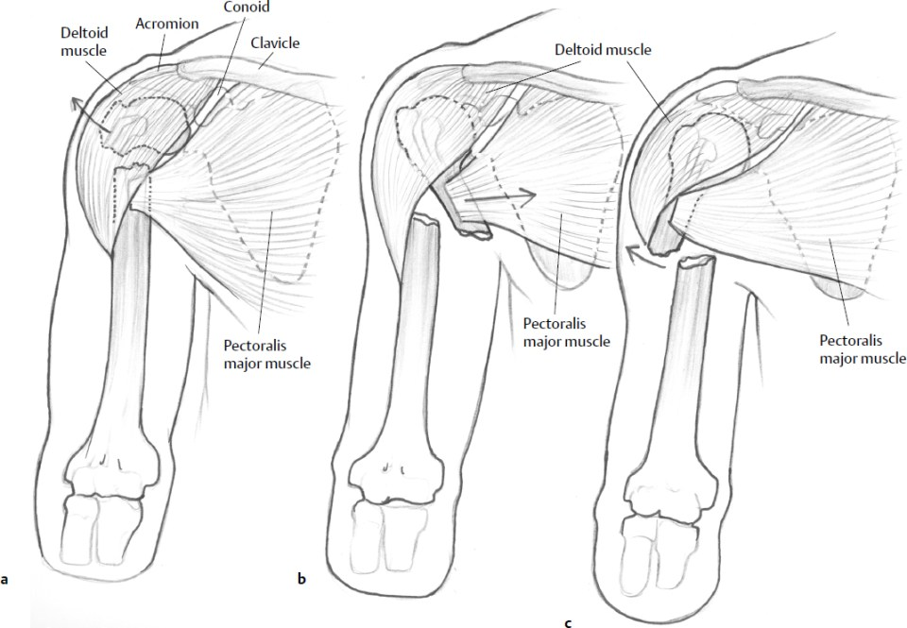
Figure 13. Typical displacement of fragments of the humerus depending on the level of the fracture.

Clinical symptoms. Fracture of the diaphysis of the humeral bone is easily defined. Deformation, sharp painfulness, abnormal mobility, swelling of the shoulder and often the angulation of the bone fragments are arising at the place of the trauma. Shortening is observed at the change of the anatomic length of the humeral bone. The radiography made in two projections, specifies the diagnosis. Diaphysis fractures of the humeral bone, especially in the middle and inferior one-third, are quite often accompanied by the injury of radial nerve (contusion, partial or its complete separation). It is evident by the passive hanging of the hand, absence of its active extension and abduction of the pollex. In addition, at the research of pain sensitivity in the innervation zone of the radial nerve its decrease becomes quite evident. Injury of the radial nerve is often connected with its entrapment by the bone fragments. In this case open reposition with the inspection of the nerve is prescribed.
Treatment. After anesthesia of 20 ml 2 % Novocain solution the reposition of the peripheral fragment is made by the central fragment with the immobilization of the abduction frame (TSITO, Bogdanov, Land, etc.) in the position of shoulder abduction up to 90° and displacement forward down to 30-40° from the frontal plane. Starting from the 10-th day - gymnastics for the hand and fingers. From the 20-th day-massage and movements in the elbow joint. Term of immobilization is 6-8 weeks. Work capacity is restored in 8-12 weeks.
In some cases, at the bed cure of the patient, the frame is replaced by the skeletal extension.
Operative treatment of the humeral bone fractures is applied in the event of impos sibility to compare the fragments in the closed way. It arises at the cross dentate frac tures crises and incarceration of the soft tissues between the fragments. Under the gen eral anesthesia or field anesthesia the longitudinal incision of the skin between the bra. chial muscle and biceps is made, and the bone fragments are defined, and after thet is fixed with the metal plates, beams and pins are introduced intramedullary by the retrograde way. The thoracobrachial plaster bandage is imposed until the bony union. The ununited fractures of the humeral bone and false joints are treated by the operative method. The steady osteosynthesis in a combination with the osteoplasty or with the of the compression distraction devices.
Fractures of the humeral bone inferior end.
Fractures of the inferior end of the humeral end are divided into the extraarticular and intraarticular. The supracondylar extension and bending fractures, situated a little bit higher or on the level of transition place of the metaphysis' spongy bone to the cortical part of the diaphysis, are reffered to the extraarticular fractures, and the transcondylar extension and bending fractures and the epiphysiolysises of the distal end of the shoulder, intercondylar (T and Y-shaped) shoulder fractures, fractures of the lateral condyle, frac tures of the medial condyle, fractures of the capitellum of humerus, fractures and apo physeal of the medial epicondyle, fractures and apophyseal of the lateral epicondyle are reffered to the intraarticular fractures. (A. V. Kaplan).
Supracondylar fractures of the humeral bone.
Supracondylar fractures of the humeral bone arise more often than other fractures of the inferior end of the shoulder at children. They make 15 % of all the fractures of the upper extremity at children up to 16 years. Supracondylar fractures occur at adults too, but much less often. These fractures are juxta-articular and depending on the mecha nism of the trauma, are divided into the extension and flexion (bending). According to the localization the supracondylar fractures of the humeral bone are referred to the meta physeal. The fracture plane here passes at the border, which joins the epicondyles with the inferior one-third of the humeral bone. The extension supracondyle fractures of the humeral bone arise owing to the excessive extension in the elbow joint at falling on the abducted hand. The plane of the fracture often as the oblique direction and goes from the iront backwards and from down upwards. Central fragment of the humeral bone dis places forward into the elbow antecubital fossa and implants into the soft tissues. The peripheral end together with the elbow joint is pulled backwards by the triceps. Thus there is the rotational displacement with the turn of the epiphysis, more often in the external direction.
The described state of the fragments threatens with the entrapment of the vessels and nerves in view of displacement not only along the length, but also on width, especially triangle is not changed at measurement. The fracture place is sharply painful at the pal pation. Function of the hand is impaired.. If there is the compression of the artFigure ery, then the pulse at the radial artery is absent or it can be hardly defined. Occurrence of the movement disorder and of the sensitivity point to the peripheral nerves injury. At the bend ing supracondylar fracture the end of the upper fragment is palpated at the back surface of the shoulder. There is no retraction above the elbow joint, the axis of the shoulder is downwards and is bent aside forward. The important differential diagnostic sign of the supracondylar fractures is the violation of the ratio between the shoulder axis and the line connecting both epicondyles (Marx's sign). Usually, the shoulder axis crosses the above mentioned line in the middle at right angles. Radiography in two projections is prescribed for the specification of the diagnosis. It is recommended for children to make the radio graphic films of the healthy and of the injured hand because of the ossification focuses availability, which can be recognized as the fracture.
Treatment. At the fractures without the displacement of the fragments, after anes thesia the plaster splint is imposed from the base of the fingers up to the humeral articula tion, and the hand is bent in the elbow joint at the right angles. The term of fixation al children up to 14-16 days, at adults --3-4 weeks.
The supracondylar fractures with the displacement of the fragments are urgently repositioned. All the kinds of the displacement are eliminated, including the rotation of the distal fragment. At the extension fractures the single stage reposition is made as follows: doctor grasps the forearm of the patient in the inferior one third and in the area of the radiocarpal articulation with one hand, applies the careful traction along the axis of the extremity and at the same time eliminates the rotation of the distal fragment by the cor rect placing of the forearm in relation to the shoulder - the pronation of the forearm for the relaxation of the round pronator muscle. The axis of the extremity is straightened. The countertraction is made by the assistant with the shoulder. To reposition the inferior frag ment, the repositioning person places one hand on the internal-frontal surface of the lower part of the upper fragment and fixes it, and he puts the other hand - on the rear-external part of the fragment and displaces it forward and inwards.. After the reposition of the fragments the bending of the extremity in the elbow joint is carried out up to the 60-70° angle and the plaster splint ins imposed. The forearm is positioned between the pronation and supination. Then the control radiography is carried out. It is necessary to observe the extremity after the immobilization, for not to let the blood circulation disorder. Terms of fixation is for 14-18 days. The function of the hand after the fracture is restored in 8-10 weeks.
At the bending fractures the reposition of the distal end is made by the central frag ment. All kinds of displacement are eliminated, including the rotational, by means of the correct placing of the forearm in relation to the shoulder. The hand is left unbent in the elbow joint at the angle of 120° and is fixed by the plaster splint for the period of 14-18 days. If at the single stage reposition the displacement of the fragments is not eliminated, then the skeletal traction is imposed with the load of 3-4 kg. In case of necessity the corrigent traction is applied. In 2 weeks the constant traction is replaced with the plaster splint for the period of 2 weeks also. Then the functional method of treatment is pre scribed. Work capacity of the patients is restored in 8-12 weeks.
Operative treatment is applied under prescriptions when it is not possible to com pare the fragments manually. The bone fragments are fixed with the thin pins, plates and screws which are removed in 3 weeks. The functional method of treatment is prescribed to the patient.

Recommended Books
- Traumatology and orthopedics : textbook for students of higher medical educational institutions / edited by Golka G. G., Burianov O. A., Klimovitskiy V. G. – Vinnytsia : Nova Knyha, 2018, – 400 p.
- Venger, V.F. Traumatology and orthopedics / V.F. Venger, V.V. Serdyuk, Rashed Mochammad. – Odessa. Druk, 2006.- 248p.
- Duckworth, T. Lecture notes. Orthopaedics and fractures / T. Duckworth, C.M. Blundell. – 4th ed.
- David, Ip. Orthopedic Traumatology – A Resident’s Guide / David Ip. – 2nd ed.

