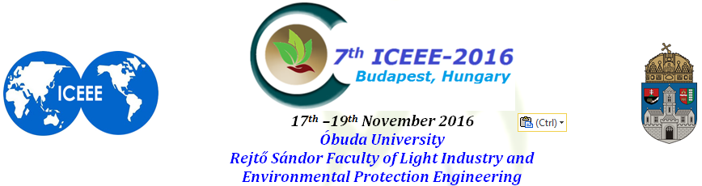

NEW APPROACHES IN CREATION OF 1,2,4-TRIAZOLE-CONTAINING
BIO-ACTIVE COMPOUNDS FOR ENVIRONMENTAL BIO-TECHNOLOGIES

Mikhailo SLIVKA¹, Maksym FIZER¹, Ruslan MARIYCHUK³, Valerii PANT’O¹,
Vjacheslav BAUMER², Andrii KRIVOV’IAZ¹, Galina KOVAL’¹, Vasil LENDEL¹
¹Uzhhorod National University, Uzhhorod, Ukraine
²SSI “Single Crystals” NAS of Ukraine, Kharkiv, Ukraine
³University of Prešov in Prešov, Prešov, Slovakia

Modern environmental technologies now are widely used in industry, particularly, in the production of medicines and external disinfecting and antifungal agents. One of the objectives of “clean industry” is: to develop of energetically no-costs technologies, to shed of toxic and harmful substances that are involved in the production process or formed during the manufacturing process.
The aim of our study was to develop for environmental bio-technologies the procedure of the creation of new bio-active condensed and functional 1,2,4-triazole's derivatives, which contain such elements as Selenium and Tellurium. Development Se, Te-containing bioactive compound is an actual task, because these minerals are essential to the human body with one hand, and on the other hand all known about high toxicity of Selenium and Tellurium compounds.
In our investigation we carried out simulations and compare the toxicity of Sodium Selenite and Telurite (that used as carriers of Selenium and Tellurium), other forms of Se(IV), Te(IV) (their oxides) and Se, Te-containing 1,2,4-triazoles. The result - a large decrease in the index of toxicity for Se, Te-containing 1,2,4-triazoles has been received. As a model object for binding selenium and tellurium in organic form we have chose the 1,2,4-triazole system, because this heterocyclic is none toxic and can be synthesized from available reagents and with using safe environmental water & ethanol as the medium. Introduction of Se, Te was made according to elaborated by us technology which uses as a medium non-toxic solvents (acetic acid - water) and does not requires significant energy costs (air environment, room temperature) – that is, technology developed by us is consistent with the requirements of environmental engineering. We also studied in detail the composition and structure of the obtained compounds (NMR, IR, and RSA) and studied their properties (resistance to different environments, constant basicity, modelling toxicity, etc.). The biological investigation of bactericidal and fungicidal activity for Se, Te-containing 1,2,4-triazoles also has been realized.
Here we present the results of successful receiving of bio-active Se(Te-)containing heterocycles according requires of environmental bio-technologies; their bio-evolution as bactericides & fungicides also has been done.
Keywords: environmental bio-technologies, bio-active Se(Te-)containing 1,2,4-triazoles, bactericide, fungicide
Acknowledgements. This study was partially supported by Visergrad Found (Project 51600925).
Corresponding address: (mvslivka@email.ua)
Title: Dr.
Name: Mikhailo SLIVKA
Department: Department of Organic Chemistry
Faculty: Faculty of Chemistry
University: Uzhhorod National University
Post Address: 46 Pidhirna St, 88000, Uzhhorod, Ukraine
City, Country: Uzhhorod, Ukraine
Telephone/mobile: +380503725325 Fax: +380312235091 E-mail: mvslivka@email.ua
Please, kindly fill the form and return back by e-mail to Prof. Dr. habil Hosam B. Hamuda

