МІНІСТЕРСТВО ОСВІТИ І НАУКИ УКРАЇНИ
ДЕРЖАВНИЙ ВИЩИЙ НАВЧАЛЬНИЙ ЗАКЛАД
«УЖГОРОДСЬКИЙ НАЦІОНАЛЬНИЙ УНІВЕРСИТЕТ»
ФАКУЛЬТЕТ ІНОЗЕМНОЇ ФІЛОЛОГІЇ
КАФЕДРА АНГЛІЙСЬКОЇ ФІЛОЛОГІЇ

«ПЕРЕКЛАД ДІЛОВОГО МОВЛЕННЯ»

Для студентів 3 курсу денної форми навчання

Освітній рівень: бакалавр
Галузь знань: 01 Освіта/ 03 Гуманітарні науки
Спеціальність (напрям підготовки): 035 Філологія
Статус курсу: вибірковий

Ужгород – 2022

ДВНЗ «Ужгородський національний університет»
Факультет іноземної філології
Кафедра англійської філології

Навчально-методична розробка «Переклад ділового мовлення» для студентів 3 року навчання денної та заочної форм навчання за напрямом підготовки 035.04 Філологія. Германські мови та література (переклад включно)

Розробники: Гайданка Д. В., доцент кафедри англійської філології, Іванова А., доцент кафедри англійської філології

Мова навчання дисципліни: англійська

Обсяг дисципліни в кредитах ЄКТС : 03
Загальна кількість годин: 90
Практичні (лабораторні): 44
Самостійна робота: 46
Статус дисципліни: обов’язкова
Вид контролю: залік

Рецензенти:
Глюдзик Ю.В., канд. філ. наук, доцент кафедри англійської філології
Дерді Е.Т., канд. філ. наук, доцент кафедри англійської філології

Затверджена на засіданні кафедри англійської філології:

Протокол від « » ____________ №

Завідувач кафедри англійської філології (доц. Голик С. В.)

(підпис)

Схвалено методичною комісією факультету іноземної філології:

Протокол від « » ____________ №

Голова (доц. Синьо В. В.)

(підпис) (прізвище та ініціали)

© Гайданка Д. В., Іванова А.О. 2022 рік

    - ОПИС НАВЧАЛЬНОЇ ДИСЦИПЛІНИ

Найменування показників | Галузь знань, напрям підготовки, освітньо-кваліфікаційний рівень | Характеристика навчальної дисципліни
 |  | денна форма  навчання | заочна форма навчання
Кількість кредитів – 03 | Галузь знань:  03 – Гуманітарні науки  (шифр і назва) | Нормативна
Спеціальність:
035.04 – Філологія (германські мови та література (переклад включно))
(спеціалізація – Англійська мова та література)
Модулів – 2 |  | Рік підготовки:
Змістових модулів – 2 |  | 3-ій | 3-ій
 |  | Семестр
Загальна кількість годин – 90 |  | 6-й | 6-й
 |  | Лекції
Тижневих годин для денної форми навчання: 03  аудиторних – 3  самостійної роботи  студента – 46 | Освітньо-кваліфікаційний рівень:  бакалавр | 0 год. | 0 год.
 |  | Практичні
 |  | 44 год. | 2 год.
 |  | Лабораторні
 |  | 44 год. | 0 год.
 |  | Самостійна робота
 |  | 46 год. | год.
 |  | Індивідуальні завдання
 |  | 0 год. | 0 год.
 |  | Вид контролю
 |  | дві модульні контрольні роботи та підсумковий семестровий модульний контроль (залік).

*Примітка.
Співвідношення кількості годин аудиторних занять до самостійної і індивідуальної роботи становить для денної форми навчання:
Аудиторна робота – 49%, СРС – 51%

    - МЕТА НАВЧАЛЬНОЇ ДИСЦИПЛІНИ

Мета вивчення дисципліни – сприяння практичному опануванню студентами нормативної бази функціонування англійської мови в комунікативно-мовленнєвих ситуаціях ділового спілкування; забезпечення глибокого засвоєння видів і типів перекладу при роботі у ситуаціях ділової комунікації; покращення якості перекладу матеріалів ділового спрямування з урахуванням лексичних, синтаксичних, граматичних та прагматичних особливостей їх перекладу; опанування студентами стратегій і технік перекладу у професійних ситуаціях; поглиблення навичок перекладачів, які працюватимуть у ділових структурах, у сфері ділових відносин; зовнішньоекономічної діяльностi, менеджменту, зв’язків з громадськістю тощо.
Предметом вивчення навчальної дисципліни є особливості перекладу у сфері ділової та професійної комунікації.
Завдання навчальної дисципліни – підвищення ефективності ділової комунікації за рахунок лексичних та комунікативних вправ; забезпечення фонових знань, необхідних студенту для роботи з матеріалами блоку ділової комунікації; відпрацювання навичок перекладу в умовах ділових контактів з урахуванням норм соціального етикету, обміну професійною інформацією, взаємодії на професійному рівні.

    - ПЕРЕДУМОВИ ДЛЯ ВИВЧЕННЯ НАВЧАЛЬНОЇ ДИСЦИПЛІНИ

Передумовами вивчення навчальної дисципліни «Переклад ділового мовлення» є опанування таких навчальних дисциплін (НД) освітньої програми (ОП):

Шифр НД за ОП | Назва навчальної дисципліни
ОК 12 | Англійська мова (практичний курс). Рівень В2-В2+
ОК 14 | Практична граматика англійської мови
ОК 16 | Порівняльна граматика англійської та української мов

    - ОЧІКУВАНІ РЕЗУЛЬТАТИ НАВЧАННЯ

Відповідно до освітньої програми «Переклад ділового мовлення», вивчення навчальної дисципліни повинно забезпечити досягнення здобувачами вищої освіти таких програмних результатів навчання (ПРН):
Програмні результати навчання | Шифр ПРН
Використовувати мову(и), що вивчається(ються), в усній та письмовій формі, у різних жанрово-стильових різновидах і регістрах спілкування (офіційному, неофіційному, нейтральному), для розв’язання комунікативних завдань у побутовій, суспільній, навчальній, професійній, науковій сферах життя | ПРН - 14
Здійснювати лінгвістичний, літературознавчий та спеціальний філологічний аналіз текстів різних стилів і жанрів | ПРН - 15
Знати й розуміти основні поняття, теорії та концепції обраної філологічної спеціалізації, уміти застосовувати їх у професійній діяльності | ПРН - 16

Очікувані результати навчання, які повинні бути досягнуті здобувачами освіти після опанування навчальної дисципліни «Переклад ділового мовлення»:
Очікувані результати навчання з дисципліни | Шифр ПРН
Здатність вільно, гнучко й ефективно використовувати мову(и), що вивчається(ються), в усній та письмовій формі, у різних жанрово-стильових різновидах і регістрах спілкування (офіційному, неофіційному, нейтральному), для розв’язання комунікативних завдань у різних сферах життя. | ФК-6.
Здатність вільно оперувати спеціальною термінологією для розв’язання професійних завдань. | ФК-8.
Усвідомлення засад і технологій створення текстів різних жанрів і стилів державною та іноземною (іноземними) мовами. | ФК-9.
Здатність здійснювати переклад текстів різних стилів та жанрів; здатність здійснювати усний переклад відповідно до комунікативного спрямування. | ФК-11.
Здатність до організації ділової комунікації. | ФК-13

5. ЗАСОБИ ДІАГНОСТИКИ ТА КРИТЕРІЇ ОЦІНЮВАННЯ РЕЗУЛЬТАТІВ НАВЧАННЯ

Методи навчання
Навчання здійснюється з використанням комунікативно зорієнтованої методики та інтегративного підходу, в рамках якого розвиваються всі види мовної та мовленнєвої компетенції студентів.
1. Словесні: розповідь, пояснення, бесіда,
2. Наочні: ілюстрація, демонстрація, презентація
Програмне забезпечення
- Навчально-методичні матеріали (підручник Business Partner B1+).
- Навчально-методичне забезпечення самостійної роботи студентів.
- Комплекс індивідуальних креативно-дослідних завдань.
- Засоби контролю й самоконтролю.
- Комплекс літератури з дисципліни.

Форми контролю та критерії оцінювання результатів навчання
Форми поточного контролю: усне опитування, презентації, переклад фахового тексту, заключний проєкт, глосарій термінів;

Форма модульного контролю: письмова

Форма підсумкового семестрового контролю: залік

Розподіл балів, які отримують здобувачі вищої освіти (модуль 1)
Поточне оцінювання та самостійна робота |  |  |  |  |  |  |  |  | Модульна  контрольна робота | Сума
Т1 | Т2 | Т3 | Т4 | Т5 | Пр | Переклад |  |  | 50% | 100
4 | 4 | 4 | 4 | 4 | 10 | 20
Розподіл балів, які отримують здобувачі вищої освіти (модуль 2)
Поточне оцінювання та самостійна робота |  |  |  |  |  |  |  |  | Модульна  контрольна робота | Сума
Т1 | Т2 | Т3 | Т4 | Т5 | Пр | Переклад |  |  | 50% | 100
4 | 4 | 4 | 4 | 4 | 10 | 20
Т1, Т2 ... – теми
Пр. – презентація
Переклад – переклад фахового тексту

- Поточний контроль: (50%) усне опитування самостійно опрацьованого фахового перекладу (Контроль вірності, адекватності та самостійності виконання перекладу у запланованому обсязі (4 друковані сторінки формату А4 за 5,5 год.)
- Підсумковий контроль: Підготовка групового проєкту та презентація укладеного Портфоліо Перекладача (наявність усіх структурних підрозділів ) — 20 %; Знання англо-українського галузевого глосарію — 10 % Контрольна робота (контроль знання письмових базових моделей фахового перекладу) — 20 %

Розподіл балів, які отримують студенти
МОДУЛЬ 1
Модульна контрольна робота | Оцінка за роботу на практичних заняттях | Всього
25 балів | 25 балів | 50 балів
МОДУЛЬ 2
Модульна контрольна робота | Оцінка за роботу на практичних заняттях | Всього
25 балів | 25 балів | - балів

*Переведення даних 100-бальної шкали оцінювання в 5-бальну шкалу за системою ECTS здійснюється в такому порядку:

ШКАЛА ОЦІНЮВАННЯ СТУДЕНТА

ОЦІНКА  ЄКТС | СУМА БАЛІВ | ОЦІНКА ЗА НАЦІОНАЛЬНОЮ ШКАЛОЮ
 |  | екзамен | залік
A | 90-100 | 5 (відмінно) | 5/відм./зараховано
B | 80-89 | 4 (добре) | 4/добре/ зараховано
C | 65-79
D | 55-64 | 3 (задовільно) | 3/задов./ зараховано
E | 50-54
FX | 35-49 | 2 (незадовільно) | Не зараховано

Обговорення програмних питань з дисципліни на практичних заняттях проводиться систематично. Оцінка рівня знань при проведенні модульного поточного контролю та на практичних заняттях здійснюється таким чином:
Оцінка «відмінно»: студент має систематичні глибокі знання навчального матеріалу; без помилок виконав домашнє завдання; ґрунтовно викладає матеріал, має правильне мовлення; активно використовує лексичний мінімум в мовленні, творчо підходить до вирішення поставлених завдань.
Оцінка «добре»: студент засвоїв навчальний матеріал; викладає матеріал у логічній послідовності; виконав домашнє завдання, але допустив у ньому незначні помилки; має незначні помилки в мовленні та недостатньо використовує лексичний мінімум.
Оцінка «задовільно»: студент засвоїв навчальний матеріал не в повному обсязі; дає неповну відповідь на поставлені питання; допустив значні помилки в домашньому завданні; не володіє лексичним мінімумом модуля; допускає грубі помилки в мовленні.
Оцінка «незадовільно»: студент не засвоїв навчальний матеріал; на може викласти матеріал іноземною мовою; на виконав домашнього завдання; не володіє лексичним мінімумом мовлення.

Об’єкти поточного контролю:
- відвідування практичних занять;
- систематичність та активність роботи на практичних заняттях;
- виконання модульних контрольних робіт;
- виконання завдань для самостійного опрацювання та індивідуальних завдань;
- виконання фінального групового проєкту
Модульний контроль за вивченням матеріалу дисципліни здійснюється за 25 бальною шкалою. Структура кожного комплексу завдань за модулями містить завдання різного рівня складності для перевірки рівня засвоєння граматичного і лексичного мінімуму.

- ПРОГРАМА НАВЧАЛЬНОЇ ДИСЦИПЛІНИ
6.1. Зміст навчальної дисципліни
Змістовий модуль 1.
Тема 1 Бізнес-комунікація, її види та функції. Жанрово-стилістичні особливості офіційно-ділового стилю. Термінологія ділового спілкування загального використання. Жанрова класифікація офіційних документів. Формат документів.
Тема 2 Корпоративна модель Маккінсі. Тверді та м’які навички. Лідерство. Види підприємств. Ключові терміни і поняття, абревіатури англійською та українською мовами.
Тема 3 Структура компанії. Види підприємств. Ключові терміни і поняття. Абревіатури. Види організаційно-правової організації підприємств англійською та українською мовами.
Тема 4. Особливості написання ділової кореспонденції. Типологія офіційно-ділових листів. Структура ділового листа, його частини та їх розміщення. Порівняльний аналіз зразків написання ділових листів англійською та українською мовами. Особливості оформлення листів-заяв, рекомендаційних листів. Написання резюме та супроводжуючого листа за форматом EUROPASS.
Тема 5. Особливості та різновиди контрактів. Використання спеціалізованої термінології для оформлення контрактів. Особливості оформлення листів-запитів, листів-скарг. Порівняльний аналіз зразків контрактів англійською та українською мовами. Мовленнєві шаблони. Мовні кліше і лексичні одиниці ділового англійського і американського мовлення; способи відтворення ідіоматичних виразів, інтернаціональної лексики, реалій; правила перекладу ділової кореспонденції, контрактів, патентів та інших документів; лексичні трансформації при перекладі.
Змістовий модуль 2.
Тема 6. Ділові зустрічі. Порядок денний та написання протоколу зустрічі. Особливості ділової бесіди по телефону: використання типових зразків мовлення у типових мовленнєвих ситуаціях
Тема 7. Бізнес-цикли та тренди. Опис даних, графіків, діаграм.
Тема 8 Тема 8. Розкриття поняття ―презентація, зразок проведення презентації. Інформативні презентації, Мотивуючі презентації. Підготовка до проведення презентації. Використання наочності при проведені презентації. Особливості використання лексичного матеріалу при проведенні презентації.
Тема 9 Розкриття поняття «переговори». Типи переговорів. Зразки ведення переговорів. Дипломатичні переговори та протокол. Етапи проведення переговорів. Типи дипломатичних документів.
Тема 10 Особливості оформлення, написання та перекладу звітів та мемо.

  - Структура навчальної дисципліни

Назви змістових модулів і тем | Кількість годин
 | денна форма |  |  |  |  |  |  |  | Заочна форма
 | усього |  |  | у тому числі |  |  |  |  | усього | у тому числі
 |  |  |  | л | п | лаб | інд | с.р. |  | л | п | лаб | інд | с.р.
1 | 2 |  |  | 3 | 4 | 5 | 6 | 7 | 8 | 9 | 10 | 11 | 12 | 13
Практика усного та письмового перекладу
Змістовий модуль 1
Письмовий переклад галузевих текстів.
Тема 1. Бізнес-комунікація, її види та функції. Жанрово-стилістичні особливості офіційно-ділового стилю. Термінологія ділового спілкування загального використання. Жанрова класифікація офіційних документів. Формат документів. |  |  | 8 |  | 4 |  | 4
Тема 2. Корпоративна модель Маккінсі. Тверді та м’які навички. Лідерство. Види підприємств. Ключові терміни і поняття, абревіатури англійською та українською мовами. |  |  | 8 |  | 4 |  | 4
Тема 3. Структура компанії. Види підприємств. Ключові терміни і поняття. Абревіатури. Види організаційно-правової організації підприємств англійською та українською мовами. |  |  | 8 |  | 4 |  | 4
Тема 4. Особливості написання ділової кореспонденції. Типологія офіційно-ділових листів. Структура ділового листа, його частини та їх розміщення. Порівняльний аналіз зразків написання ділових листів англійською та українською мовами. Особливості оформлення листів-заяв, рекомендаційних листів. Написання резюме та супроводжуючого листа за форматом EUROPASS. |  |  | 8 |  | 4 |  | 4
Тема 5. Особливості та різновиди контрактів. Використання спеціалізованої термінології для оформлення контрактів. Особливості оформлення листів-запитів, листів-скарг. Порівняльний аналіз зразків контрактів англійською та українською мовами. Мовленнєві шаблони. Мовні кліше і лексичні одиниці ділового англійського і американського мовлення; способи відтворення ідіоматичних виразів, інтернаціональної лексики, реалій; правила перекладу ділової кореспонденції, контрактів, патентів та інших документів; лексичні трансформації при перекладі. |  | 8 |  |  | 4 |  | 4
Модульна контрольна робота 1 |  |  |  |  | 2
Разом за 1 модуль |  |  | 42 |  | 22 |  | 20
Тема 6. Ділові зустрічі. Порядок денний та написання протоколу зустрічі. Особливості ділової бесіди по телефону: використання типових зразків мовлення у типових мовленнєвих ситуаціях |  |  | 8 |  | 4 |  | 4
Тема 7. Бізнес-цикли та тренди. Опис даних, графіків, діаграм. |  |  | 8 |  | 4 |  | 4
Тема 8. Розкриття поняття ―презентація, зразок проведення презентації. Інформативні презентації, Мотивуючі презентації. Підготовка до проведення презентації. Використання наочності при проведені презентації. Особливості використання лексичного матеріалу при проведенні презентації |  |  | 8 |  | 4 |  | 4
Тема 9. Розкриття поняття «переговори». Типи переговорів. Зразки ведення переговорів. Дипломатичні переговори та протокол. Етапи проведення переговорів. Типи дипломатичних документів. |  |  | 10 |  | 4 |  | 6
Тема 10. Особливості оформлення, написання та перекладу звітів та мемо. |  |  | 12 |  | 4 |  | 8
Модульна контрольна робота 2 |  |  | 2 |  | 2
Разом за 2 модуль |  |  | 48 |  | 22 |  | 26
Разом |  |  | 90 |  | 44 |  | 46

- ІНСТРУМЕНТИ, ОБЛАДНАННЯ ТА ПРОГРАМНЕ ЗАБЕЗПЕЧЕННЯ, ВИКОРИСТАННЯ ЯКИХ ПЕРЕДБАЧАЄ НАВЧАЛЬНА ДИСЦИПЛІНА
(у разі потреби)

Технічні засоби: комп’ютер, інтерактивна дошка, проектор, мобільний телефон, підручник з інтерактивною мовною лабораторією та комплексом додаткових завдань.
Засоби діагностики результатів навчання:

Засобами оцінювання та методами демонстрування результатів навчання є:
- іспит
- стандартизовані тести
- презентації
- виконання індивідуальних та групових завдань
- есе
- комплексні контрольні роботи.

THEME 1. BUSINESS COMMUNICATION.

1.Definition,

2. Types,

3.Examples,

4. Importance,

5. Methods, Functions

Communication is an essential element in the success of any business. The process of transferring information from one person to another, within and outside the business environment, is termed as ‘Business Communication.’ The term ‘Business Communication’ is derived from general communication which is associated with business activities. In other terms, communication between business parties or people for business-related tasks is considered as ‘Business Communication.’
Effective business communication is the way employees and management communicate to achieve organizational goals. The objective is to improve organizational efficiency by reducing mistakes. Business Communication includes different aspects like marketing, public relations, customer relations, corporate and interpersonal communication, etc.
Basic elements of Business communication:
- Sender
- Business information
- Receiver
- Feedback
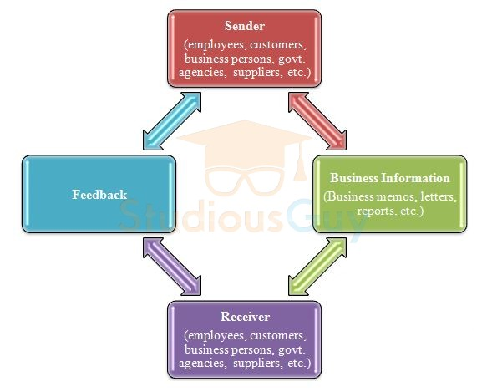
It involves a regular flow of information, and feedback is a crucial aspect of business communication. Due to different levels of hierarchy and the involvement of a huge number of people, business communication plays an important role in different management functions i.e. planning, coordinating, organizing, directing, and controlling.
Types of Business Communication
1. Internal Business Communication occurs among the members of the organization. This communication includes both formal and informal communication. Also, different departments that transmit communication by different means to employees come under internal communication. Internal communication should be effective as it is a vital source of viewing and representing organizational issues. Effective internal business communication may increase job satisfaction levels, productivity, and the efficiency of employees by decreasing their turnover and grievances and helps in increasing profits.
It is further categorized as internal (upward) communication and internal (downward) communication.
a. Internal (Upward) Communication: This type of internal communication involves the bottom to the top management approach. Here, the information flows from subordinates to managers or any person that is on the upper in the hierarchy level. For example, employees of the HR department of an organization prepare an attrition report and communicate the same to the HR Manager. The attrition report consists of information on the monthly or annual employee turnover of an organization and reasons for the same. This helps the HR Manager to understand the cause of attrition and to take corrective measures on time to reduce employee turnover.
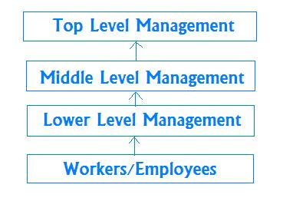
b. Internal (Downward) Communication: the information flows from the top-level management to the employees in an organization. This information is related to passing on instructions to subordinates or employees to do their respective tasks. Downward communication is being used by managers to communicate different goals, procedures and policies, guidelines, decisions, instructions, etc. to their subordinates.
The process of downward communication in business includes passing on messages from the top level to the lower level through the chain of hierarchy. This type of communication can be in oral or written form. The written form includes different notices, manuals, news display in electronic form, etc. whereas, the oral form of downward communication includes different face-to-face conversations, telephonic communication, meetings, etc. For example, the top-level management may instruct managers of different departments on certain new rules and regulations in the work area that need to be carried out in routine activities of different departments. Like there may be a change in the office working hours or office timings by the management and the same is communicated to employees by circular or notice or through the e-mail system.
2. Horizontal/Lateral Business Communication is related to communication among co-workers i.e. either verbal communication or written communication. This may include inter-departmental communication or communication between cross-departments and can be between people of the same or similar rank in a company. This is a crucial communication to achieve the desired results. So, this communication happens among employees having an equal hierarchy level. To achieve the functional effectiveness of different organizational units, horizontal or lateral communication is required for seeking mutual cooperation and mutual help. E.g., the Marketing head of an organization is supposed to communicate about market trends, customer needs and expectations, product demand scenario, etc. to a production head for production of products accordingly. Similarly, the HR manager of an organization works with different department heads for different functioning like hiring, training needs of employees, performance appraisals, welfare activities, etc.
3. External Business Communication is communication with people who are external to the organization (customers or shareholders or suppliers or partners or regulatory bodies, etc.) e.g., the purchase department supervisor may communicate with vendors for purchase quotations of raw-material and similarly, the sales department communicates with customers for sales of goods or services. External communication facilitates increasing sales volume, effective operations, an increase in profits of organization, etc. This ultimately results in increasing corporate image, goodwill and overall performance of the organization by achieving its goals and customer satisfaction.

Importance of Business Communication
1. Helps in increasing productivity: Effective business communication increases the productivity of staff by boosting up teamwork. It creates a trustworthy and understanding environment among employers and employees. Effective communication is related to cooperating with employees and understanding their needs and desires. By doing so, employees are able to accomplish their tasks more effectively and efficiently. Also, the scope of mistakes or errors during their work minimizes due to effective communication.
2. Helps in increasing customers: Customers are an important part of any business and effective business communication can facilitate attracting new customers and retaining the current customers. A well-defined marketing strategy and public relations campaign run by an organization generates the interest of customers in its goods or services and helps in building the corporate image in customers.
3. Enhances business partnerships: Business Communication also improves partnerships in business. It plays a significant role in dealing with external business clients or vendors. Vendors may be required to communicate on products regularly for improvements. Also, an effective and harmonious relationship with other businesses determines the further success of an organization. A business unit that has developed its image as an entity for easy partnership through its effective communication can attract other business units for forming business relationships with them.
4. Facilitates innovations in business: Effective business communication helps in business innovations as well as it facilitates employees to convey their ideas and suggestions openly. Similarly, at the time of launching any new product in the market, effective communication ensures the performance of the sales team, market acceptance of the product, fast delivery of products in the market, etc.
5. Information exchange: Business communication is required by an organization for exchanging information with internal and external stakeholders. This helps in achieving its goals effectively.
6. Preparation of plans and policies: Through effective business communication, organizations can make their plans and policies properly. Relevant information is required for preparing these plans and policies. Through communication, different managers source information through reliable channels.
7. Execution or implementation of plans and policies: To implement or execute the prepared policies and plans in a timely manner, managers are supposed to communicate these throughout the organization. Through effective communication, they are able to disseminate plans and policies to the internal and external stakeholders.
8. Boost the efficiency of employees: Effective business communication plays a key role in increasing the efficiency of staff. Through communication, different plans and policies, critical issues, goals of an organization, etc. are described to employees that enhance their knowledge and make them efficient to do their tasks effectively.
9. Goals achievement: Through effective business communication employees become attentive and productive in doing their jobs that result in the timely accomplishment of their tasks and easy goals attainment.
10. Helps in solving problems or issues: Through different communication channels, managers get information about different routine and non-routine issues and based upon that they can take required actions to sort out those issues.
11. Facilitates decision-making: Effective decisions require up-to-date information. Using effective communication, managers can acquire information from different sources and can utilize it for making correct decisions.
12. Improves worker-management industrial relations: In the workplace, workers and management have an industrial relation. The success of any business depends upon the healthy industrial relation. Business communication plays a significant role in maintaining harmony in this.
13. Helps in brand and product/service promotions: In today’s competitive business environment, lots of companies offer similar kinds of products or services. To sell their products in a good manner, businesses need better communication to promote products and services in an effective way.
14. Reduces chances of conflicts: Through effective communication different business parties can exchange information in a smooth way. This results in fewer conflicts, controversies, arguments between them.
15. Increases employee satisfaction level:
Effective communication which is fair and smooth creates better mutual bonding and the understanding between employees and management. This helps in increasing the satisfaction level among employees who put their maximum efforts to achieve the goals.
16. Increases employee loyalty: Through effective business communication, employees are well informed about their performance from time to time. Also, employees get appreciation, rewards in both monetary and non-monetary terms for their better performance. This enhances their loyalty towards the organization.
17. Enhances efficiency of managers and leads to effective leadership: Effective business communication leads to an increase in the operational efficiency of managers. With the help of fair communication, managers can perform different managerial functions like planning, directing, organizing, controlling, etc. smoothly. Moreover, if communication is effective then only effective leadership can be taken place. For qualitative leadership activities, a proper and smooth system of communication in business is essential.
18. Proper functioning of different departments: If information is shared smoothly and effectively in inter-departments and intra-departments then different departments of any business like accounts, finance, purchase, operations, HR, IT, and production, etc. can do their tasks more accurately and timely (Source: https://studiousguy.com/business-communication/).

Business Communication Methods

1. In-person (Face-to-Face) Business Communication is the most common and preferred method of business communication. As it is generally in the form of meetings or conferences which is face to face communication format. This requires refined in-person skills. This method also includes non-verbal communication i.e. body language. While having a conversation between two or more people in business, body language like gestures, facial expression, etc. also play a vital role in communicating a person’s attitude towards others. Good listening skills are also an element in better in-person communication. Most of the business communication includes listening skills to understand fast discussions.
2. Communication by email system: An e-mail has become the most widely used communication system in any business. Due to its feature of sending and receiving mass or multiple messages at a time, email is considered as one of the preferred methods in business communication. It also increases efficiency as emails can be sent and responded in fast mode. The conversation through email can be among two or more than two people and is the best substitute for formal face to face meetings as discussions can be done in an email system.
3. Web conferencing: In the web conferencing method of business communication, the internet is being used for communication in meetings, conferences, presentations, seminars, and imparting training. It includes features like sharing of files, screens, real-time chatting, recording, etc. This can be considered as the most effective way of interacting with people sitting at different locations. Web conferencing is done by using the phone (teleconferencing) or video equipment (videoconferencing). Workplaces also opt for the teleconferencing method of business communication. If it’s not feasible for people of an organization or business to attend a physical meeting or conference then communicating through telephone conferencing is an effective method. This also saves travel expenses as people who often require extensive traveling for business purposes so they can communicate through teleconference by sitting in their office. Videoconferencing is also similar to teleconferencing except in videoconferencing one can see the people whom to communicate with. This requires video conferencing equipment that is arranged by the IT department of a business.
4. Written communication: Written business communication is a formal and detailed form of communication than other methods. Different written communication tools include formal letters, brochures, posters, etc.
5. Other methods: There are other business communication methods like an instant messaging system. This technology is easy to use as one can easily connect with people while working offsite and have conversations without waiting so long.

Business Communication Functions
1. Communicating job functions to employees: Informing about assigned job roles is a crucial key function of business communication. Team members having clarity on expected job tasks and how they can contribute to achieving objectives of the organization by fulfilling their job functions, they can contribute more to the completion of their assigned tasks. In the absence of clarity of their roles, employees might not be able to complete their work as expected.
2. Providing adequate feedback: Providing timely and accurate feedback to employees and customers is also an important function of business communication. The performance of employees can be enhanced by providing regular feedback to them regarding their work performance and competencies. This helps them to understand their current skill set, strengths and also they can fill any gap in case of any shortage of required skills. Regular feedback from customers and other stakeholders on products and services of business facilitates the improvement in the production process and quality.
Different informative communication lies in an organization like job descriptions, assigned targets to achieve, performance management, etc.
3. Convincing clients: Business communication is also often used to convince prospective customers, clients and business partners in order to finish a business deal or transaction. This type of communication can be in both oral and written form like a Sales Officer may convince a client on phone call or in written form i.e. providing a mass advertisement in magazine or newspaper for a new product launch or exciting offers on existing products. Both credibility and emotions are an important element of this function of communication. Moreover, this type of communication can be utilized in PR (public relations) activities and to build the organization’s brand image.
4. Employee motivation for better decision-making: Communication in businesses is used in a strategic form to enhance the decision-making capability of employees related to their daily activities and for their long-term objectives related to the business. Like if performance-based bonuses or incentives are communicated among employees effectively then it motivates employees to contribute to the organization’s growth more efficiently and they can achieve their work expectations in a timely manner.
5. Building social bonds: Communication has a critical role in supporting employees to build a social circle or bond. Some organizations have an open culture or work environment in which employees from all levels can communicate with each other and their superiors freely. Other organizations prefer to follow a hierarchy or chain of command in communication.
When employees have a social bond with people whom they work with like their colleagues, supervisors, clients, etc., then their job efficiency improves as the team spirit increases.

Self-check:
*What are the main peculiar features of business communication?
* What barriers to effective business communication can you distinguish?

THEME 2. THE STYLE OF OFFICIAL DOCUMENTS
1.The definition and objectives
2.Language (morphological, lexical and syntactic) features

1.The definition and objectives
The official business style is sometimes called “officialese”. This FS is not homogeneous and is represented by the following substyles or variants:
1. The language of business documents.
2. The language of legal documents.
3. The language of diplomacy.
4. The language of military documents.
Like other styles of language, this style has a definite communicative aim and, accordingly, has its own system of interrelated language and stylistic means.
The main aim is to state the conditions binding two parties in an undertaking. These parties may be: the state and the citizen; a society and its members (statute or ordinance); two or more enterprises or bodies (business correspondence or contracts); two or more governments (pacts, treaties); a person in authority and a subordinate (orders, regulations, instructions, authoritative directives); a board or presidium and an assembly or general meeting (procedure acts, minutes) etc.
The aim of communication in this style of language is to reach agreement between two contracting parties on the basis of previously attained concordance. This most general function of the style of official documents predetermines the peculiarities of the style.
The most striking feature is a special system of clichés, terms and set expressions by which each substyle can easily be recognized, for example: I beg to inform you, I beg to move, I second the motion, provisional agenda, the above-mentioned, on behalf of, private advisory, Dear Sir.
Each of the subdivisions of this style has its own peculiar terms, phrases and expressions which differ from the corresponding terms, phrases and expressions of other variants of this style.
Essential features:
  - special nomenclature, which is conspicuous in the text and therefore easily discernible as belonging to the official language style.
  - the use of abbreviations, conventional symbols and contractions, for example: M.P. (Members of Parliament), GVT (government), H.M.S. (His Majesty’s Steamship), $ (dollar), LTD (limited).
  - the use of words in their logical dictionary meaning (in military documents sometimes metaphorical names are given to mountains, rivers, hills or villages, but these metaphors are perceived as code signs and have no aesthetic value, as in: “2.102 d. Inf. Div. Continues atk. 26 Feb. 45 to captive objs. Spruce Peach and Cherry and prepares to take over objs Plum and apple after capturing by CCB, 5th armd. Div.”). Words with emotive meaning are not to be found in the style of official documents either.
  - the most noticeable of all syntactical features are the compositional patterns of the variants of this style. Thus business letters have a definite compositional pattern, namely, the heading giving the address of the writer, the date, the name of the addressee and his address.

- Language (morphological, lexical and syntactic) features of the official business style
The official and business style is designed to serve legal relations between citizens and the state, in connection with which it is used in various documents: from state acts and international contracts to business correspondence. The most important functions of style - message and impact - are realized in such official documents as laws, decrees, decrees, orders, agreements, agreements, statements and many others. This style is also called administrative since it serves the sphere of official business relations, the field of law and public policy. Another name for it - business speech - indicates that this style is the oldest of the book, and its origins must be sought in the business speech of Kievan Rus, as legal documents (, various treaties, letters) were created already in the 10th century.
The official and business style is distinguished by:
- stability,
- closeness
- standardization.
Despite the wide variety of business documents, their language is strictly subject to the requirements of official business presentation. It provides for the accuracy of the wording of legal norms and the necessity of absolute adequacy of their understanding; the composition of obligatory elements of the document execution, ensuring its legal competence; standardized nature of the presentation; stable forms of the location of the material in a certain logical sequence, etc.
The official and business style does not accept expressive elements: evaluation vocabulary, high or low words (joking, ironic), figurative expressions. The most important requirement for the language of the document is the objectivity and impassivity of the presentation of facts.
The official and business style functions primarily in the written form, but oral is not excluded, in particular statements by state and public figures at solemn meetings, meetings, receptions. The oral form of a business speech is characterized by a full style of pronunciation, a special expressiveness of intonation, logical stresses. The speaker can tolerate some kind of emotional uplift of speech, even the interspersion of language-specific languages, without violating the literary norm, however. Invalid accents, non-literary pronunciation are inadmissible.
The vocabulary of the official speech is characterized by the wide use of special words and terms (legal, diplomatic, military, economic, sports, etc.). The desire for brevity calls for reference to abbreviations, complex names of state bodies and supra-state entities, as well as institutions, organizations, societies, parties, etc. ( RF, CIS, MOE, Airborne Forces, Air Force, FDI, housing and communal services, LDPR, MUP, Ministry of Finance, Ministry of Health, Rosstat ). Since the structure of state bodies, the names of parties and social movements are subject to change, many new words appear and this part of the vocabulary is constantly updated, replenished.
In business and official texts, words and phrases not used in other styles are used: the above, the following, the above, the proper, is prohibited, committed, punishable , etc. This includes stable phrases: measure of restraint; appeal; act of civil status; act of disobedience; a pledge not to leave the place, etc. Regular use of such words and expressions that do not have synonyms contributes to the accuracy of speech, excludes inobservance.
Morphological features:
- nominal nature (an absolute predominance of nominal parts of speech with little use of verbs). The inappropriateness of the expressive coloring of the official speech makes it impossible to use interjections, modal words, a number of particles, words with suffixes of subjective evaluation, adjectives in comparative and superlative terms. Nouns denoting posts are usually used in the form of masculine gender (accountant, director, lab assistant, postman, controller , etc.).
- high frequency of verbal nouns is a consequence of the consolidation of stable speech (synonymous with verbal expressions): the order of compilation and execution of the transportation plan; in order to improve the order of tax collection , etc. In such phrases of speech, there often arises a chain of genitive forms of nouns (finding out the conditions for the crime, checking compliance with the passport regime ), which makes the phrase heavy and sometimes makes it difficult to perceive.
- the adjectives and participles in business speech often appear in the meaning of nouns (sick, resting, undersigned ) productive short forms of adjectives ( must, mandatory, necessary, accountable, amenable, responsible ). Appeal to similar forms is dictated by the prescriptive character of the business speech: The call of experts is mandatory for determining the causes of death (UPK RSFSR).
- the selection of indicative pronouns due to the complete absence of individualization of speech and concreteness, accuracy of utterance. Instead of demonstrative pronouns , this, that, such , etc. the words present, present, appropriate, known, specified, the above, the following , etc., are used . Unspecified pronouns: some, some, something etc.
- the high frequency of the verbs-ligaments), the substitution of the verbal predicate by the combination of the auxiliary verb with the noun name, assist, supervise, carry out care , etc.). Business style has the lowest frequency of verbs: for every thousand words, they account for only 60 (in scientific style - 90, in artistic speech - 151).
- the predominance of the ascertaining and descriptive types of speech over narration and reasoning and the prescriptive nature of the official business style determine its static character, the supplanting of verbal forms by verbal nouns.
- among the semantic groups of verbs represented in the business style, the main role is given to words with the meaning of must ( follows, is to be imputed, committed, ), as well as abstract verbs indicating being, availability ( is, there is ). See, for example: Persons who are in constant upbringing and maintenance, are obliged to deliver the content to the persons who actually raised them, if the last are incapacitated and needing help and can not receive content from their children or spouses.
- non-finite forms of verbs are used - participles, gerunds, infinitives, which often appear in the sense of an imperative mood (take note, make a proposal, recommend, remove from use)
- present-day forms fulfill the function of prescription: Enterprises are liable ...; The tenant is responsible for the property (such verb forms of time are called these prescriptions ).
- The forms of the future tense acquire in the context different shades (requirements, prescriptions, possibilities, close to the need): The boundaries will be by what they existed on October 1, 1941 . (i.e., established by agreement); The military command will select ... (= should select ). Another meaning of the future, typical for business texts, is the future conditional (surreal), which usually occurs in complex sentences with subordinate clauses: The insured amount is paid if permanent disability occurs during the year.
- One of the typical meanings of the past tense is the accentuated statement, a pronounced fixation of the information reported in writing (agreements, contracts, etc.): Ukraine confirms that it transferred the funds ... to pay off part of the debt for the previously supplied United States gas; We, the undersigned ..., examined, measured, collated drawings and took a single-family panel house (act).
- perfect forms are used in texts of more specific content (orders, orders, minutes of meetings, resolutions, acts, contracts) mostly in combination with the modal words of obligation, categorical order, permission (must tell, the right to prescribe, the obligation to transfer, the obligation to provide), and also the statement ( the ministry considered, adopted measures, made a proposal, organized, paid, completed , etc.).
The syntax of the official business style reflects the impersonal nature of the business speech (Complaints are submitted to the prosecutor, Cargo is transported ... ):
  - passive constructions are widely used, which allow abstracting from specific performers and focusing attention on the actions themselves ( According to the competition credited ... - , Ten patients are accepted, 120 applications are registered; of the order is prolonged provided ... ).
  - cliched turns with odious prepositions: for purposes, in communication, on the line, on the basis of , etc. ( in order to improve the structure, in connection with these complications , for lack of cooperation and mutual assistance, based on the decision taken ). Such cliches are a specific feature of the official business style. The use of such syntactic constructions is necessary for expressing typical situations; they facilitate and simplify the compilation of standard texts.
  - composing unions rather than subordinates (as the law prescribes, but does not explain, proves, the charter).
  - the prevalence of complex syntactic constructions: a simple sentence is not capable of reflecting the sequence of facts to be considered in an official business plan.
  - conditional-infinitive constructions (especially in the texts of laws, where it is motivated by the target task - to stipulate the conditionality of the legal norm).
  - the use of infinitive and impersonal sentences with the meaning of necessity. In order to achieve laconicism and accuracy, parallel syntactic constructions (participial and adverbial turns, constructions with verbal nouns) are often used.
  - a strict and specific order of words in the sentence due to the requirement of consistency, consistency, accuracy of the presentation of thought. A stylistic feature is also the preferential use of indirect speech . To direct speech in the official business style resorted only in those cases when it is necessary to quote the legislative acts or other documents verbatim.
  - paragraph division and rubrication;
  - Requisites - permanent elements of the content of the document: names, dates, signatures, as well as the graphic design accepted for this document. All this is of paramount importance in record keeping, testifies to the literacy of the originator of the document, its professionalism and the culture of speech.

THEME 2 McKinsey 7S Model
1. Definition and origin
2. Brief insight into the 7S
3. Application of the tool

      - Definition and origin
McKinsey 7S model is a tool that analyzes a firm’s organizational design by looking at 7 key internal elements: strategy, structure, systems, shared values, style, staff and skills, in order to identify if they are effectively aligned and allow an organization to achieve its objectives.
McKinsey 7s model was developed in the 1980s by McKinsey consultants Tom Peters, Robert Waterman and Julien Philips. Since its introduction, the model has been widely used by academics and practitioners and remains one of the most popular strategic planning tools. It sought to present an emphasis on human resources (Soft S), rather than the traditional mass production tangibles of capital, infrastructure and equipment, as a key to higher organizational performance. The goal of the model was to show how 7 elements of the company: Structure, Strategy, Skills, Staff, Style, Systems, and Shared values, can be aligned together to achieve effectiveness in a company. The key point of the model is that all seven areas are interconnected and a change in one area requires a change in the rest of a firm for it to function effectively. Below you can find the McKinsey model, which represents the connections between seven areas and divides them into ‘Soft Ss’ and ‘Hard Ss’. The shape of the model emphasizes the interconnectedness of the elements.
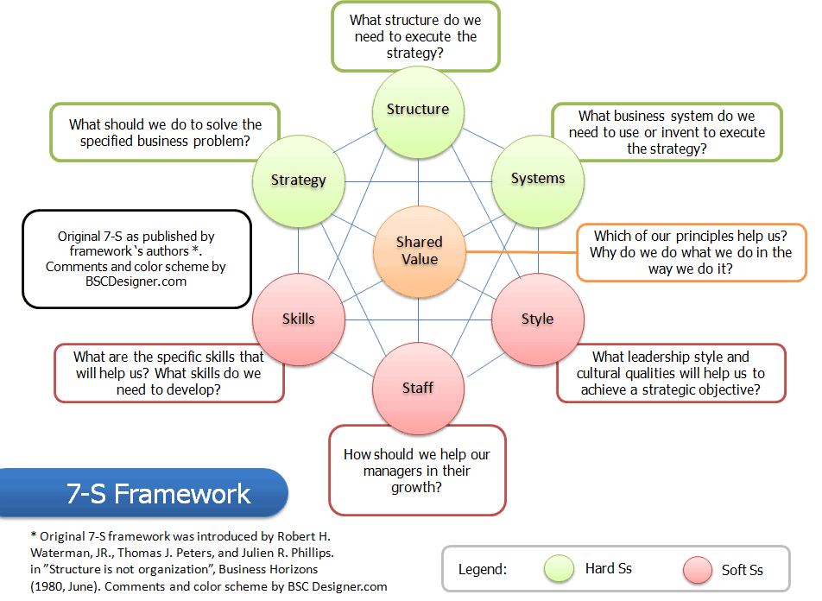
Source of the photo: https://www.hotelkpis.com/7-s-framework-for-a-hotel.htm
2.Brief insight into the 7S

7s factors. In McKinsey model, the seven areas of organization are divided into the ‘soft’ and ‘hard’ areas. Strategy, structure and systems are hard elements that are much easier to identify and manage when compared to soft elements. On the other hand, soft areas, although harder to manage, are the foundation of the organization and are more likely to create a sustained competitive advantage.
Hard S | Soft S
Strategy | Style
Structure | Staff
Systems | Skills
 | Shared Values
Strategy is a plan developed by a firm to achieve sustained competitive advantage and successfully compete in the market. What does a well-aligned strategy mean in 7s McKinsey model? In general, a sound strategy is the one that’s clearly articulated, is long-term, helps to achieve competitive advantage and is reinforced by strong vision, mission and values. But it’s hard to tell if such strategy is well-aligned with other elements when analyzed alone. So the key in 7s model is not to look at your company to find the great strategy, structure, systems and etc. but to look if its aligned with other elements. For example, short-term strategy is usually a poor choice for a company but if its aligned with other 6 elements, then it may provide strong results.
Structure represents the way business divisions and units are organized and includes the information of who is accountable to whom. In other words, structure is the organizational chart of the firm. It is also one of the most visible and easy to change elements of the framework.
Systems are the processes and procedures of the company, which reveal business’ daily activities and how decisions are made. Systems are the area of the firm that determines how business is done and it should be the main focus for managers during organizational change.
Skills are the abilities that firm’s employees perform very well. They also include capabilities and competences. During organizational change, the question often arises of what skills the company will really need to reinforce its new strategy or new structure.
Staff element is concerned with what type and how many employees an organization will need and how they will be recruited, trained, motivated and rewarded.
Style represents the way the company is managed by top-level managers, how they interact, what actions do they take and their symbolic value. In other words, it is the management style of company’s leaders.
Shared Values are at the core of McKinsey 7s model. They are the norms and standards that guide employee behavior and company actions and thus, are the foundation of every organization.

3.Application of the tool
The model can be applied to many situations and is a valuable tool when the organizational design is at question. The most common uses of the framework are:
- To facilitate organizational change.
- To help implement new strategy.
- To identify how each area may change in a future.
- To facilitate the merger of organizations.

The following steps that should help you to apply this tool:
Step 1. Identify the areas that are not effectively aligned
During the first step, your aim is to look at the 7S elements and identify if they are effectively aligned with each other. Normally, you should already be aware of how 7 elements are aligned in your company, but if you don’t you can use the checklist from WhittBlog to do that. After you’ve answered the questions outlined there you should look for the gaps, inconsistencies and weaknesses between the relationships of the elements. For example, you designed the strategy that relies on quick product introduction but the matrix structure with conflicting relationships hinders that so there’s a conflict that requires the change in strategy or structure.
Step 2. Determine the optimal organization design
With the help from top management, your second step is to find out what effective organizational design you want to achieve. By knowing the desired alignment you can set your goals and make the action plans much easier. This step is not as straightforward as identifying how seven areas are currently aligned in your organization for a few reasons. First, you need to find the best optimal alignment, which is not known to you at the moment, so it requires more than answering the questions or collecting data. Second, there are no templates or predetermined organizational designs that you could use and you’ll have to do a lot of research or benchmarking to find out how other similar organizations coped with organizational change or what organizational designs they are using.
Step 3. Decide where and what changes should be made. This is basically your action plan, which will detail the areas you want to realign and how would you like to do that. If you find that your firm’s structure and management style are not aligned with company’s values, you should decide how to reorganize the reporting relationships and which top managers should the company let go or how to influence them to change their management style so the company could work more effectively.
Step 4. Make the necessary changes. The implementation is the most important stage in any process, change or analysis and only well-implemented changes have positive effects. Therefore, you should find the people in your company or hire consultants that are the best suited to implement the changes.
Step 5. Continuously review the 7s. The seven elements: strategy, structure, systems, skills, staff, style and values are dynamic and change constantly. A change in one element always has effects on the other elements and requires implementing a new organizational design. Thus, continuous review of each area is very important [Last updated: August 16, 2022, by Ovidijus Jurevicius (Source: https://strategicmanagementinsight.com/tools/mckinsey-7s-model-framework/)]

*Example of McKinsey 7S Model. Use a simplified example to show how the model should be applied to an existing organization. You can choose an organisation to your liking (Apple, Facebook, Chanel, etc.) and describe its institutional design, objectives and culture according to the McKinsey 7S Model.

THEME 3. ORGANISATIONAL STRUCTURES
1. Types of organisational structures.
2. Types of ownership.

    - Types of organisational structures.
Organizational structure is the method by which work flows through an organization. It allows groups to work together within their individual functions to manage tasks. Traditional organizational structures tend to be more formalized—with employees grouped by function (such as finance or operations), region or product line. Less traditional structures are more loosely woven and flexible, with the ability to respond quickly to changing business environments.
Organizational structures have evolved since the 1800s. In the Industrial Revolution, individuals were organized to add parts to the manufacture of the product moving down the assembly line. Frederick Taylor's scientific management theory optimized the way tasks were performed, so workers performed only one task in the most efficient way. In the 20th century, General Motors pioneered a revolutionary organizational design in which each major division made its own cars.
Today, organizational structures are changing swiftly—from virtual organizations to other flexible structures. As companies continue to evolve and increase their global presence, future organizations may embody a fluid, free-forming organization, member ownership and an entrepreneurial approach among all members.
Key Elements of Organizational Structures. Five elements create an organizational structure: job design, departmentation, delegation, span of control and chain of command. These elements comprise an organizational chart and create the organizational structure itself. "Departmentation" refers to the way an organization structures its jobs to coordinate work. "Span of control" means the number of individuals who report to a manager. "Chain of command" refers to a line of authority.
The company's strategy of managerial centralization or decentralization also influences organizational structures. "Centralization," the degree to which decision-making authority is restricted to higher levels of management, typically leads to a pyramid structure. Centralization is generally recommended when conflicting goals and strategies among operating units create a need for a uniform policy. "Decentralization," the degree to which lower levels of the hierarchy have decision-making authority, typically leads to a leaner, flatter organization. Decentralization is recommended when conflicting strategies, uncertainty or complexity require local adaptability and decision-making. Configuration. The shape of the organization's role structure, which includes:
- Chain of command. The number of vertical levels or layers on the organizational chart.
- Span of control. The number of direct reports per manager or the number of horizontal levels or layers on the organizational chart.

Types
Organizational structures have evolved from rigid, vertically integrated, hierarchical, autocratic structures to relatively boundary-less, empowered, networked organizations designed to respond quickly to customer needs with customized products and services.
Today, organizations are usually structured vertically, vertically and horizontally, or with open boundaries. Specific types of structures within each of these categories are the following:
- Vertical—functional and divisional.
- Vertical and horizontal—matrix.
- Boundary-less (also referred to as "open boundary")—modular, virtual and cellular.
VERTICAL STRUCTURES (FUNCTIONAL AND DIVISIONAL)
Two main types of vertical structure exist, functional and divisional. The functional structure divides work and employees by specialization. It is a hierarchical, usually vertically integrated, structure. It emphasizes standardization in organization and processes for specialized employees in relatively narrow jobs.
This traditional type of organization forms departments such as production, sales, research and development, accounting, HR, and marketing. Each department has a separate function and specializes in that area. For example, all HR professionals are part of the same function and report to a senior leader of HR. The same reporting process would be true for other functions, such as finance or operations.
In functional structures, employees report directly to managers within their functional areas who in turn report to a chief officer of the organization. Management from above must centrally coordinate the specialized departments.
A functional organizational chart might look something like this:
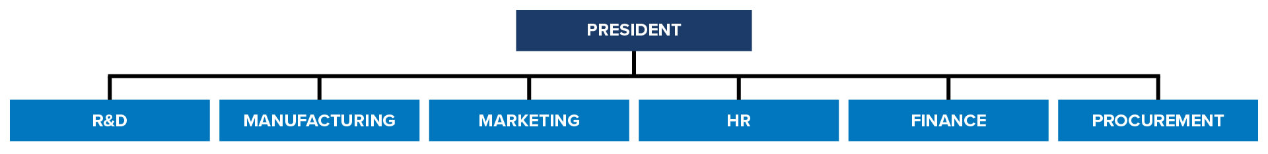
An appropriate management system to coordinate the departments is essential. The management system may be a special leader, like a vice president, a computer system or some other format.
Also a vertical arrangement, a divisional structure most often divides work and employees by output, although a divisional structure could be divided by another variable such as market or region. For example, a business that sells men's, women's and children's clothing through retail, e-commerce and catalog sales in the Northeast, Southeast and Southwest could be using a divisional structure in one of three ways: Product—men's wear, women's wear and children's clothing. Market—retail store, e-commerce and catalog. Region—Northeast, Southeast and Southwest.

A divisional organizational structure might look like this:
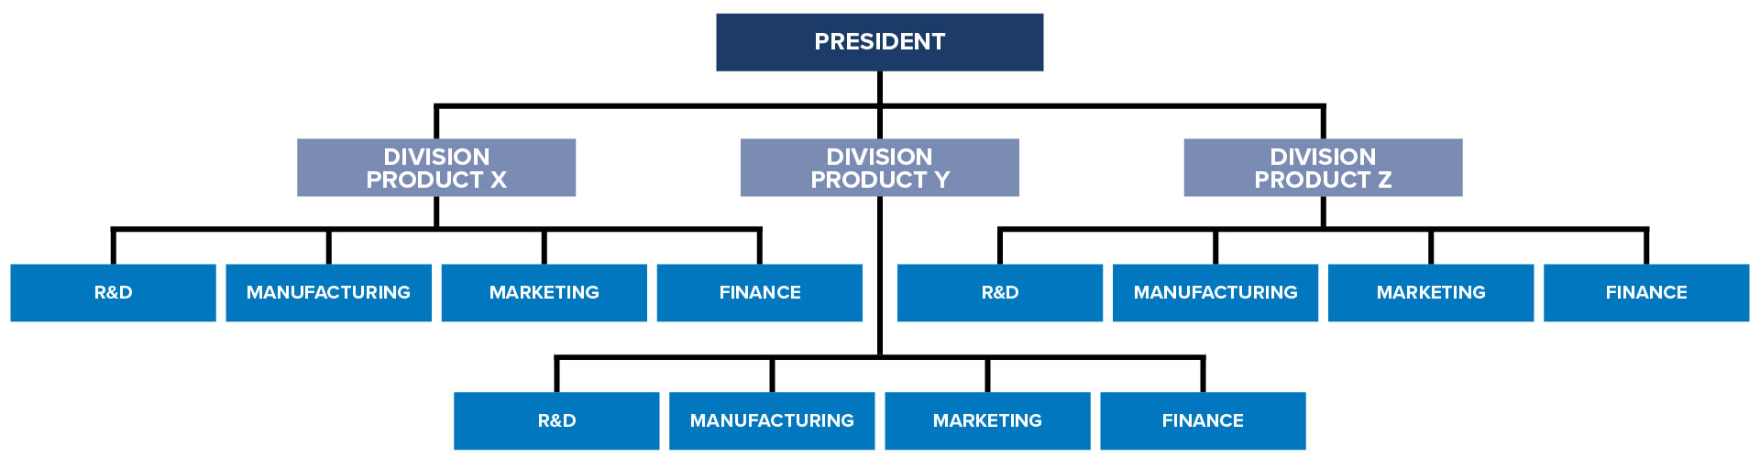
The advantages of this type of structure are the following:
- It provides more focus and flexibility on each division's core competency.
- It allows the divisions to focus on producing specialized products while also using knowledge gained from related divisions.
- It allows for more coordination than the functional structure.
- Decision-making authority pushed to lower levels of the organization enables faster, customized decisions.
The disadvantages of this structure include the following:
- It can result in a loss of efficiency and a duplication of effort because each division needs to acquire the same resources.
- Each division often has its own research and development, marketing, and other units that could otherwise be helping each other.
- Employees with similar technical career paths have less interaction.
- Divisions may be competing for the same customers.
- Each division often buys similar supplies in smaller quantities and may pay more per item.
This type of structure is helpful when the product base expands in quantity or complexity. But when competition among divisions becomes significant, the organization is not adapting quickly enough, or when economies of scale are lacking, the organization may require a more sophisticated matrix structure.
MATRIX ORGANIZATIONAL STRUCTURES
A matrix structure combines the functional and divisional structures to create a dual-command situation. In a matrix structure, an employee reports to two managers who are jointly responsible for the employee's performance. Typically, one manager works in an administrative function, such as finance, HR, information technology, sales or marketing, and the other works in a business unit related to a product, service, customer or geography.
A typical matrix organizational structure might look like this:
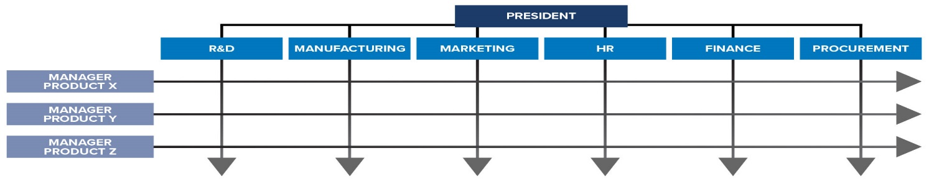
Advantages of the matrix structure include the following:
- It creates a functional and divisional partnership and focuses on the work more than on the people.
- It minimizes costs by sharing key people.
- It creates a better balance between time of completion and cost.
- It provides a better overview of a product that is manufactured in several areas or sold by various subsidiaries in different markets.
Disadvantages of matrix organizations include the following:
- Responsibilities may be unclear, thus complicating governance and control.
- Reporting to more than one manager at a time can be confusing for the employee and supervisors.
- The dual chain of command requires cooperation between two direct supervisors to determine an employee's work priorities, work assignments and performance standards.
- When the function leader and the product leader make conflicting demands on the employee, the employee's stress level increases, and performance may decrease.
- Employees spend more time in meetings and coordinating with other employees.
These disadvantages can be exacerbated if the matrix goes beyond two-dimensional (e.g., employees report to two managers) to multidimensional (e.g., employees report to three or more managers).
Matrix structures are common in heavily project-driven organizations, such as construction companies. These structures have grown out of project structures in which employees from different functions formed teams until completing a project, and then reverted to their own functions. In a matrix organization, each project manager reports directly to the vice president and the general manager. Each project is, in essence, a mini profit center, and therefore, general managers usually make business decisions.
The matrix-structured organization also provides greater visibility, stronger governance and more control in large, complex companies. It is also well suited for development of business areas and coordination of complex processes with strong dependencies.
Matrix structures pose difficult challenges for professionals charged with ensuring equity and fairness across the organization. Managers working in matrix structures should be prepared to intervene via communication and training if the structure compromises these objectives. Furthermore, leadership should monitor relationships between managers who share direct reports. These relationships between an employee's managers are crucial to the success of a matrix structure.
OPEN BOUNDARY STRUCTURES (HOLLOW, MODULAR VIRTUAL AND LEARNING)
More recent trends in structural forms remove the traditional boundaries of an organization. Typical internal and external barriers and organizational boxes are eliminated, and all organizational units are effectively and flexibly connected. Teams replace departments, and the organization and suppliers work as closely together as parts of one company. The hierarchy is flat; status and rank are minimal. Everyone—including top management, managers and employees—participates in the decision-making process. The use of 360-degree feedback performance appraisals is common as well.
Communications and Technology. The last few years have seen an unprecedented expansion and improvement of online communication. Software has pushed the boundaries of workplace communication beyond e-mail into collaborative social media platforms and innovative intranets. The decline in traditional communication methods and the dramatic increase in cyber communication has had a major impact on the workplace and is leading to restructuring. As organizations continue to restructure to remain competitive, communications can drive the transition to an effective new organizational structure. Research suggests that companies can positively affect their credibility with employees through various organizational communication programs.
(Source:https://www.shrm.org/resourcesandtools/tools-and-samples/toolkits/pages/understandingorganizationalstructures.aspx)

*Follow the link and watch the video about types of organisational structures: https://www.youtube.com/watch?v=4o6v0XIylzA. Make notes of the main organisational structures, and their features.
*Draft your own glossary of the key terms and find their equivalents.
*Explain the corporate structure of a company you know well, draw an organigram and
describe its work relationships. Use words and expressions below.
to consist of
To be made up of
To be composed of
To include
To contain
to be divided/split into
to be in charge of-
to be responsible for-
to assist or to be assisted by
to be accountable to
*Departments. Find the words corresponding to the description of each division or department.
Distribution Plant Training Purchasing
Audit Billina Market Research
It organizes the manufacturing process.
It buys in supplies.
It ensures that the product reaches dealerships and wholesalers.
It sends out invoices and receives payment.
It checks the accounts.
It organizes in-house courses for employees.
It finds out whether or not a product will sell.

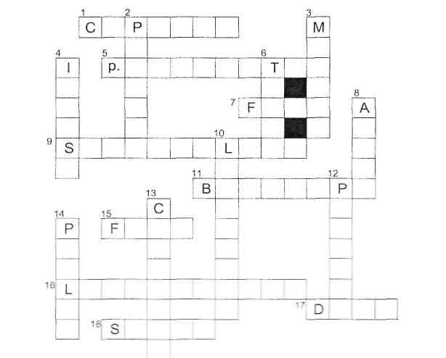
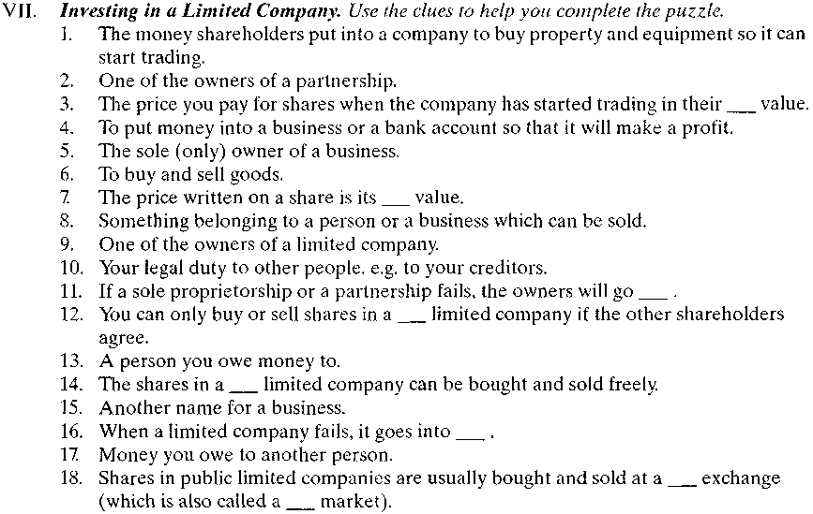

      - Types of ownership
Sole Proprietorship (UK), Individual Proprietorship (US). Sole proprietors are individuals carrying out economic operations in various spheres of business activities (industrial, trade, transport, banking etc.) and concluding commercial deals on their own behalf. The legal form is not to be indicated in the name of the firm. The hired staff are not referred to as proprietors. The proprietors must be registered in the trade register, obtain a licence to carry out business activities and keep the books reflecting the results of the latter. The contents of the books are a commercial secret not accessible to a third party. In case of a lawsuit, the books can be open for the court and the parties concerned provided the proprietor acts either as a plaintiff or a defendant. Also, the books can be made public in case of either insolvency or inheritance. Sole proprietors are not subject to public reports therefore it is not possible to get true information about their activities. The sole proprietor is not a legal person and is fully liable with his property by the obligations of his firm. Millions of sole proprietors in the world carry out business activities mainly in the sphere of various services and retail trade.
Unlimited Partnership (UK), General Partnership (US). The main feature of unlimited partnership is equal and collective responsibility for the property for all members of the partnership. In other words, creditors can be paid either at the expense of the partnership's property or private property of the members. Besides, the agreement cannot provide for the exception of property liability of any of the members before a third party. The property of the unlimited partnership is a joint property of its members. The profit obtained is distributed proportionately to the share of participation in the property of the partnership. Concession of the share of participation can be made only with the consent of the members. The number of the members of the partnership is not limited. The unlimited partnership can be disbanded either in case of insolvency or resignation of one of its members or by resolution of all participants. Unlimited partnerships are not subject to public report.
Limited Partnership (UK, US) The limited partnership is a contractual union of entrepreneurs participating only by way of contributions without taking direct part in the management (investors); and those who, apart from contributing, carry out direct management of the partnership and are fully liable by the partnership's obligations with their own property (full members). It takes at least one full member and one investor to form a limited partnership. The limited partnership is to be registered just like any unlimited partnership. The name of the partnership includes the names of one or two full members; the including of the name of the investor into the firm's name makes the investor equally and jointly liable by the partnership's obligations.
Master Limited Partnership Master limited partnerships carry out business activities on the basis of a Charter and are to be registered. One or more full members and shareholders as investors make a partnership. Shares can either be sold to or distributed among the investors or quoted on the stock exchange. Full members run the partnership and are liable by the partnership's obligations. The shareholders run the risk of devaluation of their shares. A legal person can act as a full member. Thus a master limited partnership bears characteristics both of a limited partnership and a public limited company. The advantage of a master limited partnership is in getting additional income through an issue of securities and their subsequent sale on the securities market. Dividends are tax exempt, so the investors are mainly attracted by a tax regime of master limited partnerships which pay only income tax.
Private Limited Company (UK), Close Corporation (US) A private limited company has the word "Limited" or the abbreviation 'Ltd' in its name. A private limited company should be registered under the Companies Act and act in compliance with its Charter. The company is a legal person fully liable by the company's obligations. The equity capital of the company is formed at the expense of deposits; the shareholders get a certificate of deposit which is not considered to be a security and as rule can not be assigned to third persons without the consent of other shareholders of the company, that provides for the close character of the company. There are private limited companies with a single shareholder.
There is one more circumstance that limits the financial rights and hence production opportunities of the private limited companies, they are not allowed to issue debentures and announce public subscription for their shares.Private limited companies keep statutory books which are not subject to public report. The number of members of the company is not large, usually consisting of close relatives or people knowing each other well, who united for business.
Public Limited Company (UK), Corporation (US). Public limited company is the main legal form of large firms. A public limited company is a union of investors called shareholders. It carries out business activities on the basis of the Articles of Association and is to be registered under the Companies Act. Any legal person or an individual can be a founder of the company. The shareholders are not liable by the company's obligations. The public limited company is the most stable form of unification of capitals as the resignation of any of its investors does not involve the liquidation of the company. The investor has a right to sell his shares without consent of other shareholders. The initial share capital is formed by way of selling shares. During that period, the initial share capital is the only source of financing of its activities. The funds obtained from the sale of shares are used for the purchase of plots of land, industrial premises and offices, equipment, basic commodities (raw materials) to launch manufacturing activities. Therefore the company receives an income and also can be financed by way of issuing debentures and securing bank loans.Thus a number of advantages make a public limited company the most effective means of concentration and centralisation of capital goods and capital. The shareholders can return their capital only by way of selling shares at the price currently quoted on the stock exchange.
The shareholders have property and personal rights. Property rights are realised in case of liquidation of a company and in case of getting dividends. Personal rights mean the right to vote; normally a share gives a right for one vote. The decisions are to be taken by a large majority, hence the person or a legal person holding the majority interest is the one who makes resolutions. Public limited companies' names must have the abbreviation "pic"' in their name
Problem-solving. Work in small groups. Decide what sort of business you would start in these situations. There is no one correct answer in any case and you may be able to think of more than one possibility. Give reasons for the decisions you make. Practice the second conditional.
- You and your spouse (husband or wife) want to start a grocery shop in a small village. There is already one grocery shop in the village owned by an old lady. Your bank will lend you the money you need.
- Two couples have enough money to buy a small hotel which they will all work in. One of the couples has two young children.
- You want to sell fruit and vegetables from a stall at the market. You need £500 which you can borrow from your father.

 | Single individual  owns company | Two or more owners/ directors | Quoted on  Stock Exchange | Workers run the company | Unlimited liability | Limited liability | Owner is self-employed
Public Limited Company (PLC)
PrivateLimited Company
Sole Trader
Partnership
Cooperative
*Types of companies. There are five main types of legally constituted company. Each type of company has different characteristics. Tick the correct characteristics for each business type, or write "possibly" if the characteristic could apply.

  - Ways to translate names of organisations and types of ownership
As a rule, we transliterate rather than translate the names of organisations into English. For instance, theUkrainian company “Енергія” in English will remain “Energiia”, whereаs the English company “Energy” in Ukrainian transltion may be rendered both as Energy and “Енерджі”.
Matlock and Associates, LLC develops software that helps secure information — Matlock and Associates, LLC розробляє програмне забезпечення, яке допомагає захистити інформацію.
ТОВ in English may be rendered as LLC — Limited liability company, Ltd — Limited company, or, in some cases, LLP — Limited Liability Partnership. Sometimes this type of ownership may be transliterated — TOV.
LLC in English always follows the name of the company, unlike the Ukrainian "ТОВ". Also, there is usually a comma between the name and the LLC, and the name is not enclosed in quotation marks.
LLP or Limited Liability Partnership is a partnership with limited liability. Although, for the British, it is a complete analogue of our "товариство з обмеженою відповідальністю". For Ukrainians, this translation option for "ТОВ" is the least common, whereas LLC and Ltd are more frequent: AB Corporate, LLP is a boutique law firm specializing in business and family law — AB Corporate, LLP — це юридична фірма, яка спеціалізується на комерційному та сімейному праві.ЗАТ та ВАТ – Закрите акціонерне товариство та Відкрите акціонерне товариство.
Joint-Stock Company (Акціонерне товариство) — all the shareholders own a company. It can be open with anyone capable of buying shares and closed, where laws, company rules, and other factors regulate the composition of shareholders. As a rule, we transliterate ЗАТ and ВАТ in documents and add an English equivalent, e.g.: ЗАТ «Основа» — ZAT (CJTC) Osnova, ВАТ «Радіо і телебачення» — VAT (OJTC) Radio I Telebachennia.
Closed Joint-Stock Company or CJTC — Закрите акціонерне товариство.
Individual entrepreneur — is an equivalent of the Ukrainian ФОП, although Americans would prefer Sole Proprietor, the British — Sole Trader.
Other common business abbreviations should be rendered as follows:
- State Enterprise — Державне підприємство ДП
- Private Enterprise — Приватне підприємство ПП
- Research and Production Enterprise — Науково-виробниче підприємство НВП
- Joint venture — Спільне підприємство СП
- Public Limited Company PLC — відкрита публічна компанія з обмеженою відповідальністю.
- Incorporated (Inc)/Corporation (Corp.) — компанія з обмеженою відповідальністю.
- Limited Duration Company LDC — компанія з обмеженим терміном.
- International Business Company або International Company — міжнародна комерційна компанія.
- Limited Partnership LP — командне товариство.
- Exempted company — звільнена від податків компанія.
- Non-Resident Company — компанія нерезидент.
- Qualified Company — компанії зі спеціальним статусом, які самі обирають податкову ставку.
- Daughter company або Subsidiary company — дочірня компанія.
- Open Joint-Stock Company або OJTC — Відкрите акціонерне товариство.
“& Со” - “повне товариство” — юридична особа, підприємство, де всі учасники проводять спільну діяльність і солідарно несуть відповідальність.

NB! In English, company names do not use quotation marks, e.g. City Orange company — Компанія “Сіті оранж”. Also, all words in the company names are capitalized. If the company has the name ТОВ “Червоний клин”, in the documents, it is necessary to indicate its transliterated version TOV Chervonyi Klyn and add the foreign equivalent Chervonyi Klyn, LLC. At the request of partners, the name can be indicated in Cyrillic at the beginning of the document, and further, throughout the document, the Latin version is used

To translate foreign company names and types of ownership, the safest option is to use transliteration. We can also use the explanation in parentheses (Omnicove, LLC — “Омніков Ел Ел Сі”). The most common abbreviations are transliterated in the following way:
- LLC — «Ел Ел Сі»,
- JSC — «Джей Ес Сі»,
- CJSC — «Сі Джей Ес Сі»,
- PLC — «Пі Ел Сі».
In literature and non-official documents, it is allowed to directly translate the name and organizational form of the company indicating the country of origin, e.g. Flowers, LLC — Товариство з обмеженою відповідальністю «Флауерс» (США).
To translate Ukrainian ФОП we can use the following options: In the US, we would use the option Sole Proprietor. In the UK, it is the Sole Trader is a person professionally engaged in trade, whereas a practising lawyer or accountant is referred to as a Sole practitioner. However, according to Ukrainian legislation, to refer to sole proprietors, given their practice, it is more appropriate to navigate between an Individual Entrepreneur or Private Entrepreneur.

(*За матеріалами «Перекласти не можна залишити: як написати ТОВ англійською і не помилитись» https://grade.ua/uk/blog/pereklasti-ne-mozhna-zalishiti-yak-napisati-tov-anglijskoyu-i-ne-pomilitis/?fbclid=IwAR2M8OdjQrTfzoLzYgwtAXmF6G3D156n8KGT4SUQMWm8gj67KWByYOWpG8.)

*DISCUSSION. What kind of organization would you like to work for? Why?
- the state
- a private limited company
- a nationalized company
- a partnership
- a public limited company

*Fill the gaps using the words from the box and translate the text into Ukrainian:
market | shares | dividends | Debts | face | Liability
liquidation | unlimited | freely | Limited | creditors | Bankrupt
When a limited company has started trading, you do not invest in (1) by giving more capital to the company. You buy them from one of the shareholders. If it is a private limited company, shares can be bought and sold (2) _________, usually at a Stock Exchange. If the company is doing well and paying high (3)________, then you might pay less than the (4)____________value of the shares. If it is doing badly, you might pay less than the face value of the shares. The price you pay at the Stock Exchange (or to a shareholder) for your shares in their (5)____________value.
If the company fails, it will stop trading and go into (6)________. This means that all the company's property and equipment (its assets) must be sold and the money from the sale will be used to pay its debts to its (7)___________. The shareholders may lose the money they paid for the shares. If the company still does not have enough money to pay all its (8)_______, the shareholders do not have to pay any more money. In other words, the shareholders' (9)_________________
for debts is limited to the value of their shares. On the other hand, if you are an owner of a business, which is not (10)___________, for example, a sole proprietorship (owned by one person) or a partnership (owned by between 2 and 20 people) and your business fails, you will go (11) . In this case, you might have to sell your own private possessions (your house, car, furniture etc.) to pay all your creditors. In other words, sole proprietors and partners have (12) liability for their firm's debts.

THEME 4. BUSINESS LETTERS
1. The types of business letters
2. Cvs and Covering letters

1. The types of business letters
There are different kinds of business letters, used for different purposes. They are divided into two types: the business to business type and the business to client type. Business-to-business types are intended for company-to-company communication:
- Appreciation letter – a letter of gratitude and appreciation for help extended, or a good business deal.
- Thank you – is a letter of gratitude.
- Congratulations – is a letter that praises the recipient for a job well done.
- Letter of recognition – a written statement of recognized efforts similar to an appreciation letter.
- Letter of reference – is a character reference letter. It is a letter building up the character of a person to be accepted in a job.
- Recommendation – is an endorsement letter to hire a certain person.
- Sympathy letter – is a letter of condolences to a person or family.
- Invitation letter – is a letter persuading a person or a company to join an event or an occasion.
- Letter of credit – is a way of endorsing a certain business to be considered a credit loan.
- Letter of interest – a reply to an invitation that confirms presence on the event/occasion.
- Business memorandum – notices that are distributed to the staff. They are reminders of company activities or imminent changes in the company.
- Business introduction – is done to introduce a new business to the readers.
- Business letter – a letter that talks about the plans for the business.
- Donation letter – a letter asking for donations.
- Termination letter – more popularly known as a resignation letter. It signifies someone's desire to leave a job permanently.
NB! For all forms of business letters, strict compliance with the literary norm is necessary at all language levels: it is inadmissible to use lexical-phraseological means of colloquial, versatile character, dialectal, professional-slang words; non-literary variants of word change and word formation; conversational syntactic constructions.
Self-check:
- What is the communicative aim of business letters within the trade?
- How can a notion ―business letter‖ be defined?
- How should your letters sound?
- What are the stylistic peculiarities of business letters?
- What are the linguistic peculiarities of business letters?
- What are the communicative peculiarities of business letters?
- How should a business letter be structurally organized?
- What are the peculiar features of patterns of punctuation used in business letters?
- What are the peculiar features of business letter styles?
- What is the message as one of the important elements of the business letter?
- What is the method for writing any letter?
- How can you organize the information in your letter?
- What is the form of a complimentary close if the letter starts with the salutation ―Dear Mr Brown‖?
- Point out the difference between business letter layouts in English and Ukrainian.
- What are the components of the semantic structure of a business letter?
- What role do abbreviations play in business letter writing?
- What are the ways of translating English syntactic constructions used in business letters?
- What are common and different features used in business letter writing in English and Ukrainian?

Put the following parts of a business letter into the right order
1) Salutation 2) Body Text 3) Letterhead 4) Complimentary Close 5) Inside Name and Address 6) Date 7) Surname and Signature Task

Linguists distinguish such patterns of punctuation:
1) the open pattern of punctuation
2) the closed pattern of punctuation
3) the blocked pattern of punctuation

Linguists distinguish such business letter styles:
1)Semi - indented Letter Style
2) Fully – blocked Letter Style
3) Fully-indented Letter Style.

Translate into English
- У відповідь на Ваш лист від 2 березня цього року повідомляємо Вам, що…
- У відповідь на Ваш запит і підтверджуючи нашу телефонну розмову, яка відбулась сьогодні, ми із задоволенням пропонуємо Вам…
- Ми зараз уважно вивчаємо Ваш запит і сподіваємось у найближчий час надіслати Вам свої пропозиції.
- Змушені звернути Вашу увагу на не задовільну якість коробок – вони надто великі, незграбні, не привабливих тонів, виготовлені з картону дуже низької якості і зовсім не мають вигляду святкового дитячого подарунка.
- Упевнений, що переговори, що відбулися посприяють зміцненню та подальшому розвитку довірчих партнерських відносин.
- Будемо вдячливі за всі зауваження і пропозиції, які Ви визнаєте необхідним висловити у відповідь на наші ініціативи.
- До мого великого жалю, ми не зможемо почати постачання продукції до липня 1998 року, оскільки до цього терміну зв'язані певними договірними зобов'язаннями. Дуже розраховую на Ваше розуміння даної ситуації і сподіваюся, що ми зможемо повернутися до продовження діалогу.
- Розглядаючи ВАТ «Каскад» як постійного і надійного партнера, фахівці нашої фірми з усією відповідальністю підійшли до вивчення Вашої пропозиції. Результати проведених нами досліджень дозволяють достатньо упевнено констатувати: реалізація проекту має серйозні комерційні перспективи

Continue the following definitions
A business letter is –
Communication is the process –
Semi-indented Letter Style is characterized by –
Open Pattern of Punctuation is characterized by –

2. CVs and cover letters

It is a good idea to have a regularly updated CV, even if you are not actually applying for another job. It helps you see the milestones you have achieved and the personal attributes you have enhanced. It also helps you see yourself as a brand: that is to say, what makes you special over and above the next person.
Include only facts that can be verified, and make sure you accurately describe your personal attributes. You must be able to deliver what you say you can.

What Is a CV Document?
CV stands for Curriculum Vitae or “course of life.” In the US, a CV is a 2–12 page academic document that describes your school career in deep detail. In Europe, a CV is a standard 1–2 page resume for a job, tailored to the position. In other words, the meaning and definition of a CV depend on your location.
What Is an American CV? In the United States, a CV document is an exhaustively comprehensive rundown of your entire academic career. It’s massive, like a federal resume (a document used for applying to a federal administration position. It should show your work experience and skills match government job requirements. A federal job resume should be 4–6 pages) or an academic cv (a formal document widely used by researchers and scholars when applying for academic jobs. An academic CV details your educational background, professional appointments, research and teaching experience, publications, grants, awards, fellowships, and other key achievements. Your academic CV is not a resume you’d use to apply for a job outside of academia. As its aim is to demonstrate your academic experience and achievements. There is no page-count limit for an academic CV). Since it is not tailored to a specific job opening, it adds everything universities might care about. That means every publication, conference, and school project you’ve done.
What Does CV Mean in England? In Europe and Ireland, a CV is a resume for a job. It’s 1–2 pages long. It doesn’t list every achievement. Instead, it touts accomplishments that prove key skills needed for the job. It’s similar to American resumes with a few notable exceptions (https://zety.com/blog/what-is-a-cv) .
If you’re applying for a job in Europe or New Zealand, here’s how to write a job CV:
- Choose the right CV format.
- Lead off with your contact info.
- Write a CV summary.
- Add tailored work experience and achievements.
- Include an education section that fits the job.
- Salt in bonus CV sections to astonish recruiters.
- Save your work in PDF form.
- Use 1-inch margins all the way around.
- Pick one good CV font and stick with it.
- Make your CV as long as you need.
- List education first, then work experience and qualifications, publication, honours, grants, and conferences.
- Add teaching and research experience.

When applying for a job, send a good cover letter with your CV, as this can improve your chances of getting to the interview stage. Do not use a standard letter; customize it for your prospective employer. Make every effort to send the letter and your CV to the correct person, spelling their details and job title correctly, and to the right address. Incidentally, you may have seen the expression ‘To whom it may concern’, and wondered when to use it. It is used where the writer does not know who the recipient will be. For example, if you are a contractor leaving one assignment, the company for whom you have worked may give you an open reference
Once you have correctly addressed your letter, then:
- Say where you saw the job advertised.
- Show how you have done some research on the company (refer to something relevant on its website, such as its values).
- Answer the question ‘Why should you get the job?’ by highlighting the special skills you can bring.
- Mention any special factors that the company should take into account.
- Show what you expect from a prospective employer as much as what they can expect from you.
- State your availability.

Summary:
- In Europe, Ireland, and New Zealand, a CV meaning is the same as a US job resume. We just call them different names.
- In the US, a CV is an exhaustive academic resume, usually 2–12 pages long.
- Use an academic CV in the US for master’s or doctoral programs. Don’t tailor it to any job or position.
- Customize a CV for a job in Europe or New Zealand just as you would customize a US resume.
- Choose a legible cover letter font like Arial or Garamond, and keep it between 10 and 12 points in font size.
- Set even margins on masterall sides. 1-inch margins should be perfect.
- Left-align all your contents.
- Use double cover letter spacing between paragraphs and 1–1.15 between lines.
- Be sure to keep your cover letter length to one page.
- Title your cover letter by JobTitle—CoverLetter—YourName.
- Let your cover letter layout stay intact en route to the recruiter by saving the file in PDF.
- Create a consistent look by mirroring a resume header to your template.
- Make a clean cover letter layout to keep enough whitespace on the page.
- Find an angle to write your cover letter—motivation to advance, shared values or mission statement, recent developments in the industry. Doing thorough research always helps.
- Start your cover letter with a relevant accomplishment that makes the reader want to carry on.
- Create a smooth transition from the hook through your strengths to motivation in 3 to 4 paragraphs, tops.
- Call your recruiter to action in the cover letter closing and ask for a meeting with you (https://zety.com/blog/how-to-write-a-cover-letter).

Self-check:

*Point out the difference between the CV and the resume
*What purpose does a resume serve?
* If you had little or no experience, which resume would probably be better:
a) chronological b) functional
*Follow the link and look at the Europass CV-builder: https://europa.eu/europass/eportfolio/screen/cv-editor?lang=en and point out the main components of a good CV.
*Look at the sample Europass CV (source: https://www.uianet.org/sites/default/files/crm/Contacts/69136/CV%20-%20COJOCARU%2C%20Cristina_1.pdf) and point out its key features.

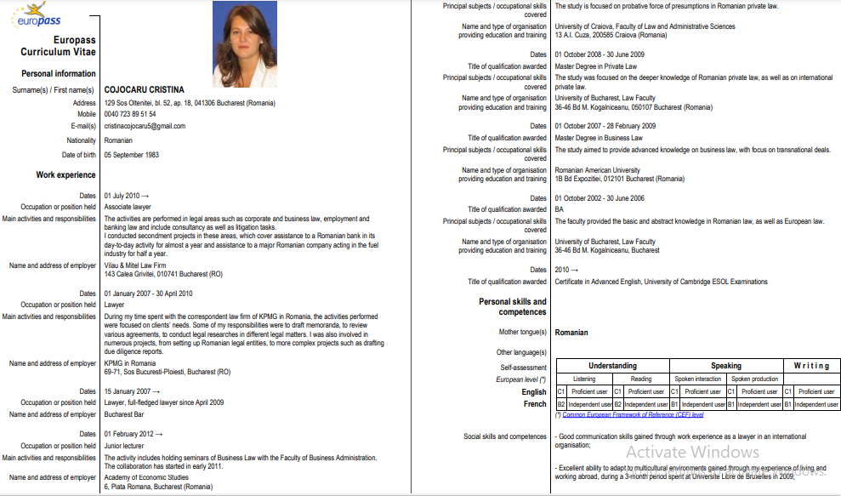

*Generate your CV using the Europass template.
*Reading: How to Write A Cover Letter
No one likes job hunting. Scouring through online job listings, spiffing up your résumé, prepping for grueling interviews — none of it is fun. For many, the most challenging part of the process is writing an effective cover letter. There’s so much conflicting advice out there, it’s hard to know where to start. Do you even need one, especially if you’re applying through an online system?

What the Experts Say. The answer is almost always yes. Sure, there will be times when you’re submitting an application online and you may not be able to include one, but whenever possible, send one, says Jodi Glickman, a communications expert and author of Great on the Job. “It’s your best chance of getting the attention of the HR person or hiring manager and an important opportunity to distinguish yourself from everyone else.” And in a tight job market, setting yourself apart is critical, says John Lees, a UK-based career strategist and author of Knockout CV. Still, as anyone who’s ever written a cover letter knows, it’s not easy to do well. Here are some tips to help.

Do your research first.
Before you start writing, find out more about the company and the specific job you want. Of course, you should carefully read the job description, but also peruse the company’s website, its executives’ Twitter feeds, and employee profiles on LinkedIn. This research will help you customize your cover letter, since you shouldn’t send a generic one. It’ll also help you decide on the right tone. “Think about the culture of the organization you’re applying to,” advises Glickman. If at all possible, reach out to the hiring manager or someone else you know at the company before writing your cover letter, advises Lees. You can send an email or a LinkedIn message “asking a smart question about the job.” That way you can start your letter by referencing the interaction. You might say, “Thanks for the helpful conversation last week” or “I recently spoke to so-and-so at your company.” Of course, it’s not always possible to contact someone — or you may not get a response. That’s OK. It’s still worth a try.

Focus it on the future.
While your résumé is meant to be a look back at your experience and where you’ve been, the cover letter should focus on the future and what you want to do, says Glickman. “It can be helpful to think of it as the bridge between the past and the future that explains what you hope to do next and why.” Think of it as an opportunity to sell your transferrable skills.

Open strong.
“People typically write themselves into the letter with ‘I’m applying for X job that I saw in Y place.’ That’s a waste,” says Lees. Instead, lead with a strong opening sentence. “Start with the punch line — why this job is exciting to you and what you bring to the table,” says Glickman. For example, you might write, “I’m an environmental fundraising professional with more than 15 years of experience looking for an opportunity to apply my skills in new ways, and I’d love to bring my expertise and enthusiasm to your growing development team.” Then you can include a sentence or two about your background and your relevant experience, but don’t rehash your résumé. Chances are the hiring manager or recruiter is reading a stack of these, so you want to catch their attention. Stay away from common platitudes, too. “Say something direct and dynamic, such as ‘Let me draw your attention to two reasons why I’d be a great addition to your team.'”. “With social media, it’s often possible to find the name of a hiring manager,” says Glickman.

Emphasize your personal value.
Hiring managers are looking for people who can help them solve problems. Drawing on the research you did earlier, show that you know what the company does and some of the challenges it faces. These don’t need to be specific but you might mention how the industry has been affected by the pandemic. For example, you might write, “A lot of health care companies are overwhelmed with the need to provide high-quality care while protecting the health and safety of their staff.” Then talk about how your experience has equipped you to meet those needs; perhaps explain how you solved a similar problem in the past or share a relevant accomplishment. You want to provide evidence of the things that set you apart. There are two skills that are relevant to almost any job right now: adaptability and the ability to learn quickly. If you have brief examples that demonstrate these skills, include those.

Convey enthusiasm.
Hiring managers are going to go with the candidate who has made it seem like this is their dream job. So make it clear why you want the position. “Lees suggests writing something like “I’d love to work for your company. Who wouldn’t? You’re the industry leader, setting standards that others only follow.”

Watch the tone.
At the same time, don’t go overboard with the flattery or say anything you don’t mean. Authenticity is crucial. You don’t want your tone to undermine your message, so be professional and mature. A good rule of thumb is to put yourself in the shoes of the hiring manager and think about “the kind of language that the hiring manager would use with one of the company’s customers.”

Keep it short.
Much of the advice out there says to keep it under a page, even shorter is better. “Most cover letters I see are too long,” says Lees. “It should be brief enough that someone can read it at a glance.” You do have to cover a lot of ground — but you should do it succinctly.

Get feedback.
Be specific about the kind of feedback you want. In particular, request two things. First, ask your friend if it’s clear what your main point is. What’s the story you’re telling? Are they able to summarize it? Second, ask them what’s wrong with the letter. “Other people are more attuned to desperation, overselling, over-modesty, and underselling,” says Lees, and they should be able to point out places where the tone is off.

When you can’t submit a cover letter.
Many companies now use online application systems that don’t allow for a cover letter. You may be able to figure out how to include one in the same document as your résumé, but that’s not a guarantee, especially because some systems only allow for data to be entered into specific boxes. In these cases, use the format you’re given to demonstrate your ability to do the job and your enthusiasm for the role. If possible, you may try to find someone to whom you can send a brief follow-up email highlighting a few key points about your application.

Principles to Remember

Do:
- Have a strong opening statement that makes clear why you want the job and what you bring to the table.
- Be succinct — a hiring manager should be able to read your letter at a glance.
- Share an accomplishment that shows you can address the challenges the employer is facing.

Don’t:
- Try to be funny — too often it falls flat.
- Send a generic cover letter — customize each one for the specific job.
- Go overboard with flattery — be professional and mature.

Source: https://hbr.org/2014/02/how-to-write-a-cover-letter?utm_medium=social&utm_campaign=hbr&utm_source=facebook&tpcc=orgsocial_edit&fbclid=IwAR3JO9Y3pEM5F2StDS4AgkaTmNMv4zSD0ZrW1lbhmRS6uOsKnYXNz229GnI&registration=success

*Look at the case studies posted Harvard Business Review and discuss the pros and cons of each cover letter:

Case Study #1: Demonstrate an understanding of what the company needs.
Michele Sommers, the vice president of HR for the Boys & Girls Village, a nonprofit in Connecticut, recently posted a job for a recruiting and training specialist. “I was looking for someone with a strong recruiting background who could do everything from sourcing candidates to onboarding new hires,” she says. She also wanted the person to hit the ground running. “We’re a small team and I can’t afford to train someone,” she says. More than 100 candidates applied for the job. The organization’s online application system doesn’t allow for cover letter attachments, but one of the applicants, Heidi (not her real name), sent a follow-up email after submitting her résumé. “And it’s a good thing she did, because she would’ve been weeded out otherwise,” Michele says. Heidi’s résumé made her look like a “job hopper” — very short stints at each previous employer. Michele assumed she was a poor performer who kept getting fired. She was also the only candidate who didn’t have a four-year college degree. But Heidi’s email caught Michele’s eye. First off, it was professional. Heidi stated clearly that she was writing to double-check that her application had been received. She went on to explain how she had gotten Michele’s name and information (through her husband’s boss, who was on the board) and her personal connection to Boys & Girls Village (her father-in-law had done some work with the organization). What really stood out to Michele, though, was Heidi’s understanding of the group and the challenges it was facing. She’d done her research and “listed some things she would do or already had done that would help us address those needs,” says Michele. “The personality and passion she conveyed in the cover letter came through during her phone screening,” Michele says. Heidi ended up being more than qualified for the job. “I wanted this role to be bigger from the get-go, but I didn’t think that was possible. When I met her, I knew we could expand it.” Three weeks later Michele offered Heidi the job and she accepted.

Case Study #2: Catch their attention.
Over the past four years, Emily Sernaker applied for multiple positions at the International Rescue Committee (IRC). She never gave up. With each application, she sent a personalized cover letter. “I wanted my cover letter to highlight my qualifications, creative thinking, and genuine respect for the organization,” she says. Sarah Vania, the organization’s regional HR director, says that Emily’s letters caught her attention, especially because they included several video links that showed the results of Emily’s advocacy and fundraising work at other organizations. Emily explains, “I had prior experience advocating for former child soldiers, human trafficking survivors, vulnerable women, and displaced persons. It’s one thing to make statements in a cover letter, like ‘I can make a pitch, I am a creative person, I am thoughtful,’ but showing these qualities seemed like a better way of convincing the recruiter that the statements were true.” This is what Emily wrote to Sarah about the video: Here is a short video about my story with activism. The nonprofit organization Invisible Children made it for a youth conference I spoke at this year. It is about four minutes. As you’ll see from the video, I’ve had a lot of success as a student fundraiser, raising over $200,000 for Invisible Children. I’ve since gone on to work as a consultant for Wellspring International and have recently concluded my studies as a Rotary International Ambassadorial Scholar. In each of the cover letters, Emily also made clear how much she wanted to work for IRC. “To convey enthusiasm is a vulnerable thing to do and can come off as naivete, but, when it came down to it, my enthusiasm for the organization was genuine and expressing it felt right,” she says. This is how Emily conveyed her interest in working for IRC: You should also know that I have a sincere appreciation of the IRC. I have enjoyed learning about your programs and have personally visited your New York headquarters, the San Diego New Roots farm, the We Can Be Heroes exhibit, and the Half the Sky exhibit in Los Angeles. The IRC is my top choice and I believe I would be a valuable addition to your fundraising team. Emily learned throughout the process that the organization had hundreds of applicants for each position and it was extremely competitive. “I appreciated that I wouldn’t be the best for every opening but also remained firm that I did have a significant contribution to make,” she says. Eventually, Emily’s persistence paid off. She was hired as a temporary external relations coordinator, and four months later she moved into a permanent role.
*Follow the link and watch the video about writing a cover letter that stands out: https://www.youtube.com/watch?v=oms7o5wQ4o4

THEME 5. CONTRACTS AND AGREEMENTS

1. Definition and origin of the contract
2. Legal Contract

The term «agreement», like the term «treaty» itself, is used in a number of senses. In a generic sense, it covers any meeting of minds — in this case the minds of two or more international persons.
A distinction must always be drawn between agreements intended to have an obligatory character (i. e. the assumption of legal rights and duties) and agreements not intended to have such a character. In a restricted sense, the term «agreement» means an agreement intended to have an obligatory character but usually of a less formal nature than a treaty. Like treaties, agreements in this restricted sense may be concluded between Heads of State, between States or between Governments.
No doubt because of its general and relatively innocuous meaning, «agreement» is the term invariably used to describe understandings intended to have an obligatory character concluded (a) between the United Nations and the specialized agencies (including the ―relationship agreements‖ covered by Articles 57 and 63 of the Charter) and (b) between the specialized agencies themselves («inter-agency agreements‖). A term substantially equivalent to «agreement» is «arrangement». The view that an «agreement» implies an undertaking somewhat more definite than an «arrangement» is not believed to be correct. Other terms sometimes used instead of «agreement», though believed to be substantially similar, are:
(a) memorandum of understanding constituting an agreement;
(b) understanding;
(c) agreed joint statement;
(d) memorandum constituting an agreement;
(e) joint declaration constituting an agreement.
Sometimes agreements are concluded between a Government Department in one country and a Government Department in another. It depends on the circumstances whether such ―inter- departmental agreements‖ are binding under international law or whether they are merely private law contracts.
Agreements are frequently concluded by exchange of notes, sometimes referred to as «letters». In such cases, the representative of one government sends the representative of another government a note setting forth the arrangements proposed or to be agreed upon. The reply agrees to and frequently repeats the terms of the first note. A temporary or working arrangement made in order to bridge over some difficulty pending a permanent settlement is usually referred to as modus vivendi. This type of a temporary arrangement is made in a most informal way and does not require ratification.
Commercial agreements of a temporary nature have often been entered into in the form of a modus vivendi by the United States as well as Great Britain. Most agreements of a binding nature follow the same compositional design, with some variation, as treaties and other international compacts.

2. Legal contracts
5 essential components of legal contracts:
- agreement between the parties (домовленість між сторонами);
- аn intention (намір створити певні юридичні відносини);
- сertainty as to the terms of the agreement (впевненість щодо умов угоди);
- capacity to contract (правоздатність, дієздатність до укладення контракту);
- consideration (взаємне задоволення, яке повинна мати угода, контракт, договір).
The structure of a typical contract
- title and date (назва та дати);
- parties and recitals (сторони контракту та виклад фактів, інформації (чому контракт укладається));
- operative part/provisions – основна частина контракту;
- other operative provisions – інші положення контракту;
- the boilerplate clauses – стандартні положення контракту;
- signature block – блок підписів;
- schedules, аppendices, exhibits, annexes - різновиди додатків до контракту.
Contract dates:
- the date of the agreement – дата укладання угоди;
- the effective date/the commencement date – дата набрання угодою чинності.
- «NOW THEREFORE, IT IS AGREED AS FOLLOWS» – this phrase opens the provisions of the contract.
Contract provisions may contain the following:
- the subject of the contract (предмет контракту);
- the price of the work (consideration) (ціна контракту, взаємне задоволення);
- warranties, payment terms (гарантії, умови оплати);
- other key, usually negotiated issues between the parties (інші ключові питання, які зазвичай обговорюються сторонами).
Nota Bene: Counterpart vs counterparty. «Counterpart» – оригінальний примірник контракту для кожної сторони (A counterpart is a duplicate or copy of a legal document. If a contract is entered into by two parties, for example, two originals are often signed so that each party has in its possession one original, signed version of the contract: “This agreement has been signed in two original, identical counterparts of which each party has received one.” «Counterparty» - контрагент, одна зі сторін контракту. A counterparty, on the other hand, is one of the parties to a contract, transaction, trade, etc. In the above example, therefore, there are two counterparties: “Both of the counterparties are required to sign the contract in order for it to be valid.”[https://advokatpost.com/structure-of-a-commercial-contract-tonkoshchi-kontraktnoho-prava-anhlijskoiu-movoiu-z-liudmyloiu-kolodnyk/]

Some of the important contract phrases you need to know.
Ab Initio (Ab Init): Latin, meaning from the beginning – з самого початку.
acceptance – прийняття пропозиції;
agreement – контракт, угода, договір; contract – контракт, договір;
Assignment / Novation: the Parties to a contract may, under agreed conditions, transfer or assign (novate) any of their liabilities, rights or obligations under the contract to a third party – поступка прав та передача боргових зобов’язань.
to be binding in law – мати юридичну силу;
Bona Fide: Latin, meaning in good faith - добросовісний.
to be entitled to – мати право;
to be legally bound – приймати юридичні обов’язки;
capacity – правоздатність, дієздатність;
Capitalised Terms: A word or a group of words can be defined to have a specific meaning in a contract, to prevent misinterpretation of that word or group of words – капіталізовані терміни.
case law – прецедентне право;
claim – позов;
successful claim – переможний процес;
clause – пункт контракту;
to break a contract – порушити контракт; to be in breach of contract (formal) – порушити контракт; to carry out a contract – виконати контракт; to draw up a contract; to make a contract – укласти угоду; to perform a contract – виконати контракт; to sign a contract – підписати контракт;
contractor – сторона контракту; subcontractor - підрядник;
Consideration: the benefit given by each Party to a contract to the other Party in exchange for the contractual promise of another Party to the contract - взаємне задоволення, яке повинна мати угода, контракт, договір.
Counterpart: a copy of a contract, often created so that each Party to the contract may have its own copy - оригінальний примірник контракту для кожної сторони.
damages – відшкодування збитків;to award damages – присудити відшкодування збитків; to claim damages – вимагати відшкодування збитків; to pay damages – відшкодувати збитки;
defendant – відповідач;
Deed: a special type of legally binding and enforceable contract that does not require Consideration to pass from one Party to another – договір, акт, дарча .
Default: the circumstances where a Party to a contract is considered to be in Breach of Contract – невиконання зобов’язань.
Deliverables: a collective name for all those tangible things that a Party to a contract is required to supply, often by an agreed date – результати укладання угоди, які зазвичай ділять нa:
Tangible / intangible — матеріальні (наприклад, новий офіс) та нематеріальні (наприклад, нова програма навчання для співробітників).
Internal / external — внутрішні та зовнішні. Внутрішні deliverables — це ті результати, які не бачать клієнти, але, тим не менш, важливі для досягнення мети. Зовнішні — це фінальні результати, які постачаються замовникам.
disagreement – розбіжності, суперечки;
evidence – доказ;
Express Terms: the terms actually written in a contract or verbally agreed before or at the time the contract is made. See Implied Terms – точне формулювання.
Indemnity: a contractual obligation on a Party to a contract to compensate for any loss another Party to the contract may suffer in the circumstances that are the subject of the Indemnity, such as payment of reasonable court costs in the settlement of a contractual dispute – гарантія від збитків.
injunction – a court order sought by a Party to a contract to make another Party to the contract do or stop doing something - судова заборона;
Inter Alia: Latin, meaning among other things – між іншим.
Insolvency: the situation where a person or business is unable to meet their financial obligations. See Bankruptcy, Liquidation and Receivership - неплатоспроможність.
Force Majeure: the circumstances or situations described in a contract that may prevent one or more of the Parties to the contract from performing their contractual obligations. – форс-мажорні обставини
Governing Law: the union, country or state / provincial laws applicable to a contract застосовне законодавство; застосовне право, право, що регулює.
legal action – позов;
Litigation: the conduct of court proceedings to resolve a dispute – судовий процес.
to lose an action – програти судову справу; to take legal action – звернутися до суду, подати позов; to win an action – виграти судову справу;
legal code – правовий кодекс;
legal intention – правовий намір;
Liability: a Party to a contract's legal obligation, on its Breach of Contract, to compensate another Party to the contract for any harm so caused – зобов’язання за контрактом
Mala Fide: Latin, meaning in bad faith, opposite of Bona Fide - недобросовісний.
obligations of contractors – обов‘язки сторін;
offer – пропозиція; to accept an offer – прийняти пропозицію; to reject an offer – відхилити пропозицію;
Party: Any individual, group or organisation participating in a contract. 'Parties' has a corresponding meaning – сторона контракту;
rights of contractors – права сторін;
specific performance – судова постанова, дія за судовою постановою;
sue – подати позов, звернутися до суду;
terms of a contract – умови контракту;
transaction – угода, операція; to make a transaction – укласти угоду;
valueable consideration – зустрічні зобов’язання;
plaintiff – позивач
Period: The length of time a contract is expected to be in force (see also 'Term') – термін виконання контракту .
Pro Tempore (Pro Tem): Latin, meaning for the time being.
Quid pro quo: Latin, meaning something for something. The basis for definition of Consideration in a contract, where each Party to the contract should offer something to the other – компенсація, послуга за послугу.
Recitals: A section in a contract that states who the Parties are and their reasons for entering into the contract. Sometimes called 'Background' or 'Preamble' - виклад фактів, інформації (чому контракт укладається.
Termination for cause: a contract may identify the conditions under which a Party to the contract could terminate a contract due to another Party's material breach of the contract – припинення контракту
Void: making a contract unenforceable in law - недійсність правочину.
Waiver: an intentional surrendering of rights by a Party to a contract - відмова
Warranties: promises made in a contract – гарантійні зобовязання

*The language of contracts is often complicated by specialist vocabulary and long sentences. Study the following list of words common in legal contracts.

Key Words
to allege | joint participation | Duration
Amendment | joint venture agreement | terms of a contract
to be defined as | to make a claim against | Obligation
to be entitled to | to enter into an agreement | Territory
to be in force | on the part of | to furnish
to claim | party/parties | to undertake
Consent | prior | Hereby
to default | solely
Delivery | to stipulate

Translate the following phrases:
Written agreement; to draw up a contract; signed contract; to supply goods; to resolve the disagreement; unlikely events; to contain many clauses; to take legal action; rights and obligations of contractors; judgements made by the courts; to clarify the law; Unfair Contract Terms Act; to win an action; to make a transaction; to deliver goods
Find the phrases with the similar meaning among the following:
To sort out disagreements; to win a case; to contract; court decisions; to take legal action; to deliver goods; contractor; clauses; agreement; to break a contract; to win a case; parts of contract judgements made by the courts; party; to resolve disagreements; to be in breach of contract; to sue; to win an action.
Explain the underlined words in the sentences below.
1. Lin Ltd and Wait & Co signed a contract entering into a joint venture to manufacture teapots.
2. The agreement stipulated that Lin would supply technical experts experienced in the design of teapots.
3. Under the terms of the contract Wait would not attempt to sell any teapots produced solely by them, without the prior consent of Lin.
4. To do so would represent default on the part of Wait, and Lin would be entitled to demand an explanation.
5. In the event of such a default, Lin could make a claim against Wait, alleging the breaking of an agreement still in force.
6. Wait claimed that an amendment had been made to the original contract, permitting them to sell a particular teapot.
7. The two parties are now engaged in a legal dispute.
8. Meanwhile, Wait has given an undertaking not to proceed with sales of the teapot.

Look at the structure of the extract from a legal document, skim the text and answer the following questions.
? | What part of the document is this?  What is the contract about?  What is the function of the following paragraphs?  • paragraph one  • paragraph two  • paragraph three

Joint Venture Agreement
This agreement is entered into this 28th day of June 1991, by and between Fornaro Elttrica S.p.A., a company organised and existing under the laws of Italy, having its principal office in Alba, Cuneo, (hereinafter referred to as 'F') and Warwick Photographic, a company organised and existing under the laws of Canada, having its principal office of Ottowa, Ca., (hereinafter referred to as 'W'.)
WITNESSETH THAT
WHEREAS, 'F' has acquired valuable experience, technical data amd know-how relating to the designing manufacturing, assembling and marketing of products defined as JWS-20.
WHEREAS, the parties recognising that they could only with difficulty separately and successfully exploit such business, agree that the most appropriate manner for them to enter into said business while minimising the technical and financial risks is through their joint participation in the manufacture of products.
An important element in understanding texts, and legal documents in particular, is to see the relationships between words in sentences. This is referencing. Here is an example from the beginning of a Joint Venture Agreement.
This agreement is entered into on 17th March 1991 between Eurolectric of Hull and Pekka Oy of Helsinki. The aforementioned parties undertake to form a joint partnership to design, manufacture and market a printer. The said product shall bear the name of both participants in the present contract.

*The text below is a copy of a Letter of Preliminary Agreement. Read the following questions, then scan the text to find the answers.
? | 1. What is the purpose of the agreement?  2. What are the parties involved?  3. What is the product?  4. How long is the agreement for?  5. What are the responsibilities of each party?  6. Who pays the expenses?

Letter of Prelimenary Agreement
PASCUAL RUIZ CABESTANY & Cia (PASCUAL) San Sebastian, Spain and BOOGAARD NV (BOOGAARD) of Utrecht, Holland, conducted friendly discussions on a proposal for a joint undertaking to develop a Food Mixer (the AB20) and for a joint venture company (PROCOL) to manufacture AB20 in Taiwan.
The parties have reached a tentative understanding, hereby sign this Letter of Prelimenary Agreement (LPA) to establish clearly how they are willing to pursue.
1. AGREEMENTS
1.1 The parties will endeavour to conclude mutually acceptable Joint Venture Agreement, Technical Master Agreement and Distributor Agreement drafted and proposed by PASCUAL and the parties anticipate the need to obtain appropriate governmental approvals and shareholders' decisions.
1.2 In this purpose the parties agree that they will do their utmost to successfully assume their own responsibility stipulated in the attached 'Working Guidelines' mutually agreed. It is agreed that the parties should undertake the following responsibilities:
2. RESPONSIBILITIES
2.1 *Engineering of AB20 by PASCUAL *Prototype of AB20 by BOOGAARD
*Manufacturing Cos Analysis (Taiwan Simulation) of AB 20 byBOOGAARD
*Business Plan of PROCOL by PASCUAL/ BOOGAARD
3. DURATION
The parties agree that this LPA should be effective by October 31, 1993 and it is agreed that duration of this LPA can be extended by written consent of the parties.
4. COSTS
4.1 The parties agree that the costs they should bear to assume their responsibilities stipulated in Para 2 shall remain in charge of each party without any claiming possibility in case of termination of LPA caused by any of the parties.
4.2. The parties agree that they should bear the costs for their responsibilities stipulated in Para 2 and it is understood that the balance of costs born from the date of signature of this LPA between the parties could be amortised by Technical Master Agreement.

*Select the best meaning from the alternatives given for the following words from
Underlying |  | commitment/promise
 |  | wish/need
 |  | Idea
Hereby |  | today
 |  | near here
 |  | by signing this document
Pursue |  | follow
 |  | proceed
 |  | Develop
Stipulated | invented
 | designed
 | specified
effective | useful
 | in force
 | good
consent | permission
 | idea
 | letter
assume responsibilities | to employ people
 | to meet obligations
 | to make money
bear | refuse to pay costs
 | increase costs
 | meet costs
Many verbs have been removed from the paragraph below. Complete the sentences with appropriate verbs. The first is already completed, as an example.
to be allowed | to terminate | to state
to be entitled | to furnish | to default
to be effective from | to undertake | to specify
to notify | to enter into
The parties (1) enter into as agreement to sell office equipment. According to the contract, the parties (2)_______to work together for a minimum period of three years. Neither party is (3)_____to end the agreement without tendering written notice 90 days in advance. The contract, which is (4)______31st July 1991, (5)______the responsibilities of each party. Either party is (6)_______to sell the products in any state of South or Central America. The manufacturer shall (7)________the distributor with all relevant documentation. If either party (8)_______on any item herein, the other shall have the right to (9)_______the agreement. In such circumstances, the terminating party should (10)_____the other party of its intention at least 90 days prior to the date intended for the termination. The terminating party should also (11)___the reasons for the termination.

*Look at a part of the sample contract in English, describe its peculiarities and translate into Ukrainian:

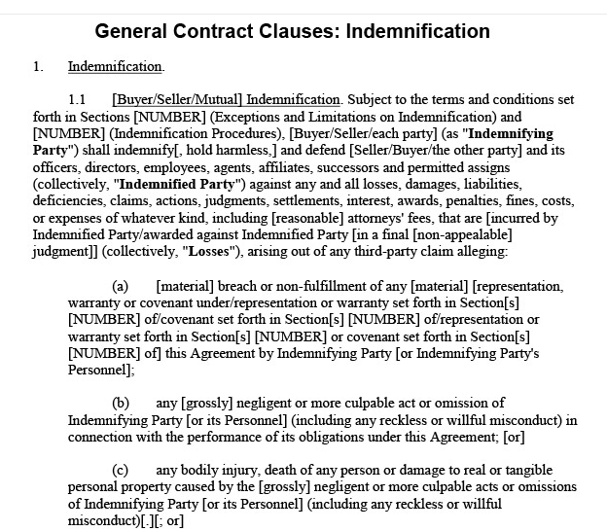

*Look at the sample labour contract in Ukrainian and translate it into English (Source:https://www.dilovamova.com/index.php?page=4&dmua=47&tdmua=%C4%EE%E3%EE%E2%B3%F0-%D2%F0%F3%E4%EE%E2%E0-%F3%E3%EE%E4%E0):

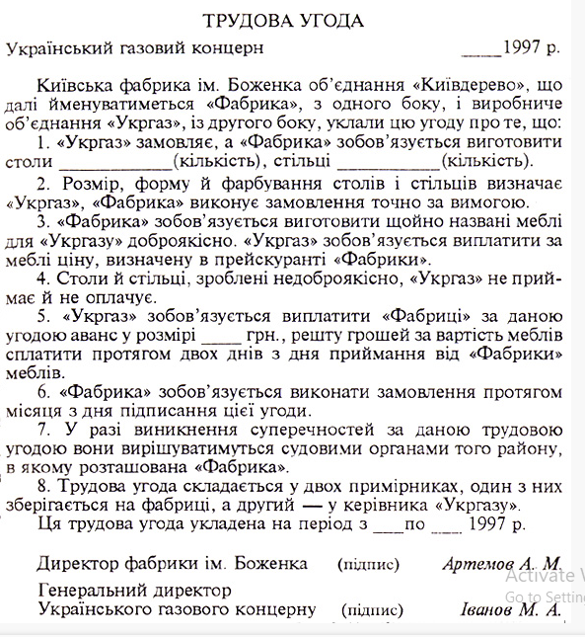

THEME 6. BUSINESS MEETINGS AND TELEPHONING

1. Business Meetings. Making up Agendas and Taking Minutes of the Meeting
2. Telephoning

1. Business Meetings. Making up Agendas and Taking Minutes of the Meeting
Business people spend quite a lot of time in meetings, and meetings come in all shapes and sizes, ranging from formal committee meetings to informal one-to-one meetings.
There are several reasons why meetings are held:
- reaching decisions in a means that all the participants can feel more committed to the decision;
- more information is available;
- different and unexpected ideas can be contributed;
- meetings can lead to more imaginative and informed decisions – often more courageous decisions than one person might feel brave enough to make.
Some of the drawbacks of meetings are:
- more time is required than if one person made the decision;
- there's more talk (and this is sometimes irrelevant and repetitive);
- there's more group pressure.
The larger the meeting, the longer it may take to reach a decision. There seem to be ideal sizes for meetings, depending on the purpose. A meeting where information is being given to people can be quite large, because there is not likely to be much discussion, and questions may be asked by a few individuals on everyone else's behalf.
The way a committee operates depends on the chairperson: he or she may control the proceedings very strictly, or let everyone speak whenever they want. An effective chairperson should be flexible. In some committee meetings the members have to take a vote before a decision can be made: formal proposals or 'motions' may have to be tabled, seconded and discussed before a vote can be taken. Other meetings may require a consensus of the members: everyone agrees with the decision – or at least no one disagrees.
Most meetings have an agenda. For a formal meeting, this document is usually circulated in advance to all participants. For an informal meeting, the agenda may be simply a list of the points that have to be dealt with. The purpose of an agenda is to speed up the meeting and keep everyone to the point. The agenda for a formal meeting must be organized in logical order. Often the agenda shows not only the topics but the meeting's function regarding each topic {'to receive a report on . . . ', 'to approve . . .', etc.). All items on which a decision is to be taken should appear on the agenda, which would usually have this format:
1. Minutes of the previous meeting
2. Matters arising
3. Items
4. Any other business (AOB)
Taking minutes, and writing them up later, are special skills, involving decisions like 'Do we need know which person made every point?' and 'Is this point worth mentioning?' Minutes usually report details of the time, date and duration of the meeting and the names of those present, but the content of the report itself may be detailed or brief, depending on the anticipated readership.
Even one-to-one or small informal meetings are structured (usually with an agenda) and planned. They are different from chance conversations in a corridor or over coffee. Small informal meetings may also take place or continue during a meal.
Minutes are a written record of the transactions and recommendations of a meeting. They are usually taken by a secretary or committee member. The minutes are filed as a permanent record of the meeting. Copies are passed to the participants and other interested parties prior to their reconvening. Minutes must be clear, precise, and accurate.
The minutes should contain only major topics and recommendations, not every point that was discussed. The typed minutes are an organized and condensed version of the meeting. The tone should be formal and objective, reporting the major points and the names of the persons making them.
After the minutes are completed, they are usually first passed to the chairman or president for approval and then circulated to the participants as well as to absent members. The minutes should be submitted as soon as possible and distributed prior to the next meeting of the group. At the next meeting each member will have a copy of the minutes; as a first order of business, the minutes will be amended or corrected, and approved by vote. The secretary then signs the minutes with the notation, approved.

Scheme of the MINUTES:
*
MINUTES OF THE _____________________{(TITLE)} MEETING
__________________{(DATE)}

The _____________________ met in a regular session at____________ _{(exact time)} on ______________ (_{exact date)} . The meeting was held at ___________________ _{(premises, city, region)}.

______Members present: ________Members absent:
NAME NAME
NAME NAME
______members were present, representing a quorum.

- Call to Order
Chairperson____________ called the meeting to order at ______a.m/p.m.

- Roll call
_____________called the roll.

- Approval of the Agenda
Member_______ distributed the agenda which had been sent via email in advance. _________made a motion to amend the agenda which was seconded by__________. ___ members were in favour, 1 member_____opposed.
VOTE: Agenda was approved with a few additions: Compliance checklist, updated contact information, updated norms. The majority ruled and the agenda was approved.

4. Approval of Minutes
Council member_________displayed the minutes from the _____________meeting on the projector for those who may not have received them via email.
Moved, seconded, and carried that the council approve the minutes of the ________________ meeting.
MOTION: ____________; SECOND:______________
MOTION CARRIED

5. Recognition of visitors
The council recognized our visitor________{name.} Mr. / Mrs. Stated/agreed/claimed/expressed concern that….
The council acknowledged _______________and agreed to look into the procedure in more detail.

6. Presentations

7. Chair report
Bylaws review
The council discussed looking into the bylaws to determine the necessary steps for______________. It was discussed _____________. The council agreed that the bylaws needed to be reviewed overall.

8. Report of the Principal / members
It was discussed that____MOTION:___________; SECOND: __________
MOTION CARRIED

9. Review of the subsequent meeting dates
It was decided that there would be an additional meeting on____________.

10. Adjournment
With no further business and motions to come, the meeting was adjourned at__p.m.
The next meeting of the Super High-School Site Council will be held on_____.
At____ a.m/p.m. at_______.

*GLOSSARY

*In a regular session – у черговому порядку (на черговому засіданні)
*To call to order – оголосити відкритим
*Chairperson – головуючий/-а
*Represent a quorum – представляти кворум (необхідна для голосування кількість)
*Agenda – порядок денний
*to be on the agenda
*Move a motion – вносити пропозицію
*Second a motion – підтримати пропозицію, резолюцію, подання
*Carry a motion – прийняти пропозицію
*Motion carried – пропозиція підтримана

*Motion opposed – пропозиція відхилена
*Abstain from voting – утриматися від голосування
*Compliance checklist – контрольний перелік / список відповідності та дотримання правових норм
*Roll call – перекличка, поіменне голосування
*Report - звіт
*The majority ruled – більшість постановила / визнала
*Bylaw – внутрішній устав (rules of administration), регламент
(*часовий регламент – time limit)
*To be reviewed overall – бути переглянутим у цілому (загалом)
*Adjournment of the meeting – закриття засідання
*To be adjourned – бути закритим / завершеним
*Suspension of the meeting – перерва засідання

2. Telephoning
Everybody has tough days. Before picking up the telephone, smile. It will help a voice sound pleasant even if not feeling pleasant. Here are some tips:
- Be kind, polite, direct, enthusiastic, and speak with a strong voice.
- Try to find a quiet room where there is no background noise (i.e. television, radio).
- Do not yell at children or talk to others in the room while on the telephone.
- Do not eat, drink, or chew gum while talking on the telephone.
- Always have paper and pen by the telephone as well as resume, references, work history, questions.
- Make sure the other people in household are prepared to take messages.
- Do not let children answer the telephone.
- Never put an employer on hold to answer call.
- When a person in household answers the telephone, tell them not to ask who it is before they say if applicant is home.
- If asleep when an employer calls, whoever answers the telephone should be instructed to wake the applicant immediately, especially if an employer is calling during the late morning or afternoon hours.
- Make sure the telephone is answered by saying, "Hello", NOT "Speak" or "Yeah"
- When answering the telephone and the caller says, "Is home?" DO NOT respond with: "Yes". This is confusing to the caller. Instead, answer by saying, "This is he/she" or "Speaking".
An answering machine/voice mail is used to take calls when an individual is out. If the individual does not have an answering machine, purchase one NOW so that calls from potential employers are not missed. If the individual has an answering machine, now is the time to update the "unusual" or "unique" greeting. Ask: "What will the future employer think of my message and how that message represents me?" Some tips:
Do:
- Make sure message is polite, direct, and businesslike.
- Make sure message can be understood clearly.
- EXAMPLE: "Hello, this is (phone number). I am sorry I am not available to take your call right now. Please leave your name, telephone number, a brief message, and the best time to reach you. I will get back to you as soon as possible".
- Return telephone calls promptly
Do Not:
- Make crude comments or mention social references in message (i.e. I'm unable to answer my phone because I'm out partying).
- Have music playing in the background.
- Let children record the greeting.
- Use multiple people when recording the greeting.
- Preach.
When leaving a message for someone to return telephone call, try to have the correct pronunciation of their name and make sure the following is clearly stated:
- Name
- Telephone number
- Message
- The best time to call back
- Name once again
- Telephone number once again
- Then hang up gently

Self-check:
*What is the difference between business and informal telephone talk?
*How to make a business call to people you do not know?

*Here are the stages of a phone call. Read them and put them into the most logical order:
a) close conversation politely and hang up f) greet the person called b) confirm follow-up action (e.g. e-mail) g) introduce yourself c) develop call into points h) request the person you are calling d) explain the purpose of the call i) summarise e) j) make sure the person you are calling is available to talk

*Essential phrasal verbs for telephoning - look at the box and match the phrasal verbs with their meanings. Be careful – some phrasal verbs are synonyms:

Hold on
Hang on | Answer the phone
Hang up | Finish the call
Ring off | Make a phone call
Ring up | Return a phone call
pick up | Contact
Put through | Connect
Get through | wait
Call back

THEME 7. BUSINESS TRENDS

Business cycle
One the inherent characteristics of any market-directed economy is a tendency for economic activity to proceed in a series of fits and starts. No economist has, therefore, proved a better prophet than President Calvin Coolidge, who once delivered the following remark: "The business cycle of the country will get better or worse'.'
Although no two cycles have been identical in either duration or intensity, there has been a consistent up-and-down pattern through the years. Economists studying business cycles have identified four phases through which these cycles pass as they swing down, up and back again. These phases are 1) recession, 2) trough, or depression, 3) expansion, or recovery, and 4) peak, or prosperity
Recession. During a recession, economic activity goes into a decline. Consumers buy less than before. The decline in consumer demand prompts firms that service consumers to cut back on their own orders. The pace of manufacturing slows. As workers are laid off, the unemployment rate rises. Salaries and wages fall, consumer demand is further reduced, and the recession intensifies. Contrary to your expectations, prices do not necessarily fall during a recession. In those industries in which competition is keen, prices do come down with the decline in sales. Where there is little competition, however, prices are likely to be 'sticky' the economists" way of saying that prices tend to stay where they are. With little or no competition to undercut them, managers are able to maintain prices by laying off workers and reducing output.
Trough, or Depression. Sooner or later, a recession will bottom out into what economists refer to as the trough of the cycle. When the recession is mild and short-lived, the trough will be reached before the levels of unemployment and business shrinkage become serious. At other times, recessions have reached very low levels of output and employment and extended over long periods of time before running their course. This pattern was especially persistent in the years before World War II. Economists in those years were likely to use the term 'depression' in describing the trough of the business cycle.
Expansion, or Recovery. In time, optimism creeps back into the economy. The level of spending begins to increase as consumers and business firms expand their buying and production. As more and more workers find jobs, unemployment drops. This process leads to an increase in income and further growth of spending.
Peak or prosperity. As the upper turning point of the business cycle is reached, the economy closes in on its capacity. As sales increase, business firms expand their operations. Meanwhile, businesses that may have been idle or only partly utilized will again produce at or near their capacities. This in turn will reduce unemployment as workers are hired to handle the increased output. Prices are likely to rise during peak periods, because, as incomes increase, so do business and consumer demand, thereby fueling inflation. If the recovery climbs enough, the economy will reach the point of full employment. By this we mean that the country ‘s productive resources will be working to capacity. If, however, the recovery is short-lived, the peak may be reached at something less than full employment.
Phases of the business cycle (See Figure)

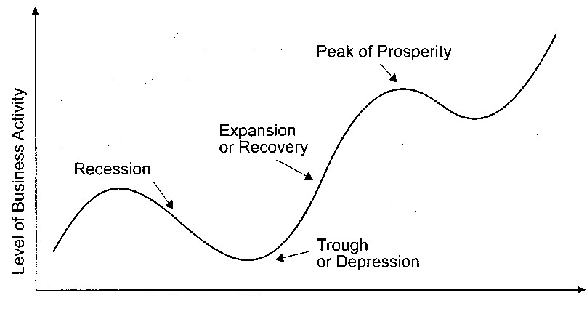

business cycle AmE (syn. trade cycle, cyclical fluctuations, economic fluctuations,trade-cycle) - економічний цикл
recession (syn. contraction, downturn) -спад ділової активності
depression (syn. trough, slump) - різке падіння, депресія expansion (syn. recovery, upturn) -пожвавлення
peak (syn. boom, prosperity) - пік; бум; різке піднесення ділової активності
decline - зниження, погіршення, занепад
to lay off- звільнювати працівників
undercut - збивати ціни; продавати за цінами, нижчими, ніж у конкурентів
to bottom out - перебувати на найнижчому рівні
shrinkage - скорочення persistent - постійний, стійкий
to creep - підкрадатися, повзти
to utilize - використовувати capacity - потужність
line graph - лінійний графік, flowchart - ланцюгова діаграма, pie chart - секторна діаграма, segment - сегмент, сектор, histogram/bar chart - стовпчикова діаграма , table - таблиця
column - стовпчик
row - лінійка
plan - план
diagram - схема, діаграма
drawing, illustration - малюнок,ілюстрація
vertical axis or у axis - вертикальна вісь
horizontal axis or x axis - горизонтальна вісь
The different types of lines in graphs: solid line - пряма лінія, broken line - перервана лінія dotted line - пунктирна лінія, curve – крива, undulating line - хвиляста лінія, fluctuating line – ламана

Self-Check:

What do we call 'business cycle"?
What is recession?
What happens in economy during depression?
What characterises period of recovery?
Describe economic activity during prosperity period.

Complete the definitions with the words from the box.

prices | depression | events | moves | activity
recession | series | boom | demand | recovery
capacity | falling | business | GNP | financial
within | unemployment | investment | cycle | severe
Cycle - a period of time in which a (1) of events happening in a certain order is completed, and then happens again and again with the (2) coming each time in the same order and generally (3) a similar length of time. Trade cycle - a cycle in time during which trade (4) from a state of high activity - (5) - through a running-down period - contraction, downswing, (6) , downturn - to a state of low activity - (7) , stagnation -, then upward again when business improves - (8) , revival - until there is a return to high (9) once more. The whole (10) then begins again. Boom - the part of the (11) cycle that follows recovery, in which the economy is working at full (12) . (13)_____ demand, (14)___ , and wages rise, while unemployment falls. If government control of the economy is not sufficiently tight, a boom can lead to a recession and ultimately to a slump. Depression - an extended or (15) period of recession. Depressions occur infrequently and some economists believe they occur in long (about 50-year) cycles (Kondratieff waves). The most recent Great Depression occurred in the 1930s. Depressions are usually associated with falling prices and large-scale involuntary (16)____. They are often preceded by major (17) crashes, e.g. the Wall Street crash of 1929. Recession - a slowdown or fall in the rate of growth of (18)______. Economic growth usually follows a cycle from boom to recession and back again. Recession is associated with falling levels of (19) _____rising unemployment, and sometimes (20) prices.
*Business Trends. Here is a range of vocabulary available to describe and interpret movements in graphs, bar charts and other visual data. Group the words below under the appropriate heading:
rise, peak, level out, plummet, grow, bottom, remain stable/steady, plunge, increase, improve, decline, go up, decrease, accelerate, drop, fluctuate, fall, pick up, jump, recover, shoot up, stabilize

Move up | Move down | Move in various directions | No change
Visual Aids. Pictures often help to make information clearer. A. Label the following using words from the box.

pie chart | table | flow chart | Map
histogram/bar graph | segment | Row | diagram
Column | plan | picture | line graph
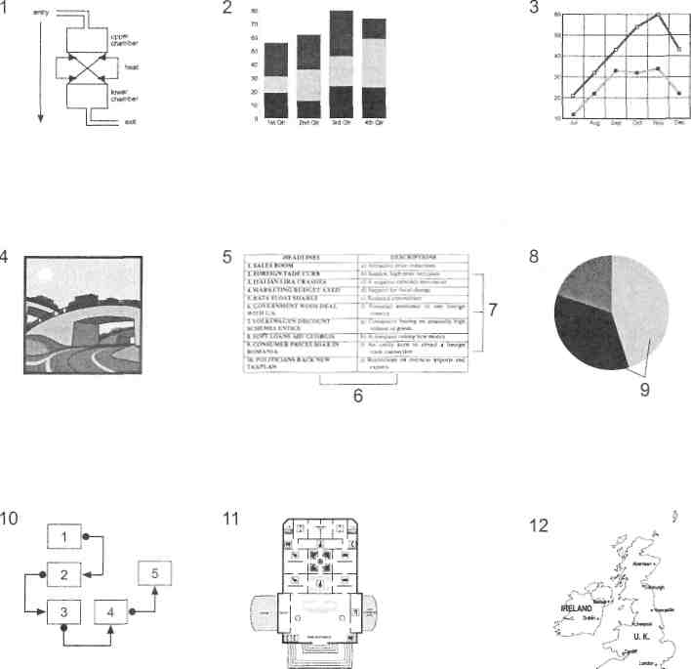

Match the words from the box with the correct letters in the pictures.

broken line vertical axis
undulating line solid line
horizontal axis dotted line
curve fluctuating line

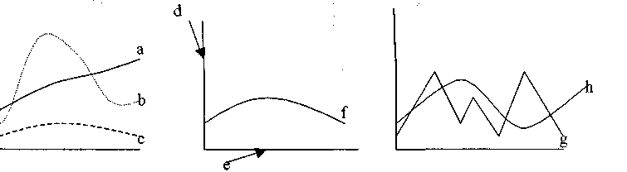

Describing trends. Read the statements about foreign exchange movements, then replace the words in italic with synonyms from the box.

volatile | a slight recovery | Bearish | Bullish | unpredictable
outperformed | picked up | Peaked | Slipped | fluctuated
sluggish | subdued | Plummeted | firmed up | remained constant
- Sterling has been rather susceptible to sudden change recently.
- The Deutschmark showed some improvement on Friday.
- The yen has made more progress than most European currencies this year.
- The market makers have been rather aggressive in their buying this morning.
- Pound trading was thin in Frankfurt yesterday.
- Cocoa prices reached a high point at midday.
- Trading of softs was very slow last week.
- On Wall Street, leading stocks became stronger last month.
- Silver prices plunged yesterday, closing, 14 pence below the previous close.
- The dollar moved up and down in London last week.
- Share prices slid slightly after the resignation of the Chairman.
- Commodity prices were erratic last week.
- The level of inflation stayed the same during 1993.
- Commodities trading improved yesterday after a slow start.
- A quiet, low trade volume options market was forecast.

The Language of Graphs. Match the terminology in the box with the points on the graph below.

vertical axis | horizontal axis | bullish market | peak
slump | fluctuations | upward trend | rise
downward trend | bearish market | remain constant | units
stand at | level off | reach a low | fall
curve | Drop

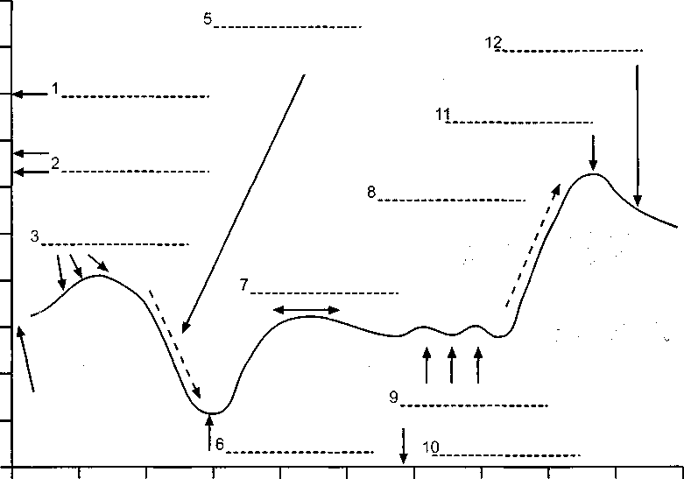

Writing Practice. Make a short summary about business cycle from the above

THEME 8. PRESENTATIONS
READING. Making An Effective Presentation
Successful presenters understand that what the audience sees in a presentation makes a stronger impact than the words they hear. We've been wired to take in information primarily through our eyes ever since cave dwellers began looking over their shoulders for approaching mastodons.
Academic research demonstrates the importance of nonverbal communication. One study by Albert Mehrabian, professor emeritus of psychology at UCLA, assigns only a 7% value to the choice of words in face-to-face communications, while tone of voice has a 38% value and facial expression 55%. The study was measuring the impact of single words in a laboratory setting, not in a presentation--but should be carefully considered by presenters who agonize over choice of words and give short shrift to preparing their presentation.
There's a different way to break down the components of an effective presentation. Like the Mehrabian formula, this one has three parts and a percentage value for each.
The first--and most important--part is to make an emotional connection with the audience, because without it the presenter's message will not be fully heard. The second is to generate and maintain a high level of energy to hold the audience's attention through the whole presentation. The third is to focus the content on the payoff for the audience.
Many speakers underappreciate these components. Using them can help you improve your effectiveness at presenting by significant margins.
*Make an Emotional Connection with the Audience. Consciously or not, the audience forms a bias for or against a presenter within seconds. We all make a tentative judgment about everyone we meet on scant evidence, though we may not admit it because we see ourselves as rational beings. More than anything else, it's the personal impression you make that determines whether or not the audience accepts your message. You must come across as likable and trustworthy.
The key to being likable is simple: Show you like the audience and they'll reciprocate. Once they like you they'll give you the benefit of the doubt on trustworthiness. You'll get a strong start toward likability if before you begin speaking you take a bit of time to look around the audience warmly, enthusiastically and with a big smile.
Maintain steady eye contact with the audience throughout the talk. If you don't, you will quickly signal that you don't want to be there, that you aren't really committed to your message or even that you're a shifty character. By speaking with the genuine feeling you'll make it clear you believe deeply in what you're saying. This will encourage the audience to believe in it, too. Practice the presentation so well that you don't need a script. A script is a barrier against making an emotional connection because it keeps you from making eye contact and communicating your passion for your message.
Show them your humanity. This is particularly important for speakers who have power over the audience. Tell them some stories that reveal your vulnerability and express the values you have in common with them. Everyone loves a story.
The audience has to know that you know your subject. Presenters whose expertise isn't recognized by the audience shouldn't try to establish it by describing their credentials. Let the person introducing you describe them and endorse you enthusiastically.
People like people who are similar to themselves. Be yourself, but also try to fit in with the members of the audience as much as possible. Speak to the audience's level of knowledge. Cite references they recognize and respect. Express the feelings you share with them. Dress just a little bit better than the people in the audience.
If you're announcing unwelcome news, express your empathy with the audience. Talk about specific incidents to show you understand the issues involved and are up to date with the details. If there's an opposing viewpoint, show the audience you understand it and acknowledge the parts you agree with. Keeping silent about the other viewpoint might infer you're afraid to challenge it. If you have to apologize for something, do it without making excuses. Whatever your message, speak directly and without circumlocution or Dilbert-speak. Make it clear you'll answer questions at the end--so be sure to leave enough time for them.
If there are other speakers, come early, sit in the audience to hear what they have to say and expand on their comments when you present your message. Sitting in the audience helps build a bond between you and the audience members. You also may want to get to the meeting room early and introduce yourself to the audience members as they arrive. This will help you make an emotional connection.
*Present with Energy. Capture the audience's attention right away by telling a dramatic story and keep the energy level high all through your presentation. To get them excited about your idea you have to show them your own excitement about it.
Walk in strong, move confidently to where you'll present, stand tall, smile, survey the room and begin to speak, with conviction. Underscore important points with movement: your whole body, your arms, your hands, your head and your changing facial expressions. Vary your voice pitch and pace, using a dramatic pause when you get to something important. Use mostly short sentences, dynamic words, onomatopoeia ("bang!", "boo-hoo") and active verbs. The perfect verb or noun doesn't need a modifier. Move closer to the audience at key points. Wade into the audience if it's appropriate. Come to the presentation well-rested so you can stay energetic.
Keep reading the audience. If you feel their interest flagging, do something unexpected: Pause abruptly, change your voice level or tempo, bring out a hidden prop, ask a question or involve the audience in an exercise.
Keep it short. The higher an audience's management level, the shorter its attention span. You'll earn points by taking less time than you were given and you'll maintain a high energy level all the way to the end of the presentation.
*Spell Out the Payoff for the Audience. If you're presenting information, give lots of attention to describing its relevance and applicability rather than telling every little detail. If you want the audience to accept a change you're announcing, focus on the benefits for them. What's in it for me? every audience wants know. Appeal to the head, with evidence the audience will find credible, and the heart, with inspiring descriptions of the payoff.
The payoff might be crystal clear to you--but never assume it is for the audience. Restate your key points in different ways, with examples and analogies. Make them memorable with sound bites that use alliteration, acronyms or rhymes.
Since the eyes are so important in learning, you'll want to use visuals. But don't let them upstage you because it's you who's the star of the show. Keep the visuals simple and use only a few. Don't make the audience feel they're suffering death by PowerPoint at the hands of a merciless PowerPoint Ranger. Wait until you've established likability and credibility before you turn their attention to the visuals.
*The Metrics. What's the relative value of the three components of this approach to presenting? Mnemonic devices are always useful so let's create a formula. Clearly, making an emotional connection by being likable and trustworthy is the most important component, because if you lack it your argument won't be accepted. You might not even be listened to. Let's give it a 50% value.
The other two components--presenting with energy and spelling out the payoff--are equally important. Let's give them 25% each. We now have a 50%–25%–25% formula for the new approach to making a successful presentation.
What we have altogether are two different but complementary tools you can put to work. Combining them will help you deliver a knockout presentation.
The 7%-38%-55% rule deals with the information the audience takes from the presentation. It will help you remember the importance of nonverbal communication. The 50%-25%-25% formula is about you, the speaker, and what you offer the audience. It will help you remember the importance of connecting emotionally with the audience, keeping the energy high and spelling out the payoff.
Bill Rosenthal is chief executive of Communispond Inc.

THEME 9. NEGOTIATIONS

      - Negotiations and business etiquette
      - Negotiations and international documents
      - Diplomatic documents
      - How to Successfully Negotiate in English Strategy

  - Negotiations and business etiquette
Nobody actually wants to cause offence but, as business becomes ever more international it is increasingly easy to get it wrong. There may be a single European market but it does not mean that they behave the same in Greece as they do in Denmark.
In many European countries handshaking is an automatic gesture. In France good manners require that on arriving at a business meeting a manager shakes hands with everyone present. But Northern Europeans, such as the British and Scandinavians, are not quite so fond of physical demonstration.
In France, it is not good manners to raise tricky questions of business over the main course. The business has its place: after the cheese course. Unless you are prepared to eat in silence, you have to talk about something - something, that is, other than the business deal which you are continually chewing over in your head.
In Germany, as you walk sadly back to your hotel room, you may wonder why your apparently friendly hosts have not invited you out for the evening. Don't worry, it is probably nothing personal. Germans do not entertain business people with quite the same enthusiasm as some of their European counterparts.
The Germans are also notable for the amount of formality they bring to business. As an outsider, it is often difficult to know whether colleagues have been working together for 30 years or have just met in the lift. If you are used to calling people by their first names, this can be a little strange. To the Germans titles are important. Forgetting that someone should be called Herr Doktor or Frau Direktorin might cause serious offence. It's equally offensive to call them by a title they do not possess. In Italy the question of a title is further confused by the fact that everyone with a university degree can be called Dottore – and engineers, lawyers and architects may also expect to be called by their professional titles.
Italians give similar importance to the whole process of business entertainment. In fact, in Italy the biggest fear, as course after course appears, is that you entirely forget you are there on business. If you have the energy, you can always do the polite thing when the meal finally ends and offer to pay. Then after a lively discussion, you must remember the next polite things to do – let your host pick up the bill.
These cultural challenges exist side by side with the problems of doing business in a foreign language. Language, of course, is full of difficulties – disaster may be only a syllable away. But the more you know of the culture of the country you are dealing with, the less likely you are to get into difficulties. It is worth the effort. It might be rather hard to explain that the reason you lost the contract was not the product of the price, but the fact that you offended your hosts in a light-hearted comment over on aperitif. Good manners are admired: they can also make or break the deal.

2.Negotiations and international documents
The major and, in fact, increasingly important aspect of diplomatic work is the drafting of diplomatic documents. There are many different forms of official diplomatic documents. A considerable proportion consists of documents that are of a purely intradepartmental nature. Another category of diplomatic documents are those through which official international intercourse goes on in written form. Such documents express the position of a state on a particular question of international affairs. Some of them are confidential by virtue of specific circumstances (there are even oral messages or oral statements whose contents are read out but not officially handed over to the addressees). A large number of diplomatic documents are never published owing to the insignificance of their subject matter (for instance, notes requesting visas). But a fairly large proportion of diplomatic documents, particularly those relating to important international problems, are made public.
Until recently diplomatic practice distinguished the following five forms of written official communications:
(1) personal notes,
(2) verbal notes (notes verbales),
(3) aides-memoir
(4) memoranda,
(5) semi-official letters.
A personal note takes the form of a letter drawn up in the first person on behalf of its signatory. It begins with a salutation and ends with a complimentary phrase, that is, a standard expression of polite respect.
A verbal note is considered to be the most commonly used form of diplomatic communication. It is drawn up in the third person and is not usually signed. It begins and ends with standard formulas of courtesy. Some handbooks on diplomatic practice, notably the fundamental book by Ernest Satow, do not name personal notes as an independent form of diplomatic communication, but simply refer to "notes". It is, however, stipulated that a note may be either in the first or in the third person. [...]. In diplomatic practice it is now common to distinguish between personal notes and verbal notes, the former being a note drawn up in the first person and signed, and the latter being drawn up in the third person and either initialed or left unsigned. Until fairly recently the choice of the form of a note, signed or unsigned, was regarded as a definite indication of the state of relations between the countries concerned. Nowadays verbal notes have become part and parcel of international intercourse, and no one would now regard a verbal note sent to an embassy as a display of any ill will.
The aide-memoire. Diplomatic practice knows two types of aides-memoire: (a) handed over personally and (b) delivered by a courier. The purpose of transmitting an aide-memoire is to facilitate the further progress of a transaction and to prevent the subject of a personal conversation or an oral statement from being misinterpreted or misunderstood.
A memorandum may be a separate and independent document or it may be appended to a personal note or a verbal note. In the latter case, the memorandum elaborates and justifies the subject matter dealt with in the note. The distinguishing feature of a memorandum is a detailed exposition of the factual or legal aspects of a particular question. In describing the memorandum, Ernest Satow notes that this form of the diplomatic document is often a detailed statement of facts, and of arguments based thereon, not differing essentially from a note, except that it does not begin or end with a formula of courtesy, and need not be signed, but it may be convenient to accompany it with a short covering note. In earlier times these were often termed deduction or expose de motifs.
Semi-official, or informal, letters are sent to officials, with whom one is acquainted, in cases involving personal favours (thanks for an invitation, a request for assistance) or relating to administrative matters. Most forms of diplomatic documents contain the following components, or elements: (a) protocol formulas; (b) purport; (c) argumentation; (d) exposition of the fact or facts. Included under the heading of "protocol formulas" are the proper titling of the person addressed, an expression of respect for the addressee at the beginning and the complimentary phrase which concludes the document. Protocol formulas are used in personal messages of heads of government or state, personal notes, verbal notes, and aides-memoire delivered by a courier (the latter form has almost completely gone out of use). Other forms of diplomatic documents contain no protocol formulas. As the name itself suggests, the purport is the principal part of a diplomatic document. In extent it may be very short as compared with the other parts. Yet it is the purport that carries the main idea of the document and is, in fact, a concentrated expression of a state's position on the main issue under discussion. To point out the purport correctly means to correctly grasp the meaning of a diplomatic document.
By their content diplomatic documents, whatever their form (notes, declarations, aidesmemoire, etc.), may be classified as follows:
a) documents containing proposals;
b) documents registering a protest;
c) documents warning of possible measures of retaliation;
d) documents establishing a political or international legal position in respect of an act committed by another state or statesor in respect of an international event
e)documents announcing measures contemplated or implemented, which are of international significance;
g) documents recording an agreement or a degree of accord reached.
Generally speaking, diplomats divide international agreements into three parts.
- the preamble, which states the overall purpose of the act;
- the second part embodies the substantive commitments undertaken by the parties and comprises most of the «text».
- the third part is the «final forms», more or less stereotyped, equivalent to the precautions that governments have been traditionally called to take to guarantee juridical regularity of the negotiation and the qualification of the plenipotentiaries, and the specifications of how the agreement shall be brought into force, how it may be terminated and, sometimes, how it may be amended. This is what is called the «protocolary» or «formal provisions*. (J. Wood & J. Serres)
Self-check:
What are the most frequent techniques of negotiations?
Which are the most common international; documents?
What are the essential constituent parts of international agreements?

3. Diplomatic correspondence
Diplomatic correspondence includes 1.formal letters. 2. informal letters and E-mails. 3. notesverbales or memoranda.
Formal letters are those employing diplomatic style and phraseology.
The text of a formal diplomatic letter should begin with the expression ―I have the honour to ...‖, except in the case of formal letters from undersecretaries or officials of equivalent rank to permanent representatives. These begin with ―I am directed by the Secretary General to ...‖ or ―On behalf of the Secretary-General, I have the honour to ...‖. The expression ―I have the honour to ...‖ is usually required only in the opening sentence. Succeeding paragraphs should normally begin without this introductory phrase. Where it is necessary to refer to a resolution or act of one of the organs of the United Nations or to a previous communication from the Secretary-General, the appropriate form is ―I have the honour to refer to ...‖ or ―I invite your attention to ...‖. If a request is made of the addressee, the expression ―I should be grateful‖ is appropriate.
The address should also contain personal titles such as ―His Excellency‖, ―Her Excellency‖ and ―Ambassador‖, written in full. Normally such letters are addressed only to heads of State or Government, ministers for foreign affairs and permanent representatives. Subjects which require formal letters include, among others, official statements of policy by the Secretary-General, actions taken or ‗contemplated of the Secretary-General in connection with decisions or recommendations of organs of the United Nations, acknowledgements of the credentials or appointments of permanent representatives, and similar information to Governments and permanent missions on matters involving the duties and responsibilities of the Secretary General under the Charter (From "Diplomatic Ceremonial and Protocol"by J. Wood& J. Serres)
Structural Parts:
- Salutation for a formal letter is ―Sir‖ or ―Madam‖ followed by a comma. In addressing a person with ambassadorial rank, the form ―Excellency‖ may be used. The salutation should begin with the same margin as the text and should be typed six or more lines below the reference number, depending on the length of the letter.
- The close for formal letters should be indented as a separate paragraph. Formal letters to ministers for foreign affairs or permanent representatives should, as a rule, include the name of the addressee in the address.
- The full address should be given on the ‗envelope, but details such as street address and room number maybe omitted on the letter itself. The date should be in the form ―2 August 2002‖. The names of the months should not be abbreviated, and cardinal numbers should be used. The date should appear in the upper right-hand part of the page on the same horizontal line as the reference number, ending at least fifteen spaces from the right-hand edge.
- The left-hand margin should be twenty spaces from the edge of the page and the right-hand margin about fifteen. To contribute effectively to the conduct of the business of the United Nations, its official correspondence must be clear and accurate in content, direct and dignified in style, correct in form and attractive in appearance. (From “United Nations Correspondence Manual”)
2. Informal letters are used for the day-to-day correspondence of the Secretariat with persons outside the Secretariat and for communications addressed to other organizations in the United Nations system. They are also used for letters from the Secretary-General or from under-secretaries-general or assistant secretaries-general to permanent representatives or senior members of missions or delegations, except when the subject makes a formal letter more suitable.
- The salutation of an informal letter should begin with the same margin as the text and be followed by a comma. It should be six or more lines below the reference number, depending on the length of the letter.
- The complimentary closing should be centred above the signature block. The salutation and corresponding closing may take any of the following forms, as appropriate:
Salutation
Dear Sir ( Dear Madam), Yours truly, Dear Sirs ( Dear Mesdames), Dear Mr.... (Dear Mrs...), Yours sincerely, Dear Miss.... (Dear Ms...), ( or Sincerely yours), Dear Mr. (Madam) Ambassador
E-mail
The electronic mail (e-mail) was started in the late 60s by the U.S. military that were searching for a way of communication in the event of a large-scale nuclear war. They needed a system that would be decentralized, reliable, and fast in case the central institutions were destroyed. They came up with e-mail. In the early 70s, e-mail was limited to the U.S. military, defense contractors, and universities doing defense research. By the 70s it had begun to spread more broadly within university communities. By the 80s, academics in a number of fields were using e-mail for professional collaboration. The 90s saw an explosion of the use of e-mail and other computing networking. It is estimated that more than 25 million people throughout the world were using it in the mid-90s. E-mail is a way of sending a message from one computer to one or more other computers around the world. A subscriber to e-mail needs a terminal, such as a PC, a telephone line, and a modem, which is a device of converting signals into text. E-mail users must also have access to a mailbox, which they can call from anywhere in the world to retrieve messages. They receive a mailbox number and a password for confidentiality.
E-mail is fast, cheap, and relatively reliable. It permits to send large amounts of information to different addressees and allows people to retrieve messages at any time.
A typical e-mail address is: direct@askbooks.kiev.ua (the e-mail address of the A.S.K. Publishers House). The part to the left of the @ sign, called use rid, has been chosen as a personal handle. The part to the right is called the domain and represents the particular computer that receives and delivers the message.
E-mail message usually comes into two parts: the heading and the body.
The heading includes: the date, the writer's name, the addressee's name, which is to receive a copy (c.c.), if any, and the subject. The body of the message bears an ordinary content of a letter but a bit shorter.
The golden rule for writing e-mail messages is KISS (keep it short and simple). Use short phrases instead of long, active voice instead of passive; avoid foreign words, metaphors, and scientific terms.
There's no bold in e-mail, so use capitals or asterisks. Among the abbreviations used in e-mail there are: BTW – by the way; IMHO – in my humble opinion; CONT – container; SHPT – shipment; RQST – request; BUZ – business; MESS – message.
- How to Successfully Negotiate in English
Negotiating takes place when two or more people have different views and want different things. They therefore come together to discuss the situation and try to reach an agreement. Most people understand that negotiation is a matter of give-and-take: You have to be willing to make concessions to get concessions in return and, hopefully, reach a consensus in the end. We all negotiate on a daily basis, e.g. with family, friends, landlords, employers or business partners. In business, negotiation skills are important in both informal day-to-day interactions and in formal transactions, such as negotiating sales conditions, service delivery and other legal contracts.
Every time you negotiate, you have to make choices that affect whether you achieve a successful outcome for yourself or your business. To get the best outcomes, you need to understand the steps involved in the negotiation process. While many negotiations are straightforward, some can take a lot of time and be very challenging. Your success will depend on how you approach each of the three basic steps: preparation, negotiation and closing
Negotiations Strategy (Source: English for Business and Economics / VYSOKÁ ŠKOLA EKONOMICKÁ V PRAZE Fakulta mezinárodních vztahů. 2016. P. 28)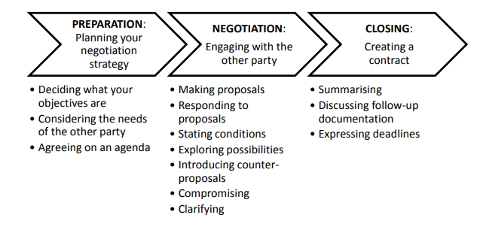
Formulate your objectives using the following phrases:
1. We must (insist on) … 2. Our main concern is … 3. It is vital / crucial that … 4. Our intention is … 5. I would like to … 6. We might like to … 7. I am willing to accept … if … 8. I think we will have to agree to … 9. We can trade … against … 10. A few things we can compromise on are …
Strategy 1: Identify Your Ultimate Goal, Limits, and Alternatives
Prior to entering a negotiation, determine your ultimate goal. Ask yourself the following question: What do I want the outcome of this negotiation to be? When you answer the question, provide a straightforward answer with no bells and whistles (= no enhancements, special additions, or frills), e.g. I want a raise that matches my workload and expertise.
Not all negotiations will end with your ideal outcome. Compromise may be required and an alternative may need to be considered. To go in prepared for every possible outcome, determine the minimum or alternative which will bring satisfaction, even if the ideal outcome doesn’t manifest from the negotiation process. Essentially, identify your bottom line – the ideal, final outcome – but also be prepared with a minimum that will satisfy you.
The following phrases are useful when communicating this: I/We draw the line (= to set a boundary, rule, or limit) at X because of Y. X is non-negotiable because of Y. Anything less than X does not meet my/our needs, since Y.nI’m willing to meet you halfway (= to compromise or concede to some things to gain other advantages) at X, but anything less than that will not meet my needs.
In English-speaking culture, it is often equally important to reflect on how you’d like everyone to feel at the end of a negotiation. Particularly, if you value the relationship between you or your company, and the other side. To do this, prioritize solutions or outcomes that create a win-win situation or a feeling of mutual success.

Strategy 2: Find Common Ground & Build Rapport.
To establish a feeling of mutual success from the beginning of the negotiation process, prioritize building rapport and gaining trust with the other side. When you enter negotiations, the relationship between you and the other party should help guide your approach. Start off with small talk to help you establish common ground (= mutual or shared interest). Incidentally, this is also a great way to feel out (= to cautiously gain knowledge of a person’s POV or feelings associated with a situation) the person sitting on the other side of the table. The following questions are helpful conversation starters for building rapport:
- How has your day/week been so far?
- I heard you [verb]. How was the experience?/How is it going?
- I noticed [insert observation]. What do you enjoy most about X?

Strategy 3: Understand the Other Side
As you enter your negotiations, it’s essential to strive for insight into the other side’s point of view, demands, and reasons. Why should you know the other side?
Knowing the other side will help you make informed decisions, weigh your options (= to consider the pros and cons of each option thoroughly when considering two or more options), and prepare impactful supporting arguments throughout the negotiation process. To successfully gain insight into the motives driving the other side, stick to asking open-ended questions that focus on the ‘why’ behind a statement:
- What do you think is a fair and reasonable solution/outcome/number? Why?
- Could you please tell me more about how you arrived at X?
- Why do you believe X?
- How do you feel about this aspect of X?
- Why is X important to you?
- What part of my proposal causes concern or hesitance?

Strategy 4: Establish Trust
Finding common ground, building rapport, and asking open questions are all key to establishing trust. In addition to the aforementioned tips, the following techniques are useful for gaining trust:
Tip #1: Speak Directly and Concisely
Remember avoiding the bells and whistles when establishing your needs in Tip #1?
Well, the same clarity, directness, and conciseness will be appreciated by the other side.
This means using concrete and straightforward language to express your thoughts, goals, and needs. To do this successfully, avoid ranges and share concrete numbers, dates, results, etc. Rather than say: We’d be satisfied if the project is completed within 3-4 months.
Say: We require the project to be completed by January 5, 2023.
By expressing your thoughts in a straightforward manner, you acknowledge the importance of the other side’s time. Not only does this reduce ambiguity, but it also reduces the chances of miscommunication.
Tip #2: Show Interest & Openness
Sincerity and honesty go a long way in producing successful negotiations. Instead of bending the truth (= to mislead; to leave out certain facts in order to gain a specific response), focus on honestly sharing your reasoning and thoughts.
Remember, as much as you want to understand the other side, the other side also wants to understand you. Think back to your answers to the pre-negotiation questions in Tip #1 and share your thoughts with the other side. Your sincerity will help both sides to come to a mutual, satisfying decision.
Tip #3: Actively Listen
Nothing is more genuine and important than engaging in active listening. Prior to diving into your points, ensure you’ve understood the other side by asking clarifying questions, such as the following:
- You’re saying X. Is that correct?
- If I understood you correctly, you think X. Am I right?
- What I heard you say was X. Have I understood you well?
- Could you please clarify what you mean by X?
While listening to the other side, use vocal cues (i.e. mhm, ah, I see, true, good point, I understand, right), body language (i.e. nodding, leaning towards the speaker, maintaining eye contact), and avoid interrupting to demonstrate complete respect and attention towards the speaker. Moreover, summarizing and echoing the other side’s main points will also demonstrate your sincerity and ensure clarity is maintained. To summarize, the following phrases are useful: I understand. So what you’re saying is X. Ok, so you would like/prefer X. So you’re telling me that your company needs X.
Tip 4: Use Inclusive Language
Consider the following sentences:
      - – I want a solution that satisfies these conditions.
– We need a solution that satisfies these needs. The inclusive language that focuses on ‘we’ rather than ‘I’ will decrease the chances of alienating the other side. Instead of setting the tone for a win-lose situation, you’ll improve the chances of negotiating a deal that satisfies both sides

(Source: #254:How to Successfully Negotiate in English | 4 Strategies + 20 Essential Phrases: https://www.speakconfidentenglish.com/negotiate-in-english/https://www.speakconfidentenglish.com/negotiate-in-english

Scenario 1: Perhaps, you’re negotiating a raise and the company doesn’t agree with your proposal. Instead, they offer you the same salary with better benefits.
At that point, you may say, “An increase in my salary is non-negotiable because it would ensure I’m able to keep up with the current cost of living in this city and that it matches my current workload.” To help you consider all possible outcomes and factors, ask yourself the following questions before you finalize your bottom line:
- What do I (or, my company) want from this negotiation?
- What is the bottom line?
- Why is this goal or result important for me/us?
- What will happen if I am not successful in reaching my goal?
- Are there any alternative agreements or compromises I’m willing, and not willing, to accept?
- What alternatives or compromises can I propose, if necessary?
- What kind of relationship do I have with the other party? And do I want to keep a good relationship after the negotiation?
- What are the consequences if I win or lose this negotiation?

Scenario 2: Imagine you’re meeting with a potential buyer for your product and feel awkward after shaking hands and sitting down. Continue to negotiate:
To break the ice, you might say, “In coordinating this meeting today, I had the opportunity to interact with a number of your team members. Everyone was so well-organized! What’s the secret?...

Scenario 3: Imagine your travel buddy wants to change your itinerary for the last day. They share that the new itinerary will ensure you visit all the attractions before your leave.
You might say and clarify, “I understand. So what you’re saying is to leave the tourist attractions for the final day since a weekday will mean that there is less of a crowd. Is that right?”

THEME 10. REPORTS
A report is written for a clear purpose and to a particular audience. Specific information and evidence are presented, analysed and applied to a particular problem or issue. It offers recommendations for future action. The information is presented in a clearly structured format making use of sections and headings so that the information is easy to follow. As the main purpose of a report is to inform the audience, it must be logically organised.
The standard components of a report are Introduction, Main body or Findings, Conclusions and Recommendations. However, other sections such as Procedure or Method can be added as well. It is necessary to check the accuracy of the report content, as well as writing style, grammar, spelling and punctuation. It is essential to show that you are being objective (i.e. not letting your personal opinion and interests affect the report and not adding any persuasive elements). You can do this by using the report as the subject of the sentence (This report shows…) or by using passive voice (Conclusions are drawn…). Reports used in government, business, education, science, and other fields, are aimed to display the result of an experiment, investigation, or inquiry.
Report writing tips:
- Analyse the task carefully. Who is the report for? Why do they want it? What do they need to know?
- Structure the report into clear sections using numbering and headings, so information is easy to find.
- In general, write in a more formal, objective and impersonal style.
- Aim to be clear, concise and precise.
- Ensure all your sources are clearly referenced in the text.
- Proofread carefully, checking for clarity as well as accuracy.
- The report must comply with the ABC of report writing – be Accurate, Brief (does not mean short but without unnecessary details), and Clear.
Source: English for Business and Economics / VYSOKÁ ŠKOLA EKONOMICKÁ V PRAZE Fakulta mezinárodních vztahů. 2016. P. 71

How to Create a Financial Report in 6 Simple Steps

Step 1: Title of the Report
Open a new document in MS Word, Apple Pages, or MS Excel as needed. On the first page of the document, you need to write down the title of the report, preferably towards the center of the report. Under the title of the report, specify details of your company like the name, address, and contact information.

Step 2: Table of Contents
Moving on to the next page, you should enter the table of contents. This will help the reader navigate through the topics that are present in the report. Number each page without fail. If you are planning to create an annual financial report, you can go through our annual financial report templates in Pages.

Step 3: Financial Review
Write a brief introduction to the financial report. You can include the cost of operating expenses and what it includes. You should also state if the company’s cash flow has increased or decreased along with its market investment details.

Step 4: Enter the Various Factors
Once you have given an executive summary, you can proceed to enter other important information of the financial report such as profit and loss statement, cash versus revenue, financial statement position, liabilities, and investment. You can touch upon each topic and give a brief about the situation and what is its impact.

Step 5: Insert Graphs
Make use of graphs to support the various factors that you have discussed in the report. Place the graph underneath or above the top so that it is easier to refer to and understand. Presentation is an important aspect of any report, so make sure you organize the contents of the report carefully.

Step 6: Save and Print
When all of the above steps are completed, you can save the document templates samples and get them printed. Also, before you print the report, it would be wise to go through the information once again to avoid any errors.

Report translation into English is primarily concerned with linguistic nuances. However, specialised expert knowledge of the financial and legal spheres is equally important for adequate translation. After all, the technical terminology used in a financial document can have a completely different meaning in everyday life.
The annual report contains a vast amount of information about the economic state of an enterprise. It includes:
    - a balance sheet of the enterprise;
    - profit and loss statement;
    - information on the flow of funds;
    - audit report.
All these documents contain a lot of digital information (see below balance sheet example), which cannot be misinterpreted. Therefore, the translation of the annual report into a foreign language requires not only high qualifications and experience from the translator but also a responsible attitude to work. In addition, you need to know the peculiarities of writing numerical data in different countries (decimal numbers, fractions) and use them correctly in the translated text.

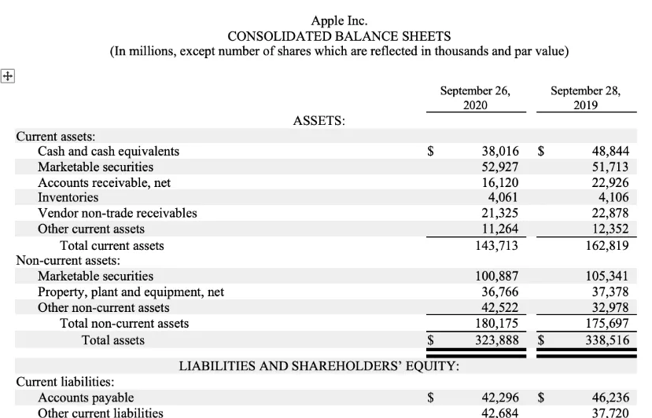

*Below you can see some terms closely connected with report writing. Match them with their definitions:
1. font 2. bullet point 3. proofreading 4. layout 5. draft
a) the way in which text and illustrations are arranged on the page b) an early version of a report that may have changes made to it before it is finished c) an item in a list with a small symbol in front of it d) letters of a particular style e) checking and making corrections to a document (particularly in relation to spelling and inconsistencies in layout)

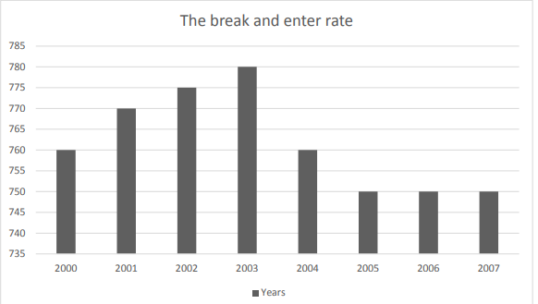
Introduction
This report examines the changes in the total property crime rate between 2000 and 2007.
Findings
In 2000 the total property crime rate was 2,500 offences per 100,000 population. Then the rate rose 1__________ (sharply/sharp) and reached 3,800 in 2001. After a 2__________ (moderate/moderately) fall in 2002, the rate started to 3__________ (increase/decrease) again and reached a 4__________ (peak/top) in 2003. However, after fluctuating for some months, the total property crime rate dropped 5__________ (considerably/considerable) throughout 2004 and the beginning of 2005. The rate stayed at about 2,400 offences from mid-2005 6__________ (to/by) mid-2006 before 7__________ (decreasing/decrease) again. In 2000 the break and enter rate was about 760 offences per 100,000 population. 8__________(From/Since) 2000 to 2003, there was a steady 9__________ (upward/downward) trend in the rate, which 10__________ (reached/arrived) its highest point in 2003 and then 11__________ (showed/fell) a significant downward trend until mid-2005. After being stable for a few months, the rate continued to fall 12__________ (slightly/slight), dropping to around 750 in 2007.
Conclusion The total property crime rate fluctuated from 2000 to 2003, whereas the break and enter rate showed a general upward trend. Both rates peaked in 2003, fell significantly until mid-2005, stabilized for some months and 13__________ (fell/grew) slightly during 2006 and 2007.

*Look at the financial report form (https://blank.dtkt.ua/blank/50), point out its’ layout peculiarities and transate it into Ukrainian:
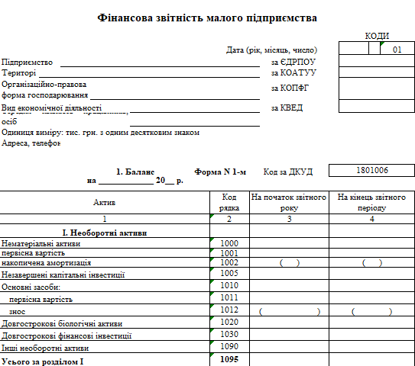

References

Основні:

Business Partner B1+. Business Partner B1 Coursebook and MyEnglishLab. Pearson, 2018.

Красюк Н. Економіка та фінанси діловій англійській мові. Навчальний посібник для студентів вищих навчальних закладів. Львів: Видавництво Львівського банківського інституту Національного банку України, 2004. 252 с.

Должанський М.І., Должанський A.M. Бухгалтерський облік в Україні з використанням Положень (стандартів) бухгалтерського обліку: Навчальний посібник. Л.: ЛБІ НБУ, 2003. 494 с.

Сєргєєва О. В. Особливості перекладу економічних текстів. Тексти і завдання для розвитку навичок перекладу для студентів напряму підготовки «Філологія. Переклад»: метод. Вказівки для студ. 5-го курсу / уклад. Сєргєєва О. В. [Електронний ресурс]. Хмельницький : ХНУ, 2013. 46 с. Режим доступу : https://msn.tup.km.ua.

Черноватий Л. М., В. І. Карабан, І. О. Пенькова, І. П. Ярощук Переклад англомовної економічної літератури. Економіка США. Навчальний посібник для студентів вищих закладів освіти. Вінниця, НОВА КНИГА, 2007. 416 с.

English for Business and Economics / VYSOKÁ ŠKOLA EKONOMICKÁ V PRAZE Fakulta mezinárodních vztahů. 2016. P. 71

Talbot F. How to Write Effective Business English. The Essential toolkit for composing powerful letters, emails and more, for today’s business needs. London and Philadelphia: Kogan Page, 2009. 135 p.

Wood J.R., Serres J.C. Diplomatic Ceremonial and Protocol: Principles, Procedures, and Practices. Columbia University Press, 1970. 378 p.

Додаткові:

Mascull Bill. Business Vocabulary in Use. Intermediate. Cambridge University Press. 2010. 176 p.
McCarthy M., O’Donnel F. Academic Vocabulary in Use. Cambridge University Press. 2018. 177 p.
Horner D., Strutt P Words at Work. Vocabulary development for Business English. Cambridge University Press, 1996. 128 p.
Reynolds Garr. Presentation Zen: Simple Ideas on Presentation Design and Delivery (Voices That Matter). New Riders; 3rd edition (December 14, 2019). 336 p.
Ricks B.R., Gow K.F. Business Communication: Systems and Applications. John Wiley & Sons Australia, Limited, 1987. 400 p.
H. Victor Conde. A Handbook of International Human Rights Terminology, University of Nebraska Press, 2004. 393p.
Useful links:
https://hbr.org/
https://studiousguy.com/business-communication/
https://strategicmanagementinsight.com/tools/mckinsey-7s-model-framework/)
https://www.speakconfidentenglish.com/negotiate-in-english
https://www.dilovamova.com
https://europa.eu/europass/eportfolio/screen/cv-editor?lang=en
https://advokatpost.com/structure-of-a-commercial-contract-tonkoshchi-kontraktnoho-prava-anhlijskoiu-movoiu-z-liudmyloiu-kolodnyk
https://www.shrm.org/resourcesandtools/tools-and-samples/toolkits/pages/understandingorganizationalstructures.aspx
https://zety.com/blog/what-is-a-cv

