MINISTRY OF EDUCATION AND SCIENCE OF UKRAINE
STATE HIGHER EDUCATIONAL INSTITUTION
UZHHOROD NATIONAL UNIVERSITY
MEDICAL FACULTY
DEPARTMENT OF GENERAL SURGERY

Stoika Vasyl, Kochmar Vitalii, Filip Stepan, Sheregii Andrii, Pushkash Ivan

DAMAGE TO THE SPINE

Educational and methodical instructions for independent work
5th year students, medical faculty
in the specialty "Medicine"

UZhHOROD - 2023
Methodical developments have prepared:
Stoika Vasyl Volodymyrovych - PhD, Docent of the Department of General Surgery of Uzhhorod National University.
Kochmar Vitalii Mykhailovych - Assistant of the Department of General Surgery of Uzhhorod National University.
Filip Stepan Stepanovych – Doctor of Medical Sciences, Professor, Head of the Department of General Surgery.
Sheregii Andrii Andriiovych - PhD, Docent of the Department of General Surgery, Uzhhorod National University.
Pushkash Ivan Ivanovych - PhD, Docent of the Department of General Surgery of Uzhhorod National University.

Reviewers:
Doctor of Medical Sciences, Professor of the Department of General Surgery Kanziuba Anatolii Ivanovych.
PhD, Docent of the Department of General Surgery, Uzhhorod National University Slyvka Rudolf Mykhailovych.

Methodical recommendations are approved
at the Academic Council of the Medical Faculty
of “SNEI” Uzhhorod National University
protocol №__ from "__" ________ 2023.

Responsible for the issue:
Dean of the Medical Faculty, Uzhhorod National University
Doctor of medical sciences, Professor Boldizhar Oleksandr Oleksandrovych

Actuality of theme
Injuries of the spine and spinal cord are diverse pathologies characterized by various injury mechanisms. Spine injuries are among the most serious injuries. They make up 0.4 - 0.5% of all fractures of the bones of the skeleton. A significant number of the injured are young people. 20-40% of closed injuries of the spine are complicated by damage to the spinal cord of varying degrees of severity. A significant percentage of those dissatisfied with the result of treatment remains. Disability with complicated spinal injuries is 95%. Mortality in this group of patients is up to 30%.
Establishing a diagnosis is crucial for the correct treatment of patients with spinal injuries.

The purpose of the lesson
Teach students to recognize the most common spinal injuries. Learn the technique of examining the spine, the classification, clinical symptoms, methods of diagnosis of spinal injuries, the main means of operative and conservative treatment.
To solve this problem, the student must know before class:
- Anatomical and physiological features of the spine.
- Means of diagnosis of spinal cord injuries..
- Classification of fractures of the spine.
- Classification of vertebral dislocation.
- Clinical symptoms of fractures, dislocations and ligaments damage of the spine.
- Methods of treatment of patients with spinal injuries.
- Indications for surgical treatment.

By the end of the practical lesson, each student should be able to:
- Collect the trauma history and identify clinical symptoms of damage to the spine.
- To analyze the mechanogenesis of trauma.
- Carry out special means of examination of patients with spinal cord injuries. Identify and describe the radiographic features of spine injuries.
- Provide emergency medical care at the stages of treatment. Transport immobilization Antishock therapy.
- Develop indicators for operative and conservative treatment.
- To predict the consequences of injuries and diseases of the spine.

The main theoretical provisions of the topic..
The vertebral column has a number of different functions.

Stability, support and movement
The spine consists of seven cervical, 12 thoracic and five lumbar vertebras with sacrum and coccyx (Fig. 1). Each vertebra is composed of a vertebral body, pedicles, laminae, transverse processes and a spinous process (Fig. 2). Intervertebral discs lie between each cervical, thoracic and lumbar vertebra with movement anteriorly occurring at the disc and posteriorly at the two facet joints (synovial joints). Two vertebrae and the disc between form a ‘motion segment’ (Fig. 3). These motion segments allow differing amounts of flexion/ extension, lateral bending and rotation with the total movement being considerable. In the thoracic region movement is limited by the ribs and sternum.
The normal spine is straight when viewed from behind but is curved when viewed from the side with the cervical and lumbar spine being lordotic (curve convex anteriorly) and the thoracic spine being kyphotic (convex posteriorly). These normal sagittal curves assist in maintaining balance, but this is largely achieved by large longitudinal, paraspinal muscles running bilaterally up the whole length of the spine and strong ligaments.

Haemopoietic function
The marrow of the vertebral bodies retains its blood - forming capacity throughout life, and vertebrae are, therefore, subject to blood-borne diseases and diseases of the haemopoietic system, such as infection and primary haematological malignancies, e.g. myeloma and metastatic disease. Being cancellous bone, they unite readily after fracturing. Ossification occurs from a single centre in the body and a ‘ring’ epiphysis for each end-plate.

Spinal cord and nerve root transmission
The spinal cord contains upper motor neurones (UMNs), which are highly susceptible to damage, particularly from rapid compression, movement or ischemia (failure of blood supply). Once damaged, these UMNs often do not recover even if the cause of the damage is reversed (e.g. compression is removed). There is good evidence that after fracture, decompression makes no difference to the likelihood of neurological recovery. This is thought to be because the damage is done at the time of the injury when the fracture fragments in the spinal canal are more displaced than their final resting position.
In slower forms of spinal cord compression, such as metastatic tumour deposits and particularly infection, decompression of the spinal cord can result in improved neurological function. The spinal cord finishes at approximately L1 spinal level in the adult and below this is the cauda equine, which finishes at S2. The nerves within the cauda equina are all lower motor neurones (LMNs) and are less easily damaged by movement or compression, and when there is a motor or sensory deficit, decompression may produce recovery. The only exceptions are the sacral nerve roots supplying the bladder, bowel and sexual function. If these nerves are compressed, rapid decompression is needed to improve the probability of recovery (cauda equina syndrome). In the spinal cord region, nerve roots exit at every level (LMNs) and these behave in the same way as lumbar nerve roots within the cauda equine, i.e. if there is dysfunction due to compression, decompression may regain function.

History
Most diagnoses can be made from a good history and examination. When spinal pain is the dominant symptom, it is important to decide whether there are any ‘red flags’. These suggest more sinister spinal pathology, such as tumour, infection or fracture, and justify urgent referral to an orthopaedic spinal surgeon. If there is any suggestion of early spinal cord compression, emergency referral is needed.
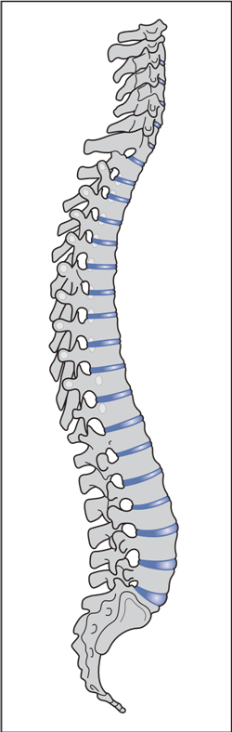 | 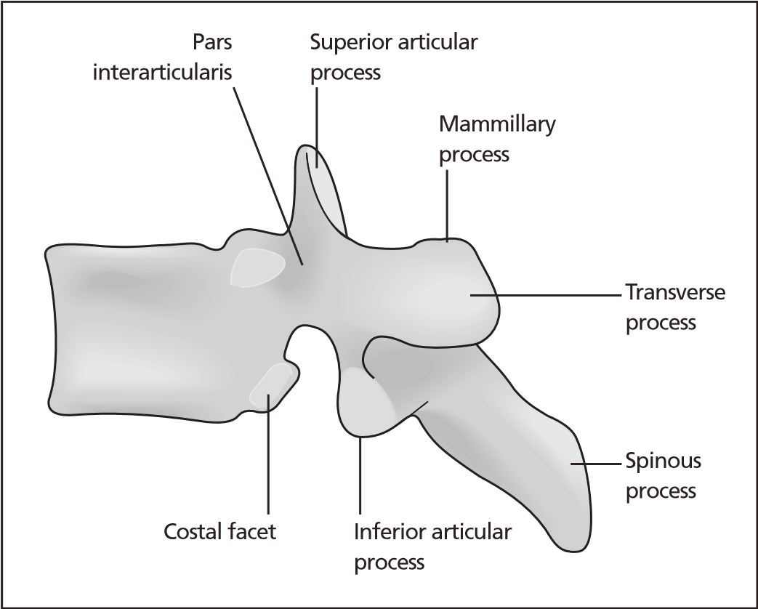
 | Figure 2 Typical thoracic vertebra.
 | 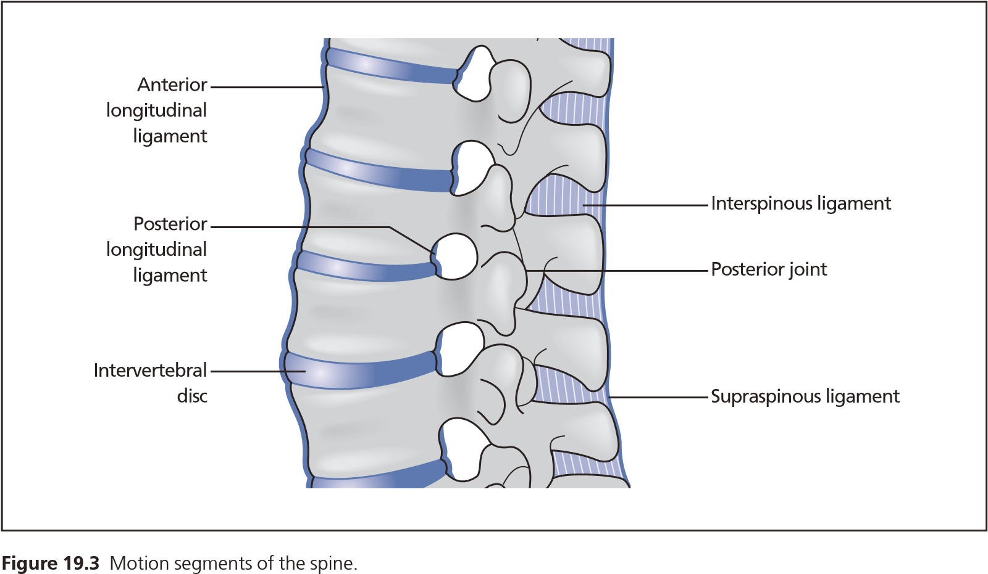
Figure 1 The spine. | Figure 3 Motion segments of the spine.

Red flags
- New onset of back pain if aged under 10 or over 60 years.
- Previous history of carcinoma (even if many years ago for breast carcinoma).
- History of osteoporosis or prolonged steroid use and minor trauma.
- History of HIV or immunosuppression.
- Back pain with new systemic sinister features which may themselves need investigation, e.g. unexplained appetite and weight loss.
- Non-mechanical low back pain, especially with significant night pain and thoracic pain.
- Rapid onset lower limb neurological symptoms suggesting spinal cord or cauda equina compression.
- Bladder and bowel dysfunction.
Often patients will present with axial pain (pain related to the axial skeleton, i.e. neck or low back pain) and radicular pain (upper or lower limb pain in a dermatomal or myotomal distribution suggestive of nerve root compression in the cervical or lumbar spine). It is important to determine whether one symptom is dominant or whether the disability is equally from the axial pain and from the radicular pain. This helps guide treatment, as generally, axial pain is difficult to treat with poor success rates whilst radicular pain is easier to treat with higher success rates.

Examination
- Inspection. The patient should be adequately exposed and viewed standing (or sitting) and the posture of the spine, its shape and any exaggerated or abnormal curves noted. When the patient is viewed from the side, is the kyphosis and lordosis within normal limits and is the patient’s trunk angled excessively forwards or backwards? When viewed from the back are there any lateral spinal curves? These are often accompanied by a muscular/rib prominence on the side of the curve, which becomes more pronounced on forward bending (scoliosis) (Fig. 4). Is the head positioned above the pelvis or is there any frontal plane imbalance? It is always important to look for skin lesions, such as malignant melanoma, as the trunk is a common site and on the back they can often go unnoticed. A dermatomal rash suggestive of herpes zoster may be the cause of the pain.
- Palpation. Running the fingers down the spinous processes will detect a localized kyphus or a gap in the ligaments (only present in trauma) and any lateral deviation in the spinous processes will suggest a scoliosis. Occasionally, a ‘step’ in the spine may help to diagnose a subluxation or spondylolisthesis. Tenderness in the para-spinal muscles is usually only of relevance after trauma. Lipomata are common on the back but if they are close to the midline they need careful evaluation with imaging before any attempted removal as they can communicate with the dural sac.
Temperature differences are rarely felt in spinal disease.
- Movements. All movements should be tested. Limitation of movement may occur in one direction and not in others. Rotational movements are particularly prone to restriction. Low back pain on forward flexion may suggest the disc as the pain source whilst pain on extension may suggest the facet joints.
Measurement is rarely of value in the diagnosis of spinal conditions, except that overall height may diminish progressively in certain diseases, notably osteoporosis. Radiological measurement of the curve size (Cobb angle) is valuable in scoliosis (Fig. 5).
- Neurology. Full neurological assessment of arms and legs is essential in examining any spinal condition. Thoracic lesions may cause girdle pains and anaesthesia around the trunk.
Lasegue’s test is performed in patients with lower limb radicular pain (sciatica). The painful leg is passively lifted with the knee extended and when the patient complains of tightness in the back or leg this angle is noted. The angle is then reduced until the tightness just settles and the ankle is dorsiflexed. If the patient experiences his/ her usual leg symptoms in the usual distribution, this is then recorded as ‘positive tension signs’ and it is this finding rather than the reduced straight leg raise that suggests a positive test.
A sensory examination of each dermatome both for light touch and pin prick should be performed, as well as a myotomal examination of muscle strength (L2 = hip flexors, L3 = quadriceps, L4 = ankle dorsiflexion, L5 = extensor hallucis longus, S1 = ankle plantar flexion).
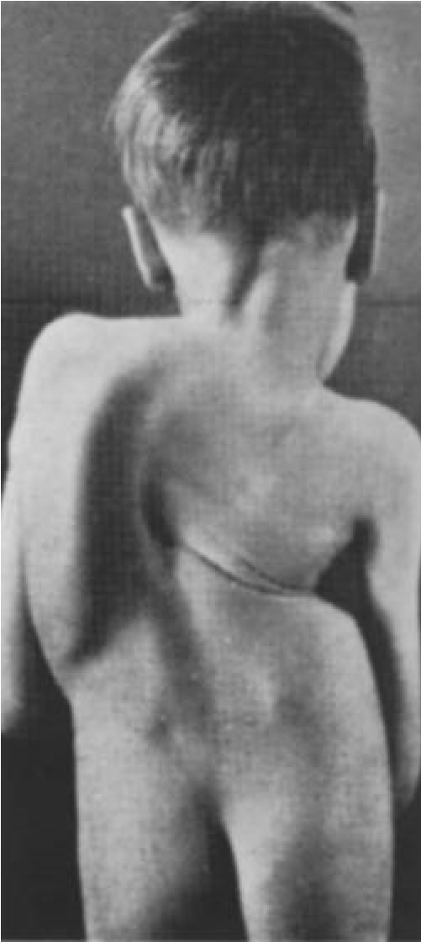 | Figure 4 Idiopathic scoliosis.

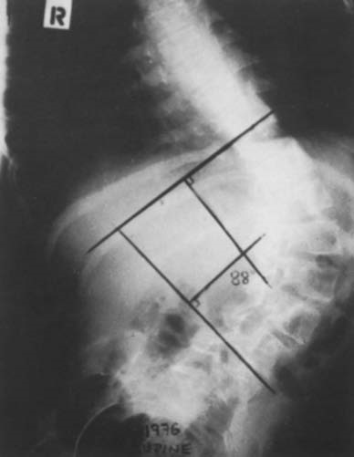 | 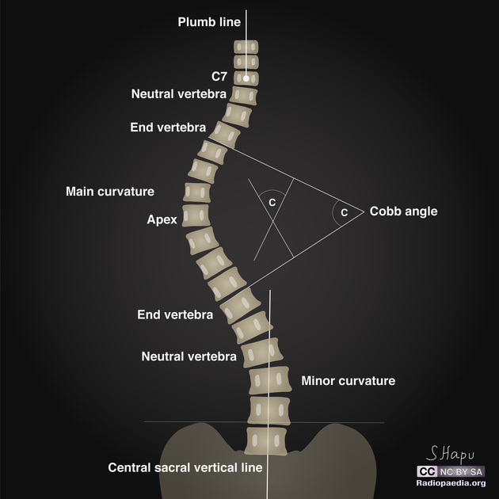
Figure 5 Method of measuring X -r ays in scoliosis.

Upper motor neurone signs, known as long tract signs, suggest pathology within the central nervous system, i.e. brain or spinal cord. These include increased muscle tone (spasticity), brisk reflexes, extensor Babinski reflex and ankle clonus. Long tract signs should always be taken seriously.
- Circulatory disturbances may be relevant, particularly in a patient with leg pain on walking. This may be due to arterial disease, particularly if the patient is a smoker or diabetic, or may be due to lumbar spinal stenosis. Peripheral pulses must be checked.
- Lymphatic glands should be palpated, e.g. an acute torticollis may arise secondarily to inflamed neck glands and neoplastic conditions affecting the spine may cause enlargement of glands, e.g. lymphoma.
- A full general examination, particularly of the abdomen, breasts and urinary system, is always indicated, e.g. an aortic aneurysm may be a cause of chronic back pain.

Traumatic conditions

Stability
In terms of stability, the spine can be considered as an anterior and posterior complex. The anterior complex consists of the vertebral bodies and inter-vertebral discs, with the posterior longitudinal ligament being its posterior border. The posterior complex consists of pedicles, laminae, facet joints, spinous processes, paravertebral muscles, inter- and supra - spinous ligaments. An injury to one complex is usually stable whilst a two- complex injury is usually unstable and requires surgical treatment (Fig. 6). The anterior complex injury is almost always a vertebral body fracture and can be seen on plain radiographs as an anterior wedging of the vertebral body. CT scans are excellent at looking for bony injury and will define the extent of the bony injury, i.e. vertebral body (including any retropulsed fragment back towards the spinal cord or cauda equina) and determine any bony injury to the posterior complex. If the CT scan shows a two-complex injury, it is unstable and usually requires surgical stabilization. If the CT scan shows the bony posterior complex is intact, a significant posterior ligamentous injury needs to be excluded. On clinical examination there may be posterior tenderness, a step or gap between the spinous processes or bruising or swelling. If the clinical examination is normal, in the commonest case of a thoracolumbar fracture, the patient can be gradually sat up and a sitting lateral radiograph performed. If on comparison of the supine and sitting lateral radiographs there is an increase in the kyphosis (anterior wedging at the fracture), this suggests a posterior ligamentous injury and stabilization is required. If there is no increase in kyphosis, the posterior ligamentous complex is intact and the patient can be mobilized and treated conservatively. There is no evidence that brace treatment improves the final result.
Stabilization of the spine is most commonly achieved posteriorly by placing pedicle screws in the vertebra above and below the level of injury and connecting them with a rod on each side to bridge the unstable level (Fig. 7).
Neurology
A vertebral column injury may or may not result in neurological deficit. Neurological deficit implies the injury is unstable and is likely to require stabilization. Deteriorating neurological function following an injury is an absolute indication for stabilization and possibly decompression. The neurological deficit may be a spinal cord injury (UMN) or may be a cauda equina or nerve root injury.
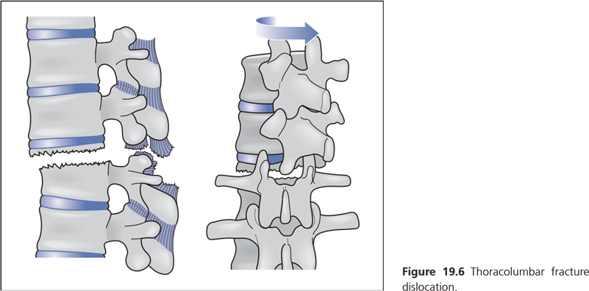 | 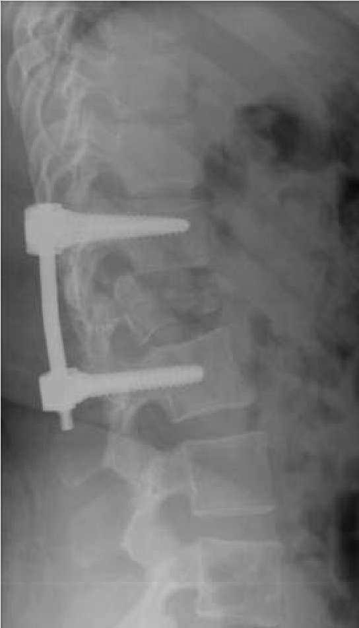
Figure 6 Thoracolumbar fracture dislocation. | Figure 7 Spinal fixation for fracture.

Spinal cord injury
Fracture is the usual cause with the spinal cord injury occurring at the time of the fracture. The spinal cord injury may be complete or incomplete, although for the first 24–48 hours the spinal cord goes into ‘spinal shock’ and an apparently complete injury may occasionally be incomplete. Complete motor loss associated with a positive bulbo-spongiosus reflex is a bad prognostic sign.
Initial management involves:
1 Avoiding further spinal cord injury by in-line spinal immobilization, logrolling and rigid cervical collar. The spinal board should be removed on arrival in hospital as this rapidly causes pressure sores.
2 Maintaining blood pressure (systolic 90–100 mmHg) and oxygenation to optimize the oxygenated blood reaching the injured cord.
3 Urinary catheter (patient will be in urinary retention).
4 Nasogastric tube (for paralytic ileus).
5 Pressure area care.
Patients with complete spinal cord injuries make no recovery and the level of their injury determines function. Thoracic spine injuries result in paraplegia (loss of function and sensation in the lower limbs, including bladder and bowel control). Cervical spine injuries result in paralysis with a varying degree of upper limb involvement depending on the level (quadriplegia). Complete spinal cord injuries above C4 seldom survive as diaphragmatic function is lost and there is no voluntary respiratory function.
Patients with incomplete spinal cord injuries always make some recovery. It is rarely a complete recovery but they will usually walk. At the initial neurological examination, patients with incomplete spinal cord injury may just have a flicker of movement in the big toe or perianal sensation, so a careful and complete neurological examination is essential.
Cervical spine
These injuries must always be considered as the consequences of a missed injury may be a permanent spinal cord injury. They should always be suspected in unconscious patients, patients with significant trauma (high - speed road traffic accident, falls from a height) and particularly in patients reporting even very mild neurological symptoms following an accident. For example, a patient with tingling in the distribution of an upper limb nerve root may have a cervical unifacet fracture or dislocation (Fig. 8). The thoracic and lumbar spine should be assessed clinically and a complete neurological examination of upper and lower limbs performed.
A lateral radiograph of the cervical spine is the first investigation and the C7/T1 junction must be visible for the radiograph to be considered adequate (Fig. 9). This radiograph should be inspected for:
- Adequacy
- Bony alignment
- Vertebral body fractures
- Facet joint fractures/dislocations
- Spinous process fractures
- Increased soft - tissue shadow anteriorly suggestive of injury
An AP and open mouth view should also be obtained.
The indications for a CT scan of the cervical spine are:
- Fracture visible or suspected on radiographs
- Neurological deficit
- Head injury requiring CT scan.

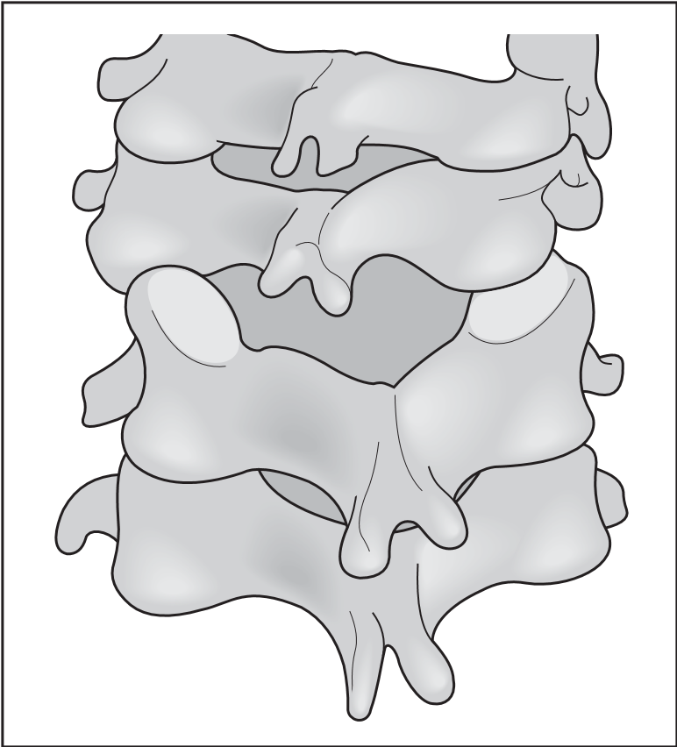 | 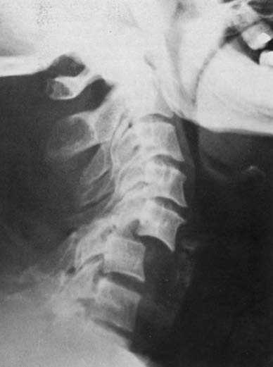
Figure 8 Cervical subluxation. | Figure 9 Cervical subluxation— lateral X- ray.

An MRI scan should be performed if there is any neurological deficit and in cervical facet dislocations before reduction as a significant disc protrusion within the spinal canal may cause a neurological deficit on attempted reduction of the dislocation.
In the unconscious patient, it is generally accepted that the cervical spine can be cleared if a consultant radiologist finds no evidence of bony injury on a cervical spine CT scan. The hard collar can be removed, making nursing much easier and reducing the risk of an occipital pressure sore. When the patient becomes alert enough for a clinical examination of the neck, this should be performed. A normal CT scan does not exclude an unstable cervical spine due to disc disruption at the front and a ligamentous injury at the back, i.e. no bony injury, but fortunately these are extremely rare.
If a cervical spine fracture is diagnosed or if the patient is unconscious, the thoracic and lumbar spine should be imaged using either plain radiographs or CT scans with sagittal (lateral) reconstructions.
Treatment depends on the degree of instability with more stable injuries being treated with a rigid collar (Aspen or Philadelphia); slightly less stable injuries in a halo-vest (a halo is fixed to the skull using four diagonally placed screws and the halo is then connected by lateral posts to a lined non-removable polyethylene jacket); and unstable injuries being treated by anterior and/or posterior instrumented stabilization and fusion with the aim being to fuse as few motion segments as possible.
Fractures of the atlas (C 1, Jefferson fracture). The ring of the atlas is usually fractured in four places as a result of a vertical compression force. This is usually a stable injury and spinal cord damage is uncommon. They are difficult to detect on plain radiographs but diagnosis is confirmed on CT. Treatment in a collar is usually adequate.
Fractures of the odontoid peg (C 2)
These are common and easily missed. The fracture is usually at the base of the peg and displacement may be considerable, while still allowing survival. A lateral radiograph often shows the fracture with the degree of angulation and displacement. In young patients, treatment is either halo-vest immobilization for 8 – 12 weeks or stabilization with anterior screws across the fracture (only certain fracture patterns are suitable). Non-union is reported in 30–70% and is treated with a C1/2 posterior fusion. Elderly patients do not tolerate a halo - vest and are treated in a rigid collar. Non-union (pseudarthrosis) usually occurs in the elderly but is fairly stable and does not cause symptoms.
Hangman’s fracture (C 2/3 traumatic spondylolisthesis)
Pedicle fractures of C2 allow forward subluxation of C2 on C3. There are degrees of severity of this injury and traction is rarely needed. When required, however, it should only be applied by a spinal surgeon familiar with these injuries as severe distraction and spinal cord injury can occur in some types of this injury. The less severe forms of this injury can be treated with a rigid collar or halo-vest immobilization, whilst the more severe form requires anterior C2/3 discectomy and fusion (iliac crest bone graft + anterior plate).
Subaxial injuries ( C3 –C7)
Vertebral body fractures can be relatively stable, requiring only collar immobilization, or may be completely shattered with posterior complex injury requiring corpectomy (removal of the fractured bone) and reconstruction with iliac crest bone graft and an anterior plate with or without posterior stabilization. In more severe injuries, spinal cord injuries are common.
Facet joint dislocations may be unilateral or bilateral and may be associated with fracture of the facet joint. They are usually detected on the lateral radiograph by anterior subluxation of the superior vertebral body on the inferior vertebral body. A 25% subluxation suggests a unifacet problem, whilst a 50% subluxation suggests a bifacet dislocation (Fig. 9). Early reduction is advised, ideally after an MRI scan to exclude a large protrusion within the spinal canal. Reduction is best performed using skull traction and by gradually increasing the weight with the neck flexed. With each additional 10 lb, a clinical examination and lateral radiograph should be performed. Weights should be increased to a maximum of approximately 40% body weight. Once the reduction is achieved, the neck is extended and most of the weights removed. These injuries, even when reduced, are often unstable and require anterior (or posterior) stabilization.
Isolated spinous process injuries are stable and require only symptomatic treatment.
Whiplash injuries
These are usually considered to be soft-tissue injuries to the neck or low back from motor vehicle accidents, usually when the patient’s car is hit from behind. The symptoms are usually of pain in the neck, sometimes with radiation down the arm and occasionally with paraesthesiae or numbness in the arm or hand. The onset of symptoms is often delayed by a few hours or even days. The neck is usually stiff and there may be objective neurological signs. Radiographs are usually normal or show degenerative changes only and treatment is conservative with analgesia and early mobilization. The prognosis is variable; most patients recover completely, others continue to have troublesome symptoms over a long period and occasionally the disability proves to be permanent.
Ruptures of ligaments in the cervical department of the spinal column occur and the forced rotational movements of the head, impact in the face and falling on head. The local pain and restriction of movements appear at this. The diagnosis is specified after the thorough clinical-radiological examination. It is necessary to exclude the injury of the bone apparatus of the spinal column.
Treatment. The blockades with 0,25-0,5% Novocaine solution into the painful area are carried out at the ruptures of ligaments, there is the rest needed with the temporal immobilization by the Shants' collar for the period of 2-3 weeks. Then the curative exercises and physiotherapy are prescribed. The work capacity is recovered in 3-6 weeks.
Ruptures of the intervertebral disks. Ruptures of the intervertebral disks occur at people of young and middle age, more often and men. The mechanism of trauma is indirect more often. Rupture of the disk occurs as the result of its compression at falling on the head with the turn or at the impact in the head. Instead of the vertebra body compression injury the disk is crushed.
Clinical symptoms. There is the sharp pain appearing in the injured segment of the neck, and connected with the rupture of the fibrous ring and prolapse of the nucleus pulposus. The patients are having the forced position (of the head and neck), by the reason of sharp restriction of movements. The radiography and the spinal puncture are carried out for the specification of the diagnosis, which allow defining the necessity of the subarachnoid space and the composition of the cerebrospinal fluid. Y. L. Tsivyan recommends carrying out the pneumomyelography in addition for the specification of the interrelation of the prolapsed disk and elements of the spinal cord. The computer tomography (CT) and also the nuclear magnetic resonance imaging (NMRI) are the very informative kind of research.
The treatment is carried out depending on the character of the disk injury. The immobilization and relief are prescribed. The bed rest and the Shants' collar or the short relieving body cast with the head holder for the period of 3-6 weeks are prescribed. The traction of the cervical department of the spinal column with the help of the Glisson's loop on the inclined plane with the load of 2-3 kg is applied with success. The polyvitamins (thiamine bromide, cyanocobalamin, calcium pangamate and ascorbic acid) are prescribed to the patients for the better regeneration of the injured tissues of the disk. The electrophoresis with Novocaine, massage and thermal procedures are prescribed after the abatement of the sharp pain. In some cases the intradisk blockades with the introduction of 1 ml of 0.5% Novocaine solution and 1 ml (25 mg) of hydrocortisone are prescribed for the abatement of the sharp pain. Preliminary the anterolateral surface of the neck at the side of the injury is processed with the 5% alcoholic iodine solution. The projection of the injured intervertebral disk injury is drifted on the skin. With the left hand forefinger the doctor presses back the sternocleidomastoid muscle and the vascular fascicle outwards, on the appropriate level, and at the same time penetrates inside and forward. Then by the finger he sticks the injection needle 10-12 cm long in the direction from the outwards to the inside and from the front back to the stop into the intervertebral disk or vertebrae body. The position of the needle is controlled by the radiogram. The anesthetic mixture is introduced into the injured disk by the syringe. If the conservative methods appear ineffective then the operative treatment is applied. It is meant for the elimination of the prolapsed nucleus pulposus which compresses the root or the substance of thew spinal cord.
SUBLUXATIONS AND DISLOCATIONS OF THE CERVICAL VERTEBRAE
There is the disorder of interrelation in the intervertebral joint at the subluxations and dislocations. The superincumbent vertebra is considered to be dislocated. The mechanism of trauma is very diverse. The dislocation of the vertebra can occur as the result of the sharp rotation and also sharp bending or unbending of the neck. At the first two mechanisms of trauma the displacement occurs forwards, and at the unbending - backwards. Displacement of the vertebra body backwards is exceptionally seldom observed. Subluxations and dislocations of the vertebrate can be unilateral and bilateral.
Unilateral dislocations are occurring most often between the IV and V, V and VI vertebrae. Dislocations of the cervical vertebrae are divided into simple and complicated by the trauma of the spinal cord. The unilateral dislocation forms at the sharp rotation as the result of the capsule and ligaments of the intervertebral joint rupture. The lower articular process of the superincumbent vertebra turns around its longitudinal axis and displaces upwards and forwards. Its apex is held up at the edge of the articular surface of the upper process of the subjacent vertebra.
Clinical symptoms. Pain at the side of the subluxation. The muscles of the neck are tensed. The head is bent and is rotated to the opposite, healthy side. The diagnosis is specified by the radiography.
Treatment. The single-stage and gradual reposition is applied. At the gradual reposition the patient is laid on the bed with the board. Preliminary 1 ml of 1% pantopon (omnopone) solution is introduced subcutaneously. The head of the patient is hanging over the edge of the board which is covered with the mattress. There occurs the self-reposition of the subluxation under the influence of the hanging head weight during the period of 2-5 hours. After the control radiography the neck is fixed with the Shants' collar in the position of the hyperextension for the period of 3-4 weeks. It is also possible to achieve the gradual reposition of the constant traction with the help of the Glisson's loop with the load of 2-3 kg during the period of several days. If it is not possible to reset the subluxation by the constant traction then the single-stage reposition is applied. 30-40 minutes before the reposition 1 ml of 1% omnopone solution is introduced to the patient. Then he is laid on the back with the head hanging over the edge of the table. The repositioning person puts on him the Glisson's loop and tied to it cord he puts over his belt. Two other assistants are fixing the superarm of the patient. The repositioning person puts one his palm on the occiput of the patient and the other palm he puts under the chin of the patient. The traction is carried out with the help of the Glisson's loop during the period of 10-15 minutes, then, not reducing the traction, the head of the patient is slowly deviated to the opposite side and the chin is rotated to the medial line. At this moment the lower articular process of the dislocated vertebra becomes released and is set back to its place with the clicking sound. After the control radiography the short body cast with the collar or the Shants' collar is imposed for the period of 3-4 weeks.
Bilateral subluxations appear at the sharp hyperextension of the neck. Sharp pain appears in the cervical department of the spinal column, the movements of the head are almost impossible. The neck muscles are tensed and the head is displaced forwards. The diagnosis is specified by the radiography. The subluxations can be accompanied by the compression of the spinal cord roots.
Treatment. Gradual and single-stage reposition is carried out by means of the traction by the head with the consequent alternate reposition in the left and right joints. After the control radiography - immobilization by the thoracocranial body cast.
Complete unilateral dislocations of the cervical vertebra also occur at the sharp rotation of the head. At this moment the lower articular process of the superincumbent vertebra after the rupture of the bursa displaces forwards in relation to the upper articular process of the subjacent vertebra.
Clinical symptoms. A sharp pain and the abrupt dysfunction appear in the area of the neck. The neck muscles are tensed. The head is bent to the side of the dislocation.
The chin is displaced to the opposite, healthy side. The spinous process of the dislocated vertebra is displaced outwards.
The diagnosis is specified after the additional neurological and radiological research The gradual or single-stage reposition by Riche-Gutter is applied.
Complete bilateral dislocations of the cervical vertebra occur at falling on the bent head.
Clinical symptoms. The movements of the head become impossible, the head appears to be displaced forwards and bent downwards. The neck muscles are tensed. The spinous process of the dislocated vertebra is going forwards and the subjacent one becomes prominent. The diagnosis is confirmed radiologically.
Treatment. The single-stage reposition is applied and at the chronic dislocations - skeletal traction by the parietal tubers. In 3-4 weeks after the dislocation reposition by the skeletal traction the body cast is imposed for the period of 2-3 months. Operative reposition is applied in the cases, when it was impossible to eliminate the reposition by the conservative method.
FRACTURES OF THE CERVICAL VERTEBRAE BODIES
Fractures of the cervical vertebrae bodies most often occur under the influence of the sharp bending of the neck at the moment of falling on the head from the height, and also at diving into the water at the shallow places, much less often at its sharp unbending,
Clinical symptoms. The pain appears in the injured part of the neck, the movements are disordered, the muscles are tensed. After additional neurological and radiological research the diagnosis is determined. At the reading of the radiograms it is of vertebrae bodies V, VI and VII are observed. The neurological status is rather thoroughly checked; i.e. fractures in the cervical department, especially fracture-dislocations, are often accompanied by the injury of the spinal cord or its roots.
Treatment. At the simple fractures of the cervical vertebrae the patient is laid on the bed with the board covered with mattress. If at the patient has the bending fracture with formation of the angle opened forward, then it is necessary put the pillow under shoulders of the patient, and his head should hang downwards. The head end of the bed is raised for 50 cm from the floor, thus position of the patient creates conditions for the reclination of the compressively changed vertebra body. At the unbending fracture of the cervical vertebrae with the formation of the angle opened backwards, the pillow is put under the head of the patient, and Glisson's loop fastens to the upper back of the bed.
In 15-30 days, after the reposition of the broken vertebrae, the traction can be replaced by the body cast with the collar for the period of 8-10 weeks. The patient carries out the gymnastics while in the body cast. The working capacity is restored in 5-6 months. At severe fractures and fracture-dislocations the single-stage reposition or skeletal traction by the cranium is applied. The operative treatment is prescribed depending on the indications.
INJURIES OF THE THORACIC AND LUMBAR VERTEBRAE
Injury of the thoracic and lumbar departments make 75,4% of all traumas of the spinal column. At this fractures of the thoracic vertebrae are discovered at 33,7% in relation to all fractures of the spinal column, and fractures of the lumbar vertebrae make 41,7%. Among various kinds of injuries the isolated fractures of the vertebrae bodies are prevailing in 61,6%. They are mainly localized in the area of the XI, XIII thoracic, and I, II lumbar vertebrae in the most movable part of the spinal column. The vertebrae bodies located in the less movable part of the spinal column are injured less often. The curves. and also the joint spinous processes are injured significantly seldom. As for the fractures of the transverse processes, they are avulsing mainly in the lumbar department. The classification of Y. L. Tsivyan (1971) reflects the clinical forms of the injuries of the lumbar and thoracic departments of the spinal column more completely. According to this classification the injuries of the spinal column are divided into two big groups: 1 - stable and II - unstable. The following are referred to the stable injuries of the posterior department of the spinal column: ruptures of the ligaments, fractures of the spinous transverse processes, and also curves with the displacement as well as without any displacement. The following are referred to the stable injuries of the anterior department of the spinal column: compression, clinoid fractures of the vertebra body with the different degree of its height reduction; longitudinal and splintered fractures of the vertebrae bodies; ruptures of the disk fibrous ring with the prolapsus of the nucleus pulposus. The following are referred to the unstable injuries: a) dislocations and subluxations; b) fracture dislocations.
Moreover, fractures of the spinal column can be without the impairment of the spinal cord integrity and with it.
Fractures of the thoracic and lumbar vertebrae bodies is the most often kind of injury as the result of the bending mechanism action.
Clinical symptoms. At the examinations of the back the small kyphosis is defined on the place of the trauma with the prominent spinous process, and there is the falling back under it. The gap between the prominent and subjacent spinous processes is widened. Palpation of the mentioned spinous processes increases the morbidity. The rectus muscles of the back are tensioned and any attempt to make a move in the spinal column and load along its axis also amplifies the pain. The diagnosis is specified after the neurological and radiological methods of research.
Treatment. At the simple fractures of the vertebrae bodies with the small degree of compression the functional method of V. V. Gorinevskaya, Y. F. Dreving and Z. V. Basilevskaya is applied. The patient is laid on the flat bed with the mattress and the traction by means of Glisson's loop is carried out. The head end of the bed is lifted for 40-50 cm from the floor. The body weight is the countertraction. The cushion 25 long 10 cm wide and 7 cm high filled with the flax-seed or millet is put under the broken vertebra. The bed rest lasts for 8 weeks. The curative gymnastics is prescribed from the first days according to the periods for the formation of the muscular jacket. The intensity of the exercises is increased after the improvement of the patient's condition. The unbending exercises and massage are started after 10-15 days. The patient is allowed to walk in 8 weeks. The work capacity is recovered in 4-5 months. It is recommended to apply the stage reclination according to the method of A. V. Kaplan on account of putting the increasing on height and width cushions under the back and with the following imposition of the body cast for the reposition with the significant anterior compression of the vertebra body (fig. 5). The single-stage expanding of the broken vertebra body is also applied. This technique was suggested by Buhler and Davis and was elaborated by R. Watson-Jones, B. A. Petrov, and I. Y. Kazakevich. It is based on the maximum extension of the spinal column. At this moment occurs the sprain of the anterior longitudinal ligament which is tightly united with the vertebrae bodies and thus eliminating the vertebra deformation. The reposition should be carried out under the local anesthesia. The spinous process of the broken vertebra in the position of the patient on one of his sides can be defined. The needle is stuck paravertebrally deviating 6 cm from the line of the spinous processes. At the fracture of the thoracic vertebrae the sticking place is located 2-3 cm higher than the level of the prominent spinous process due to the oblique position of the spinous processes. Considering the horizontal direction of the spinous processes the injection in the lumbar department is carried out at the level of the appropriate spinous process. After the anesthesia carried out the skin is punctured with the needle 10-12 cm long at the angle of 35° to the horizontal line. The needle is connected to the syringe containing 10ml of 1% Novocaine solution. As the needle moves 5ml of 1% Novocaine solution is introduced into the soft tissues. At the depth from 5 up to 8 cm the needle reaches the transverse process or rib (in the thoracic department). Turning around it along the upper edge the needle is introduced and at the depth of 10 cm it reaches the broken vertebra body. After the blood drop appeared from the needle, 5 ml of 1% Novocaine solution is introduced into the hematoma. The same technique is applied at the carrying out of anesthesia on the other side of the spinal column. Only 10ml of 1% Novocaine solution can be introduced to the place of the vertebra body fracture from two sides, otherwise it can penetrate into the subarachnoid space and can bring on the side effects. The single-stage forced unbending of the spinal column is carried out between two tables after the anesthesia. The body cast is imposed in such position. The following treatment - is functional, curative gymnastics, massage.
The indications to the operation are the fractures of the vertebrae bodies with the significant compression and also the comminuted fractures, which are combining with the injury of the intervertebral disks. The fixation of the posterior department of the spinal column is carried out after the reposition of the broken vertebra with the help of mechanical constructions or bone grafts. The operation by the technique of Y. L. Tsivyan is the most effective on the anterior department of the vertebrae bodies.
Treatment of the spinal column fractures, complicated by the injury of the spinal cord.
Injury of the spinal cord occurs more often at the fracture-dislocations, comminuted fractures with the disorder of the spinal canal wall integrity and also at the injury of the spinal column posterior department and at the spondylolisthesis. According to the data of Z. V. Basilevskaya the paralysis's are most often observed at the fractures in the cervical department of the spinal column (43,5%) then in the thoracic (33,4%) and lumbar (23,1%) departments. The motional and sensing disorders in the spinal cord depend on the condition, contusion, compression by the displaced bone fragments or hematoma and also on the partial or complete rupture. Fractures of the spinal column with the paralyses are always accompanied by the spinal shock. The character of the spinal cord injury is specified after the spinal shock symptoms disappearing only. It is important to eliminate the compression of the spinal cord fast. The level of its injury is determined at the neurological research by the bounds of the skin innervation disorder and also by the disorder of the tendinous and muscular reflexes. Patients with the fractures of the spinal column and paralysis's occurred in result of the spinal cord compression are — subject to the urgent operative treatment - decompression laminectomy. Other patients with the trauma of the spinal cord are treated conservatively. In view of sudden disorder of the tissues trophism the pressure sores are developing fast. It is necessary to arrange good bed care for the patient, to turn him often and to wipe him with the camphor alcohol the sacrum, heels, the scapulas areas, etc. For the reposition or prevention of the further displacement of the fragments and other complications the skeletal traction by the skull bones is applied. The disorder of urination, cystitis and ascending pyelonephritis are characteristic for the patients with the paralyses. For the constant bladder emptying and long-term washing-out by means of antiseptic solutions the Monroe system is applied. The antiseptic solution enters the bladder by 6-10 drops per minute (ethacridine lactate 1:1000) or Furacillin (1 : 5000) through the catheter connected with the reservoir. After filling the bladder the reservoir tube is pinched and the tube connected through the T-tube with the bladder is let down to the level of the bladder thus emptying it. The washing out of the bladder is carried out 5-6 times per day. This method contributes to the onset of the urination automatism. If there is the ascending infection developed in the urinary tracts then the suprapubic cystotomy is prescribed. It is necessary to keep an eye on the emptying of the bowels at patients with the injury of the spinal cord, applying the mechanical cleansing, to carry out the respiratory gymnastics. To prevent the contractures and recover the respiratory functions the early curative gymnastics and massage in the complex recovery treatment are prescribed. Further on the patients with the paralysis of the lower extremities are subject to the prosthetics and treatment in the sanatoriums for the spinal patients. FRACTURES OF THE TRANSVERSE PROCESSES
The transverse processes are more often injured at the result of strong muscle tension, applying to them. This trauma is mainly observed in the lumbar department of the spinal column. Fractures of the transverse processes can be unilateral and bilateral. There appears the sharp pain which localizes by the sides of the spinous processes. The pain amplifies at the active movement to the side of the injury and palpation of the injured area. The final diagnosis is specified after the radiography made in anteroposterior direction.
Treatment. The Novocaine blockades by A. V. Kaplan consisting of the separate introduction of 10 ml of 0,5-1% Novocaine solution into the area of each injured transverse process are effective. It is recommended to repeat the blockades at the persistent pain. After the elimination of sharp pain the massage and therapeutic exercises are prescribed. The work capacity is recovered in 4-6 weeks.
Osteoporotic wedge fractures
Minor trauma, even sneezing, may cause anterior thoracic wedge fractures in patients with known osteoporosis, or they may be a fi rst presentation of osteoporosis. Analgesia and possibly brace treatment (for comfort) along with treatment of the osteoporosis is sufficient for most fractures with the pain gradually settling. If the pain fails to settle after 3 – 6 months, vertebroplasty or kyphoplasty can be performed. This involves inserting a hollow probe down the pedicle of the collapsed vertebra, from posteriorly using image intensifi er (X- ray) guidance. Bone cement is then injected. Pain is usually significantly improved but risks include cement leakage around the spinal cord with paralysis and adjacent level vertebral fractures.
Sacrum and coccyx
Sacral fractures occur from direct impact or are associated with pelvic fractures. They may produce neurological problems, particularly affecting the bladder, and often cause long - term pain. ‘Sacral insufficiency’ fractures occur in patients with osteoporosis, with the pain usually settling to a tolerable level.
Coccydynia is a condition in which there is chronic pain in the coccygeal region, often following an injury or after childbirth, but sometimes for no obvious reason. The pain is much worse on sitting. It is difficult to cure, but may be helped by injections of local anaesthetic and steroids with manipulation of the coccyx via the rectum under general anaesthesia. Excision of the coccyx may be necessary, but is not always curative.
Recommended Books
- Traumatology and orthopedics : textbook for students of higher medical educational institutions / edited by Golka G. G., Burianov O. A., Klimovitskiy V. G. – Vinnytsia : Nova Knyha, 2018, – 400 p.
- Sethi, M. K., Obremskey, W. T., & Jahangir, A. A. (Eds.). Orthopedic traumatology: an evidence-based approach. Springer. 2018. 438 p.
- Venger, V.F. Traumatology and orthopedics / V.F. Venger, V.V. Serdyuk, Rashed Mochammad. – Odessa. Druk, 2006.- 248p.
- Duckworth, T. Lecture notes. Orthopaedics and fractures 4th ed./ T. Duckworth, C.M. Blundell.// John Wiley & Sons. 2010. 245р.
- David, Ip. Orthopedic Traumatology – A Resident’s Guide / David Ip. – 2nd ed.

