УЖГОРОДСЬКИЙ НАЦІОНАЛЬНИЙ УНІВЕРСИТЕТ
Кафедра іноземних мов

Методична розробка

Англійська мова для студентів 1 курсу
немовних факультетів

ENGLISH FOR GENERAL PURPOSES
PartI

.
Доцент Шпеник С.З.
Ст.викладач Минда О.І.

Ужгород - 2021

УДК 378.091:811.111(07)

Методична розробка до курсу (частина І): Англійська мова для студентів 1 курсу. (Englishforgeneralpurposes) / укладачі:Шпеник С.З., Минда О.І. – Ужгород: «Шарк». 2021. – 48 с.

Рецензенти:
- доктор педагогічних наук, професор Козубовська І.В.
- кандидат педагогічних наук, доцент, доцент кафедри англійської філології та методики викладання іноземних мов Мукачівського державного університету Гарапко В.І.

Мета методичної розробки – забезпечити практичне оволодіння студентами лексичними та мовленнєвими моделями, необхідними для вільного спілкування англійською мовою на повсякденну тематику. Матеріали методичної розробки сприятимуть оволодінню навичками та вмінням читання, мовлення (діалогічного і монологічного) та письма на повсякденну тематику. Методична розробка призначена для студентів першого курсу немовних факультетів.

Рекомендовано до друку
Вченою радою Факультету іноземної філології ДВНЗ «УжНУ»
від 15 вересня 2020 р., протокол № 6

ПЕРЕДМОВА

Дана методична розробка складається з двох частин і містить добірку текстів з предмету «Englishforgeneralpurposes» і призначена для студентів перших курсів немовних факультетів. Розробка укладена відповідно до навчальної програми з іноземних мов для немовних факультетів.
Метою даного видання є поглибити знання студентів, отримані у середній школі. Цій меті підпорядковано структуру посібника та завдання кожного умовного розділу.
Перша частина містить 5 розмовних тем: 1. I am a Student at Uzhhorod National University.2. English in my Life.3. The Modern Society. 4. Leisure Time Activities. My Hobbies.5. Daily routine. Jobs. Studying.Кожна тема включає базовий текст (призначений для закріплення активної лексики певної теми) з активним тематичним словником; умовно-комунікативні та комунікативні тренувальні вправи для засвоєння лексики активного словника.

Topic 1. I am a Student at UzhhorodNationalUniversity
WARM-UP
I.a) Complete the table with information about yourself.
Full name:
Born:
Zodiac sign
Early life:
Later life:
Character:
Likes:
Plans:
Favourite activity:
Favourite food:
b) Go around the room and collect as much information and about as many of your groupmates as you can.
c) Standing in a circle share your knowledge about each of your groupmates you think to be interesting.
II. Check the chart and try to match the words with their definitions.
1. to graduate  2. to enter university  3. assessment record book  4. synopsis of lecture  5. Academic department  6. dormitory  7. campus  8. placement  9. internship  10. Dean | a) a brief summary of a lesson  b) the land on which a college or university and related institutional buildings are situated  c) the head of a university faculty/department or of a medical school  d) a temporary job that someone does in an organizationto get work experience  e) become a student at university  f) a period of time during which a student works for a company in order to get experience of a particular type of work  g) successfully complete an academic degree, course of training  h) a university or college hall of residence  i) a booklet containing all grades obtained by the student  j) a division of the university

Active vocabulary
to leave school – закінчити школу  to graduate from college/ university – закінчити інститут / університет  to take an interest in – цікавитися  to make up one's mind – вирішитищось  to be going to do smth. – збиратисящосьробити  to devote oneself to – присвятити себе ч/н  admissionsoffice – приймальна комісія apply – подавати заяву (про прийом на роботу, до закладу освіти т. ін.)  applicant – абітурієнт  interview – співбесіда з абітурієнтом при поступленні до вузу  to enter college (university) – вступити в університет | to take up / to do journalism/ math/ physics – вивчати журналістику/ математику/ фізику  in order to become good specialists – длятого, щобстатихорошимспеціалістом  Natural Sciences – природничі науки (biology, physics, chemistry, etc.)  Social Sciences – суспільні науки (communication studies, anthropology, criminology, economics, geography, history, political science, psychology)  Humanities – гуманітарні науки  LiberalArts – гуманітарні науки, Am. загальноосвітні предмети  to expel (exclude) from the university – відрахувати з університету
student membership card – студентськийквиток  student assessment record book – заліковакнижка  librarycard – читацький квиток  Transcript – документ, якийвидаєтьсявузом, депредставленіпрослуханіпредмети, отриманіоцінки, кількістьгодин  abridged transcripts (from credit / examination records) – витяг із заліково-екзаменаційних відомостей | course – курс, предмет, дисципліна  totakeac.in ... – вивчати (предмет)  c. ofstudy – курс навчання  compulsorycourses – обов’язкові предмети  electivecourses (electives) – обов’язкові курси за вибором  optionalc. – курси за вибором  synopsis of lectures (notes) – конспектлекцій  curriculum – навчальний план  syllabus – робоча програма
classes – заняття  to attend /to go to сl. – відвідувати з.  be present at cl. – бути присутнім на з.  be absent from cl. – бути відсутнім із з.  toskip/cut / misscl. – пропускати з. без поважної причини ("втікати з з.") | to play truant/ to stay away from cl. without permission – пропускати з. (без дозволу)  to disrupt cl. – зриватиз.  practical cl. – практичні з.
seminar– семінар,групове заняття з якого-небудь предмета або теми  lecture – лекція  NOTE: at the seminar/ lecture/ examination/ English class  tutorial – індивідуальне з.  workshop – колоквіум | coremodule/discipline – основна / базова тема / дисципліна  placement – місце проходження практики  internship – практика (стажування) по спеціальності в процесі навчання або після нього для здобуття практичного досвіду роботи по спеціальності
be in – навчатися  - thefirst year – на першому курсі  - the Faculty – на факультеті  - the department of – спеціалізуватися на кафедрі  be a first-year student – навчатися на першому курсі  fresherbr., freshman аm. – “свіжачок”, першокурсник  sophomoream. – с-т другого курсу вузу; назва другого курсу  junioram. – с-т передостаннього курсу у вузі; назва першого курсу | senioram. – с-т останнього курсу вузу; назва останнього курсу  undergraduate student br. – с-тбакалаврату  graduates.br. – с-т, який вступає в аспірантуру  visitings. – с-т, який проводить семестр або більше в іншому закладі (включене навчання)  transfers. – с-т, який переводиться з одного навчального закладу в інший  monitor – староста
to do well at university / to keep up with one’s studies– добревчитися  not to fall behind/ to keep up with the group – встигатизагрупою  to cope with – справлятисяз  to do one’s best – робити все можливе  study by fits and starts – вчитися нерегулярноto read up for – готуватисядо  to cram– зубрити  to fall / lag behind with one’s studies – відставатиу навчанні  to burn the midnight oil – засиджуватисядопізна  by which I am greatly attracted – (тут) який мене дуже зацікавив | exam – екзамен, іспит  to do well on the e. – добрескластиі.  to do poorly on the e. – поганоскластиі.  exemptfromFinale. – звільнений від випускних і.  comprehensive e. / final exams (finals) – і. вкінцікурсупрограми  midtermexams (midterms) – і. в середині курсу програми  to sit/take an e. – складатиі.  to pass the e. – скластиі.  to fail the e. – “провалити і.”  to cheat in the e. – списувати на і.  resit(ane.) – перескладати і.  crib – шпаргалка
fellowship – форма стипендії для аспірантів  tuition – Br.навчання  Am. вартість навчання (без інших витрат), плата за навчання | need-basedscholarship – стипендія, яка надається студентам, які не можуть оплатити своє навчання (при цьому враховуються академічні показники)

degree – академічий ступінь, який присвоюють після успішного завершення програми навчання; ступені, які отримуються  Bachelor (Bachelor’s Degree) – ступіньбакалавра  Bachelor of Science – Бакалаврнаук  - B. of Arts – гуманітарнихдисциплін  - B. of Laws (LLB) – юридичнихнаук  Master (Master's Degree) – ступіньмагістра  M. of Arts (MA) – гуманітарнихнаук  M. of Education Degree (MEd) – вобластіпедагогіки  M. of Science (MS) – наук  Diploma with Honors –дипломзвідзнакою  Magna cum laude (lat.) – звідзнакою (удипломі)  term /year/final paper – курсоваробота  graduation – закінченнянавчальногозакладу  graduation paper/thesis – дипломнаробота  tomeetadeadline – виконати роботу/завдання вчасно (до вказаного терміну) | grade – оцінка; рік навчання або клас academic grading – оцінювання знань в університеті  Failed (F) – несклав  Failure for Non-Attendance – неявкана іспит  Honors Mark / Excellent – оцінка "Відмінно"  Good – добре  Incomplete (INC) – залікова робота не складена  Passed (P) – склав  Passing Mark – оцінка «склав»  Repeat (R) – повторневивченнякурсу  Satisfactory (S) – задовільно  Unsatisfactory (U) – незадовільно  No Grade Audin (NG) – курспрослухано  FinalGrades – кінцеві оцінки  good (academic) standing – хороша успішність, тобто студент має хороші результати з усіх дисциплін  credit – кредит  CreditsAttempt – заявленікредити  CreditsEarned – отримані кредити
university staff – працівникиуніверситету  Prorector / Vice-rector – проректор  Rectorate / Academic Administration – ректорат  Dean – Декан  dean’s office – деканат  Head of Department – завідувачкафедри  FacultyAdviser – куратор | Academicadviser – науковий керівник; викладач-консультант  Tutor – академічний наставник, куратор якого закріплюють за студентом або групою студентів для консультування з питань, пов’язаних з матеріалом, що вивчається; репетитор  Assistant Professor – старшийвикладач  Associate Professor – доцент

accommodation – приміщення, розміщення  dormitory (dorm) / residence hall(am.)  hall of residence/ hall (br.) – гуртожиток  campus – кампус (університетський комплекс (університетська територія разом з будівлями корпусів, іноді зі студмістечком) | liveoncampus – жити в студентському містечку  live in college – жити у гуртожитку  flatsharing – кімната, яка здається у квартирі окремо, в інших кімнатахпроживають інші– flatmates  studioapartment – однокімнатна квартира з маленькою кухнею
READING
II. Read the sample for your personal story about the university studies.
AT UNIVERSITY
Let me introduce myself: I am ... . a student at UzhhorodNationalUniversity. Now I am a freshman, as they put it in America, and I am doing mathematics (history/ physics/ law/ philology/ journalism, etc.). I take a full course of mathematics, let alone some other things. I must say I take a special liking to the subjects in which I am going to major (to specialize),and that is mathematics which was my favourite subject at school.
It was shortly (long) before leaving school that I made up my mind to enter this faculty and take up mathematics seriously as my future specialty. Whether I will make a very good scientist (lawyer) or teacher remains to be seen, but I am sure that eventually I will become quite knowledgeable in the field of many subjects. It’s great to be a student. Many colleges and universities offer great opportunities for studying and for social life. My choice fell on the UzhhorodNationalUniversity (UzhNU).
The Uzhhorod National University is a classical university founded in 1945. It provides training programs in 9 specialties of Junior Specialist qualification, in 36 fields of Bachelor programmes as well as in 84 fields of Specialist and Master Programs. It’s interesting to know that there are ten languages that are taught at University: Ukrainian, English, German, French, Polish, Hungarian, Romanian, Slovak, Czech, and Spanish at some faculties.
Housing for the students is offered by six residence halls with 4 thousand places available. There are also kitchens, bathrooms with showers, and laundries. Gyms with fitness equipment allow the students to train arm wrestling and martial-arts training. The access is granted at any time and is free. On their own initiative the students can create various societies to enjoy music, drama, poetry and different kinds of dance.
I must say the first day at university was unforgettable. We gathered in front of the university building where the Rector congratulated us on the beginning of the session and wished us success in our academic life.
Later we met our Dean … who spoke about the subjects we were to study and various departments of the faculty. He/she also told us that in order to become good specialists we would have to work hard: attend all classes. As well as lectures, there are regular seminars at which one of a small group of students will have to read a paper he or she has written. The paper is then discussed by the tutor and the rest of the group. Twice or three times a week students have practical lessons. Beginning with the second year they have to present a year paper to their scientific advisors and go to their placements for two or four weeks for acquiring practical skills. At the end of each term, we will take several examinations and credit-tests.
For our identification as students we’ll receive student membership cards, for entering the university library we’ll get library membership cards, and the third document is a student assessment record book.
Being a student is fun, but it does have its down side. For most students it is the first time that they have left home and is therefore somewhat disconcerting. First-year students have to make a break not just from home, but very often from their friends. The realization that there is now no mechanism around to take dirty smelly clothes and magically transform them into clean ones is a horrible one. They learn a new way of living and studying.
I am a full-time student, so I will have to attend classes every day. My working day begins at 8:00. As a rule, we’ll have three or four classes a day. We will have lectures and seminars in different subjects and the most of them are compulsory. Since I want to pass my exams successfully I cannot miss any classes. It’s interesting to know that we’ll have a monitor in our group whose responsibilities are not very clear to us, but one thing is definite – he or she will be in charge of our group.
During the working day we will have several short breaks, so we will be able to have a snack in the cafeteria, or share the latest news with our friends.
And some words about my faculty.
The Faculty includes different departments, that of … .
Our world-renowned faculty do not only teach. They make discoveries and develop new innovations.
I am sure I'll enjoy my studies at university. I hope after studies I’ll become a good specialist in mathematics.
III. Answer the questions.
1. When did you decide to enter this faculty?
2. Did anyone help you to choose the university to enter or it was your own decision?
3. What are your first impressions as a “freshman”?
4. What are your expectations of studying at the university?
5. Who is the monitor of your group? What are his / her duties?
6. What for do you need student membership cards, student record books and library cards for?
7. Who was the first person you got acquainted with at university?
8. What departments are there at your faculty?
9. What do you want to become after graduation?
10. What are the advantages of living at home and at the residence hall?

IV. Fill in the gaps using the words and expressions from the text.
1. I … of mathematics, let alone some other things.
2. It was shortly (long) before leaving school that I … my mind to enter this faculty and … mathematics seriously as my future specialty.
3. Housing for the students is offered by six … with 4 thousand places available.
4. Our Dean told us that as well as lectures, there are … at which one of a small group of students will have to read a paper he or she has written.
5. Twice or three times a week students have … .
6. I am a … student, so I will have to attend classes every day.
7. We will have … and … in different subjects and the most of them are compulsory.
8. We’ll have a … in our group whose responsibilities are not very clear for us.
9. It provides … in 9 specialties of Junior Specialist qualification, in 36 fields of Bachelor programmes as well as in 84 fields of Specialist and Master Programs.
10. I hope after studies I’ll become a good … mathematics.

V. Find another way of expressing the parts in italics. Consult the text.

1. Now I am a first-yearstudent and I am doing mathematics.

2. I must say I like the subjects in which I am going to major (to specialize) very much.
3. I take a full course of mathematics besides some other things.
4. For most students it is the first time that they made a break from home.
5. After finishing school, I decided to become a university student.
6. If you ask me why I have taken up physics for a special study, my answer will be: I am very much interested in it.
7. English was the subject he liked bestat school.
8. I am sure my sister will eventuallybecome a good teacher.
9. Since I want to pass my exams successfully I cannot stay away from classes.
10. At the end of each semester we will have to sit credits and exams.
VI.Paraphrase the following sentences using your active vocabulary.
1. Josits late at night preparing for her classes.
2. Dan constantly misses classeswithout any serious reason.
3. Pete failed all his exams. It’s possible that the Dean’s office will not let him continue his studyingat the university.
4. Joshis fond of shouting, disputing and arguing. The lecturer always puts him bad marks for his indecent behavior.
5. Martindidn’t pass the exam yesterday.
6. Brenda was absentfrom the class. She was in the hospital.
7. The lecturer asked Steven to leave the examination test as he was looking up words in the dictionary and it was forbidden.
8. Maria will probably graduate with good marks. She is the best student in the group.
9. Betty is a freshman. She doesn’t know much about the university life yet.
10. Ann lags behind the group.
VII. Match the words with their meanings:
1) seminar  2) semester  3) quarter  4) academic year  5) class  6) lesson  7) lecture | a) one of the four main periods that the academic year is divided into at schools and universities  b) a period of time in which a teacher (lecturer, tutor) teaches a group of students  c) discourse giving information to a class, etc.  d) small class at a university, etc., for discussion and research  e) the period of the year when there are school or university classes  f) one of the two periods that the academic year is divided into  g) a period in which someone teaches one person or small number of people, used especially about particular skills such as music, swimming, or driving
VIII. Talk about your attitude towards the following things. Discuss which activities you consider to be difficult and which ones – easy. Continue the list. Compare your answers with those of other students in the class.
Model:I find talking about things that don’t interest me boring.
I find writing long tests annoying.
I find | attending lectures (seminars, classes)  taking notes  making reports  writing essays  doing homework  correcting mistakes  participating in group discussions  missing classes  disrupting classes  coming late to classes (lectures, exams)  cheating (at exams and tests)  taking examinations  failing examinations  retaking examinations  translating from Ukrainian into English and vice versa | boring  embarrassing  depressing  confusing  exciting  annoying  worrying  amusing  challenging
PROJECT
IX. Ben Mock, blogger at Lancaster University, UK, offers four helpful tips for students and prospective students to foster independence, responsibility, a social network and the confidence to succeed at university.
After reading these ideas interview some sophomores and seniors at your faculty and find out what advice they have for the freshers to survive at the uni.
FOUR THINGS YOU NEED TO DO TO SURVIVE UNIVERSITY
University is hard. You are essentially thrown into the deep end of life and expected to swim. From my personal experience, high school won’t prepare you for life at university, but maybe this blog will help. Today, I present to you four things you need to do in order to survive at university.
1. Get used to working independently
If you’ve got through the British education system, you have been had a helping hand at every turn. The same is probably true elsewhere – it is unlikely that you have had to complete independent research at the same level as you will have to do at university, wherever you went to school. At high school, you will have had regular classes, textbooks tailored to your course and all the help that your teacher can provide.
Things are very different at university – you will be expected to complete independent research and wider reading for your classes and assessments. While you can go to your lecturers, they will only be able to provide so much information. Their job is not to spoon-feed you information, but to help you understand what you uncover on your own.
There are a number of ways you can prepare for this shift in work mentality. If you are entering sixth form, look into whether your school or college offers an independent research qualification such as an EPQ (Extended Project Qualification) or STEM. Running your own project on a topic of your choice is a great way to become accustomed to doing research effectively, as well as helping you to pick up vital skills such as keeping to word limits and referencing. If your place of education does not offer something in this vein, just do it in your spare time. Choose something you are interested and compile a project on that topic. Hone your research skills; you won’t regret it.
2. Learn how to budget
Chances are that moving to university will be your first experience of living independently. One vital skill you need to learn before day one of university is how to budget. You do not have unlimited money and if you do not keep track of your cash, you will lose it all very quickly.
While it sounds daunting, budgeting is relatively simple. You need to work out how much money you will have and deduct. I recommend working on a monthly basis with a weekly breakdown of what you will need to spend, how much you will/can spend and how frequently you will spend that amount of money. I guarantee that you will have to make sacrifices, but if not having Netflix means you’re able to eat, it’s worth it.
On the topic of money, do not be afraid to ask for help. Parasitic companies such as payday loan companies will jump on the chance to ensnare you if you are afraid and unsure what to do, so it’s worth getting help before you get that desperate. Most of you will only be 18 or 19 years old when you leave home and so people, like your parents, will understand if you mess up financially. Don’t be afraid to admit your mistakes and go to someone who can help you without hurting you in the long run.
3. Network and socialise
As a psychologist, I can tell you that humanity is a very social species. We cannot survive without social interaction but, then again, anyone who has played The Sims can tell you that. University is where you are going to build bonds with people, potentially for life.
Don’t go to university and spend all your time work or commuting between home and the library, because you have then spent three years and £27,000 (figure may vary) for a library. Go out, make friends and experience new things. I assure you that you won’t regret it.
On a similar thread, I strongly encourage you to network. One of the best things you can do while at university is build up a network of contacts in industry and academia.
These are the people who will offer you jobs and opportunities; these are the people who will write you a glowing reference for that job you really want. Don’t try to force this, but make use of the natural opportunities that life at university is sure to offer you and you will come out of university with a strong web of contacts that you can use to shape your future.
4. Don’t be afraid to voice your opinion
I’ll admit I was terrible at doing this in my first year. However, if you never voice your opinion, nothing is going to change. You can shape your experience of university through what you say and do.
Don’t like how a module is taught? Use the opportunity your department will provide you to share your opinion in order to improve the module. Disagree with a decision made by a student body? Raise your concerns so that things will be treated differently in the future. You should be free to speak your mind without fear of repercussion or dismissal. If you don’t speak out, the conversation never starts.
While voicing your opinion is not essential to surviving university, it is a great way to be the change you want to see in the world. Change starts with you, and if you stand up and let yourself be heard, you can do great things with that opinion.
X. Use the sample of a letter and the active vocabulary.
You are studying at university and your friend recently asked your opinion about the institution. Write a letter explaining student life and giving your recommendations. Include the following:
- why did you apply for admission to this uni
- what do you like and dislike about it
- would you recommend this uni to your friend. Why?
Dear Mayra,
I trust you must be doing well. I'm delighted to know about your prospective to study in the same college as mine. I hope this information would serve you best.

Patel memorial college always make endeavours to excel at all courses that are offered for both domestic and international students. It is one of the prominent and autonomous college in the nearby area. Therefore, I decided to get my MBA degree from this highly reputed educational institution and I feel proud on making this decision.

It offers a wide range of courses in distinct fields like as medical, engineering, business, travel tourism and so forth. I really admire the fact that this uni has equal emphasis on theory and practical aspects. It's constant attempt towards excellence is commendable.

It would be a pleasure to have you in my college. I'm sure that you will accomplish your dreams someday being a part of this institution. It'll be a chance for you to explore yourself with international students in an excellent learning environment. Of course, you must stay with me in my hostel. But don't worry about it, I really hope you can make it.
Take care and write back soon.

Regards Angelina
XI. Think about your answers to these questions.
1. Are you a full-time or part-time student?
2. What subject(s) are you studying?
3. Why did you choose this/these subject(s)? Which topic/subject do you find the most difficult/interesting?
4. What are you planning to do when you finish studying?
5. Is there anything else you would like to study in the future?

Topic 2. English in my Life
Active vocabulary
asset – активи, перевага цінність  businessheadquarter –головнеуправління/штаб-квартира бізнесу  cross-border business communication – транскордонне ділове спілкування  due to – через, завдяки  facet – граніт, аспект  far-flung places – далекімісця  financial hubs – фінансовівузли/центри  generous estimates – щедрі підрахунки  entertainment –розваги  LinguaFranca –мова міжетнічного спілкування  marketplace –ринок  workforce –робоча сила  language– мова  defaultl. of – м. за замовчуванням  dominatingl. – домінуюча м.  hybridl. – гібридна м.  locall. – місцева м.  nationall. – національна м.  primaryl. – м., якою людина володіє та спілкується з народженняL1/L2  principal foreign l. – основна іноз. м.  secondl. – м., яку людина вивчає  taxing l. – вимоглива м. | have impact – мативплив  inevitable role – неминучароль  native speaker – носійрідноїмови  non-native speakers – неносіїмови  syllabus – робоча програма  primarysourceofcommunication – первинне джерело спілкування  share ideas and thoughts – ділитися ідеями та думками з...  to be comprised of – складатися з  to branch out – розгалужуватися  to coin new words – карбувати нові слова  to continue to evolve and absorb – продовжувати розвиватися і поглинати  to dub – дублювати  to grasp – схоплювати  to grips with – зіткнутисяз  to intend – мати намір  to make oneself understood – вести бесіду іноземною мовою  to separate from – відокремитивід  to span wars – охоплювативійни  to subtitlea movie/film – субтитруватифільм  wide range of – широкийасортимент
WARM UP
I. A. What is the difference between the following words? Give sentences using these words.
There – their – they’re | bring – take | its – it’s | fewer – less | lie – lay
There are several active students in this group.
Their goal is to learn as much as they can.
They’re learning much.
It is (it’s) very difficult.
Its task is to teach something.
B. Give your own examples of confusing words in English.
II. In pairs brainstorm as many advantages of learning languages (not just English) as you can in 5 minutes. Give feedback to the whole class.
III. Look at an infographic “The Advantages of Learning Languages”. Compare your own answers and select the 5 facts which you find most interesting or surprising and share them with your partner.
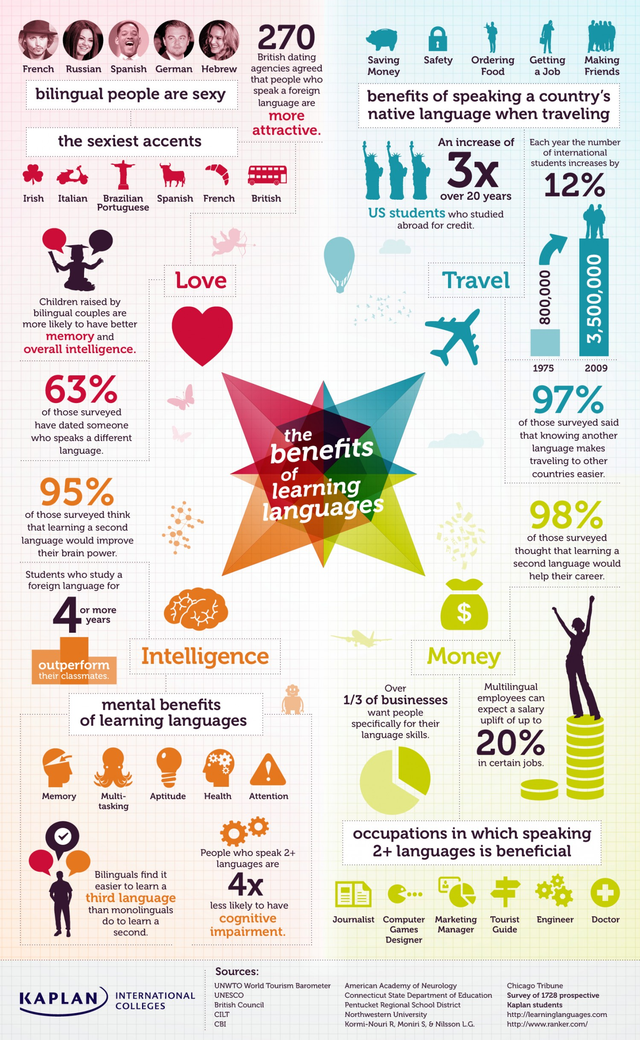

IV. Read the text.
THE IMPORTANCE OF THE ENGLISH LANGUAGE IN TODAY'S WORLD
Language
Language is our primary source of communication. It's the method through which we share our ideasandthoughts with others. Some people even say that language is what separates us from animals and makes us human.
There are thousands of languages in this world. Countries have their own national languages in addition to a variety of local languages spoken and understood by their people in different regions. Some languages are spoken by millions of people, others by only a few thousand.
Why Learn English?
English has been considered to be the first global Lingua Franca. It is one of the most dominating languages of the world having its impact on every field of work. Undoubtedly, English plays a much greater role in the world that it is inevitable for people to ignore it fully. Here are 10 reasons why English is such an important language.
1. It’s the most commonly spoken language in the world. Depending a bit on how you count, in addition to the approximately 400 million native speakers, English is understood and/or spoken by 1-1.6 billion people. With over a quarter of the world speaking the language, there’s always someone to practice with, especially when you travel.
2. It’s the language of international business. With world business headquarters predominantly in the financial hubs of the UK and USA, English has long been the default language of trade. Therefore, English is the dominant business language and it has become almost a necessity for people to speak English if they are to enter a global workforce. Research from all over the world show that cross-border business communication is most often conducted in English. Its importance in the global market place therefore cannot be understated, learning English can really change your life.
3. Most movies are in English. Hollywood is a powerhouse of global entertainment, so it’s natural that English would become the main language for movie-making. Sure, the movies are often dubbed over or subtitled – but they’re really best enjoyed in the language in which they were intended.
4. It’s easy to learn. This is debatable depending on who you speak to, but it’s generally accepted that English isn’t the most taxing language to get to grips with. The vocabulary is simple to grasp and it has developed throughout different languages regarding its evolution that can be read in the article about the history of English language. Therefore, many speakers of those languages can see where concepts in English originated from and fast adapt to understand the basics of English.
5. It helps you understand other languages. English has a long and fascinating history that spans wars, invasions and influences from around the globe. Cultures that have helped shape modern English include Romans, Vikings and the French. For this reason, it’s a hybrid languagecomprisedof Latin, Germanic and Romance elements.
6. You can say things in a hundred different ways. One of English’s best assets is its flexibility: you can often find many different ways to explain the same thing thanks to its wide range of vocabulary. It’s said to have well over 750,000 words (depending a bit on how you count – some generous estimates put that number at 1 million) and is adding new ones every year as mentioned in the article about the history of English language.
7. It can be used around the world. English is also hugely important as an international language and plays an important part even in countries where the UK has historically had little influence. It is learnt as the principal foreign language in most schools in Western Europe. It is also an essential part of the curriculum in far-flung places like Japan and South Korea, and is increasingly seen as desirable by millions of speakers in China. Therefore, if you have the basics of English language you can make yourself understood in nearly every corner of the world.
8. It’s really flexible. Non-native English speakers who learn it as a second language often comment on how many ways there are to say things. That’s because English doesn’t discriminate – you can use it however you like. Countries like Singapore have taken this concept to heart, inventing an entirely new type of English called ‘Singlish’ that has absorbed facets of other languages like Chinese and Malay.
9. It’s the language of the internet. Most of the content produced on the internet (50%) is in English. So, knowing English will allow you access to an incredible amount of information which may not be otherwise available.
10. It continues to change. Selfie, Hashtagging, Blogging, Smasual, etc. All these words are new to the English language but have already become valued members of the lexicon. More than any other language, English continues to evolveandabsorb new words that branch out – often untranslated – into other languages. Every year approximately more than 1.000 new and approved words are added to the Oxford Dictionary. This tremendous development is the result due to technology, Social Media and how people spontaneously coin new words during daily life. (Available at: http://www.lingualearnenglish.com/blog/featured/a-short-history-of-the-english-language/)
V. Answer the questions:
1. Why is English considered by the author to be important?
2. What adjectives are used to describe the English language?
3. What new words are mentioned in the text? Have you ever heard them?
4. In what countries can you make yourself understood? (according to the author)
5. Why is English easy to understand?
6. Why is English important for economics?
7. What is the role of Hollywood for the English language?
8. How many people understand and/or speak English?
9. Why is English considered to be easy for learning?
10. What is the best asset of the English language?
VI. a) Match the following words with their definition:
Singlish |  | a) means that something is exceptionally good or great; remarkable. |  |  |  | b) is a philosophy/ lifestyle on love and relationships in which one remains single |  |  |  |  | c) is a variety of English spoken in Singapore, incorporating elements of Chinese and Malay. |  |  |  |  | d) In the music industry, is a type of release, typically a song recording of fewer tracks than an LP record or an album.
Selfie | a) is a person concerned chiefly with one's own personal profit or pleasure. |  |  |  |  |  | b) concerned more with the needs and wishes of others than with one's own; unselfish. |  |  |  |  | c) is an individual person as the object of his or her own reflective consciousness. |  |  |  | d) is an image of oneself taken by oneself using a digital camera especially for posting on social networks
Smasual |  |  | a) clothes or shoes suitable for everyday wear rather than formal occasions |  |  |  |  |  | b) is a dress style – smart but casual. |  | c) is a British term to describe that something is good or went well |  |  |  |  | d) So extremely cute or adorable that you have an uncontrollable urge to smash it.
Hashtagging |  |  |  |  | a) is attaching a label to smb/smth |  |  | b) is using the symbol Σ that classifies or categorizes the accompanying text |  |  |  |  | c) means finding the top hashtags for Twitter and Instagram |  | d) is using the symbol # before and after a word or phrase that classifies or categorizes the accompanying text (such as a tweet)
Blogging |  |  |  | a) means maintaining or adding new entries to a blog |  |  |  |  |  | b) online tools for creating photo montages |  |  |  | c) is the largest social network for sports betting. |  |  | d) deleting or erasing a blog
b) Try to guess the meaningof the following words: It’s not easy. Look them up in the dictionary.
Awesomesauce | Beer / wine o’clock | Bitheads | Chairdrobe
Chillax | Frankenfood | Guyliner | Hiberdating
Hipster | Illiterati | Jeggings | La-laLand
Mankini | Photobomb | Raptivist | Screenager
Sexting | Sinceriously | Smasual | Trumpaganda
Twitterati | Unfriend | Voluntourism | Youthquake
c) Googleup 3-5 new words and make your groupmates guess their meaning.
VII. Fill in the gaps
1. Language is our … communication.
2. Countries have their own … languages in addition to a variety of … languages
3. English has been considered to be the first … .
4. English is the … language and it has become almost a necessity for people to speak English if they are to enter a … workforce.
5. … communication is most often conducted in English.
6. English could become the … for movie-making.
7. The English vocabulary is simple to grasp and it has developed throughout ….
8. Cultures that have helped shape modern English include …, …, … .
9. English is a … comprised of Latin, Germanic and Romance elements.
10. Thanks to … of the English language it is easy to find many different ways to explain the same thing.
11. English is learnt as the … in most schools in Western Europe.
12. English is the essential part of the curriculum in … like Japan and South Korea, and China.
VIII. Decide whether the following sentences are true or false:
1. English is hugely important as an international language and plays an important part even in countries where the UK has historically had little influence.
2. Countries like Singapore have invented an entirely new type of English called ‘Chiglish’.
3. Non-native English speakers who learn it as a second language often comment on how many ways there are to say things.
4. English is the only language that remains unchanged.
5. Tremendous development of Chinese is the result due to technology, Social Media and how people spontaneously coin new words during daily life.
6. Some people even say that sounds are what separate us from animals and make us human.
7. Countries have their own hybrid languages in addition to a variety of second languages spoken and understood by their people in different regions.
8. Some languages are spoken by millions of people, others by only a few thousand.
9. French is one of the most dominating languages of the world having its impact on every field of work.
10. English is understood and/or spoken by not so many people.
11. The movies are best enjoyed if they are dubbed over or subtitled.
12. Every year approximately more than 1.000 new and approved words are added to the Oxford Dictionary.
IX. GROUP WORK
a) What do you think about the position of English as a world language?
b) Read opinions of people from different parts of the world about the position of English as a world language.
c) Compare with your own answers and discuss them in small groups. Present the answers to the group.
(Taken from http://www.esl-lounge.com/talking-points-world-language.php )
1. English is the language of the modern world. All people around the world know about its importance in our life for work or while meeting people from other cultures. They might not be from Britain or America, but they could speak English. And we also need English for traveling to other countries. This doesn’t mean that our native language is not important. I believe all people love their mother tongue, but still, now the first language in the world is English.
Moulaye
2. Don't worry about the Chinese language replacing the English language. That will never happen for many reasons. The number one reason why Chinese will never become popular even in Asia is due to its difficulty. Also, so many Asian nations dislike Chinese. As a result, India, Vietnam, Japan, the Philippines, and South Korea do not have much interest in learning Chinese. Even in Thailand (where I used to teach) there is little to no interest in learning Chinese.
Phibbs, Boston
3. Well, I totally agree that English has become number one all over the world. I am convinced that it will still be the dominant language for two or maybe three decades to come. In a great number of countries, including my country Uzbekistan, much attention is paid to learning English. It goes without saying that when learning a foreign language, in our case it's English, we also take in a large amount of cultural information. But, anyway, people should also take up learning the Mandarin language, because today we see that the power of China in the world is rising.
Yulduz, Uzbekistan
4. Yep, I can say English is a global language and it's spoken by a wide range of people. If you know English, then you can travel all over the world and that's absolutely true from my point of view. Personally, I give the second preference for Spanish because it's the most commonly spoken language in Latin America and even I love to speak in Spanish as well as English.
Santhosh, India
5. I believe that English should not be the world language as it is the mixture of languages like Hindi, Arabic, French, Greek, etc. A world language should be one which is pure of itself not a mixture.
Paul Madhav
There is no denying the fact that the English language is the global language spoken by a great deal more people than the native speakers of the language. You – beinga native or non-native speaker – doesn't matter much anymore. This language is used for communication, not for flaunting your accent. As long as someone can speak passable English, it is fine. Native speakers mustn't look down on those who speak their language sometimes with mistakes.
VictorAmbrose
6. I think that the English language can be put at the first place in the world. I think that most people prefer to learn it as a second language. Many sciences are written in English. And so, there are thousands of cites which are written in English. It is my second language after Arabic. And I find it very interesting and I adore the English literature. I think that Shakespeare is an important reason to be spread all over the world.
Ahmed
7. I am a half British half French English teacher who lives in Paris. I love the English language and its literature and am fully conscious of its importance in the world. What really annoys me though is the way in which people assume you speak English, regardless of where you are or what language you are speaking at that instant. I mean for example all the tourists who walk up to you and ask in English where the Louvre or Notre Dame is. It is rude to assume that the other person speaks English without even bothering to ask them if they do. I tend to answer that I do not speak English ( which implies that I WON'T speak the language to someone who can't even be bothered to learn how to say hello in French)... Far more annoying is the way in which waiters and museum employees assume that if you are not French you are too thick to know the language: my boyfriend is Spanish and we speak Spanish when we are together. Every single time, the waiters will address us in English! It is extremely rude! In conclusion, I just wanted to say that it is true that English is an important language, that 1/7th of the world's population does speak it however it is important to remember that other languages do exist and even if it helps to speak English, it is not compulsory, and people should not assume it is the only language there is.
Claudine
8. The idea of English as a world language is very good. As for my country, Malaysia, the educational system is slightly changing. They start using English at teaching critical subjects, such as mathematics and science including physics, chemistry and biology. So, I think that the idea can be achieved, and nothing is impossible. We have to make an effort towards it. Together we can. By the way, now I am learning TESL and I am going to be a future teacher. I really want this idea to become a reality.
MuhdHanin
9. On the topic of English as a world language, I do not agree that by measure of convenience, imperialism, or otherwise that English should be relegated to status of "the" world's language. If such were to be so, then soon enough, there would be even more dialects of English than exist now. Language depicts one's culture, and in a perfect world, we’d make an effort to steep ourselves in as many as possible including effective strategies for hearing impaired and brain-injured individuals. They need their language too.
JenniferCerron
10. I think that English is nowadays the dominant language in the world and has been improving during all the 20th century. But I'm not sure that this language will continue to keep its rank, for few reasons:
- the economic development of China will become also cultural when this country will be the first economically (in a few decades maybe) in the world. Maybe also the same for India (half world population)
- The growth of Latin languages, especially in Latin America, Europe, Africa but in the USA itself. Maybe one day Spanish will be recognised as one of the 2 America's languages together with English
- the anti-American feelings in Arabic countries
- the development of new technologies of direct translations in the next decades
So, I think English is absolutely necessary now, but I think in the future it will be only one important language among some others
Fabb
X. Focus on the following questions:
1. What other languages are mentioned in the texts?
2. What are the reasons for English becoming the world language?
3. What reasons are given against English being the world language? What other languages can be the world language?
4. What do you think, is it necessary to save your mother tongue? Why?
XI. Write an essay about the importance of English in your life. (200-300 words)
Attachment: New words
Awesomesauce (adj) | Is used to call smth extremely good
Beer o’clock/ wine o’clock (n) | The appropriate time of the day for starting to drink the indicated beverage – note that it expresses a very flexible and customizable p(o)int in time.
Bitheads(n) | These are people investing in a new thing called the bit coin and going crazy about it: that is people who are investors obsessed with the current bitcoin craze
Chairdrobe (n) | Piling clothes on a chair instead of a closet or dresser
Chillax (v) | Calm down and relax.
Frankenfood (n) | Genetically modified food.
Guyliner (n) | Eyeliner that is worn by men.
Hiberdating (v) | A person completely ignoring his/her friends in favour of a boy/ girlfriend
Hipster(n) | a trendy, modern person who likes things that are not popular
Illiterati (n) | People not well educated or well informed about a particular subject or sphere of activity.
Jeggings (n) | Tight-fitting stretch trousers for women, styled to resemble a pair of denim jeans.
La-la Land (n) | A fanciful state or dream world. Also, Los Angeles.
Mankini (n) | A brief one-piece bathing garment for men, with a T-back.
Photobomb(v) | Everyone loves to take a selfie – but who is that random person pulling a funny face in the background? They just photobombed you!
Raptivist(n) | Rap activist, who uses their lyrics to draw attention to their cause
Screenager (n) | A person in their teens or twenties who has an aptitude for computers and the Internet.
Sexting (n) | The sending of sexually explicit photographs or messages via mobile phone.
Sinceriously(adv) | Saying something in a sincere and serious manner
Smasual(adj) | Dress style – smart but casual
Trumpaganda(n) | Propaganda or information relating to DonaldTrump or his administration is now known by a new word. This is called Trumpaganda.
Twitterati (n) | Keen or frequent users of the social networking site Twitter.
Unfriend (v) | Remove (someone) from a list of friends or contacts on a social networking site.
Voluntourism(n) | These are people who volunteer overseas for a charity, maybe to work on a project for elephants’ welfare or to help build a community school, but their actual motivation is to visit foreign places. The word is also used to mean tagging on a holiday at the end of a volunteer period abroad.
Youthquake (n.) | A significant cultural, political, or social change arising from the actions or influence of young people.  It’s typically used to describe the increased engagement and participation of young people in politics. It looks and sounds a lot like ‘earthquake’, which gives a sense of destruction, disruption and change.

Topic 3. The Modern Society
“Too many people spend money they haven’t earned, to buy things they don’t want, to impress people they don’t like.”
Will Rogers, American stage and film actor
“What I’m always trying to say to the consumer is:
buy less, choose well, make it last. “
Vivienne Westwood, (fashion designer)
WARM-UP:
I. Read the quotes and think what the authors are trying to say.
II. What comes to your mind when you hear the following words and expressions:
MODERN SOCIETY TRADITIONAL SOCIETY MATERIAL SOCIETY
CONSUMERISM STATUS SYMBOL CIVILIZEDSOCIETY
VALUES THROWAWAY CULTURE
III. Look at the pictures and tell what word/expression the photos are associated with.
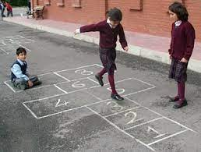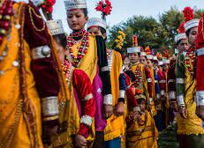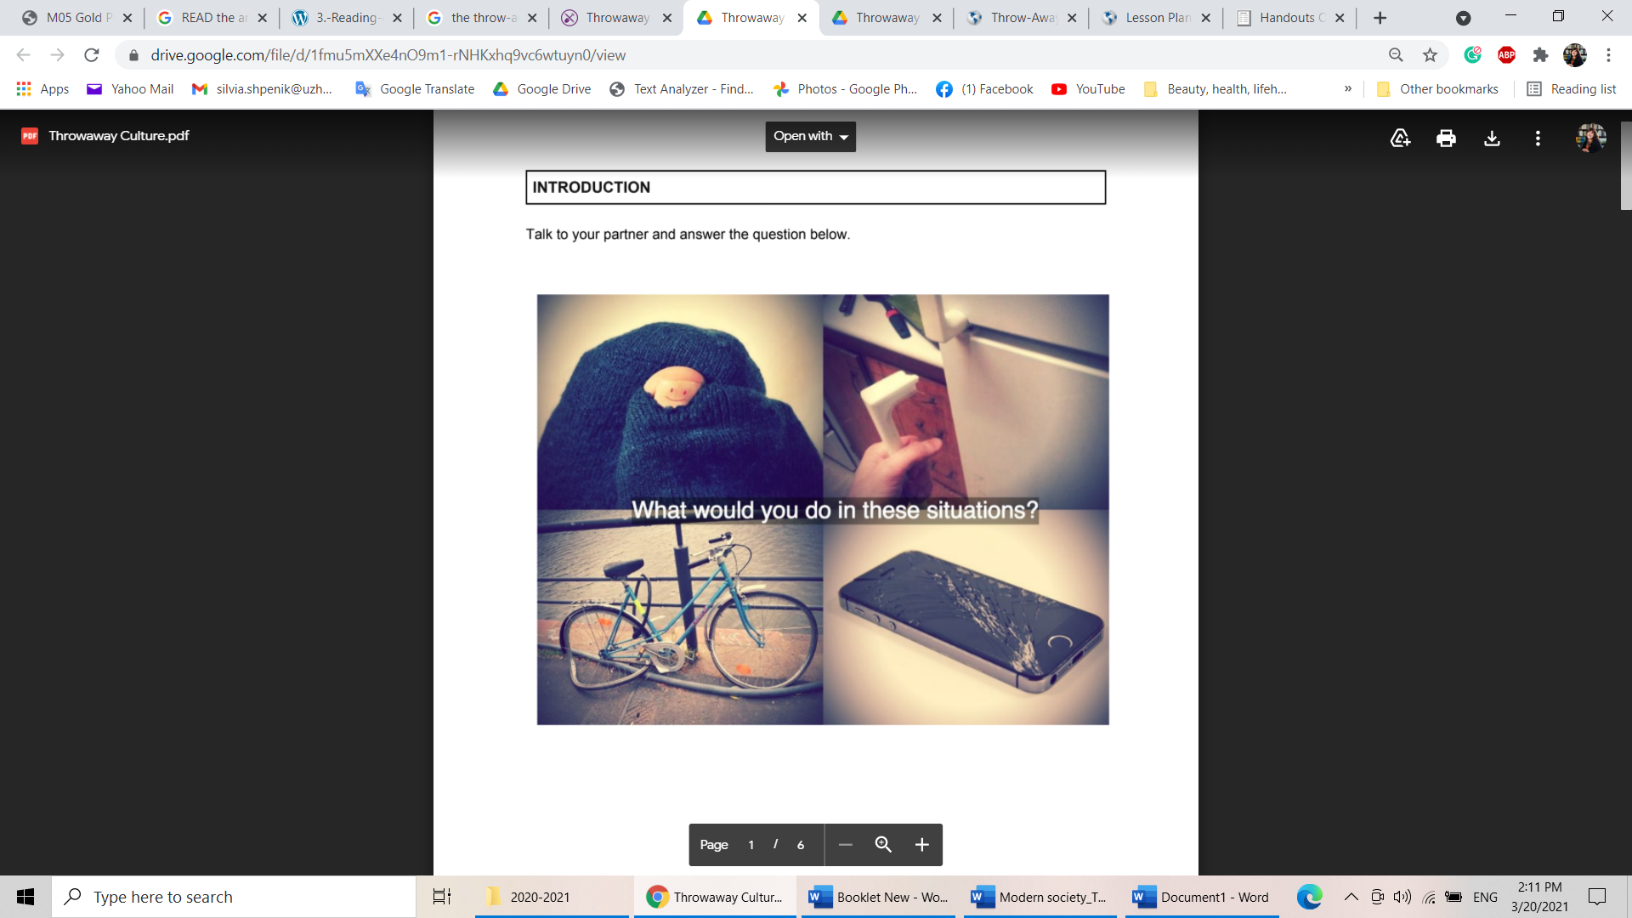

Active vocabulary
balanced blend of– збалансованасуміш  boastvalues – пишатисяцінностями  brotherhood–братство  consumer–споживач  consumersociety– суспільствоспоживáцтва  consumerism– стимулювання споживчого інтересу  conspicuousconsumption –демонстративне або показне споживання  evolvev– еволюціонувати, розвиватися  expansion– розширення, зростання  fall a victim – стати жертвою  indigenouspractices–корінні звичаї  long-cherished– заповітний, давно задуманий | luxuries– розкіш  moral – мораль, повчання  over-busy– надмірно зайнятий  pre-historic – доісторичний  slave–раб, невільник  spendthrift– марнотратство, марнотрат  superstitiousbelief–забобонні вірування  take control of smb. – взятипідконтроль  urban life – міськежиття  woes and setbacks–проблеми і невдачі  at the expense of idiom – зарахунок  keep up with the Jonesesidiom – to envy what others have and to use their possessions as a status symbol- жити як всі, жити не гірше за інших; рівнятися на сусідів
READING
IV. Read the text and find the words describing the modern and the traditional societies.
MODERN SOCIETY OR TRADITIONAL – WHICH ONE TO CHOOSE?
Man is a social animal and has been living in groups since the pre-historic times. These groups have evolved to become organized and civilized societies. The process of evolution is still going on, leading to the formation of the modern society by putting the traditional society behind the scene.
Since the words “traditional” and “modern” co-exist in the world today we need to define them.
“Traditional” refers to those societies or elements of societies that are small-scale, are derived from indigenous and often ancient cultural practices.
“Modern” refers to those practices that relate to the industrial mode of production. It is based on expansion of education, technology, industry and urban life. Its base is materializing. Social problems of various nature develop among various groups. And very often modern society is called consumer society.
But both societies have their woes and setbacks.
When speaking of the traditional society, it boasts values, traditions and its long-cherished culture and norms. The modern society is proud of the amazing technology and the freedom of choice.
The modern man doesn’t recognise that his own inventions take control of him and reduce him to nothing but a mere slave. However, people in the traditional society had a full control of their own lives. They could not communicate on cell phones or chat on social sites and were not so over-busy with their schedules and monotonous routines.
While the traditional society lacked all the luxuries that we all enjoy today at the expense of science and research, it made the people fall a victim to the traps to the superstitious beliefs. But today, the modern society has lost the morals, ethics and the emotions of love and brotherhood that distinguished them from the other animals on the planet!
An example of how the modern society affects us is the so-called philosophy of "keeping up with the Joneses". According to which, conspicuous consumption occurs when people care about their standard of living in relation to their peers.
So, there are several things we can note. Firstly, it is almost impossible to choose any one given the pros and cons of both. Probably a balanced blend of both would do. Secondly, try to be a saver instead of being a spendthrift. Thirdly, rather than trying to “keep up with the Joneses,” try to “keep up with the person you want to be.”
NOTE:
- consumer society – a society in which people often buy new goods, especially goods that they do not need, and in which a high value is placed on owning many things.
- keep up with the Joneses –The idiom originates with the comic strip Keeping Up with the Joneses, created by Arthur R. Momand in 1913. It depicts the social climbing of the McGinis family, who struggle to "keep up" with their neighbours, the Joneses of the title. The Joneses were unseen characters throughout the strip's run, often spoken of but never shown.
V. Match the words and expressions with their meaning:
1. at the expense of smb./smth. | a person who spends money in an extravagant, irresponsible way
2. brotherhood | lifelong
3. consumer society | one who saves or invests money
4. spendthrift | do it in a way which might cause someone/something harm or disadvantage
5. boast | friendship and loyalty
6. long-cherished | the action of buying something
7. setback | possess (a feature that is a source of pride)
8. ssaver | the amount of money expected, required, or given in payment for something
9. purchase | an obstacle, delay, or disadvantage
10. price | where people often buy new goods, especially goods that they do not need, and in which a high value is placed on owning many things
VI. Fill in the gaps with words from the text.
1. Very often modern society is called … society.
2. The modern society has lost the …, ethics and the emotions of love.
3. Try to be a saver instead of being a … .
4. Conspicuous … occurs when people care about their standard of living in relation to their peers.
5. The inventions take control of the modern man and reduce him to nothing but a mere … .
6. The modern society is based on … of education, technology, industry and urban life.
7. People in the traditional society had a full control of their own lives and were not so … with their schedules.
8. The traditional society boasts values, traditions and its … culture and norms.
9. Man is a social animal and has been living in groups since the … times.
10. The traditional society made the people fall a victim to the traps to the … beliefs.
VII. Are the following sentences about the modern society or about the traditional one?
a) derive from indigenous practices
b) is based on expansion of education
c) boasts values, traditions
d) loses the morals, ethics and emotions
e) people are over-busy with their schedules
f) man is a mere slave
g) people control their life fully
h) conspicuous consumption occurs
i) is affected by the philosophy of "keeping up with the Joneses"
j) people have the freedom of choice
VIII. WRITING. Using the Internet and the text compare the traditional and modern societies. Write about 3-4 spheres listed in the box:
lifestyle | technology | values
economy | consumption | ecology
transport | job and income | entertainment
SPEAKING and DISCUSSION:THROWAWAY SOCIETY
IX. Look at the pictures and react to the questions they arise:
 |  | Do you agree we live in a throwaway culture? Why? |  | 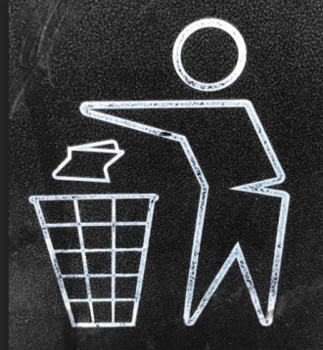 | What are some of the consequences of throwing things out instead of fixing them?
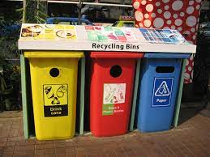 | What types of goods do we throw out most often? Why do you think that is? |  | 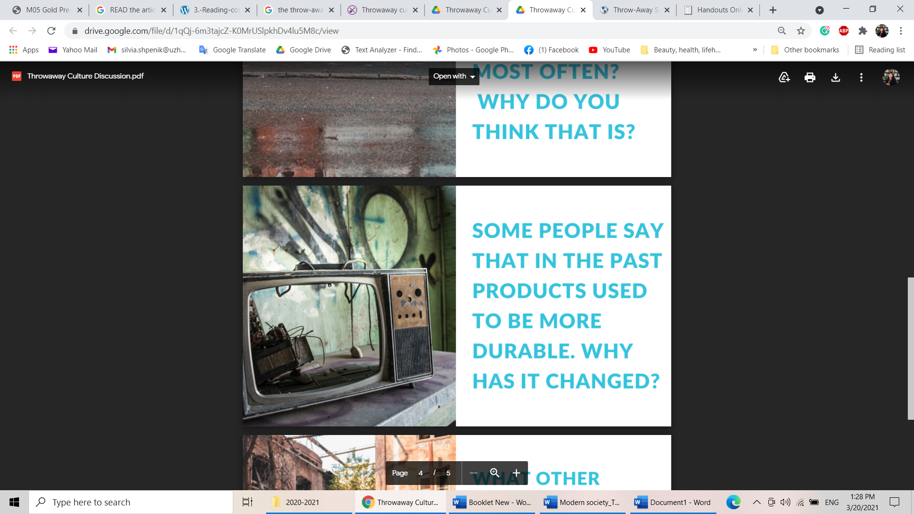 |  |  | Some people say that in the past products used to be more durable. Why has it changed?
X. Work in groups and discuss the questions.
a) What was the last thing you bought?
b) Did you need it?
c) Why did you buy it?
d) Did you shop around to get the best deal?
e) Do you ever waste your money? If yes, what on and why?
f) To fix or to throw away?What would you do in these situations?
(holey socks; torn jeans/blouses/jackets), broken tools/gadgets (phone, handle, monitor, bicycle, car, TV, computer)
E.g.: I recently bought a virtual reality headset. I also paid for a new jacket.The headset was not necessary. It was for fun and entertainment
XI. Use the verbs from the box to fill in the gaps in the text about the Swedish government’s new proposal. Remember to change the form of the verbs where necessary.
hope | spur | introduce | make | throw
slash | lack | repair | submit (x2) | claim

The Swedish government is 1) … tax breaks on repairs to everything from bicycles to washing machines so it will no longer make sense to 2) … out old or broken items and buy new ones.
Sweden’s ruling Social Democrat and Green party coalition is set to 3) … proposals to parliament on Tuesday to 4) … the VAT rate on repairs to bicycles, clothes and shoes from 25% to 12%. It will also 5) … a proposal that would allow people to 6) … back from income tax half of the labour cost on repairs to appliances such as fridges, ovens, dishwashers and washing machines.
“We believe that this could substantially lower the cost and so 7) … it more rational economic behaviour to 8) … your goods,” said Per Bolund, Sweden’s minister for financial markets and consumer affairs. Bolund 9) … the tax break on appliances will 10) … the creation of a new home-repairs service industry, providing much-needed jobs for new immigrants who 11) … formal education.
Notes:
slash – скорочувати  submit a proposal – подавати  lacksmth – не мати чогось  VAT value-added tax  spur – стимулювати  rational –раціональний  taxbreaks – податкові пільги  claimback– вимагатиповернення  throwout –викидати | repairclothes/tools –ремонтувати одягу / інструментів  introduce – впроваджувати  impact – вплив,  chemicals – хімічні речовини, хімікати  whitegoods – побутоватехніка (such as refrigerators and washing machines, typically white in color)  cover – покривати
WATCHING
XII. A. Watch the video. https://youtu.be/hRUa1x1N2z8 Write down any new information about the project you haven’t learnt from the text.
B. Compare your notes with the person to your right. Add new ideas to your notes.
XIII. A. Think of 3 different words to modify the meaning of the nouns given.
 | Culture |  | Goods

 | Impact |  | Chemicals
B. How are these nouns modified in the video? Watch the video again to check. Add the adjectives to the table.
C. Write down questions that 3 of the collocations above can answer. Ask yourpartner to answer them.
E.g.: In Sweden, you get a tax break for repairing those. → white goods
XIV. A. Choose 6 keywords that are crucial to understand the Swedish tax initiative and write them in the table below.
B. Ask your partner to summarise the story using the keywords from the table. Tick the keywords they have used.
C. Look at your partner’s table and summarise the story using the keywords. Ask them to tick the keywords you have used.
D. Compare the two stories. Was their meaning and focus similar or different? Why?

Topic 4. Leisure Time Activities. My Hobbies.
Active vocabulary
account – рахунок  advantage – перевага  disadvantage – недолік, невигода  to take advantage of – скористатись перевагою  tohaveadvantagein – мати перевагу в чому-небудь  chatterbox – любитель поговорити  clubbing – відпочинок в клубах  equipment – обладнання  exhausted – виснажений  leisurepursuits – дозвілля  leisuretimeactivity – спосіб проведення вільного часу  lucrativepursuit – прибуткове заняття  terrific – чудовий  toaffordsmth – дозволити собі що-небудь  to be good at doing smth – добре знатися на чомусь  to be in/ out of fashion – бути в моді / немодним, сучасним /несучасним  to be short of time – мати дуже мало часу  to come on time/ in time – приходити вчасно / завчасно  to drop in – завітати  to feel oneself out of sorts = to be washed out – дуже погано себе почувати  to get rid of smth – позбавитися чогось | togiveup (somebadhabits) – позбутися чого-небудь (поганої звички)  to go for a run – ходити на пробіжку, бігати  to go in for (sport) – займатися чимось (напр. спортом)  to hang out with friends – зависати з друзями, socializing with friends  to have a delightful / to enjoy the time – чудово проводити час  tokeepfit – тримати хорошу фізичну форму  tolooksmart – виглядати витончено, елегантно  tomakeachoice – робити вибір  limited income = who has to manage their money efficiently to live  financially stable= doesn't need to worry about money  to relax and do nothing – відпочивати пасивно  obsessed – одержимий  up-to-date – сучасний  "grew/grow out of" – «вирости з» (певної діяльності)  artistic – артистичний, художній  musicallyinclined – музично налаштований  to surf the internet – шукати інформацію в інтернеті  to train, to practise – тренуватись
When we talk about our hobbies, we can use the verbs play, do, or go.
Collocations for hobbies and leisure:
like + noun / Ving | I like tennis / I like playing tennis
love + noun / Ving | He loves football / He loves watching football
enjoy + noun / Ving | We enjoy sports / playing sports
be keen on + noun / Ving | She’s keen on the cinema / going to the cinema
be interested in + noun / Ving | I am interested in rock music / literature
be good at + noun / Ving | I am good at playing tennis / the guitar
have a passion for + noun | I have a passion for martial arts like judo / karate

Play + sport / game (football, video games, chess, cricket, tennis, etc.)  Play the + instrument (guitar, piano, violin, drums, etc.)  Do + hobby / individual sport (DIY, judo, yoga)  Go + activity (swimming, fishing, jogging, etc.) | My sister plays tennis every weekend.  I don’t like cricket at all.  Tom plays the guitar. He plays in a band.  My brother likes doing DIY.  I really enjoy doing yoga because it’s god for my soul and body.  I go swimming three times a week.
My hobby is …/ I am interested in …
My hobbies are …/ My hobby is …
My favorite sport is …
I sometimes go to … (places), I like it because …
I don’t like/ dislike/ hate …
In my free time, I like …
I like … when I’m free.
At weekends I sometimes go to … (places)
READING:
I. Read the text.
HOBBIES, LEISURE AND LIFESTYLE
Free time after school or work is called leisure time. It is time when we don´t have to go to work or school. It is the time of fun and entertainment. We devote time to different activities e.g. watching TV, gardening, practicing some hobbies or just relaxing. Why? To recharge ourselves, to relieve stress.
Nowadays people live very busy, stressful lives. So they need to switch off after work. Having hobbies can be beneficial to them. Hobbies bring many pleasures to our lives: we can spend more time with our family, relatives or friends, or we can even meet new friends, and most of all we can relieve stress. Having a hobby can help you avoid feeling bored and you can learn something new. There are a lot of types of hobbies.
The traditional ones are collecting objects: stamps, picture postcards, bottles, models of cars, coins, badges or other things. It can be a lifelong hobby for many people but it is an international hobby, too. People can exchange these things – swap them in different collector clubs. These hobbies are gradually becoming old-fashioned. It´s not fashionable to collect smth anymore. Then there are people who don´t like movement, so they prefer activities such as reading books, magazines, completing crosswords, watching TV or play computer games.
Energetic people do some physical activities. So, they practice some kind of sport. It is a good and healthy hobby, which helps us to be fit and keeps our body in a good condition.
There are many people who feel alone and have nobody to care about because they don’t have their own children or family. These people usually keep some pet. So, we can keep – cats, dogs, snakes, spiders, parrots, hamsters, guinea pigs, budgerigars etc. We have to feed them and they become our friends. The problem is, when you want to travel, because it is not easy to find hotels which are pet-friendly.
Small children´s hobbies are playing with dolls, cars, playing games like chase, hide and seek or board games – e.g. ludo, chess, cards, darts.
Teenagers have their special leisure interests like playing team sports, dancing at the disco, going to parties or joining some clubs. Usually they spend their leisure time actively in groups, in a good company – socialising. Some of them like staying at home watching DVDs, listening to music, browsing the Internet or chatting.
If compare with the older generation, teenagers are becoming more lazier than their parents used to. They spend more time sitting in front of TV, computer – a generation of coach potatoes (obesity).
Some children and young people join different clubs where they practice different sports, the most popular are football, tennis, dance or ride a horse.
Why do young people take up some hobbies? Sometimes, it is not their choice but the choice of their parents, who want them to have interesting hobbies. Some parents force their children to play an instrument or do some sport, because they think they will prevent them from taking drugs or drinking alcohol. Other parents failed to become musicians or sportsmen themselves, so they want their children to achieve these aims.
Adults have some other kinds of hobbies and it depends on each individual what kind of hobby to choose. Some of them take up an outdoor activity such as fishing, hiking, flying remote controlled model airplanes or kites in the park with children, water skiing, camping or cycling. Others take up an indoor activity – reading etc. Men like – repairing and maintaining their households or cars, working in the garden. Women prefer handycrafts – knitting, sewing, embroidering.
Older people prefer gardening, fishing, reading books, going to the theatre, concerts or art exhibitions. Some of them like travelling and playing cards or even some sports – e.g. golf, bowling or going to the woods, picking up mushrooms, keeping some pets, etc..
DIY (do it yourself) – mean doing practical jobs around the house. People like to redecorate their houses or repair some small pieces of furniture and household appliances. There are people who like to repair their cars by themselves, others do some cookery, gardening, knitting, sewing, wood working, etc. There are some evening courses organized for people who want to learn the basics of these activities.
Many people have creative hobbies, such as acting, choir singing, folk dancing or ball dancing, playing pop-music in amateur groups. Other popular hobbies are photography, painting, drawing and sports. There are many opportunities to develop talents in these areas.
Some people like to learn new things by reading books or participating in evening classes. They need to or want to improve their qualification. There are educational courses, e.g. of foreign languages or working with computers. However, we need to relax and to have a good time, because there are more and more workaholics who gave up their hobbies to be able to work all the time and this is considered to be a very negative phenomenon.
Dangerous hobbies are practised by people who like adrenaline and don´t hesitate to risk their life while practising their hobbies. Some of them are cave diving, base jumping, high-altitude climbing, parachuting, hangliding.
Reading is a pastime activity. Books accompany people everywhere: we read them while travelling to school/work, waiting for a doctor, during breaks at school, on holiday. Lots of people can't imagine their lives without books. So, books are given as gifts on occasions as birthdays and Christmas.
II. Find in the text:
- adjectives used to describe leisure activities;
- verbs used to introduce leisure activities
III. Answer the questions:
1. What is leisure time?
2. How do most young people spend their leisure time?
3. How can people spend their leisure time at home?
4. List some traditional hobbies.
5. Is keeping pets an interesting hobby? Why?
6. List some creative hobbies.
7. Which hobby do you practice to develop your talent for arts?
8. What are typical teenage hobbies?
9. Which hobbies can be dangerous?
10. Why old people prefer to have “calming” hobbies?
IV. What are the different types of leisure activities?
- Social: Activities done with other people
- Creative: Activities, where a person makes or creates something
- Physical: Activities that require body movement
- Cognitive: Activities that require a person to think
- Relaxation: Activities, where a person does to feel calm
- Spiritual: Activities, where a person submits to a higher power
V. Match each activity with its type as in the examples.
a. Social b. Physical c. Cognitive d. Creative
1. Gymnastics | a. Social | b. Physical
2. Playing a musical instrument |  |  | c. Cognitive | d.Creative
3. Reading a magazine
4. Spending time with friends
5. Drawing a picture
6. Playing sports
7. Watching sports event with friends
8. Walking in the park
9. Shopping with friends
10. Taking a class or course for fun
11. Decorating your home
12. Reading the newspaper
13. Giving a speech
14. Volunteering to help people
15. Attending a local concert with friends
16. Dancing
17. Playing video games
18. Working in a garden
19. Making arts and crafts
20. Bowling alone
21. Exercising
22. Talking on phone with friend
23. Attending a cook-out or picnic
24. Preparing a holiday meal
25. Eating holiday meal with others
VI.A. What benefits can leisure offer for a person? Here you have some of them.
- Improved health
- Improved social relationships
- Improved physical fitness
- Improved mental health
- Increased life satisfaction and enjoyment (and)
- Personal development and growth
B. What can a leisure activity do for you? Think at first individually. Then discuss the ideas in small groups and present the answers to the group.
Directions: Write at least one activity in the right column that would help you receive the benefit in the left column. You may write more than one answer. There are no definite correct answers. For example: stress relief could come from doing stretches, fishing, listening to music, or doing many other activities. Try not to write any activity twice.
Benefit | Activity
1. Stress relief/ relaxation
2. Personal growth
3. Pleasure/ fun
4. Better relationships
5. Increased creativity
6. Increased fitness
7. Personal meaning in life
8. Feel important
9. Reach a goal
10.Make a commitment
11.Recognition
12.Belonging
13.Lose weight
14.Build muscles
15.Improve memory
16.Use thinking skills
17.Use problem solving skills
18.Feel free
19.Self-expression
20.Experience adventure
21.Learn something new
22.Use good teamwork
23.Use communication skills
24.Enjoy the outdoors
25.Make good memories
VII. Free time: relaxation and leisure
A. Familiarize yourself with some adjectives to describe free time and leisure pursuits.
adjective | meaning | possible examples
rewarding | gives you a lot of positive experiences | doing voluntary work, helping charities
fruitful | produces good results | collaborating/cooperating with someone in an activity
lucrative | makes a lot of money | selling your own arts or crafts, writing computer games
therapeutic | makes you healthy in body and/or mind | gardening, yoga, meditation
relaxing/calming | reduces stress, gives a peaceful feeling | reading, listening to music
time-consuming | takes a long time to do | being president of a club, being a member of a committee
Examples:
1. I enjoyed being secretary of the sports club, but it was very time-consuming. I had to give up two evenings a week to do it.
2. The conservation work I do is very rewarding. I feel I'm doing something good and useful
3. Photography has been a lucrative pursuit for her. She often sells her pictures to magazines
4. Painting is such a therapeutic activity. It makes me feel good, and teaches me patience.
B. Some informal words describing the way people spend their leisure
1. Bob's a real culture vulture; he goes to every theatre and art gallery he can find. | big fan of anything cultural
2. I'm a bit of a couch potato: I spend hours every day just watching TV. | physically very inactive person
3. Mary's a bit of a dabbler: she does a pastime for a couple of weeks, then she gets bored and starts something different, | person who never keeps doing one activity for long
4. Francis is a real doer. He never sits round for long and always has some project or other. | person who believes in acting and doing things, not just thinking
5. Laura's a shopaholic. She buys all sorts of things she doesn't need, | person addicted to shopping; compare alcoholic: addicted to alcohol
C. Expressions and collocations connected with involvement in activities
1. Joeisheavily into downhill skiing these days. | inf takes a great interest in / is very involved in
2. I went off football and I started playing golf instead. | inf stopped liking / lost interest in
3. She locks herself away for hours in front of the computer and surfs the Internet every night. | isolates herself from the world
4. He's totally hooked on motor racing these days. | inf is addicted to
5. What doyou get up to at weekends, Michael? | inf do
6. Do you have a hectic social life? Yes, I have a pretty full diary. | a lot of commitments/ activities
VIII. Fill the gaps with a suitable adjective from A.
1. I find writing poetry very… It helps me to get a truer understanding of myself and gives me a good feeling inside.
2. I enjoy selling the pictures I paint, but it's not very… I only made £300 last year.
3. Gardening is very… It reduces stress levels and calms you down.
4. I've had a partnership with Jane for several years: she plays the piano and I play the violin. It's been very… for both of us.
5. Doing unpaid work at the hospital has been an experience for me. It’s very… .
6. I would like to be on the club committee, but I've heard it's very…, and I don't have a lot of free time.
IX. Answer these questions.
1. What kind of obsessions or addictions do you personally have?
2. What was the word on the opposite page that meant 'a person who is obsessed with going out and buying things'?
3. Using the same construction as in question 2 above, what could you call a person who is obsessed with, or addicted to, the following?
a) working all the time b) sport c) eating chocolate
4. What are you? Invent a word for your obsession(s) using -maniac, -holic, -addict.
X. Write An essay (150-200 words) on one of the topics:
1. Importance of leisure time
2. Hobbies and obsessions
3. My favourite leisure activities
4. Leisure activities that improve the mind
5. Leisure activities in different ages

Topic 5. Daily routine. Jobs. Studying.
WARM UP
I. Which words below can you use to describe your daily routine?
brushteeth  busy  buy something  call / chat with (someone)  clean the room  come home / stay home  cook breakfast / dinner / lunch  do exercise  do homework / housework  do ironing  drive (a car)  eatbreakfast / dinner / lunch  feed / walk a pet | finish work  get dressed / change clothes / dress up  get out of class  go for a walk  go in for sports  go on-line / use a computer / send e-mail  go out to eat/ eat out / hang out  go shopping  go to bed/ fall asleep / sleep / wake up / get up  go to university / work / home  go window shopping  have a coffee/tea  have breakfast/lunch/dinner /snack  help my mother | in time / late  on time / early  leave / arrive  morning / afternoon / evening / night  play (cards/the piano/tennis)  read / listen to music  relax  ride (the bus/ bicycle)  schedule  see a movie / watch TV  set the alarm clock  start work / studying  take a break / nap / rest  take a bus / taxi  take a shower  wash dishes  week day / weekend
II.A. What do you see in the photos below?
 A  B  C
DEF
B. How often do you do these things?

Active vocabulary
brunch = breakfast + lunch  comeround – зайти у гості  doexercises – робити вправи (зарядку)  dohomework – робити домашні завдання  dohousework – робити роботу по дому  do the shopping – робити покупки  do the washing – прати одяг  do the washing-up – мити посуд  early riser – “ранняпташка”  nighthawk / night owl /night person–“сова”  fly airplanes – пускати літаки  get dressed – одягнутися  dress up – одягнутися святково  get washed/ have a wash– вмиватися  go for a walk – йти на прогулянку  go in for sports – займатися спортом  go out – йти (у місто)  go out to eat (to eat out) – їсти у місті (ресторані/піцерії)  goshopping – ходити за покупками | gowindow-shopping – насолоджуватися вітринами  havefriendsfordinner – прийняти друзів на вечерю вдома  have an early night – рано лягнути спати  have a late night – пізно лягнути спати  have a busy daily routine –мати насичений графік  have a lie-in – валятися в ліжку  have a nap – подрімати  have a shave – побритися  have / take a shower – прийняти / приймати душ  have a snack –перекусити  to oversleep – проспати  planner –планувальник  procrastinator –людина, що любить все відкладати, баритися  stayin – залишатися вдома, не виходити з дому
III. Do you have an interesting daily routine – or a boring one?
A. Read the text about someone’s daily routine.
Sleep
During the week I usually wake up at 6.30 a.m. I sometimes lie in bed for five minutes but then I have to get up, get out of bed and get dressed). Most evenings, I go to bed at about 11.30 p.m. I'm usually very tired, so I go to sleep / fall asleep very quickly. Occasionally though, I can't get to sleep(=succeed in sleeping). When that happens, I sometimes manage to fall asleep about 3 a.m., then I oversleep(=sleep too long) in the morning. If I have a late night(=go to bed very late; not an early night), I try to have a nap(=a short sleep, e.g. 20-25 minutes) in the afternoon. The weekends are different. On Saturday and Sunday I have a lie-in. (=stay in bed until later, e.g. 8 a.m. or 8.30 a.m.)
Food
In the week I have breakfast at 7.30 a.m., lunch at 1.00 p.m., and dinner around 7 p.m. I also have one or two snacks (=small amounts of food), e.g. cakes, biscuits or fruit, during the day at work. As I live alone / on my own / by myself(=without other people), I also have to make my own breakfast and dinner(=prepare breakfast and dinner for myself), but during the week I don't bother(=make an effort) to cook very much. I also have to feed(=give food to) my two cats twice a day as well.
Keeping clean
In the summer I have a shower in the morning, but in the winter I often have a bathinstead(=in place of a shower). Sometimes I have a shave at the same time, or I shave when I have a wash and clean/brush my teeth after breakfast. I washmyhair two or three times a week.
Work
In the morning I leave home about 8.15 a.m. and get to work(=arrive at work) by 9 a.m. I have a lunch break(=stop work for lunch) from 1-2 p.m., and a couple of short breaks during the day. I leave work around 5.30 p.m. and gethome about 6.15 p.m.
Evenings
During the week I usually stay in(=stay at home) and havearest(=relax and do nothing). But at the weekend I often goout(=leave the house for social reasons, e.g. go to the cinema or disco with friends), but quite often I also havefriendsfordinner(=invite friends to my house and cook dinner for them), or friends just come round(=visit me at the house) for a chat (=conversation) or we playcards, e.g. poker or bridge.
Housework
I do the shopping(=buy the food) on Saturday. Fortunately(=luckily) I have a cleaner(=a person who cleans) and she does most of the housework: she does my washing(=washes the clothes), the washing-up (=washes the dishes) and does most of the ironing.
B. Explain the meaning of some words and expressions in bold that you haven’t known earlier.
IV. Match the verbs on the left with the corresponding words on the right
1. fall | a) cards
2. do | b) my teeth
3. have | c) a shower
4. play | d) asleep
5. go | e) washed
6. clean | f) early
7. feed | g) the ironing
8. get up | h) the dog
9. take | i) to bed
10. get | j) a rest
V. A.Read about MikeMiller and KellySmith. Compare their daily activities. Who do you think is busier? Make a list of tasks for each of them (a daily schedule).
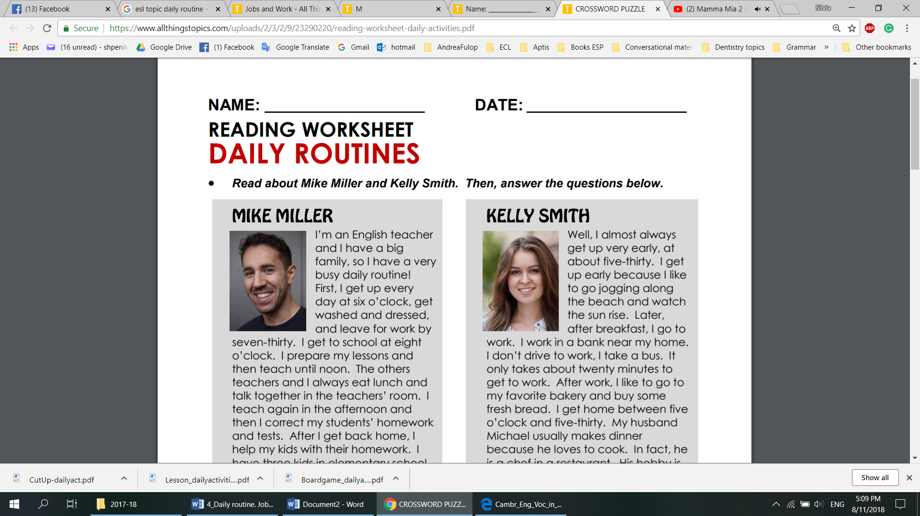  I’m an English teacher and I have a bigfamily, so I have a very busy daily routine! First, I get up every day at six o’clock, get washed and dressed, and leave for work by seven-thirty. I get to school at eight o’clock. I prepare my lessons and then teach untilnoon. The other teachers and I always eat lunch and talk together in the teachers’ room. I teach again in the afternoon and then I correct my students’ homework and tests. After I get back home, I help my kids with their homework. I havethreekids in elementary school. Their names are Mathew, Jon and Suzie. Then, I do some exercise, eat dinner with my family and watch TV before I go to bed at about ten o’clock. We love to watch travel shows. Finally, I read in bed for a few minutes before I fall asleep. | Well, I almostalways get up very early, at about five-thirty. I get up early because I like to go jogging along the beach and watch the sun rise. Later, after breakfast, I go to work. I work in a bank near my home. I don’t drive to work, I take a bus. It only takes about twenty minutes to get to work. After work, I like to go to my favorite bakery and buy some fresh bread. I get home between five o’clock and five-thirty. My husband Michaelusually makes dinner because he loves to cook. In fact, he is a chef in a restaurant. His hobby is painting, and my hobby is growing flowers in our garden. We also have a pet dog called Wolfie. In the evenings we take Wolfie for a walk, and then get to bedby nine-thirty because we have to get up so early again the next morning.
B. Explain the meaning of the words in bold. What about the words in italics?
VI.Complete the dialogue using the words from the texts above.
Ann: Don’t 1) … to cook a meal this evening?
Ben: Why not?
Ann: We could 2) … instead.
Ben: Yeah. Where?
Ann: Well. I’d like to go to that new Sushi bar. We could ask Kate and Thomas to come.
Ben: That’s miles away. No, I think I’d rather 3) … and have an 4) … night.
Ann: But it’s Friday. You can have a 5) … tomorrow if we have a late night.
Ben: Yes, I know but I’m tired. Look, why don’t you ask Kate and Thomas to6) … for a meal. I can order some pizzas from the takeaway and we’ll have a nice evening here.
Ann: Sorry, but if you don’t want to come to the bar with me, I’ll go 7) … .
VII. Match the words with their definition.
1. postpone | a) arranged systematically; in order
2. relax | b) continuously over a period of time; always
3. oversleep | c) to plan, prepare for, or organize something
4. constantly | d) make or become less tense or anxious
5. routine | e) immediately
6. afternoon | f) sleep longer or later than one intended
7. spontaneous | g) a sequence of actions regularly followed
8. organised | h) the time from noon or lunchtime to evening
9. instantly | i) cause or arrange for (something) to take place at a time later than that first scheduled
10. arrange | j) happening or done in a natural, often sudden way, without any planning or without being forced
VIII. Connect the words in two columns to make up collocations.
Answer the questions and express your opinion:
1. Do you think these people have a boring daily routine? Why? / Why not?
2. What time do you usually get up? What time do usually go to bed?
3. What do you usually eat for breakfast? Do you usually eat healthy food?
4. What things do you usually like to do for fun in your free time?
IX. DISCUSSION, Part I.
A. Group A: Interview your groupmates from the other small group B and make notes about their daily activities.
1. What time do you usually go to bed at night? Should you go to bed earlier?
2. What do you often eat for breakfast? Do you think it’s healthy food?
3. What time do you arrive at school or work? Are you ever late?
4. What time do you eat lunch? Do you eat alone or with other people?
5. What time do you get home after school or work? Are you tired when you get home?
6. What’s your favourite TV show? Why do you like it?
7. How much time do you spend on-line each day? Is it too much?
8. What time do you usually eat dinner?
9. What hobbies do you have? What’s your favourite hobby?
10. How do you like to relax in the evenings?
B. Having made the notes discuss the information in your small group and present to your teacher.
C. Write a short report about your findings.
X. Writing Practice. Using the vocabulary of the topic write:
a) about your own daily routine from the time you usually wake up in the morning until the time you fall asleep at night (or write about a classmate).
b) an essay “Are you a planner or a procrastinator??
(250-300 words).

IX. DISCUSSION. (continuation) Part II.
A. Group B: Interview your groupmates from the other small group A and make notes about their daily activities.
1. What time do you usually get up in the morning?
2. What do you often eat for lunch?
3. How do you travel to university or work (bus, taxi, …)?
4. Where do you eat lunch? What do you usually eat for lunch?
5. What do you like to do after school or work?
6. How many hours of TV do you usually watch each day? Is it too much?
7. What’s your favourite website? Why do you like it?
8. Can you cook? How often do you cook dinner?
9. Tell me about your best friend. How often do you see him / her?
10. What time do you go to bed at night? Do you think you should go to bed earlier?
B. Having made the notes discuss the information in your small group and present to your teacher.
C. Write a short report about your findings.

Література та джерела

1. Dailyroutine 1. [Електронний ресурс] // Режим доступу до ресурсу:https://brainly.lat/tarea/35343901
2. Dailyroutine 2. [Електронний ресурс] //Режим доступу до ресурсу:https://brainly.lat/tarea/26704089
3. The changing world of English[Електронний ресурс] / DIDACTIS' ADVENTURE // Режим доступу до ресурсу:https://didacticsadventure.blogspot.com/2019/10/the-changing-world-of-english.html
4. Waste not want not: Sweden to give tax breaks for repairs[Електронний ресурс] / The Guardian // Режим доступу до ресурсу:https://www.theguardian.com/world/2016/sep/19/waste-not-want-not-sweden-tax-breaks-repairs
5. What do you think about the position of English as a world language?[Електронний ресурс] / ESLLounge //Режим доступу до ресурсу:http://www.esl-lounge.com/ talking-points-world-language.php
6. http://englishtips007.blogspot.com/2014/12/free-time-relaxation-and-leisure.html

CONTENTS

Topic 1. I am a Student at Uzhhorod National University...........................................4
Topic 2. English in my Life............................................................................................16
Topic 3. The Modern Society.........................................................................................26
Topic 4. Leisure Time Activities. My Hobbies.............................................................33
Topic 5. Daily routine. Jobs. Studying..........................................................................41
Література та джерела.................................................................................................47

УДК 378.091:811.111(07)

Методична розробка до курсу (частина І): Англійська мова для студентів 1 курсу. (Englishforgeneralpurposes) / укладачі: Шпеник С.З., Минда О.І. – Ужгород: «Шарк». 2021. – 48 с.

Гарнітура TimesNewRoman.Папір офсетний
Формат видання 6084/16
Ум.друк.арк.2,79. Замовлення № 17. Наклад 100.

Видруковано ПП «АУТДОР-ШАРК»
88000, м.Ужгород, пл.Жупанатська, 15/1, тел. 3-51-25

Свідоцтво про внесення суб’єкта видавничої справи
до державного реєстру видавців,
виготівників і розповсюджувачів
видавничої продукції
Серія 3т № 40 від 29 жовтня 2012 р.

