УЖГОРОДСЬКИЙ НАЦІОНАЛЬНИЙ УНІВЕРСИТЕТ
Кафедра іноземних мов

Методична розробка

Англійська мова для студентів 1 курсу
немовних факультетів

ENGLISH FOR GENERAL PURPOSES
PartII

.
Доцент Шпеник С.З.
Ст.викладачМинда О.І.

Ужгород - 2021

УДК 378.091:811.111(07)

Методична розробка до курсу (частина ІІ): Англійська мова для студентів 1 курсу. (Englishforgeneralpurposes) / укладачі: Шпеник С.З., Минда О.І. – Ужгород: «Шарк». 2021. – 76 с.

Рецензенти:
- доктор педагогічних наук, професорКозубовська І.В.
- кандидат педагогічних наук, доцент, доцент кафедри англійської філології та методики викладання іноземних мов Мукачівського державного університету Гарапко В.І.

Мета методичної розробки – забезпечити практичне оволодіння студентами лексичними та мовленнєвими моделями, необхідними для вільного спілкування англійською мовою на повсякденну тематику. Матеріали методичної розробки сприятимуть оволодінню навичками та вмінням читання, мовлення (діалогічного і монологічного) та письма на повсякденну тематику. Методична розробка призначена для студентів першого курсу немовних факультетів.

Рекомендовано до друку
Вченою радою Факультету іноземної філології ДВНЗ «УжНУ»
від 15 вересня 2020 р., протокол № 6

ПЕРЕДМОВА

Дана методична розробка складається з двох частин і містить добірку текстів з предмету «Englishforgeneralpurposes» і призначена для студентів перших курсів немовних факультетів. Розробка укладена відповідно до навчальної програми з іноземних мов для немовних факультетів.
Метою даного видання є поглибити знання студентів, отримані у середній школі.Ційметіпідпорядковано структуру посібника та завдання кожного умовногорозділу.
Друга частина містить 5 розмовних тем: 6. Travelling. Countries and Cultures.7. Health and Accidents. Healthy Way of Life. 8. Money doesn’t Bring Happiness. 9. Ambitions and Dreams. 10. Discoveries and Inventions. The best and the worst discoveries and inventions of humanity. Кожна тема включає базовий текст (призначений для закріплення активної лексики певної теми) з активним тематичним словником; умовно-комунікативні та комунікативні тренувальні вправи для засвоєння лексики активного словника.

Topic6.1.Travelling
I. In pairs brainstorm as many types of travelling as you can.Write a list of words connected to travelling.
II. A) Do you know the difference between the following words:
TRAVEL | TRIP | JOURNEY | CRUISE | VOYAGE | TOUR | EXCURSION
B) tourist and traveller
III. Look at the pictures below. Match pictures with the words and expressions from the table. There are more possibilities for each picture.
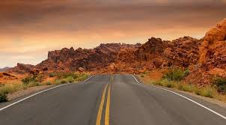A 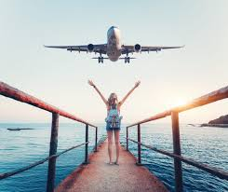B 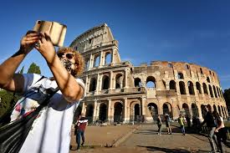C
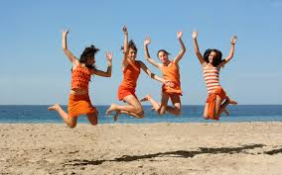D 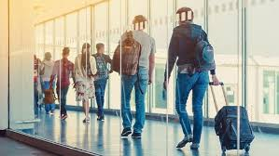E 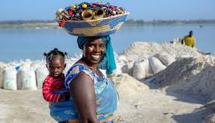F
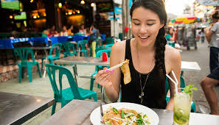G 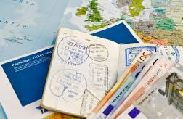H  I
a) airport  e) family  i) backpack  m) sightseeing | b) documents  f) highway  j) friend  n) meeting people | c) sea shore  g) taking photos  k) scenery  o) luggage | d) street food  h) cuisine  l) having fun  p) money

Active vocabulary
travelnoun – мандрівка, одноразова подорож, пересування, рейс, відрядження, пересування | air/rail/coach/cartravel – подорож на літаку/ поїзді / туристичному автобусі / автомобілі  foreign/overseas travel – поїздказакордон  international travel – міжнародна поїздка  business travel – відрядження  spacetravel – космічна мандрівка  interstellartravel – міжзорянийполіт  fellowtraveler – супутник
verb  мандрувати, подорожувати (далеко) | totravelin/ across/ to / through  totravelaroundtheworld / thecountry – подорожувати по світу / по країні  totravelbybus/car/train  totravelonfoot/horseback - подорожувати пішки/верхи
adjective | a travel agency/agent – турагенція/турагент  a travelling companion – супутник  travelarrangements– підготовка до подорожі  traveldocuments/tickets – проїзні документи / квитки  travelnut –запеклий мандрівник  travelsickness– захитування
trip – поїздка,подорож на короткий час з конкретною метою | a business trip– відрядження  ashoppingtrip – поїздка по магазинам  go on/take / make a trip  a skiing/hiking/trekkingtrip  fishing/hunting trip  trip to work  a day trip – одноденнапоїздка  a round trip –круїз
journey– поїздкана великі відстані та тривалий час | a car/plane/busjourney; journey to work  tomake a journey – подорожувати  togoon a journey – поїхатив подорож
tour–похід, турне, тур, екскурсія | a sightseeingtour–тур для огляду цікавих та видатних місць  a culinary tour – кулінарний тур  a guided tour – тур з екскурсоводом  a walkingtour – пішохідна екскурсія  a cycling tour – велотур  a world tour – світоветурне  a tour guide – екскурсовод, туристичнийгід  go on a tour – поїхативтур
voyage– подорож, політ, плавання, поїздка  – тривала подорож морем або по повітрю | a voyagebyboat / boat voyage – подорож на човні  a voyageintospace / space voyage – космічна подорож  togoon/tomake/ tosetoutona voyage – відправитися у морську подорож
cruise –плавання з проживанням на кораблі, круїз | a cruiseship/liner – круїзний лайнер  togoon / totake a cruise – відправитися в круїз
excursion – подорож з метою відвідати окремі цікаві місця | go on an excursion
pilgrimage –паломництво | make a pilgrimage/go on (a) pilgrimage
hitchhiking – подорож автостопом | a hitchhiker
NOTE: Remember the formation of the following words and how to use them.
Verb | Adjective | Noun
Verb | Adjective | person | action, process
travel | travelling, travelled | traveller | travelling
tour | touring, toured | tourer, tourist | tour, tourism
hitchhike | hitchhiking | hitchhiker | hitchhiking
voyage | voyaging | voyager | voyage
cruise | cruising | cruiser | cruise
 |  | pilgrim | pilgrimage
Travel Vocabulary
Airport  flight – рейс  arrival –прибуття  departure–відправка,виліт  destination– пунктпризначення  traveldocuments –проїзні документи  visaregulations – візові правила  entry/exitvisa–візадляв’їзду/виїзду | baggage / luggage(uncountable) – багаж fastenseatbelt–пристебнутиремінь безпеки  timetable/schedule –розклад  suitcase – валіза  handbag – сумочка  backpack – рюкзак  moneybelt – поясний гаманець
Travelling and touring
gocamping – відправитисяв похід  gosightseeing – оглядативизначнімісця  sightseeingholiday– екскурсійнаподорож  packageholiday– відпочинок по путівці gooncoachtourofthecity– піти на автобусну екскурсію помісту  go out at night – гулятивночі  go to the seaside– поїхатинаморе  outing –цілоденнапрогулянка  tire oneself by walking –втомитися від ходьби  become tanned (sunburnt, brown) – засмагати,засмагнути  local crafts – місцевіремесла | a tourist trap – “пастка” для туристів  highway – шосе  railway – залізниця  underground(am.)= subway (or the tube br.) – метро  give a tip –даватичайові  swarming with tourists – full of holidaymakers – кишитьтуристами  travel expenses – costs of going in a trip - витрати на відрядження/ поїздку  savemoney– економити гроші/ заощадити  spendmoney/time– витрачати гроші/проводити час  wastemoney– марно витрачати гроші
Descriptive words
a breathtaking/amazing view –захоплюючийвид  overjoyed–щасливий, задоволений  theuntouchedbeautyofpristineplaces –первозданна краса незайманих місць  exoticdestinations – екзотичні напрямки  lush / luxuriantrainforests– пишні тропічні ліси  magnificent/impressive landscapes – розкішні краєвиди | apicturesquevillage– мальовничесело  memorable experiences – пам’ятнівраження  scenic views– мальовничікраєвиди  spectacular/impressive beaches – вражаючіпляжі  stunning architecture – приголомшливаархітектура  magnificent buildings– розкішнібудівлі
IV. Match the word with its definition.
1) travelling  2) trip  3) journey  4) tour  5) voyage  6) cruise  7) excursion  8) hitchhiking  9) pilgrimage | a) a trip, esp. over a long period or a great distance  b) a long journey in a ship or spacecraft  c) a planned trip to visit a few landmarks or points of interest.  d) a journey on a large ship for pleasure, during which you visit several places  e) to travel by getting free rides in someone else's vehicle  f) going from one place to another  g) a trip to a holy place for religious reasons  h) a visit to a new environment, usually for a short amount of time  i) travelling to many different places during one trip
V. Using the words from the boxes below make as many word combinations as you can and write sentences.
travel | trip | journey | tour | voyage | cruise

air  hiking  ship | boat  hunting  shopping | bus  interstellar  skiing | business  liner  space | car  plane  sightseeing | cycling  rail  walking | fishing  round  world
VI. Choose the correct words to make the sentences correct.
1. We set sail from London and the … was at first difficult. | journey – voyage – tour – trip
2. May loves reading about other countries. This magazine is a food and … guide. | tour – trip – travel – voyage
3. Every summer they go to … across Europe. | tour – travel – voyage – cruise
4. The astronauts were scheduled for a space … . | travel – voyage – cruise – tour
5. … is the best way to learn about the cultures of different countries. | voyage – tour – trip – travelling
6. We went on an … through the hills. | cruise – excursion – tour – journey
7. The Smiths decided to go to Scotland for a short … . They have already booked return bus tickets. | travel – trip – voyage – cruise
8. My … to work takes about fifty minutes by car. | travel – journey – voyage – tour
9. The … from Manchester to London by train takes about two and a half hours. | journey – voyage – excursion – tour
10. We took a luxury … to The Caribbean, it was amazing. | voyage – tour – travel – cruise
11. During our voyage we had several culinary … | voyages – trips – journeys – tours
12. Steve’s on a business … in South America. | cruise – voyage – trip – journey
13. The old sailor said that he didn’t do as much … as he used to since he was retired. | cruise – voyage – travelling – trip
14. Public transportation companies issue reduced price … tickets to attract business of this type. | trip – travelling – excursion – journey
15. They have been saving for a long time for a … around the world. | trip – travelling – tour – voyage
16. Jake went on a day … to Ireland last Friday. He left at 5 a.m. and got back the same day. | trip – journey – voyage – tour

READING
I. Read the following questions and discuss them in groups. Compare your answers.
1. Is it possible to live without travelling? Why yes? / Why not?
2. Have you ever travelled abroad? Was it beneficial for you?
3. What makes travelling a beneficial hobby or pastime activity?
4. Explain the meaning of the following words: benefit, confidence,experience, knowledge,motivation.
II. Skim the text, get a general idea of what it is about.
III. Read the article. Make notes of new words and expressions.
10 BENEFITS OF TRAVELLING
For business or pleasure, travelling abroad has become quite common nowadays. Your stay there may be short or it may last longer depending on the circumstances. You may be travelling alone or with your friends or family members. Not all of us can travel the whole globe, but just making travel a priority – even to a new place a day's drive away – can be eye-opening.
If you stay in one place all your life, you never ‘turn a page’. You read and re-read the same thing. You don’t experience new and exciting things. Travelling allows you to ‘read page after page’ fully immersing yourself in ‘the book’ that is life.
Did you know that travelling can make your life better and happier in several ways? Read this list to find out what the top benefits of travelling are!
1) It teaches you about the world
“The world is a book, and those who do not travel read only a page.” – said Saint Augustine. Travelling can teach you more than any university course. You learn about the culture of the country you visit. If you talk to locals, you will likely learn about their thinking, habits, traditions and history as well.
2) It teaches you about your homeland
If you travel, you will not only learn about foreign cultures, but about your own as well. Travelling opens your mind to the concept that your own culture is only one option – it’s one perspective among many. You will notice the cultural differences, and will find out what makes your culture unique. After returning from a long journey, you will see your country with new eyes.
3) It teaches you about yourself

You can learn a lot about yourself through travelling. You can observe how you feel being far from your country. You will find out how you feel about your homeland. You will realise how you really feel about foreign people. You will find out how much you know/do not know about the world. You will be able to observe how you react in completely new situations. You will test your language, orientational and social skills. You will not be the same person after returning home.
4) It makes you more tolerant
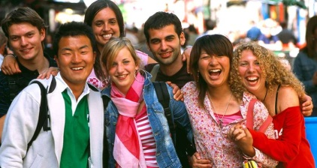
During travelling you will meet people that are very different from you. If you travel enough, you will learn to accept and appreciate these differences. Travelling makes you more open and accepting.

5) It provides you with unforgettable moments and experiences
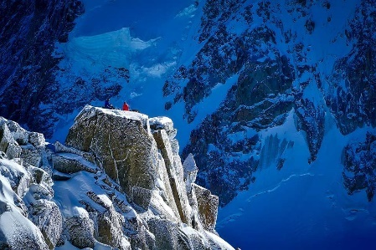
Some of my most cherished memories are from the times when I was travelling. If you travel, you can experience things that you could never experience at home. You may see beautiful places and landscapes that do not exist where you live. You may meet people that will change your life, and your thinking. You may try activities that you have never tried before.
6) It makes you more confident and independent
Travelling will inevitably make you more independent and confident. You will realise that you can cope with a lot of unexpected situations. You will realise that you can survive without all that help that is always available for you at home. You will likely find out that you are much stronger and braver than you have expected.
7) It lets you gain useful knowledge
If you travel, you may learn a lot of useful things. These things can be anything from a new recipe, to a new, more effective solution to an ordinary problem or a new way of creating something.

8) It improves your language skills
Even if you go to a country where they speak the same language as you, you may still learn some new words and expressions that are only used there. If you go to a country where they speak a different language, you will learn even more.
9) It motivates you
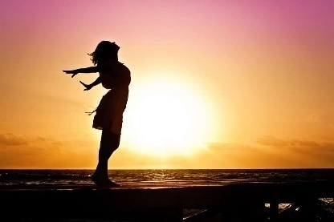
After arriving home from a long journey, a lot of travellers experience that they are much more motivated than they were before they left. During your trip you may learn things that you will want to try at home as well. You may want to test your new skills and knowledge. Your experiences will give you a lot of energy.
10) It provides you with stories you can tell your children and grandchildren
During travelling you may experience the craziest, most exciting things, that will eventually become great stories that you can tell others. When you grow old and look back at your life and all your travel experiences, you will realise how much you have done in your life and your life was not in vain. It can provide you with happiness and satisfaction for the rest of your life.
https://lifehacker.com/the-world-is-a-book-and-those-who-do-not-travel-read-o-5971748
NOTE
cultural differences – культурнівідмінності
see smth. with new eyes – побачитиіншимиочима
homeland – батьківщина
find out– з'ясувати
observe – спостерігати, відзначити
orientational and social skills – навички орієнтування та соціальні навички
more open and accepting – більш відкритий і доброзичливий
cherishedmemories– заповітніспогади
experience– досвід, знання; v дізнавати, переживати, пережити щось
inevitably– неминуче
confident – впевнений, самовпевнений
copewithasituation – впоратисяіз ситуацією
solution to a problem – рішення проблеми
in vain – марно, даремно
IV. Answer the questions:
1. How do you understand Saint Augustine’s quote “The world is a book and those who do not travel read only one page”?
2. Which part of the text is the most important/interesting and which part is not interesting or important?
3. What can you learn from travelling? Name as many points from the text as you remember.
4. What are the 5 main benefits you consider the most important?
5. How can travelling make you more confident and tolerant?
6. How can travelling make you motivated?
7. Can you add your own ideas about the benefits of travelling?
8. Think about the words confidence, independence, knowledge, motivation.
How are they connected to travelling?
9. Do you agree that travelling can boost self confidence, promote independence, increase knowledge and motivation.
Give your examples or arguments.
E.g.: When I travel, I have to confront my fears (to get lost, to lose my documents, etc.)
When I travel, I should rely on myself (finding places to eat, to buy smth., etc.)
V. Memorize words and word-combinations and make your own sentences.
Accommodation and services
to book/ reservein advance/ beforehand – замовити/забронюватизаздалегідь  have a (hotel) reservation – матизаброньовану кімнату у готелі  hotel – готель  put up at a hotel –зупинитисявготелі  there are no rooms available – вільнихномерівнемає  check in/out of the hotel –поселення/виселеннязготелю  hostel – хостел  motel – невеликий готель на шосе чи автостраді  vacateroominduetime–звільнитикімнатуупризначенийчас  payincash/paybycard – платитиготівкою/карткою | payment in local currency – оплатавмісцевійвалюті  chambermaid (maid)–покоївка  porter(BrE)/doorman(AmE)–швейцар/носійречей  pay for services – оплачуватипослуги  pay in advance / on departure –платитинаперед/привиїзді  single/doubleroom–одно-/двомісний(зоднимдвоспальнимліжком)номер  standardroom–стандартнийномер  Junior suite room – номер«напівлюкс»  Suiteroom–Номер«люкс»  Superiorroom – номерпідвищеногокомфорту  Twinroom – двоміснийномер(здвомаокремимиліжками)
all-inclusive – всевключено  B&B = bed and breakfast – тількисніданок  full-board (FB) – повнийпансіон | half-board(HB) – напівпансіон(якправило,сніданоктавечеря)  self-catering accommodation –житлозкухнею
VI. Fill in the gaps using the following words:
a) twin  b) bunkbeds  c) youthhostels  d) single  e) reservation  f) minibar | g) suite  h) family  i) bookaroom  j) frontdesk  k) wake-upcall | l) vacancies  m) double  n) motel  o) fullybooked  p) roomservice | q) checkedout  r) bellboy  s) checkedhimin  t) chargepernight  u) vendingmachine
1.WelcometotheBlueStarHotel.HowmayIhelpyou?–I’dliketo…fortwopeople,fortwonights.
2.DoyouhaveanyroomsavailableforJune,10th?I’dliketomakea….
3.Westayedinthecomfortable,spacious,newlyrenovated…forourweddingnight.
4.Howmuchisthesmallbottleofliquorinthe…?
5.Aroominwhichonlyonepersonshouldsleepiscalled…room.
6.Whenmakingareservationatahotel,Suewasaskedifshe’dprefertostayinasingleor…room.
7.Ineedaroom.Whatisthe…?
8.Carolpaidtheadditionalchargesonabill,…andleftthehotel.
9.WhenSamarrivedatthehotel,thereceptionistgreetedhimand….
10.Wearepleasedtoofferyoufull…asapartofourpackage.
11.Whenyoungpeople travel,theyoftenfindcheaperaccommodationin…
12.Afteraverylongdrive,thedrivercheckedintothecheaproadside…
13.Thehotelbarhasjustbeenclosed.Let’sbuyanorangejuiceboxfroma….Haveyougotanycoins?
14.I’mafraidthey’re…herebecauseoftheTradeFair.We’llneedtofindanotherhotel.
15.Anice…tookmysuitcasewithasmileandboughtittomyroom.
16.Wearefullybookedandhaveno…fortheupcomingweekend.
17.I’dlikea…forseveno’clocktomorrow.
18.You’llhavetocheckinatthe….
19.Ifyouwantaroomwithtwoseparatedbeds,youbooka…room.
20.Toget10peopleintooneroom,twobedsareusuallyplacedontopofeachother.Theyarecalled…room.
21.Forfamilies thereareusuallyspecialoffersiftheytakea…room.
VII. Match the words with their definition:
1) all-inclusive  2) half-board  3) full-board  4) self-catering accommodation  5) travel documents  6) backpack  7) visa regulations  8) baggage/luggage  9) local crafts  10) a tourist trap | a) service which would include all three meals (breakfast, lunch and dinner) in the price of your accommodation  b) everything that you need to travel, such as passport and tickets  c) laws that relate to entry into a country  d) an establishment that has been created with the aim of attracting tourists and their money  e) everything that you take with you on holiday  f) a hotel deal where the price includes accommodation, meals and drinks at any time  g) handmade things specific to a region  h) a fabric suitcase that you carry on your back  i) provision of bed, breakfast, and one main meal at a hotel or guest house  j) provided with lodging and cooking facilities but not meals
VIII. How important are the following hotel facilities and features to you? Can you think of any others?
anen-suitebathroom  airconditioning | warmandfriendlystaff  wirelessInternetaccess | roomservice  cable/satelliteTV | comfortablebeds  ahealthcentre
IX. Explain the differences between the following terms:
1.a key anda keycard?  2.a lift andan elevator?  3. checking in and checking out? | 4.a bill anda receipt?  5.a double room anda twin-bedded room?  6. full board and half board?
X. What are the following people responsible for in a hotel? Match the job titles with the responsibilities:
1.receptionist  2.chambermaid  3.porter  4.chef  5.waiter/waitress  6.generalmanager | a.cleaningandtidyingbedrooms  b.cookingmealsintherestaurant  c.helpingguestsatthehotelentranceandwiththeirluggage  d.runningthehotel  e.servingmealsintherestaurant  f.welcomingandhelpingguests
XI. Booking, checking in, checking out. Complete the dialogues below using the words and expressions from the chart:
available  bill | book  check | check in  fill | got  have  help | lift  reserve | served charge | charge  storeroom | fully  for | leave  key
Dialogue 1
Receptionist:Hello,PlazaHotel.MayI1) …you?
Guest:Goodmorning,I'dliketo 2) … asingleroomfortwonightsplease.
Receptionist:When 3) …,sir?
Guest:NextMonday,April3rd.
Receptionist:Letmejust 4) ...Yeswehaveonesingleroom 5) ….
Guest:Great.Howmuchisthe 6) … pernight?
Receptionist:Seventyeuros,sir.
Guest:OK,that'sfine.
Receptionist:CanI7) … yourname,please?
Guest:Yes,it'sCaulson.RobertCaulson.That'sC-A-U-L-S-O-N
Receptionist:OK,I've8) …that.Whattimewillyoubearriving?
Guest:Around8pm.
Receptionist:Thankyouandhaveaniceday.
Dialogue 2
Receptionist:Goodmorningsir,howmayIhelpyou?
Guest:Hello,I'vebookedasinglefortonight.Thename'sCaulson,C-A-U-L-S-O-N.
Receptionist:Yes,sir.Couldyou 9) … inthisform,please?
Dialogue 3
Receptionist:Hello,PlazaHotel.
Guest:Hello,I'dliketobookasingleroomforthisFridaytoSunday,please.
Receptionist:I'mafraidthehotelis 10) … bookedonSaturdayandSunday.Wouldyouliketo 11) … aroomforFriday?
Dialogue 4
Receptionist:Hereisyourkey.Yourroomnumberis302.Justtakethe12) … overtheretothethirdfloor.
Guest:Thankyou.WhattimedoIhaveto13)… outbytomorrow?
Receptionist:Checkouttimeis12pm.
Guest:Andcanyoutellmewhattimebreakfastis14) …?
Receptionist:Breakfastisservedfrom8to11am.
Dialogue 5
Guest:I'dliketocheckout,please.MynameisCaulson,room302.Here'sthe 15) ….
Receptionist:Justamoment,sir...Here'syour16)….
Guest:Canyoutellmewhatthis 17) … isfor?
Receptionist:That'sforthedrinksyouorderedlastnight.
Guest:OK.CanIpaybycreditcard?
Receptionist:Yes,ofcourse.
Guest:Onemorething.Ihaveatraintocatchinafewhours.CanI 18) … mybagssomewheretillthen?
Receptionist:Certainly.Youcanleavetheminthe 19) … overthere.
Guest:Thankyou.Goodbye.
WATCHING
XII. Before you watch the videos answer the questions.
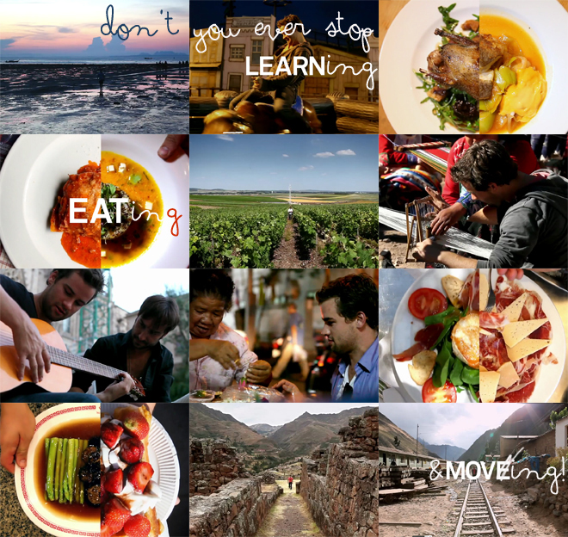
1. If You could travel to 11 countries in 44 days, which countries would you visit?
2. What would you do in each country? Tell the group your ideas.
3. Express your opinion on the following statement:Traveling basically means moving around. Discovering and MOVING to new places and finding new ‘friends you haven’t met yet’ on the road along the way. EATING new and exotic foods. And LEARNING about new things, cultures and languages.
4. Look at the photo collage and tell the group how the statement above is connected to the collage?
XIII. Watch 3 short clips MOVE, LEARN and EAT which show 11 countries visited by AndrewLees in 44 days.
www.vimeo.com/27246366
1. Try to name as many of the countries as you can.
2. Which of the things you would most like to learn to do?
3. What food and dishes are typical in the 11 countries in MOVE and LEARN? Can you name the ingredients used in the dishes?
XIV. POST-VIEWING QUESTIONS:
1. What adjectives would you use to describe the 3 short films?
2. How did the films make you feel?
3. Do you think the films have a message? What is it?
4. What adjectives would you use to describe Andrew?
5. What messages are hidden in these 3 movies?
XV. Write a composition My own epic journey. Use the ideas from 1 and 2. Write 3 paragraphs:
1) where would you go and why
2) what would you learn in each country
3) what would you eat and drink

Topic 6.2. Countries and Cultures.
When in Rome do as the Romans do.
WARM-UP
I. Comment on the meaning of the proverb written above. Share your experience if you have.
II. Discuss with your partner and answer the questions.
1. What are good manners? It is:
a) polite or well-bred social behaviour;
b) the treatment of other people with courtesy and politeness, and showing correct public behaviour;
c) a courteous manner
d) each of the enumerated above
Synonyms:etiquette; mannerliness; courtesy; courtliness; civility; propriety; good breeding; manners; gallantry.
2. Give your own examples of good manners (in the family, group, classroom, etc.)
3. In which spheres of life good manners are obligatory to be followed? Look at the pictures and try to connect them to the words in the box:
1) Greetings |  | 2) Table manners |  | 3) Punctuality |  | 4) Gender roles
5) Taboos | 6) Business |  | 7) Gestures |  | 8) Tipping |  | 9) Other

A 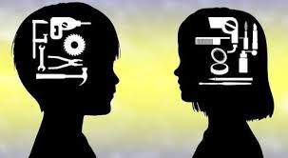B 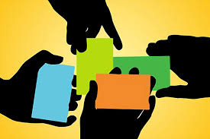C
D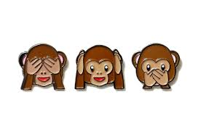E F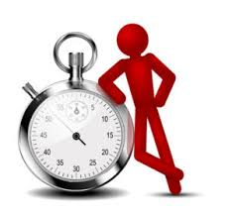G
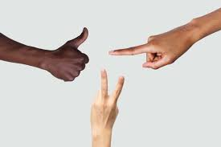H 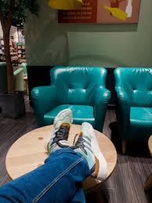 I 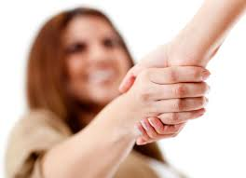 J

Active vocabulary
acknowledgment of the host's generosity – визнаннящедростігосподаря  apttounderstand–здатний зрозуміти  attest– засвідчити  avoid– уникати  begging– жебрацтво, жебракування  belching– відрижка  bone-crushing– нищівний  bumpintosomeone – зіштовхнутися з кимось  civility– ввічливість  comeacrossasrude – виглядати/здаватися грубим  compliment– комплімент, визнання  complimenttothechef– хвала кухареві  courtesy– ввічливість  courtliness– куртуазність, ввічливість  crushinghandshake– надто міцне рукостискання  culturalawareness– культурна обізнаність  cultures– культури  customs– звичаї  derogatory–зневажливий  disrespect– неповага  drillfromtheearlyage– муштрувати/ виховувати з раннього дитинства  etiquette – коректність  extension– продовження, додаток  exposeone'spalms – показувати долоні  extremelyrude– надзвичайно грубий  faceinward– долоня, спрямована всередину | forefinger– вказівний палець  gallantry– галантність  goodbreeding– вихованість  growtiredofscrapingsmthoff– втомитисящосьзішкрібати  habit– звичка  hardsqueeze– сильне стискання  host– господар  imply– мати на увазі, означати  ingrained –вкорінений  insult– образа  left-handed greeting – вітатися лівою рукою  mannerliness– скромність  manners– манери, поводження  moveahead– рухатися вперед  offensive– образливий, зневажливий  outofpoliteness–з ввічливості  propriety– пристойність  replicate– повторювати  restwithone’sfeetup– відпочивати з піднятими ногами (на стіл)  shoveintoone’spocket–сунути собі в кишеню  signofaggression–ознака агресії  signal– сигнал (тут жест)  socialbehaviour – соціальна поведінка  sole– підошва  swapbusinesscards– обмінятися візитками  the "peace" salute– жест, що означає перемогу або мир  thumb– великий палець  tipping– чайові  vulgar– вульгарний, плебейський  well-bred– добре вихований

READING
III. Read the text.
GOOD AND BAD MANNERS AROUND THE WORLD |  | A hearty handshake isn't what it seems in some Eastern cultures where it's seen as a sign of aggression.
Sit up straight. Say please and thank you. Don't put your elbows on the table. Most of us were drilled from an early age in proper manners and etiquette. But once you leave your home country, things get a bit complicated.
Perhaps you have heard this expression before that “When in Rome, do like the Romans do”. It means that whatever country you are visiting (living, working, etc.), it is polite to follow the customs of that societyand act as people acting in that place. Here are some examples of how other cultures do things differently.
1. Belching
In China, Taiwan, and much of the Far East, belching is considered a compliment to the chef and a sign that you have eaten well and enjoyed your meal.
2. Watch Your Feet!
In most of the Middle and Far East, it is considered an insult to point your feet (particularly the soles) at another person or to display them in any way, for example, by resting with your feet up.
3. Swapping Business Cards
In most Asian countries, a business card is seen as an extension of the person it represents; therefore, to disrespect a card – by folding it, writing on it, or just shoving it into your pocket without looking at it – isto disrespect the person who gave it to you.
4. Crushing Handshake
Nowadays, a bone-crushing handshake is seen as admirable in the United States and U.K., but in much of the East, particularly the Philippines, it is seen as a sign of aggression – just as if you gave any other part of a person's body a hard squeeze!
5. To Shake or Not to Shake
Orthodox Jews will not shake hands with someone of the opposite sex, while a strict Muslim woman will not shake hands with a man. To confuse matters, a Muslim man will shake hands with a non-Muslim woman. People in these cultures generally avoid touching people of the opposite sex who are not family members.
6.Clearing Your Plate
When dining in China, never force yourself to clear your plate out of politeness – itwould be very bad manners for your host not to keep refilling it. Instead, you should leave some food on your plate at each course as an acknowledgment of your host's generosity.
7. No Tipping!
In Japan and Korea, a tip is considered an insult, rather than a compliment, and for them, accepting tips is akin to begging. However, this tradition is beginning to change as more Westerners bring their customs with them to these countries.
8. Mixed Signals
The "okay" sign (thumb and forefinger touching to make a circle) is very far from okay in much of the world. In Germany and most of South America, it is an insult, similar to giving someone the finger in the United States, while in Turkey it is a derogatory gesture used to imply that someone is homosexual.
9. The "Peace" Salute
Similarly, in the U.K., when the two-fingered "V for victory" or "peace" salute is given with the hand turned so that the palm faces inward, it is considered extremely rude, having a meaning similar to raising the middle finger to someone in the United States.
10. Exposing Your Palms
In Greece, any signal that involves showing your open palm is extremely offensive. Such gestures include waving, as well as making a "stop" sign. If you do wish to wave goodbye to someone in Greece, you need to do so with your palm facing in, like a beauty pageant contestant or a member of the royal family.
11. Lose the Shoes
In many countries, particularly in Asia and South America, it is essential to remove your shoes when entering someone's home, while in most of Europe it is polite to ask your host whether they would prefer you to do so. The reason, as anyone who's ever owned white carpet will attest, is simple hygiene and cleanliness.
12. Chewing Gum
Chewing gum might be good for dental hygiene, but in many parts of the world, particularly Luxembourg, Switzerland, and France, public gum-chewing is considered vulgar, while in Singapore most types of gum have been illegal since 1992 when residents grew tired of scraping the sticky stuff off their sidewalks.
13. Don’t Rush a Meal in France
Being a dinner guest is more than just stopping by for a meal. It’s an event that will take much longer than a usual meal. Don’t eat too much of the first course because there will probably be more courses to follow.
14. Say Cheers on the Streets of Great Britain
British behavioral norms are similar to southern manners. Always be polite, regardless of the situation. If you bump into someone, apologize, even if it’s the other person’s fault. Not doing so comes across as rude. This manners habit is deeply ingrained in British children from a very early age.
You are likely to hear the word “Cheers” quite a bit when you’re in Great Britain. It’s often said in place of “Thank you” and “Goodbye.” If you’re not comfortable saying it, there’s nothing wrong with using other polite language.
The more you get out and see how a particular people live, the more you are apt to understand and replicate that custom. Just remember “When in Rome, do like the Romans do” and you will be moving ahead in your cultural awareness.
IV. A. Answer the questions:
1. What gestures are better to be avoided when travelling abroad? Give your examples.
2. In what countries public gum-chewing is considered vulgar or even illegal? Why?
3. Where is tipping considered to be insulting? Why?
4. In what countries belching is acceptable? Why?
5. Where is essential to remove your shoes when entering someone's home?
6. Where is pointing your feet at another person or displaying them considered to be insulting?
B. Find more examples of good and bad manners (5-7) and present them to the group.
V. Connect words with their definition or meaning:
1) apt  2) signal  3) compliment  4) avoid  5) manners  6) handshake  7) illegal  8) vulgar  9) well-bred  10) courtesy | a) keep away from or stop oneself from doing (something)  b) is a globally widespread, brief greeting or parting tradition in which two people grasp one of each other's like hands  c) lacking sophistication or good taste  d) having a tendency to do something  e) polite behaviour, or a polite action or remark  f) a gesture, action, or sound that is used to convey information or instructions, typically by prearrangement between the parties concerned  g) speaking or behaving in a way that is generally considered correct and polite  h) a polite expression of praise or admiration  i) not according to or authorized by law  j) the usual way in which you behave towards other people
VI. Follow the instructions:

A. Match synonyms: |  | B. Match antonyms:
1) habit  2)bad manners  3) replicate  4) compliment  5) courtesy  6) come across  7) ingrained  8) comes across | a) sound  b) respect  c) drilled  d) seem/look  e) reproduce  f) custom  g) praise  h) rudeness | 1) rude  2) disrespect  3) avoid  4) offensive  5) insult  6) confuse  7) bad manners  8) apologize | a) polite  b) clear  c) courtesy  d) mannerliness  e) insult  f) well-bred  g) compliment  h) replicate
LISTENING
VII. You will hear threepeople describe how they entertain guests in their country. Sumie is from Japan, Kate is from England, and Lucas is from Brazil.Listen and take notes in the chart below:
https://english-rooms.com/test/intermediate-listening-test-come-round-to-my-place
 | Sumie  Nagano,Japan | Kate  Bristol, England | Lucas  Porto Alegre, Brazil
The kind of invitation, formal or informal
The time of day
The preparations that the host or hostess makes
Gifts/ presents that people take
Food/drinks served
VIII. Work in small groups. Compare information. What similarities and differences are there?
IX. What happens in your country? Is it usual to invite people to your home for a meal? What are such occasions like in your home?
SPEAKING
X. Have you ever been a guest in someone's housein a foreign country? When? Why? What happened?
1. Do you agree with the saying 'When in Rome, do as the Romans do'? Do you have a similar saying in your language?
2. What are the 'rules' about greeting people in your country? When do you shake hands? When do you kiss? What about when you say goodbye?
3. Think of one or two examples of bad manners. For example, in Britain it is considered impolite to ask people how much they earn.
4. What advice would you give somebody coming to live and work in your country?
XI. Discuss the manners (greetings, table manners, punctuality, gender roles, tipping and taboos) in your country and in other country/-ies you have been to. (In case you don’t have any experience, choose the country of your dreams). Is it the same or different? Make a chart to compare. Add other positions if you consider them to be important.

 | Your country | Other country/-ies
Greetings
Table manners
Punctuality
Gender roles
Tipping
Taboos
Other
XII. Write an essay (200 words) on one of the topics:
1. Good Manners; Meaning, Value & Importance
2. Good manners and fine habits as reflections of character and personality
3. Importance of good manners
4. How habits reveal your personality

Topic 7.1.Health and Accidents.
WARM-UP
Think about words you associate with the words health and accident. Look at the pictures and match them with the problems.
A 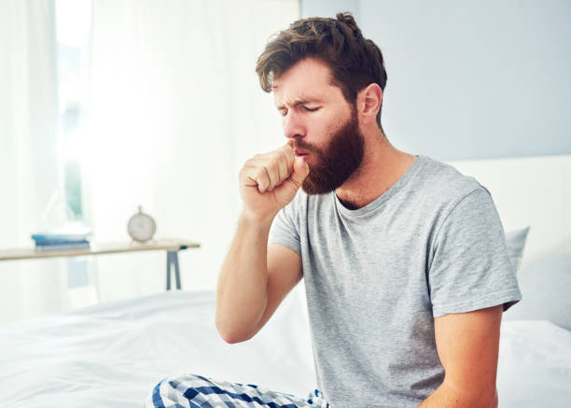 B  C

 D 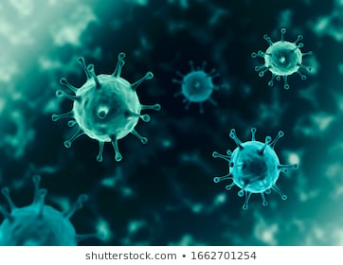 E 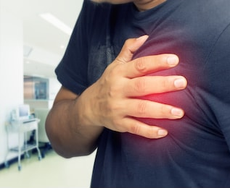 F

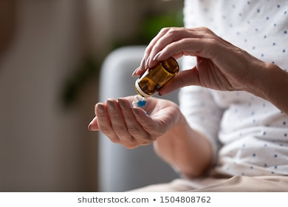 G 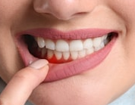 H 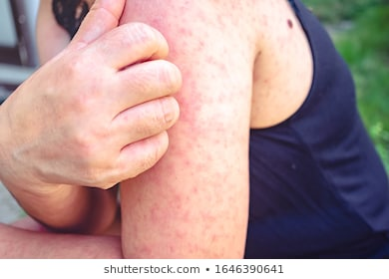 I
a) heart attack | b) stomach ache | c) toothache | d) cough | e) itchy
f) rash | g) headache | h) pills/tablets | i) fever | j) virus
Active vocabulary
ache(physical discomfort that continues for some time) – тривалий / ниючийбіль; боліти | pain (physical or mental discomfort, stronger than ache, more sudden, and more difficult to ignore) – гострий, сильнийбільабо страждання | hurt (is usually used as an adjective or verb, not a noun) –боліти, нанестиушкодженняякзабиття/рани, завдатиболю | sore– хворий (чутливий, болячий, запалений), болить, хворий
Diseases, illnesses, symptoms
allergy – алергія  be allergic to–матиалергію на  produceanallergicreactiontofood/antibiotics – мати алергічнуреакціюнаїжу/антибіотики  bite– укус  bleeding –кровотеча  brokenbone / fracture – перелом кістки  bruise (noun) – синяк  burn – опік  chickenpox – вітрянка  chills–озноб  choke – задихатися  cold(noun) – застуда  contagious– заразний  cough – кашель; кашляти  cut(noun) – поріз  diarrhea – діарея  dizziness – запаморочення  drowsy – сонливий  faint – знепритомніти  feelill – почуватися погано  -sick – хворим  -weak – слабким  -dizzy – відчувати запамороченняfever –лихоманка  fightcancer / depression / addiction – боротисязраком/депресією/залежністю (нарко-/алко-)  frostbite – обмороження  giddy – запаморочливий  haveastroke – матиінсульт  hazard – небезпека  heartattack –серцевийнапад  heartdisease – захворювання серця  to inhale–вдихати  injury(noun) – рана, поранення  internalinjury – внутрішнє поранення  to injure(verb) – поранити | nausea – нудота  insomnia – безсоння  itchy – сверблячий, що свербить  mentalillness– психічні розлади  poisoning–отруєння  rash(noun) – висип  runnynose – нежить  scar – шрам  scratch(noun) – царапина  sickness – захитування  airsickness – повітряна хвороба  motionsickness – морська хвороба  seasickness–морськахвороба  sneeze(verb) – чхати  sufferfrom – страждати від  - stomachcramps – спазмів ушлунку  -asthma – астми  -malnutrition – недоїдання  -diabetes –діабету  sunburn(noun) – сонячний опік  asprain (jointdislocation) – вивих (суглоба), розрив (зв’язки)  -sprainedshoulder /knee / elbow / wrist / finger / hip / foot / ankle– матирозтягнення плеча / коліна / ліктя / зап'ястя / пальця / стегна / стопи / щиколотки  sweat – потіти  swollen – набрякший  atwist – вивих, підвернення  - twistedankle/ thumb / knee / leg / finger / toe – матипідвертання щиколотки / великого пальця / коліна/ ноги / спини  unconscious –непритомний  vomit / tothrowup(verb) – блювати  wound(noun) – рана (рвана, різана, колота)
Treatment
to bandage an arm / leg – перев'язатируку/ногу  crutches – милиці  cure(noun) – ліки, лікування  tocure(verb) – вилікувати, зціляти  diagnosis(noun) – діагноз  todiagnoseanillness/adisease/acondition/adisorder – діагностуватихворобу/захворювання/стан/розлад  disease(noun) – хвороба, захворювання  toheal(verb) – зціляти, гоїтися  ill – хворий  illness(noun) – захворювання, слабість  sick – хворий  sickness – хвороба, недуга, недужість  to dressawound–перев’язатирану  to put on a plaster cast / bandage – накластигіпс/бандаж  to put stitches in a wound – накласти швина рану  to examine a patient – оглянутипацента  firstaid – перша допомога  firstaider – людина, яка надає першу допомогу  firstaidkit – аптечка для надання 1ої допомоги  to give an injection – зробитиіньєкцію | infection (noun) – інфекція  inflammation (noun) – запалення medicine (noun) – ліки  antibiotics(noun) – антибіотик  painkiller – знеболювальні ліки  prescribe medicine / make up a prescription – виписатирецепт на ліки  remedies – ліки, засобизахисту  sling – плащоподібна пов’язка  to take blood pressure– помірятикров’яний тиск  to take /have bloodtest – робити/здаватианалізкрові  totake/feelone’spulse – порахуватипульс  to take(smb)tohospital – відвезти у лікарню  to take /measure one’s temperature – помірятитемпературу  to take medicine / antibiotics – приймати ліки / антибіотики  to take an X-ray – зробити рентген  to treat – лікувати  treatment(noun) – лікування  undergo an examination / operation – пройтиобстеження/операцію
If something is wrong with you, it’s important to be able to explain it, to describe it. These are the common collocations:
Noun +Ache | discomfort that continues for some time | stomachache, headache, muscle ache, backache, heartache (emotional pain);  dull ache – тупий / ниючийбіль
Noun+Pain  Pain + N | moresudden and morestronger, moredifficulttoignore | abdominalpain, back pain, muscle pain  cutting pain – різкий біль; burning pain – пекучий біль  pain in one’sback/ chest/ waist/ arm/ shoulder
I have a pain / ache in my ankle / neck / shoulder.

Sore+ Noun | beingill | +throat  +eyes | +feet  +gum | +mouth – стоматит
bad + |  | badback –болі в спині; badleg – хвора нога
Hurt | isusedasanAdjectiveorVerb | Myankle/neck/shoulder hurts.  I have hurt myself. – Я поранився.
Phrasal verbs
stuffed up (nose) – blocked  to come down with a cold/flu – tostartgettingsick  to fight something off – totryyourbesttogetbetter  to get over a cold/flu – torecoverfromadisease  to look after someone – totakecareofsomeone | to pass away – todie  to pass out – tofaint  to pick something up – tocatchsome disease  to pull through – thepersonwill survive, will continue living  to shake something off – totrytogetbetter  to swell up / be swollen – fluidaccumulatedundertheskin(glands,arm,leg…)
Idioms
Rundown –feelingsick fromlivinganunhealthylifestyle  to be under the weather/ off colour – tofeelabitill | Under the weather –notfeelingyourselfusual,healthy  to feel sick / be going to be sick – Br. be going to vomit or throw up
I. Parts of the body – find the odd one out. Underline the word that does not fit. Explain why the word does not belong.
Ex.eye – nose – lips – finger – It’snotpartoftheface.
1.ankle – toe – heel–thumb
2.shoulder – knee – wrist – elbow
3.heart – lungs – hip – kidneys
4.chin – calf – ears – neck
5.palm – tongue – thumb – fingernail
6.brow – lash – knuckle – eye
7.moustache – beard – eyebrow – nail
8.thigh – shoulder – calf – knee
9.liver – neck – kidney – stomach
10.lip – tongue – cheek–teeth
II. Name the Body Part (There may be more than one correct answer.)
E.g.:Theseareusedforwalking. – legsorfeet
1.Thisisusedtosmell.
2.Theseareusedtochew.
3.Thisisusedtothink.
4.Thisisfacialhaironaman’scheeksandchin.
5.Theseareusedtopickthingsup.
6.Thisisusedwhenyouswallowfood.
7.Thisishairoverthelip.
8.Thisconnectstheheadtothebody.
9.Thisjointallowsyourarmtobend.
10.Thisjointconnectsyourhandtoyourarm.
11.Thisjointconnectsyourfoottoyourleg.
12.Thisjointallowsyourlegtobend.
13.Thisisusedtotalk.
14.Thishurtsifyouhaveabadcough.
III. Match the words on the left with the correct meaning on the right.
1. first aid kit  2. treat  3. symptoms  4. be under the weather  5. relief  6. heal  7. disease  8. pick smth up  9. unconscious  10. drowsy  11. nauseated | a) an abnormal condition affecting a living organism  b) cause (a wound, injury, or person) to become sound or healthy again  c) tired  d) a collection of supplies and equipment that is used to give medical treatment  e) give medical care  f) tofeelabitill  g) sick to the stomach, feel like vomiting  h) when a person suddenly becomes unable to respond to stimuli and appears to be asleep  i) conditions of an illness  j) making better, removal of pain  k) to catch some disease
IV.Tell in one word used from the box.
a) headache  f) cough | b) allergies  g) blocked | c) dizzy  h) prescription | d) sweating  i) fever | e) food poisoning  j) sick
1. Another way to say that somebody has a 'very high temperature', is…
2. When a person finds it difficult to breathe through the nose, their nose is…
3. When you have pain inside of your head, you have a …
4. A phrase that has a similar meaning to 'I was ill', is …
5. When you feel confused and everything seems to be moving, you are …
6. A loud noise that comes from the mouth. It is something that smokers often do, is …
7. An illness caused when somebody has eaten something which is bad, is called …
8. When water leaves the body through the skin, is …
9. The thing given by a doctor to buy medicine is a …
10. Spring and autumn are the periods when … come up.
V. Name the problem. Choose from the box.
a)chestycough | b) runnynose | c) upsetstomach | d)hayfever | e)sprainedankle
f) brokenbone | g) hightemperature | h)travelsick | i) badback | j) sorethroat
1.Somepeoplemightfeelthiswhentheygoonajourney.
2.ThisaffectsalotofpeopleduringtheSpringandSummer.
3.Ifyouhavethisyouarewarmtothetouch.
4.You'llneedapackoftissuesifyou'resufferingwiththis.
5.Thisisoftencausedbyliftingheavyobjects.
6.Thismakesit difficult toswallow.
7.Youmightsufferfromthisifyoueatsomethingbad.
8.Thiswillmeanatriptohospital.
9.Youmightgetoneoftheseifyouwalkorrunonunevenground.
10.Oneofthesymptomsofabadcold.
VI. A) Fill the gaps with the correct word or expression from the list below.
a) allergic  g) itchy  m) swollen | b) sneeze  h) runny  n) dizzy | c) sore throat  i) nauseated  o) fever | d) diarrhea  j) bruise  p) rash | e) chills  k) scratch  q) vomit | f) faint  l) contagious  r) hangover
1.WhenIhaveacold,Ihavea…noseandI…alot.
2.Anneis…tosomeantibiotics.Whenshetakespenicillin,herfacebecomesswollen.
3.Bettyfelldownwhenshewasskating.Shehasabig,purple…onherleg.
4.Ihavea….IthurtswhenIswallow.
5.Ican’tgetwarm.Iamshivering.Ihavethe….
6.Ihaveastomachacheandtheruns.Ihave….
7.Shehasn’teatenfortwodays.Ifshedoesn’teatsomethingsoon,sheisgoingto….
8.Amosquitobiteisvery….
9.Hertemperatureis40degreesC.Shehasahigh….
10.Whenchildrenhavechickenpox,theywantto…theirskinbecauseitisveryitchy.
11.Johntwistedhisanklelastweek.Itisstillbadly….Itistwiceasbigasnormal.
12.Cancerisnota…disease,butinfluenzais.
13.Yesterdayheworeawoolensweater.Nowhehasa…alloverhischest.Heisprobablyallergictowool.
14.Hehadtoomuchwinetodrink.Hefeelsvery….Theroomisspinning.Tomorrowhewillprobablyhavea….
15.Shehasanupsetstomach.Shecan’tkeepherfooddown.Sheisgoingto…again.Shehasfelt…allday.
B)
a) sprain |  | b) first aid kit |  | c) crutches |  | d) (plaster) cast |  |  | e) sling
f) plaster | g) bruise |  | h) faint |  | i) stitches |  | j) scar | k) blooddonor
1. Ak) blood donoris someone who donates some of their own blood to help people who have lost too much blood.
2. A … is a box which contains medical equipment which is useful in an emergency.
3. If you break a bone in your leg the doctor sets the leg in a …which stays on for about six weeks.
4. If you cut yourself you put a …on the cut to protect it.
5. A ... is a mark on your skin, often a white line, where the skin healed after a deep cut.
6. If you have a deep cut a doctor needs to close it with … .
7. If you hurt your arm or shoulder you may need to rest your arm in a … .
8. You … when you lose consciousness because your brain isn’t getting enough oxygen.
9. A … is a mark on your skin which appears after bumping against something hard. The skin changes colour from blue or purple to red and yellow over a few days.
10. You … your wrist or ankle when you twist it too far.
11. You use a pair of … to help you walk if you have hurt one of your legs or feet
VII. A) Discuss the difference between the words in each group below.
A) pain - hurt - injure - ache | B) treat - cure - heal
B) Choose the correct word in the sentences below.
1. What would you do if you had a sudden pain/ache in your abdomen?
2. On a scale of 1 to 10, how much does it hurt/ache when you are being given an injection in your arm?
3. If you stay on your feet all day (in comfortable shoes), do your feet hurt/ache in the evening?
4. Have you ever stepped on something sharp and hurt/injured your foot? When? Where?
5. Have you ever worn shoes which were too tight and hurt/injured your feet?
6. Have you ever hurt/injured someone emotionally?
7. What would you do to help people who had been hurt/injured in an accident?
8. Do you think paramedics should deal with the hurt/injured at the scene of the incident or just stabilise the patient and take them to hospital?
9. When you have a cold or flu, what medication do you take to treat/cure it?
10. In your opinion, how likely is it that scientists will find a treatment/cure for the common cold?
11. To what extent do you agree that sometimes the treatment/cure is worse than the disease?
12. If you have a small cut on your hand, do you go to the doctor or wait for it to heal/cure by itself?
13. Do you believe that alternative therapies, such as acupuncture, can heal/cure addiction to alcohol, nicotine, etc.?
14. Do you believe that some people have healing/curing hands?
VIII. The 10 verbs below are all related to medical problems. Use the letters to complete the verbs.
1. If you drink some very hot tea, it will b___ your mouth.
2. When you are making a sandwich, don’t _u_ your hand with the knife!
3. Humans can’t b_____e when they’re under water!
4. If you eat too much chocolate, you will have a s_____h ache.
5. Don’t run in the house! You’ll f___ down the stairs!
6. If you try to pick up something very heavy, you could in _ _ _ _ your back.
7.Averbthatmeansa'soft'or'mild'painthatnormallyaffectsthemuscles,is a _ _ _ .
8.Anotherwaytosay'vomit'somethingyouhaveeaten,ist____up.
9. Averbthatisusedtodescribeasharp/intensepain,is ___t.
10. Cardiologist is adoctorwhot____speople with heart problems.
1. burn  6. injure | 2.cut  7. hurt | 3.breathe  8. throw | 4. stomach  9. ache | 5. fall  10. treats
IX. Fill in the blanks with the missing words.
a) cold |  | b) headaches |  | c) hurt |  | d) illnesses
e) pains | f) pull a muscle |  | g) relax |  | h) stressful |  | i) stressed
Nowadays many people have very 1) … lives. Doctors say that stress can cause many 2) … , and in some cases even heart attacks. If you are feeling 3) … you are also more likely to get a 4) … or flu, or suffer from 5) … . You should try to rest and 6) … , and do exercise to keep fit. But be careful! You should start slowly, or you could 7) … your back or 8) … . If you notice any 9) … after doing exercise, see a doctor.
X. A) Determine the illness by reading the symptoms. Use the words from the box and follow the example.
a) cold | b) diarrhea | c) food poisoning | d) sore throat | e) is choking
f) feel sick | g) twist the ankle | h) feel dizzy | i) have cut | j) flu
k) high blood pressure | l) faint | m) burn | n) stomachache | o) allergic reaction
1. Tim has a temperature and aches all over.He has the flu.
2. Carol says that it hurts, when she talks, or swallows her food.
3. It’s so hot in the room that Marisa has lost consciousness.
4. Nadal's been in the toilet five times this morning. He can't stop using the bathroom.
5. Ivy feels like she's going to vomit.
6. The girl's sneezing a lot and has a cough.
7. Paulina feels that everything is spinning around.
8. Tanita's bleeding.
9. Mary's spilt some boiling water on herself.
10. Kevin fell badly and now his ankle is swollen.
11. Normal blood pressure is less than 120 over 80 (120/80). But Tony’s 180 over 140.
12. Paolo ate some prawns in the restaurant. Unfortunately, they were bad and he got sick.
13. Maurice was eating a steak and a piece of it got stuck in his throat.
14. Carol was stung by a wasp and now he she a rash and difficulty breathing.
B) Write 5-8 examples of your own and ask your groupmates to identify the illness.
READING
XI. A) Read the story.
Pete's Sharp Knife
Pete was in his kitchen. He was about to slice three green apples. He liked to eat fresh apples with cinnamon sprinkled on them. He opened the blinds so that he could get more sunlight into the kitchen. Now he could see what he was doing.
He grabbed a knife out of a drawer. It said "Surgical Stainless USA" on the side of the blade. The blade was very thin and light. It had teeth, like a saw. The handle was a brown piece of cheap hollow plastic.
He had bought this knife about 20 years ago at a county fair. It was one of those knives that were advertised on TV. It could cut through a tomato can, and then cut easily and cleanly through a fresh tomato.
"You never need to sharpen it. The sharp edge is guaranteed for life." That's how they advertised it. And Pete, for once, couldn't argue that the advertisers lied. This was a great knife.
But it was also a dangerous knife. A couple of years ago, Pete was careless. He was rapidly slicing a potato and the blade got his finger. The doctor put three stitches in Pete's finger.
"Next time, be more careful," the doctor said.
No kidding, Pete thought. He was so careful that he didn't use the knife for almost a year.
B) Answer the questions:
1. Where was Pete when the accident happened?
2. Was he about to slice apples or oranges?
3. Did he like to sprinkle salt on fresh apples?
4. When and where did he buy the knife?
5. He used to sharpen it often, didn’t he?
6. The doctor praised Pete for being smart, didn’t he?
7. How long hasn’t he used the knife since his accident?
8. What’s the moral of the story?
XII. Read about 4 people who need to phone an ambulance. In each conversation, the Caller is the person with the medical emergency; the Operator is the medical expert.
A) Read the 4 texts and decide if the sentences after each text are true or false.
1.
Operator: Can you describe the problem to me, please?
Caller: Yes. I was cutting some vegetables and I cut my hand!
Operator: Ok, and is your hand bleeding?
Caller: Yes, there’s a lot of blood! I need help!
Operator: Ok. Try to stay calm. How big is the wound?
Caller: About two centimetres long and one centimetre deep. It’s horrible!
Operator: Ok. I’ll send an ambulance to you. But first, you need to try to stop the bleeding.
Caller: Ok, how?
Operator: I need you to find a clean T-shirt. Put it on the wound and push down very hard.

a) The caller seems quite calm. T / F
b) The caller needs to put a T-shirt on his hand. T / F

2.
Operator: Hello. What’s your emergency, please?
Caller: Yes, my sister has fainted!
Operator: Ok. And is she conscious now?
Caller: No. She’s completely unconscious.
Operator: And is she breathing?
Caller: Yes, she’s breathing normally.
Operator: Ok. What happened exactly?
Caller: We were eating lunch. And suddenly she stopped talking and fell on the floor.
Operator: Ok. And did she hit her head when she fell?
Caller: No.
Operator: Ok. An ambulance will be there in a few minutes. But first, I need you to put her in the recovery position. So, make sure she’s lying on her right side, with her left arm under her head.

a) The caller’s sister is not awake. T / F
b) The operator tells the caller not to touch her sister. T / F

3.
Operator: Could you tell me what the problem is, please?
Caller: Yes. My daughter was playing in the kitchen and she swallowed some washing powder. And now she feels sick.
Operator: Ok, so she ate a toxic substance.
Caller: Exactly.
Operator: Is she conscious and breathing?
Caller: Yes.
Operator: And is her face swollen?
Caller: No, her face is normal. But her neck is a little red, so I’m worried that she’s having an allergic reaction.
Operator: Ok. I’ll send an ambulance to you. But first, I want you to give her a glass of water. She needs to drink it slowly. And if she starts to vomit, that’s ok.

a) The child feels sick because she ate some bad food. T / F
b) The child is having a very strong reaction. T / F

4.
Operator: Hello. Can you tell me what your emergency is, please?
Caller: Yes, I think my friend is having a heart attack! He needs an ambulance quickly!
Operator: Ok. What are his symptoms?
Caller: He has very strong chest pain and he says he feels sick.
Operator: Is he conscious?
Caller: Yes, but his face is very pale.
Operator: Ok. The ambulance will be there very soon. I need you to stay with your friend until it arrives.
Caller: I know how to do CPR. Should I start it?
Operator: No. Your friend is conscious, and the ambulance will be there in two minutes. So, there’s no need for CPR – give him space so that he can breathe.

a) The situation is not really an emergency. T / F
b) The operator tells the caller not to touch her friend. T / F
CPR = (cardiopulmonary resuscitation) a treatment in which you press someone’s chest repeatedly to make them start breathing again and make their heart start working again
B) In the texts above, there are 12 phrases that are in categories in the table below. Match each phrase to its definition.

Verbs | Adjectives | Nouns
bleed  faint  hit  swallow  vomit | conscious  unconscious  swollen  pale | wound  heart attack  symptom
1. … – an injury on your skin, usually serious and with blood
2. … – when an area of your body gets bigger as a result of an injury or an illness
3. … – when food comes up from your stomach and out through your mouth because you are ill
4. … – awake and able to see, hear, and think
5. … – a sign that someone has an illness
6. … – when a person’s skin is a lighter colour than usual because they are ill, shocked, or worried
7. … – to have blood flowing from your body, for example from a cut in your skin
8. … – in a condition similar to sleep in which you do not see, feel, or think, usually because you are injured
9. … – to move quickly onto an object or surface, touching it with force/impact
10. … – when someone suddenly has a lot of pain in their chest and their heart stops working
11. … – to suddenly become unconscious for a short time, and usually fall to the ground
12. … – to make food or drink go from your mouth down through your throat and into your stomach
C) Complete each sentence using one word from the previous tasks.
1. In hot weather, it’s important to wear a hat, clothes and sun cream. That way, the sun can’t burn your … .
2. If you have a pain in your … , it doesn’t always mean that you are having a heart attack! Perhaps it could be related to stress, or to something you ate.
3. If you’re feeling extremely nervous, it’s important to … slowly and try to take in as much air as you can.
4. Yesterday, I hit my finger against the wall. Now my finger is completely … – it’s so big!
5. After you have an operation, it’s important to wash the … until your skin returns to normal.
6. The last time that I fainted, I was completely … for about a minute. When I woke up, Ididn’t know where I was!
7. If a person is having a heart attack, a common … is to feel pain in the left arm.
8. Mike can’t eat some types of fish because they make him have an … reaction. It’s quite dangerous!
SPEAKING
XIII. A) Answer the questions?
1. Have you ever been in an ambulance? To hospital?
2. Do you have a first-aid kit at home, or in the car? Can you name four things usually found in a first aid kit? Have you ever given anyone first aid?
3. How do you feel about having injections?
4. Are you allergic to any drugs, e.g. penicillin?
5. What’s your blood group? Are you a blood donor?
6. Have you ever fainted, or felt faint? Why? What happened?
7. Do you have any scars? How did you get them?
8. Have you ever needed crutches? Why? How long did you need them for?
9. Have you ever worn a plaster cast? Why? What happened? Did your friends write on it?
10. Have you ever sprained your wrist? How? Did you wear a sling?
B) Ask your partner the following questions.
1. Have you ever given anyone first aid? Would you like to be a trained first aider?
2. Do you often have hiccups? What do you do to stop them?
3.How do you feel at the sight of blood? Would you like to give blood? Why (not)?
4. Have you ever had a cut which needed stitches? How many stitches did you have?
5. Do you bruise easily? How long does it take for your bruises to heal, usually?
6. When you need to take a plaster off, do you pull it slowly, or rip it off quickly?
7. Have you ever burnt yourself? How?
8. Have you ever helped anyone who has fainted? What did you do?
C) Make up a dialogue using the questions from A and B.
XIV. There may be different treatments or remedies for some health problems in different countries. How do you usually treat the following issues?
E.g.Whatdoyoudowhenyouhaveacold?
-WhenIhaveacold,I...
- If I caught a cold, I usually …
Health Problem | Remedy | Remedy | Remedy
Runny nose | Warm water and salt could be all you need to get rid of that runny nose.
Headache |  | Try peppermint oil
Hiccups
Toothache
Minoraches
Blocked nose
Stomach ache
Muscle pain
Insomnia
XV. Speak in pairs, taking it in turns to be the caller or the operator. For each conversation, follow these instructions:
• If you are the caller, describe the medical emergency which you have. You must include the 3 words/phrases suggested in the role-card. Remember to use verbs in the appropriate tenses.
• If you are the operator, listen carefully to the caller. Ask questions and make decisions, as suggested in the role-card.
To begin, you have an example.
Caller role-card  (The caller is Student A for Conversations 1&3, and Student B for Conversations 2&4) | Operator role-card  (The operator is Student B for Conversations 1&3, and Student A for Conversations 2&4)
Conversation 1 (Caller = Student A):  fall, cut, faint  Conversation 2 (Caller = Student B):  pale, allergic reaction, swollen  Conversation 3 (Caller = Student A):  swallow, toxic substance, vomit  Conversation 4 (Caller = Student B):  hit, injure, wound | You need to know:  - what happened  - if the patient is breathing  - if the patient is bleeding  - if the patient is conscious  Decide if you need to:  - send an ambulance  - ask the caller to do some action  - give other suggestions to the caller
XVI. Discuss the questions below with your classmate.
1. Think of common medical emergencies that happen …  - in the kitchen  - at the swimming pool  - during a football game  - in a restaurant  - in a classroom full of small children | 2. What should you do if you …?  - work/study a lot of hours and now you have a headache.  - touch something hot and burn your finger  - have a blocked nose because of a bad cold  - fall off your bike and injure your leg  - cut your finger when you’re cooking

Topic 7.2. Healthy Way of Life.
WARM-UP
What is healthy lifestyle. Are there any ideas shown in the photos below?
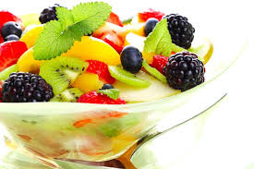A 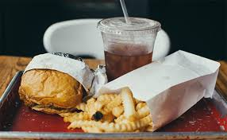 B
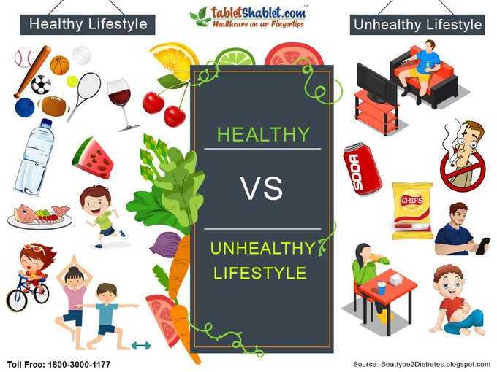

walking | habit | calories | detoxify | exercises

Active vocabulary
addiction – залежність  food with additives/ junk food/ fast food – їжа з добавками, фастфуд  bad/ unhealthyhabit – шкідлива звичка  abigdrinker – хто любить випити  burncalories – спалювати калорії  cutdownon– скоротити  detoxifyyourbody – провести детоксикацію / очищення організму  diet– дієта, харчування  balancedd.– збалансоване харчування  keep to a/ follow a/ be on d.– бути на дієті  digest – перетравлювати  doharm – нанестишкоду  anearly/alateriser – той, хто рано / пізно прокидається  eliminate – усунути, виключити  feelcravings – відчувати тягу/ бажання (що змушує до певної діяльності)  food – їжа, продукти  conveniencef. – напівфабрикати  f. intolerance – харчова непереносимість  f. rich in calories / fatty f. – калорійна їжа  f. with additives/ junk f./ fast f. – їжа з добавками, фастфуд  prefer organic f.– надавати перевагу здоровій/органічній їжі  processedf.– оброблені харчові продукти  habit– звичка, звичай  bad/ unhealthyh. – шкідлива звичка  get into a h. of – завести звичку | get rid of a /kick the h.– позбутися звички  have a sweet tooth –ласун/ка  have little physical activity – малорухатися  improve health – покращити здоров’я  influence our health – впливати на здоров’я  ruin health – нашкодити здоров’ю  takecareofyourhealth – турбуватися про своє здоров’я  inmoderation – в міру  livearegularlife – вести правильний спосіб життя  loseweight– похудати  put on/gain weight –набративагу  beobese / overweight–матинадлишкову вагу  makeitarule – взяти за правило  nutritious – поживні речовини  sedentarylifestyle – малорухливий спосіб життя  serving – порція  skipbreakfast – пропускатисніданок  snack – закуска, перекуска  stayoff–уникати  stick to a diet –дотримуватисьдієти  strain – напруга, стрес  take care of your health – турбуватися про своє здоров’я  takeregularexercises – робити вправи регулярно  vice – порок, слабкість  (un)healthy way of life = (un)healthy living – (не)здоровий спосіб життя
asfitasafiddle –здоровий та у чудовому настрої  getone’sfiveaday–їсти принаймні п’ять порцій фруктів та овочів на день | fresh as a daisy – you feel energetic and lively  Coffeeismyvice – Кава –моя слабкість  vital – життєвоважливий
An apple a day keeps the doctor away.
A healthy body is a healthy mind!
You are what you eat.
I. Match the words with their definitions.
1) addiction  2) nutritious  3) eliminate  4) serving  5) snack  6) variety  7) vital  8) cravings  9) appetite  10) strain | a) to remove or takeaway  b) small amount of food between meals  c) a very strong desire for something  d) stress or overwork, physical or mental  e) the state of being unable to live without smth.  f) extremely important  g) amount of food given to one person  h) the feeling that you want to eat food  i) changing and being a lot of different  j) containing many of the substances needed for life and growth
II. Find the corresponding expression for each explanation. There are two extra expressions.
cut down on smth  detoxify your body  get ones five a day  burn calories | improve health  digest  food intolerance  stick to a diet | convenience food  loseweight  processed food  Coffee is my vice | sedentary lifestyle  fatty food  balanced diet  have a sweet tooth
1. to remove impurities and poisons
2. food rich in calories
3. you cannot digest a particular food in a normal way and may feel ill if you eat it.
4. food which is cooked in its packaging, usually in a microwave
5. to eat at least five portions of fruit and vegetables a day
6. you eat all the right food your body needs
7. a lifestyle when people sit for long periods and are generally inactive
8. continue doing, using, saying, or talking about it, rather than changing to something else
9. you mean that you probably drink too much of that
10. to have less of smth., to do something less than before
11. like sweet food very much
12. move around, exercise, and go about your daily tasks
13. food that has chemicals or other substances added to it
14. to change food in your stomach into substances that your body can use
III. A. Divide the following words into two groups:

caviar | salt |  | coffee | tea |  | cola |  | juice | bread |  | buns
biscuits | pizza |  | sweets | milk |  | cheese |  | cream | yoghurt |  | butter
eggs | meat |  | sausage | fish |  | cereals |  | rice | fruit |  | sugar
cottage cheese |  | dairy products |  |  | sour cream |  | vegetables |  |  | chocolate

Good for your health | Bad for your health
B. Explain your choice.
E.g. Cheese is a great source of calcium, fat, and protein. It also contains high amounts of vitamins.
Consuming too much added sugar can raise blood pressure and increase chronic inflammation.
IV. What things can help us to keep fit? Make pairs of good and bad things and explain your choice.One pair is given as an example.
eating healthy | confronting people | regular eating | sitting too much
spending time in nature | not staying hydrated | cooking at home | being a workaholic
regular exercise | forgetting to call loved ones | getting enough sleep | staying on low-carb and low-fat diet
drinking clean water | ordering takeout | quiet life | staying indoors for more than 2 days in a row
dancing | eating fried / grilled food | hugging people | overtraining
E.g.Healthy eating means eating a variety of foods that give you the nutrients you need to stay healthy.
V. Here are some pictures suggesting ways to keep healthy. Talk with your friend about how important you find each of these aspects, and then agree with each other on three that you would both recommend to another friend. Try to use the phrases/words in the speech bubbles and in the box and vocabulary to discuss the topic.

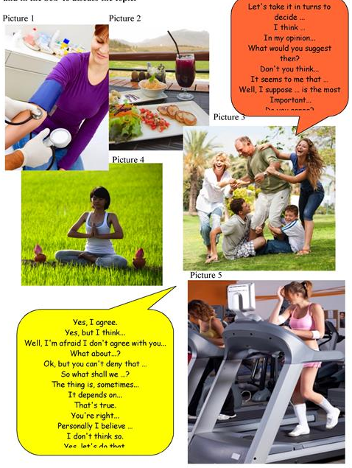
READING
VI. Read the text
Healthy Way of Life
Food we eat also influences our health. Nowadays people are very busy and they often eat in fast-food restaurants as they don’t have time to cook. Fast food is unhealthy. It is very rich in calories (fatty) and has a lot of additives. This food gives a lot of energy. But if you don’t work it out, it becomes fat in your body. The same is with chocolates, cakes and sweets. They have a lot of fat and sugar. People should get rid of a habit of eating fast food and get into a habit of eating organic food such as fruit, vegetables, and fish. There are other bad habits, which can ruin our health. It is smoking, drinking alcohol and using drugs.
Our health depends on many things: our physical activity, the food we eat and our good and bad habits. Although a lot of people are interested in staying healthy, not many people do very much about it. Modern way of life when people have little physical activity, use cars instead of walking, watch television and work on computers for many hours is quite dangerous for their health. People’s health also influences their mood.
There are many opportunities to stay healthy and be fit and one of them is going in for sports. But you needn’t be a professional sportsman. Just simple regular exercises give you energy and help you feel and look better.
Exercises that involve repeated movements such as are walking, jogging or swimming are the best. Bending and stretching which are practiced in aerobics or yoga makes your body flexible and light. The cheapest and most popular sport is jogging. If you don’t have time for it, make small changes like using stairs instead of the lift or walking or cycling instead of taking the bus and it can help you to improve your health and make you a more active person.
Also, it is very important to get rid of bad habits. The worst ones are smoking and drinking alcohol. Smoking doesn’t only cause heart and lung problems but also makes your teeth yellow and skin unhealthy.
Food we eat also influences our health. A lot of people like drinking Coca-Cola and coffee and enjoy pizza and hamburgers. But what is tasty is not healthy. You should avoid eating in fast-food restaurants and make it a rule to cook meals at home using organic food as much as possible.
Only a healthy man can enjoy his life, work well and be happy. There are proverbs “Health is better than wealth” and “Early to bed and early to rise makes a man healthy, wealthy and wise”.
VII. Connect the words to make phrases:
skip  keep to  take regular  lose  involve  take care of  put  do  help  an early  get rid of  junk  physical  make it  avoid  interested in | harm  food  feel and look better  staying healthy  breakfast  on weight  bad habits  a rule  a diet  your health  eating in fast-food  activity  exercises  repeated movements  riser  weight
VIII. Watch the next video and practise vocabulary: https://youtu.be/0aNNYEUARAk
1. What did she put into the smoothie?
a) carrot, apples, broccoli b) carrot, lemon, apples c) carrot, apples, kale
2. What should we replace soda with?
a) tea, carbonated water b) coke, tea c) beer, tea, water
3. What kind of exercises does she recommend?
a) long sleep b) to be a couch potato c) long walk
4. How can we prepare water to drink?
a) add sugar b) add lemon and frozen blueberries c) add alcohol
IX. Answer the questions:
1.Why do people care about healthy way of life nowadays?
2. How does our health depend on our lifestyle?
3. What can people do to stay healthy? What do you personally do?
4. Is sport a hobby or a part of your everyday life?
5. Is sport popular in your family? Do your parents do sports regularly?
6. Why is it important to exercise every day?
7. What bad habits do you know? Why are they dangerous?

Topic8.Money doesn’t Bring Happiness
Wealth consists not in having great possessions,but in having few wants.
Epictetus
WARM-UP
I.A) Think about words you associate with the wordsmoney and happiness.
B) Walk around the classand talk to other students (ask your groupmates) about money and happiness. Ask them the following questions:
1. Are you a happy person?
2.Whatishappinessforyou?
3.Whatdoyouthinkisthecolourforhappiness/formoney?
4.Whatmakes youfeelhappy?
5.Whatarethethreemostimportantthingsforyoutobehappy?
6. What makes them happy?
C) Share your findings with the group.
II. Read the following questions/statements and express your opinion in 3-4 sentences.
1. How do you understand Epictetus’ quotation written above?
2. Modern societies are often criticized for being very materialistic. In other words, people are too focusedon wealth and what they own and are not too concerned enough about other, more spiritualaspects of life. It is often argued that this trend has led to a more selfish and superficial society where people are only interested in increasing their socialstatus.
3. Money can’t bring happiness
III. A) Look at the pictures and the diagramme below. What is the relationship between them?
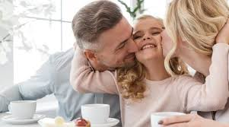 | 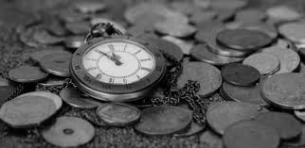 | 
B) How are the words below related to the diagramme? Make up sentences and continue with your own examples (3-5).
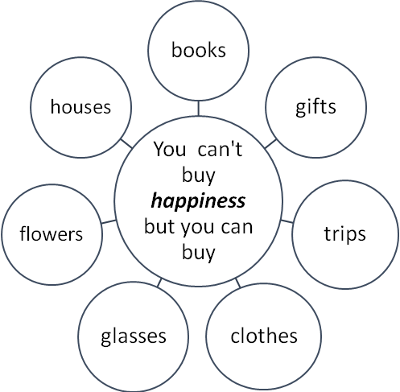
knowledge
beauty
vision
memories
home
fortune

Active vocabulary
accumulate stuff – накопичуватиречі  achievements – досягнення  afford – дозволитисобі  a big-ticket item– дорогаріч  alloy – сплав  foundation–фонд  toeyeball – придивлятися  conductastudy–провестидослідження  consume – споживати  consumerism– стимулювання споживчого інтересу, споживацтво  contentrelationships – змістовнівідносини  nurturerelationships – плекати стосунки  cost – вартість (видатки на виробництво)  price – ціна (сумма, що включає ціну за товар, послуги і т.д.)  currency – валюта  envy – заздрість  expenses – витрати  fadeaway – згасати  fancycar – вишуканий/модний автомобіль  filthyrich–непристойнобагатий  focuson – зосереджуватися на  humanuniversals–людськіуніверсалії  in a while – невдовзі  income– дохід, заробіток  inequality–нерівність | intangible – нематеріальний  mansion – особняк  minimumwage–мінімальназарплата  mint – карбувати  miserable – нещасний  mortgage – іпотека  payoff – виплачувати  poverty– бідність  anti-povertycharity – Благодійнаорганізаціяпоборотьбізбідністю  propertytaxes – податок на власність  pursueexpensivehobbies – мати дорогі захоплення  result in / lead to –призводитидо  root of the problem–коріньпроблеми  satisfaction– задоволення  save money – економити гроші  showoffsocialstatus – хизуватися / випендрюватися соціальним статусом  socialstatus – соціальний статус  socketset – набір розеток  spendinghabits–звичкавитрачатигроші  spendingspree – серія покупок, зроблена за короткий період часу  Spendthrift – марнотрат  spiritualaspects – духовніаспекти  standard of living –рівеньжиття  wealth–благополуччя  well-being–добробут  wearout – зношуватись
keepupwiththeJoneses – жити як всі, жити не гірше інших; рівнятися на сусідів
Money collocations
earnm. – заробляти гр.  borrowm. – позичати від когось гр.  lendm. – зичитикомусь гр.  investm.–вкладатикошти/гр.  spendm. – витрачати гр.  wastem. – марно витратити гр. | dirtym. – брудні гр.  extra m. – додаткові гр.  hard-earned m. – важко зароблені гр.  pocket / spendingm. – кишенькові гр.  spare m. – запасні гр.
IV. Do you know? Using the Internet complete the Money quiz.
1. What did people use instead of money throughout history?
2. What is the origin of the word “cash”?
3. When and where did the first coins appear?
4. How many currencies are used around the world nowadays?
5. Where does the word “money” come from?
6. Whose portrait was the first on a coin?
7. What is the origin of the word “salary”?
8. When did the first credit cards appear?
9. Who holds the record for appearing on more currency than any other person?
10. When and where was the first paper money created?
11. Can you name any slang words for “money” connected to food?
VOCABULARY
I. Pair up the following words. Can you explain your choice?
banknote  mint | cash  price | coin  print | cost  salary | credit card  saver | earn  spend | expenses  spendthrift | income  wage
II. The chart below contains words associated with the word "spending". Match them with their definitions.
1) consume  2) invest  3) pay  4) afford  5) waste  6) eat  7) service  8) earn  9) cost  10 save  11) price | a) give (someone) money that is due for work done, goods received, or a debt incurred  b) the action of helping or doing work for someone  c) use or expend carelessly, extravagantly, or to no purpose  d) the expense incurred in the production of a product or service  e) the payment required for the supply of a product or service  f) obtain (money) in return for labor or services  g) eat, drink, or ingest (food or drink), buy (goods or services)  h) to spend less money  i) put (food) into the mouth and chew and swallow it  j) be able to buy or do smth because you have enough money or time.  k) put (money) into financial schemes, shares, property, or a commercial venture with the expectation of achieving a profit
III. Match each sentence with the corresponding word/word combination.
a) budget | b) credit card | c) earn | d) have more money than sense | e) materialistic
f) salary | g) socialstatus | h) spending spree | i) spendthrift | j) spiritual aspects of life
1. Someone who is very careless about money and spends more than they need to.
2. An expensive series of purchases made in a short time.
3. Used for saying that you think someone is wasting their money.
4. A thin rectangular piece of plastic or metal issued by a bank or financial services company, that allows cardholders to borrow funds with which to pay for goods and services with merchants that accept cards for payment.
5. The relative rank that an individual holds – with rights, duties, and lifestyle – in a social hierarchy based upon honour or prestige.
6. Believing that having money and possessions is the most important thing in life.
7. A fixed amount of money agreed every year as pay for an employee.
8. To receive money as payment for work that you do, or to get something that you deserve because of your abilities or actions.
9. The process of calculating how much money you must earn or save during a particular period of time, and of planning how you will spend it.
10. Relating to deep feelings and beliefs, especially religious beliefs.
IV. Choose the appropriate word for each sentence.
1. He left as a poor, working class boy and returned as a ... man.
wealth wealthy wealthier
2. The new rates will affect all … , including businesses.
consume consumerism consumers
3. Kids should be taught… skills from as early as possible.
budget budgeting budgetary
4. Some football players have weekly … of over £50,000.
earning earn earned
5. Upgrading the system would be very … .
costed cost costly
6. The company makes wearable, beautifully cut clothes at … prices.
affordable afford affording
7. The company said it would pay in full all its … except Credit Suisse.
creditable crediting credits
8. We have to start cutting down on our … .
expense expenses expensive
9. He views his life as a … journey towards a greater understanding of his faith.
spirited spiritual spirit
10. That is not essentially different from somebody who has saved their … money to buy a better house.
hard-earning hard-earned hardly earned
READING
I. Read the text.
WHY MONEY CAN’T BUY HAPPINESS
Many people don’t understand why money can’t buy happiness. It seems logical that having enough to pay off your mortgage and buy a bunch of fun stuff would make you feel better.
But that’s not the way it works.
There are some very good reasons why having a higher income doesn’t necessarily make a person any happier. It can actually have the opposite effect. Many wealthy people, for example, are actually very miserable.
1. More Stuff = More Work, Less Free Time, More Expense
Comparing withthe 1960s home sizes today are much bigger. Living in a bigger home has its negatives to consider. It takes more time and effort to clean a larger home,to take care of chores around the house and miss out on much-needed rest. Moreover, bigger houses need more repairs than smaller ones and repairs can be expensive. They also cost more to live in –to heat and cool the house, to pay more in property taxes each year.
2. Buying Things Only Provides Temporary Satisfaction
Money can buy short-term happiness or satisfaction. Nearly everyone has experienced a high when they’ve bought something they’ve been desiring. But those feelings of satisfaction are usually temporary. They may last a few weeks before they fade away and that new thing is no longer interesting or exciting.
On the contrary, getting together with a few friends one hasn’t seen in a while, for example, may give the person far more satisfaction than buying a big-ticket item a person has been eyeballing. An evening with friends could create a great memory that could last a lifetime. The big-ticket item he/she buys will eventually wear out and need to be replaced.
3. Keeping up with the Joneses Isn’t Fun
One reason why so many people think that money can buy happiness is because they see their neighbors and others around them living in large mansions, driving fancy cars, and pursuing expensive hobbies, and it really looks like those neighboursare enjoying life and genuinely look happy. And all people desire the same lifestyle for themselves.
The problem with trying to keep up with the Joneses is that there’s always going to be someone new who comes along who has more stuff than you.
The root of the problem with keeping up with the Joneses is envy that will eat the person alive and keep him/her from experiencing true happiness in life.
4. Money Can’t Buy Friends and Family
When people are on their death beds, the stuff they’ve accumulated over the years no longer matters. Their achievements are no longer important, either. They want to be around those they love – their friends and family. It’s people that really matter – not stuff. And friends and family can’t be bought.
5. Money Can’t Buy Love
Many wealthy celebrities, for example, go through multiple marriages. As wealthy as they are, they never seem to find true happiness in their relationships.
That’s because money can’t buy love.
True love doesn’t care whether someone is rich or poor. But when your focus in life is on money, power, and fame, and not on your significant other, your relationship will suffer.
6. Money Doesn’t Buy Happiness
True happiness doesn’t come from having more money or from buying more stuff. Rather, it’s learning to be content, nurturing relationships, and other intangible things that have nothing to do with the size of your bank account. The things that really matter in life can’t be bought.
Money is just a tool that we use to buy the things in life that we need, and having more of it doesn’t necessarily make us happier. It’s like having a socket set to repair something when it breaks. Having two socket sets doesn’t make the repair job easier or faster.
When money isn’t our primary focus in life, it frees us to enjoy the things that really matter – friends, family, and our free time. Changing the way we view money then is the first step in achieving true happiness, the kind of happiness that comes from being content with what you have.
II. Answer the questions:
1. What is the main idea of the text? Do you agree with it?
2. Are all wealthy people happy?
3. What is disappointing if people are wealthy?
4. What can make people really happy?
5. What should people focus their life on instead of money?
III. A) What are the things that make you happy? Rate the items in the chart that make you happiest from 0 to 5, (0 – less important, 5 – most important) and share the first five with the group. Compare your results with the other’s.
 | 0 - 5 |  | 0 - 5 |  | 0 - 5
Internet |  | friends |  | money
mobilephone |  | chocolate |  | job
food |  | nature |  | travelling
studying |  | marriage |  | family
working |  | wealth |  | sleep
car/bicycle |  | shopping |  | other
B) Answer the questions:
a)Howdothesethingsmakeyouhappy?
b)Howwouldyourlifechangeifyouwerefilthyrich?
c)Doyouthinkthewealthyarehappier?Why?Whynot?
d)Doyouthinkyouwouldbemoresatisfiedandhappierifyouspentmoneyonyourselforonotherpeople?Why?Whynot?
IV. Complete each sentence with one of the words or phrases given in the box.
achievements  credit card  in debt  salary | budget  earn  intangible  symbol | consumption  earnings  mortgage  wage | credit  high earning potential  poverty  wealth
1. In many countries, there is a contrast between the … of a small number of citizens and the … of the masses.
2. A Rolls Royce is seen as a status … .
3. People in work pay income tax on their … . Those who are unemployed receive benefit.
4. … is an amount of money you receive each day or week and the money you receive each month is your … .
5. In department stores, there are three ways of paying for goods: in cash, by… and by… .
6. Housewives running the family finances have to work within a(n) … .
7. If your expenditure exceeds your income, you will find yourself … .
8. Graduates in the 1990's are attracted to jobs with … .
9. His ambition was to … the highest professional status.
10.It was an age of conspicuous … – thosewho had money liked to display it.
11.For some people, living on … is a normal way of life.
12. The Smiths will have to take out a … in order to buy the house. But due to Tim’s high salary they hope to pay it off soon.
13. For an actor, winning an Oscar is one of the greatest … you can hope for.
14. Assets such as patents, trademarks, or goodwill are known as … assets in contrast to the physical ones such as plant and machinery.
V. A) From below, choose five GOOD questions about money and happiness. Ask your groupmates and take notes.
1. Canmoneybuyhappiness?
2.Ishappinessastateofmind?
3.Doesmoremoneykeepbuyingmoreandmorehappiness?
4.Howcanyouuseyourmoneytobuymosthappiness?
5.Canbuyingextraordinaryorspecialexperiencesmakeyouhappier?
6.Doesimpulsiveshoppingmakeyouhappierthanplannedshopping?
7.IsMyMoneyBeingSpentontheThingsThatTrulyMattertoMe?
8.Whatscaresyouaboutmoney?
9.Whatdoeshavingmoneymeantoyou?
10. How do people try to show their social status? Do you think it is necessary?
11. When was the last time you donated money to charity?
12. What have you done recently to benefit others?
B) Write their answers into the following chart.
 | STUDENT1  _____________ | STUDENT2  _____________ | STUDENT3  _____________
Q.1.
Q.2.
Q.3.
Q.4.
Q.5.
C) Make mini-presentations on your findings to your group.
VI.Read the following proverbs and explain what they mean. Give their equivalents in your language:
Too much prosperity makes most men fools.
A fool may earn money, but it takes a wise man to keep it.
The rich get richer, the poor get poorer.
When money speaks, the truth keeps silent.
A fool and his money are soon parted.
Money is the root of all evil.
Health is better than wealth
The rich knows not who is his friend
Easy come, easy go
He who pays the piper calls the tune
Money Talks
Money doesn't grow on trees
Early to bed and early to rise makes a man healthy, wealthy, and wise
1.“APennySavedisaPennyEarned”(BenjaminFranklin)
2.“Toomanypeoplespendmoneytheyhaven'tearned,tobuythingstheydon'twant,toimpresspeoplethattheydon'tlike.”(WillRogers)
VII. Choose one of the proverbs and:
a) write an essay (250 words) giving your opinionOR
b) prepare a speech for 5 mins giving your opinion.

Topic 9. Ambitions and Dreams.
WARM-UP
I. Look at the following words. Are they interconnected? How? Find pairs of words that have a similar meaning. Explain them.
AIM | GOAL | TARGET | PURPOSE | OBJECTIVE | AMBITION | DREAM
VISION | WISH | HOPE | FORTUNE | DESIRE | ASPIRATION | FATE
II. Look at the quotes below. Choose two and explain how they are related to the words above.
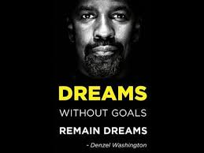
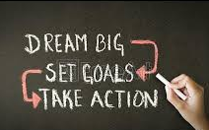
III. PRE-CLASS ACTIVITY. A) Watch the video 1 at home. https://www.youtube.com/watch?v=VNtEIIA4yA0
B) Do you remember what dreams the teenagers in the video were speaking about? Which are the 5 dreams the youngsters don’t mention?
agoodfather | physicaltherapy | missionarywork | PR | anesthesiology
interpreting/translating | archeologist – learnthehistoryofbones | haveacareerinAmericansignlanguage | nursing,performingartist | afterretirementputupapetstore
horserescuecentre | president | chef | teacher | bus-driver
firefighter | minister | miningandengineering | football | nursing
Active vocabulary
aim –мета,ціль(кінцева)  ambition–амбіція, честолюбство,прагнення  aspiration – прагнення, намагання  bucketlist–списоксправпередсмертю  fate – доля, фатум  tofloat – плавати  fortune – щастя, фортуна  FOMO (fearofmissingout) –страхщосьпропустити/прогавити  goal–мета (проміжніцілідокінцевоїмети)  legacy–спадщина, спадок  lunarproject – місячний проєкт  passdown–передати(дітям) | piece of advice–порада  purpose–ціль(причина)  racingcar–гоночнийавтомобіль  reason–причина  skill–майстерність,вміння  starringrole–головнароль  target–ціль,мішень  toclimb–вилазити,сходити  todoone'sbest–робитивсезалежневідкогось  tosave–рятувати, зберігати  vision – видіння, мрія  wage–зарплата  workhard–наполегливопрацювати
BUCKET LIST
toappear on TV –виступити(з’явитися)нателебаченні  toattend a course–прослухатикурс  tobe an extra in a film (background actor/ talent) – фоновий актор  tobecome–стати  –famous/ a millionaire– відомим / мільйонером  –goodat– експертом/ знавцем  tobuyahouse /flat / holidayhome / car–придбатибудинок/квартиру/дачу/машину  to climb the careerladder–піднятися по кар’єрних сходах  toearn 1 million–заробити1мільйон  toget– отримати  –adegree/ job/ promotion–освіту / роботу /підвищення  –married–одружитися/вийтизаміж  togoscubadiving–підводнеплавання  togotouniversity / college–пітивуніверситет/коледж  tohave –мати  –an interesting job–цікавуроботу | –alargefamily/ children–мативеликусім’ю / дітей  –asupportivewife / husband – дружину/чоловіка,щопідтримує в житті  tolearn – навчитися  –tospeakaforeignlanguage–розмовлятиіноземноюмовою  –howtodriveacar–керуватимашиною  –howtoflyaplane–літатиналітаку  tomovehouse–переїхатижити(зодногобудинкувінший)  toplay – грати  –a musical instrument–намузичномуінструменті  – in a band–вгурті(ансамблі)  toride on a horse and cart–їздитинаконіівозі  tostart your own business –почативласнийбізнес  totrektheIncaTrail – пройти стежкою інків  towriteanovel /book/ computerprogram– написатироман/книгу / комп’ютернупрограму
IV. Match the words with their definitions.
1) aim  2) ambition  3) aspiration  4) desire  5) dream  6) fate  7) fortune  8) goal  9) hope  10) objective  11) purpose  12) target  13) vision  14) wish  15) bucket list | a) the set of good or bad events that happen to you and have an effect on your life  b) the specific thing that you are trying to achieve  c) an idea or mental image of something  d) a strong desire for success, achievement, power, or wealth  e) a list of activities that people want to do before they die  f) a result that your plans or actions are intended to achieve  g) what you want to achieve when you do something  h) a strong hope or wish for achievement or success  i) what happens to a particular person or thing, especially something final or negative, such as death or defeat  j) to hope that you will get something or that something will happen  k) to want something, especially strongly  l) something good that you want to happen in the future  m) something important that you hope to achieve in the future, even though it may take a long time  n) something that you want to happen very much but that is not very likely  o) the exact result that a person intends to achieve by doing something
V. Fill in the gaps with the words from the box.
a) aim  f) dream  k) objectives | b) ambition  g) fate  l) purposes | c) aspiration  h) fortune  m) target | d) bucket list  i) goal  n) vision | e) desire  j) hope  o) was wishing
1. The book offers a … of the future in which there is a great nuclear apocalypse.
2. I've always had a burning … to be a film director.
3. She had the operation entirely for cosmetic … .
4. It is important to encourage children's dreams and … .
5. I … for summer so hard I could almost make it happen at that moment.
6. Is there any … that they will be home in time?
7. He had the (good) … to train with some of the world's top athletes.
8. Ambition is a strong … to achieve one’s goal in life.
9. My main … in life is to be a good husband and father.
10. Every week, he asked how many things she checked off her ….
11. When Sarah became a nun, she believed it was her … by God to serve him and she would have to do that for the rest of her life.
12. My … in life has always been to be financially independent.
13. One of my … for this year is to increase sales.
14. The missile strike was devastating – the … was totally obliterated.
15. When I was growing up my … was to perform in front of millions of people.
VI. A) A journalist met three are ambitious and optimistic teenagers. Read what they told him about their dreams and ambitions. Find out what they want to become.
Interviewer:So,Sara,whatdoyouwanttobe?
Sara:Iwanttobea 1) … .
Interviewer:Areyourparentsinvolvedinjournalism?
Sara:No,notatall.Infact,journalistsareprettyunpopularinmyhouse.Myfather’sinterestedinthenews,butheisn’tverykeenonjournalists.Hethinksmostofthemarearrogant,dishonestandirresponsible.
Interviewer:David,whydoyouwanttobea 2) … ?
David:I’mreallydisappointedwithourgovernment.Youngpeoplehavealottosay,butpoliticiansdon’tlistentothem.Theyjustthinkteenagersarelazyandmiserable.
Interviewer:Whydoyouthinkyoucouldbeapolitician?
David:I’mpassionateaboutmycountry.Ialsohavetherightcharacter:I’mnotatallshy!Infact,I’mveryoutgoingandI’mgoodatpublicspeaking.I’monlysixteennow,soI’mveryinexperienced,butI’mseriousaboutpolitics.
Interviewer:Rani,whydoyouwanttobea 3) …?
Rani:Well,mostsurgeonsintheUKaremenandIthinkthat’sunfairandwronginthetwenty-firstcentury.Ithinkmygenerationisresponsibleforgettingmorewomenintoimportantjobs.
Interviewer:Whatspecialqualitiesdoyouthinkyouneedtobeasurgeon?
Rani:IthinkIneedtobecaring,sensibleandveryhard-working.
1. Sarawantstobecome … | 2. David’sambitionis … | 3. Ranidreamsof …
B) Pay attention to the underlined words. How can they affect people’s life and their dreams?
NOTE
arrogant – зарозумілий, пихатий, самовпевнений  dishonest– нечесний, несовісний  (ir)responsible – (без)відповідальний  miserable – нещасний, жалюгідний  passionate – пристрасний, палкий | outgoing – доброзичливий, чуйний  inexperienced – недосвідчений  caring – турботливий  sensible – чутливий, розумний  hard-working– працьовитий
VII. WHAT ABOUT ME? A) Write a list of your own dreams and ambitions.
B) The following expressions can help you make up sentences about your hopes, dreams, and plans for the future.

It is my biggest dream to | be famous  be rich | fly a plane  drive a car
My ambition is to | travel the world | run a marathon
In 5 years, I hope to be | running the company  getting married
I can see myself doing … (in the future) | a Bachelor Degree  a Master’s Degree | my first job interview  my first experiment
I am on the point of (я збираюся) | graduating  achieving a goal | getting promoted
I am due to  (я маю) | get my exam results  receive an award
I look forward to | passing my exams  starting my new job  making lots of money | gettingmarried  having alargefamily / children  becoming famous
I plan to | start my own business  pitch an idea to my Boss | writeanovel /book
I’m counting the days until I | begin studying  graduate  am old enough to drive | am able to buy a house move to another country  movehouse
I would like to get around to | travelling  starting my own business | learning a new language  learning a new skill
I wish I could | save the world  understand bad people | save the environment  make people be more responsible

C) Use the following questions. You may think of some other ones.
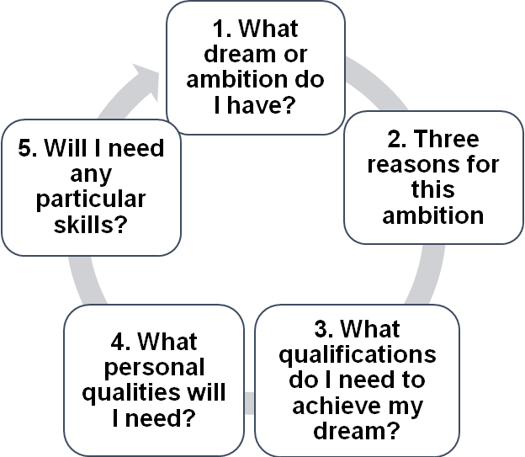
B) Use the sentences below and share your ideas with the group.
Ihavelookedatmyanswers1-5andIthinkmyambitionisrealistic/unrealistic.
Myreasonsforthisare:
WhichparticularaspectswouldIhavedifficultyinachieving?
WhichaspectswouldIfindfairlyeasytoaccomplish?
Icouldfindoutmoreinformationaboutmydreamambitionfrom …
VIII. Watch the video 2. https://www.youtube.com/watch?v=-ftKw46nC6s
1.Haveyoueverheardaboutthethingsmentionedinthevideo?
2.Whatisabucketlist?Haveyouevercreatedone?
3.Whatdoyouthinkofthisidea?
4.Whodoyouthinkinventedthisidea?
5.Whyhasitbecomesowidely-know?
6.Whatdoyouthinkabouthavingdreams?
7.Whatisthedifferencebetweendreamsandambitions?
8.Haveyouevermadealistofyourdreamsandwishes?
9.Whatis FOMO?
IX.The Daily Mail newspaper conducted a survey to see what the British public most commonly put on their bucket lists. Can you guess the top ten? (5 min). Go over the language in the boxes below:

Positive | Negative
I’ve alwaysfancied…  I’mdying/itchingtotry…  …isaburningambitionofmine.  …isoneforthebucketlist.  Apipedream(anunrealistic/improbabledream)  Iwouldjumpatthechanceto…  Ifyouofferedmethechanceto…,Iwouldbiteyourhandoff.  I’dgiveitago. | Ihavenodesireto…  …doesn’tappealtome(atall)  Whateverfloatsyourboat.  Toeachtheirown  Theideaof…doesn’tdoanythingforme.  Youwouldn’tcatchme…ing  …isnotmything.  …isnotforme.
X. A) Discuss the top ten and decide if they would be on your bucket list.
Daily Mail Top 10
1. Have a holiday home abroad  2. Learn a new language  3. Go on holiday to the Maldives  4. Buy a house  5. Swim with dolphins | 6. Drive Route 66  7. Ride a hot air balloon  8. See the Egyptian Pyramids  9. Go to a casino in Las Vegas  10. Visit Venice
B) This is the rest of the top 40. Go to http://bucketlist.org/featured/ for more ideas and create your own bucket lists.
Daily Mail Top 40:
11. GouptheEmpireStateBuilding  12.Goonacruise  13.Gowhalewatching  14.Climbamountain  15.GouptheEiffeltower  16.Learnaninstrument  17.Workinadifferentcountry  18.FloatintheDeadSea  19.Writeanovel  20.Drivearacingcar  21.Changecareer  22.TrektheIncaTrail  23.Beavolunteerforagoodcause  24.Beanextrainafilm  25.Goscubadiving | 26.Tryoutsurfing  27.HoldaKoala  28.Feedapenguin  29.Getatattoo  30.BackpackEurope  31.Ownadesignerwatch  32.Rideagondola  33.Runabigrace  34.Bungeejump  35.Reachthetopofmycareerladder  36.OwnaMulberryhandbag  37.Rideacamel  38.Rideonahorseandcart  39.Writeafilm  40.Changehaircolour
C) Ambitions can be extrinsic (зовнішні: when we are motivated to perform a behavior or engage in an activity because we want to earn a reward or avoid punishment) and intrinsic (внутрішні;when you engage in a behavior because you find it rewarding. You are performing an activity for its own sake rather than from the desire for some external reward.) What type of ambitions people mostly have? (based on the list).
XI. Work in pairs. Think of one friend or family member who has achieved their ambition and one who has changed their ambition. Describe what has happened to them using at least two if-sentences.
Ifmymotherhadn’ttakeneveningclasseswhenwewereyoung,shewouldn’tbeanursenow.
XII. Work with a new partner. Compare your wishes, dreams and ambitions from Exercise VII. Were any of your ideas the same? Are they extrinsic or intrinsic?
XIII. Use the discussion generators given below and prepare to discuss the following in groups of 3-4.Think of some other examples.
1.Ifyouareapersonwithambition,youmayhaveabigdreamorgoalthatyouaredeterminedtoreach.Doyouhaveabigdreamyouaredeterminedtoreach?Ifyes,describeyourgoalordreamandexplainwhatyouwillhavetodotoreachit(e.g.,sacrificesomefuntimetoworktowardyourgoal,sticktoyourgoalevenwhenthingsgettough,beyourownboss,etc.).
2.Whatcharactertraitswillyouneedtogetwhatyouwant(e.g.,hardworker,motivated,determined,self-disciplined,etc.)?
3.Canyougiveanexampleofhowsomeonemightbesoambitiousthattheywillhurtotherstoreachtheirgoals(e.g.,showingbadsportsmanshipinanattempttowinaballgame,cheatingtoearnthehighestgradeinclass,sayinguntruethingsaboutsomeonewhoisrunningagainstyouforstudentcouncil,etc.)?
4.Canyougiveanexampleofsomeonewhowasambitiousinapositivewayandreachedagoalordreamthatishelpfultoothers(e.g.,studentcouncilpresident,EagleScout(розвідник),doctor,teacher,policeofficer,NavySeal(морськийкотик),astronaut,etc.)?
5.Howcanwehelponeanotherreachourgoalsanddreams(e.g.,encourageeachother,berespectfulofthetimeeachofusneedstoworkonourgoals,beafriendwholistenswhensomeoneisdiscouraged,etc.)?
Closing Comments
–Beingapersonwithambitioncanbeaverygoodthing.Itmeansyouhaveastrongdesiretoreachagoalordream.Mostsuccessfulpeoplehaveambitionandthatambitionhashelpedthemreachtheirgoals.Ambitioncanhelpyou,too.Itcanhelpyoubemoredetermined,morefocused,andmoresuccessful.Nowhere’sanimportantthingtoknowaboutambition:Alwayschoosetouseyourambitiontohelpinsteadofhurtotherssothatintheend,everybodywins.

READING
XIV. Look at the title of the article and the photo. Discuss these questions with a partner. Then read the article and check your answers.
1.Whodoyouthinktherocketgirlswere,andwhatdidtheydo?
2.Whatdoyouthinktheirambitionwas?
XV. Read the article again. Work in pairs. Correct the underlined words below using words from the article to make these sentences true.
1.Themenwhoflewtothemoonweremoreexperiencedthanthewomenengineersandmathematicianswhohelpedthemgetthere.
2.Inthe1950s,“computers”weremachineswhodidmathematicalcalculations.
3.Astimewenton,therocketgirlsstartedprogrammingactualscientists.
4.Therocketgirlsworkedfixedhoursatthelab.
5TheauthorNathaliaHolthopesthatwewillseemorewomenastronautsinthefuture.
XVI. Look at the article again. Underline three expressions with the word MAKE and two expressions with the word DO. Then underline the correct options to complete the sentences below.
1.Weusuallyuse make / do todescribeperformingarepetitivetaskoranobligation.
2.Weusuallyuse make / do todescribeproducingorcreatingsomething.
3.Weuse make / do +anobjectpronoun(e.g.,something,it,that).
XVII. Circle the correct verbs to complete these sentences.
1.CanIdo/makeasuggestion?Whydon’twetaketurnsdoing/makingthehousework?
2.Iwanttodo/makesomethingtohelpthem:somethingthatwillreallydo/makeadifference.
3.I’vedone/madeanoteofallthethingsweneedtosetupandalltheshoppingweneedtodo/makebeforetheparty.
4.Theirbusinessisstruggling.They’redoing/makingeverythingtheycan,butthey’restillnotdoing/makingaprofit.
5.I’mtakingaveryinterestingeveningclassatthecollege,andI’vedone/madesomegoodfriendsthere.
XVIII. Read the text.
RISE OF THE ROCKET GIRLS
EveryoneknowsBuzzAldrin,thefamousastronaut.ButhowmanyofushaveheardofEleanorFrancisHelin,anengineerbehindnumeroussuccessfulNASAspacemissions?HelinwaspartofagroupoffemalemathematiciansworkingatNASA’sJetPropulsionLab(JPL)inthe1960s.NathaliaHolt,theauthorofabookaboutthesewomen–knownas“rocketgirls”–says,“Iftheyhadn’tworkedonthelunarproject,‘man’wouldnothavereachedthemoon.”
TherocketgirlsstartedoutatJPLinthe1950s,havingansweredajobadvertisementsaying“Computersneeded.”Theywerecalledcomputersbecause,beforetoday’sdigitaldevices,youneededhumanstodomathematicalcalculations.Andthecalculationshadtobeextremelyaccurate.Ifsomeonehadmadethesmallestmistake,aspacecraftboundforthemoonwouldstillbetravelingsomewhereinouterspacetoday,havingmisseditstargetentirely.
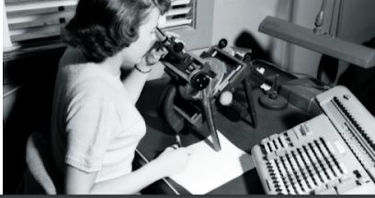
Therocketgirlswentfrombeing“computers”tobecomingthelab’sfirstcomputerprogrammersandengineers.Oneofthegroup’searlyleaders,MacieRoberts,madethedecisiontohireonlywomen,andthispolicycontinuedforthenextthirtyyears.Theybroughtinmanywomenwhowantedtobeengineersbutdidn’thavethenecessaryqualifications.Ifanyonetriedtoemployonlymenoronlywomentoday,theywouldn’tbeallowedto.ButRobertsmadetheworkenvironmentatthelabspecial.Thewomenformedcloserelationshipsandworkedflexiblehourstohelpeachotherbalancehomeandprofessionallives.Atthesametime,theyfelttheyweredoingsomethingreallyvaluable.Asaresult,manywomenstayedonworkingatJPLforthirtyorfortyyears.
Holtsaysthatifthereweremorewomenengineerstoday,sheprobablywouldn’thavewrittenthebook.Shehopesthattherocketgirlswillnowgettherecognitiontheydeserveandinspireanewgenerationoffemaleengineers.
WRITING
XIX. Read the following quotations.
1.Beingambitiousisactuallygoodaslongasyoudonotsteponotherpeople'stoesandprovideinspirationtofellowmen.SaraWellington
2.Ambitionisthefirststeptosuccess.Thesecondstepisaction.Unknown
3.Myambitionisalwaystogetbetterandbetter.LeoMessi
4.Thosemomentsyoufailarenottheend,theyareperiodsinwhichyourecollectthoughts,ideas,andambitions,andchangedirection.BenjaminChapin
5.Ambitionislikelove,impatientbothofdelaysandrivals.Buddha
6.Keepawayfrompeoplewhotrytobelittleyourambitions.Smallpeopledothat,butthereallygreatmakeyoufeelthatyou,too,cansomehowbecomegreat.(MarkTwain)
7.AmbitionisadreamwithaV8engine.ElvisPresley
8.Intelligencewithoutambitionisabirdwithoutwings.SalvadorDali
9.Themanwhostartsoutsimplywiththeideaofgettingrichwon’tsucceed,youmusthavealargerambition.JohnDRockefeller
10.Myambitionistochangetheworldforthebetter,toimpactpeopleinunimaginableways,andtoinspirepeopletowardgreatness.ATGW
A) Choose the one you like most of all. Together with your partner(s) write as many arguments for your choice as you can. (5 min)
B) Go to another group and find out their reasons. When you asked all your groupmates return to your partner and check the state of arts.
C) Write a 250 words essay explaining your point of view.

ATTACHMENT: Additional vocabulary for Ex.V, p.74.
academic – навчальний,університетський  aesthetic – естетичний  dangerous – небезпечний  different – інший,щовідрізняється  disappointed – розчарований  earthly – земний,прозаїчний  economic – господарський,ощадливий  foolish – безглуздий  further – подальший  future – майбутній  grandiose – величезний,грандіозний  high – верховний  human – мирський,людський  imperial – імперський  individual – особистий,індивідуальний  laudable – похвальний  legitimate – легітимний,виправданий,законний  literary – літературний  lofty – величний,пиндючливий  mean – жалюгідний, підлий  modest – скромний,незабагливий | noble – благородний,великодушний  personal – особистий  petty – дріб'язковий  poetic – поетичний  present – теперішний  private – приватний  professional – професійний  real – реальний,дійсний,істинний  rival – конкуруючий  secret – таємний  selfish – егоїстичний  similar – схожий  spiritual – духовний  unfulfilled – невиконаний,нездійснений  vague – невизначений,нечіткий,туманний  vain – даремний,марний,пихатий,пустий  wild – бурхливий  worldly – земний,мирський  youthful – молодіжний

Topic10. Discoveries and Inventions. The best and the worst discoveries and inventions of humanity.
WARM-UP
I. A. Think about the meaning of the following words and give examples:
1) invention discovery innovation
2) explorer inventor researcher scientist discoverer
3) useful necessary important
4) hypothesis idea vision
B. How are the words above connected?
II. A. Look at the pictures below. Guess which innovation or discovery is presented.
A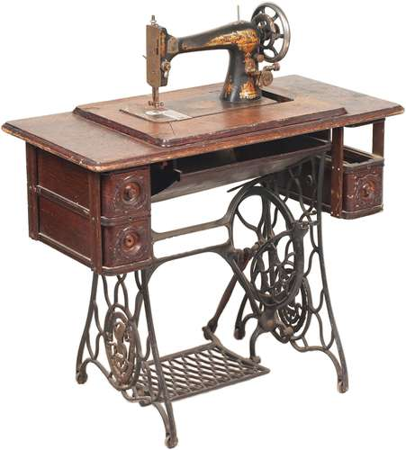B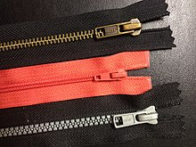C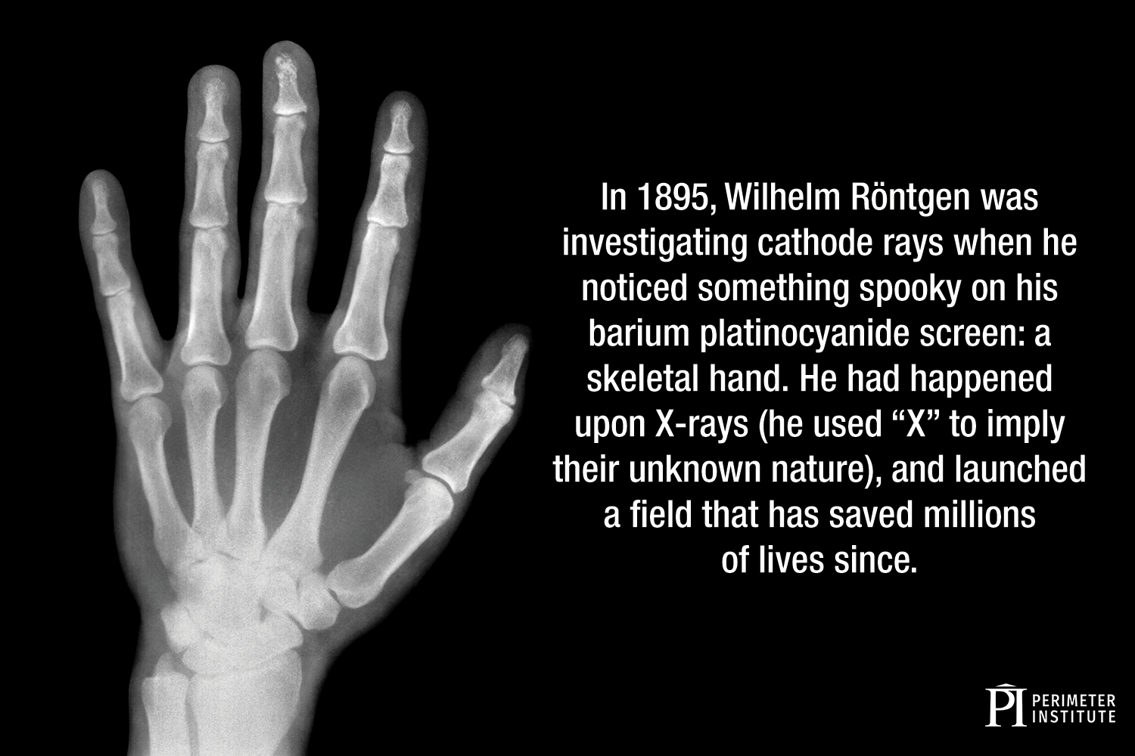D
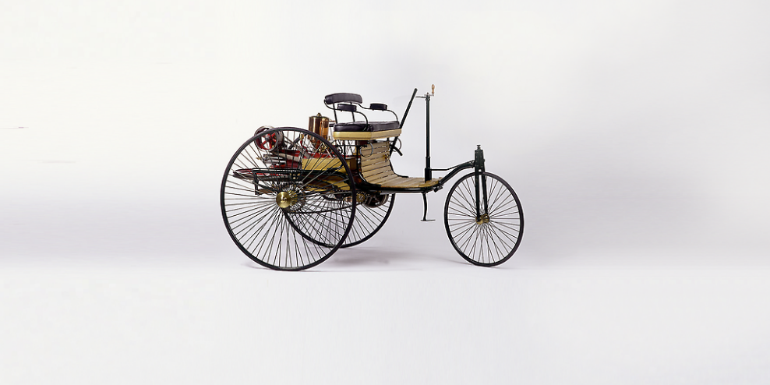 E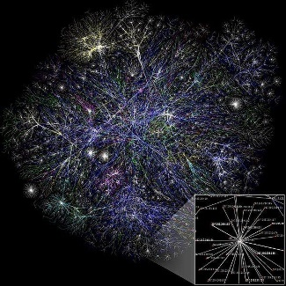 F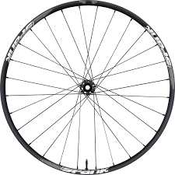 G
 H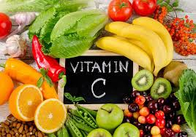 I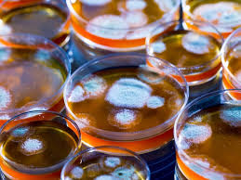 J

III. A. Read the following descriptions and match them with the pictures in Ex.II.
a) On November 8, 1895, physicist WilhelmConradRöntgen (1845-1923) becomes the first person to observe X-rays, a significant scientific advancement that would ultimately benefit a variety of fields, most of all medicine, by making the invisible visible. | b) 1846: EliasHowe patents the first practical sewing machine and threads his way into the fabric of history. For five years he worked on the basic idea. With this machine he managed 300 stitches per minute. (Seamstresses who worked by hand could only manage 50 stitches per minute.)
c) Antibiotics have long been known; it may explain why the ancient Egyptians had the practice of applying a poultice of moldy bread to infected wounds. But it was not until 1928 that penicillin, the first true antibiotic, was discovered by AlexanderFleming, Professor of Bacteriology at St.Mary's Hospital in London. | d) The first workable prototype of the Internet came in the late 1960s with the creation of ARPANET (the Advanced Research Projects Agency Network). Originally funded by the U.S. Department of Defense, ARPANET used packet switching to allow multiple computers to communicate on a single network.
e) In 1928, AlbertSzent-Györgyi isolated a substance from adrenal glands that he called 'hexuronic acid'. In 1937 he was awarded the Nobel Prize in Physiology or Medicine for his discovery of vitamin C. | f) The modern zipper was eventually designed in 1913 by GideonSundback, who worked at the Universal Fastener Company in Hoboken, New Jersey. He received a patent for his “Separable Fastener” in 1917.
g) The wheel was invented by Mesopotamians around 3500 B.C., to be used in the creation of pottery. About 300 years after that, the wheel was put on a chariot. | h) In 1878, ThomasEdison began serious research into developing a practical incandescent lamp. On October 14, 1878, he filed his first patent application for “Improvement In Electric Lights”.
i) Invented about 100 BC in China, paper has been indispensable in allowing us to write down and share our ideas. | j) The first stationary gasoline engine developed by CarlBenz was a one-cylinder two-stroke unit which ran for the first time on New Year’s Eve 1879.
B. Give your own examples.

Active vocabulary
design –розробити; дизайн  discover – відкритищосьнове  discovery – відкриття  enlighten– просвітити, інформувати  examine – досліджувати,обстежувати  experiment – експеримент, робити досліди  explore – досліджувати  figureout– здогадуватися, усвідомлювати  findings – результатидослідження,висновки  hypothesis – гіпотеза, припущення  improve – вдосконалити  innovation – новаторство,інновація  inquireinto / look into – обстежувати, досліджувати  invent – винайти  inventor – винахідник  invention – винахід  idea – думка, поняття  imagine – уявити  inform – доповідати, повідомляти  information– інформація, довідка  inspiration – натхнення  knowledge – знання | look for – шукати  observe – спостерігати  observation – спостереження  patent – патент  predict – передбачати  prediction–передбачення  prove – доводити  reason – причина  reasoning – міркування  require–вимагати, потребувати  research – дослідження  researcher– дослідник  resource – джерело  results – результати  revelation – одкровення, відкриття  revolution – революція, зміна  science – наука  scientific method – науковий метод  scientist – науковець  search – шукати, здійснювати пошук  study – вивчати  technique –техніка, технічний прийом  technology – технології  tool – інструмент,знаряддя  vision–бачення
NOTE: Remember the formation of the following words and how to use them.
Verb | Adjective | Noun |  | Collocations
Verb | Adjective | person | action, process | Collocations
discover | discoverablediscovered | discoverer | discovery | make a discovery
explore | explorableexplorational | explorer | exploration | carryoutexploration
hypothesise | hypothetical | hypothesizerhypothetist | hypothesis | construct, develop, form, have,formulate, make, propose, put forward, suggest a hypothesis
idealize | idealidealistic | idealist | idea | express / form / develop / have an idea
innovate | innovative innovational | innovator | innovation | introduce, showcaseaninnovation
invent | inventive | inventor | invention | come up with, design,submit, patent, register an invention
research | researchful | researcher | research | carry out, conduct, do research
science | scientific | scientist | science | do / practise / apply science
IV. A. Read the information and discuss the questions.
1.Doyouagreewiththelistofthemostimportantinventions?Canyouthinkofotherinventionstoadd?
2.Inyouropinion,whichinventionsmadethebiggestchangestoourdailylives?How?
3.Whichinventionssavedthemostlives?How?
WHAT IS THE WORLD’S GREATEST INVENTION?
AUKcompany,TescoMobile,asked4,000peopletonametheworld’smostimportantinvention.Someinventions–likethewashingmachineandwheel-makeeverydaylifeeasier.Some,likethemedicinepenicillin,savelives.Others–likewirelesstechnologyandtheInternet–changedthewaywecommunicate.AsLanceBatchelor,CEOofTescoMobile,says,“Alloftheinventionsinthislisthavechangedtheworldforever.”  1)wheel  2)airplane  3)lightbulb  4)Internet  5)personalcomputer  6)telephone  7)penicillin  8)iPhone  9)flushingtoilet  10)combustionengine | Alexander Graham Bell invented the first telephone in 1876. His early interest in speech, sound, and music helped him understand how sound might travel along a wire. Later he created the Bell Telephone Company, which became AT&T, the largest phone company in the U.S.
 | Orville Wright made the first powered airplane flight (right) on December 17, 1903, on a windy hillside in North Carolina, USA. The flight lasted 12 seconds for a distance of 120 feet (36.5 meters) – shorter than a Boeing 707’s wingspan. To build the Flyer, Orville and his brother Wilbur used bicycle technology, parts made from wood, a homemade engine – and no wheels.
 | Theinternalcombustionengineisthemainsourceofpowerformostcars,planes,andboats.Acar’smovementcomesfromburningfuelintheengine,whichproduceshigh-pressuregas.Othertypesofvehiclesuseelectricitystoredinbatteries,likethissolar-poweredcar.
B) Put these inventions in column 1 the order of their appearance. Begin with the latest one. Complete some research and find out who was the inventor (if possible).
Invention | when | who | Invention | when | who
V. A) Match the words with their definitions. Use them in your sentences.
1) inspiration  2) inquire into  3) figure out  4) look for  5) enlighten  6) design  7) revelation  8) discovery  9) technique  10) invention | a)to search for someone or something  b)to provide someone with information and understanding  c)the process of finding information, a place, or an object, especially for the first time  d)to make or draw plans for something  e)something that has never been made before  f)to try to discover the facts about something  g)a feeling of enthusiasm you get from someone or something, which gives you new and creative ideas  h)a skilful or efficient way of doing or achieving something  i)to understand or solve something  j)a surprising and previously unknown fact that has been disclosed to others
B)
1) discover  2) prove  3) observe  4) detect  5) predict  6) tool  7) findings  8) technology  9) prediction  10) research | a) say or estimate that (a specified thing) will happen in the future or will be a consequence of something  b) discover or identify the presence or existence of.  c) informationthatyoudiscover,oropinionsthatyouformafterdoingresearch  d) a detailed study of a subject, especially in order to discover (new) information or reach a (new) understanding  e) (the study and knowledge of) the practical, especially industrial, use of scientific discoveries  f) to watch or study someone or something with care and attention in order to discover something  g) a statement about what you think will happen in the future  h) find unexpectedly or during a search  i) apieceofequipment,usuallyonethatyouholdinyourhand,thatisdesignedtodoaparticulartypeofwork  j) demonstrate the truth or existence of (something) by evidence or argument.

C)
1) discoverer  2) explorer  3) informator  4) innovator  5) inventor  6) researcher  7) visionary  8) hypothetist  9) idealist  10) scientist | a) someone guided more by ideals than by practical considerations  b) a person who introduces new methods, ideas, or products.  c) a person who is able to imagine how a country, society, industry, etc., will or should develop in the future and to plan in a suitable way  d) a person who is studying or has expert knowledge of one or more of the natural or physical sciences  e) the first person to find or explore a place  f) someone who provides others with details, facts, etc.  g) someone who designs or creates something that did not exist before  h) a person who explores a new or unfamiliar area  i) someone whose job is to study a subject carefully, especially in order to find new information or understand the subject better  j) One who proposes or supports a hypothetical thesis
VI. Complete the sentences with the missing information about scientific discoveries using the chart below.
1. In 1543, … told the world that the Earth moves round the Sun.
2. In 1666, IsaacNewton came up with … .
3. In1859, … published a book on his theory of natural selection.
4. In 1864, Louis Pasteur explained to a group of famous scientists his belief that … cause many diseases.
5. … conducted research on radioactivity. In 1903, she became the first woman to win a Nobel Prize.
6. In 1928, Alexander Fleming discovered the antibiotic … .
7. In 1929, Edwin Hubble formed his theory that the universe is … .
8. In1953, James Watson and Francis Crick discovered the structure of the … .
9. The drink … was originated in 1886 by an Atlanta pharmacist, JohnS.Pemberton (1831–88), at his Pemberton Chemical Company.
10. JohannZahn designed the first … in 1685. But the first … was clicked by JosephNicephoreNiepce in the year 1814.
11. The year 1886 is regarded as the birth year of the … when German inventor KarlBenz patented his Benz Patent-Motorwagen.
12. The … was invented in 1998 by IBM, with the intention of replacing the floppy drive in its ThinkPad line of products.
a) MarieCurie  e) the theory of gravity  j) pen drive | b) Coca-Cola  f) NicolausCopernicus  k) modern car | c) germs  g) penicillin  l) CharlesDarwin | d) DNA molecule  h) camera  i) expanding  m) photograph
VII. Choose the true answer:
1. The first who are believed to have started using a paste to clean their teeth (even before toothbrushes were invented) are:
a) the Egyptians (around 5000BC)
b) the French (in the 18th century)
c) people in China and India first used toothpaste (around 500BC)
d) the Ancient Greeks and Romans
2. When were the first wearable eyeglasses invented?
a) in 1784 by Benjamin Franklin
b) The first inventor is unknown
c) The first known to history appearedin Italy during the 13th century.
d) The first were discovered by the Romans (they found out the ability to use to glass to enhance their ability to see small text)
3. The earliest dentures (false teeth) were produced:
a) around 700 BC byEtruscans of Italy (used gold wire or bands to attach human and animal teeth)
b) around 2500 BC,(in today’s Mexico and were made from wolf teeth)
c) in the 16th century in Japan(wooden dentures appeared in and were used until beginning of 20th century)
d) around 1728 by a French physicianPierre Fauchard
4. The first lift was invented by:
a) an English engineer SirWilliamArmstrong in 1846 (The hydraulic crane)
b) a Chinese engineer Hokkaido Aki Taki in 1560
c) Archimedesin 236 BC
d) an Andalusian engineer Ibn Khalaf in1000
5. The first computer was made by:
a) a Japanese inventor YoshiroNakamatsu in 1100 BC
b) an English mathematics professor CharlesBabbage in 19th century
c) Dr. JohnV.Atanasoff and CliffordBerry in 1937 (first electronic digital computer)
d) JohnW.Mauchly and J.PresperEckert at the University of Pennsylvania in 1945
6. The first toilet was used in:
a) Vietnam in 1500 BC b) Pakistan 2800 BC
c) Mesopotamia in 4th millennium BC d) Brazil in 300 AD
VIII. Brainstorming.
A) Make a list of things you use everyday that require electricity. Choose from the chart below and add your own ones if you consider it/them to be important.
1.………………………………………… 5.…………………………………………
2.………………………………………… 6.…………………………………………
3.………………………………………… 7.…………………………………………
4.………………………………………… 8.…………………………………………
B) Compare your answers with your groupmates. Discuss what is the most important for you and what is the one /are those you can live without.
C) Put these inventions into two columns – the best and the worst.
3Dmovies | Airconditioning | Answeringmachine | Anti-virussoftware
Automaticpencil | Ballpoint(pen) | Barcode | Bicycle
Bulletproofvest | Camera | Caralarm | Cat’seye
Correctingfluid | Dishwasher | Disposablediaper | Disposablesyringe
DNA | Electricdrill | Electriccar | Electrickettle
Electricpencilsharpener | Elevator/lift | Email | Erasablepen
Gluestick | GMfood | GPS | Hardhat
Hearttransplant | Highlighterpen | Hybridcar | Instantmessaging
Industrialrobot | Infrarednightvision | Internet | Internalcombustionengine
Iron | Keyholesurgery | Landmines | Laptop(computer)
Lasereyesurgery | Lowenergylightbulbs | Machinegun | Massagechair
Microscope | Microwave(oven) | Mobilephone | MRIscan
Nuclearpowerstation | Nuclearweapons | Pacemaker | Penicillin
Photocopier | Plasticbag | Pneumatictire | Pocketcalculator
Post-it-notes | Radio | Rechargeablebattery | Refrigerator
Rubbergloves | Satellite | Scanner | Scotch/stickytape
Sewingmachine | Shotgun | Smokedetector/alarm | Solarpanel
Speedcamera | Superglue | Tetra-pakcarton | TVremotecontrol
USBflashdrive | Vacuumcleaner | Vendingmachine | Videoconferencing
Videogameconsole | Vitamin C | Washingmachine | Xray
D) Choose 3-4 from each column and explain why you think they are the best or the worst.
IX. Look at the photos, and read the title, subheads, and opening paragraph of the reading passage on the next pages. What do you think is the purpose of each of the items described? Discuss your ideas with a partner.
InfantWarmer | WaterContainer | PortableClayCooler | HealthDetector | SolarWi-FiLight

BIG IDEAS: LITTLE PACKAGES
Cansimpleideaschangetheworld?Theyjustmight,onenewideaatatime.Creativedesignersandscientistsareworkingtoinventproductsforcommunitiesindevelopingcountries.Someoftheirinnovationsmightsolveeventhebiggestproblems–fromhealthcaretocleanwater.
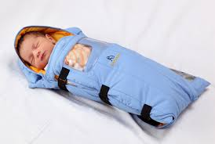  “WehopethattheembraceInfantWarmerrepresentsanewtrendforthefutureoftechnology,”saysdeveloperJaneChen.“simple,localized,affordablesolutionsthathavethepotentialtomakeahugesocialimpact.” | INFANT WARMER  Around19millionlow-birthweightbabiesareborneveryyearindevelopingcountries.Thesebabiesweighlessthan5.5pounds(2.5kilograms)whenthey’reborn.Low-birthweightbabiesareoftenunabletokeeptheirbodytemperatureswarmenough.Manygettoocoldanddie.TheEmbraceInfantWarmerhelpskeepthesebabieswarm.DeveloperJaneChensays,“Overthenextfiveyears,wehopetosavethelivesofalmostamillionbabies.”
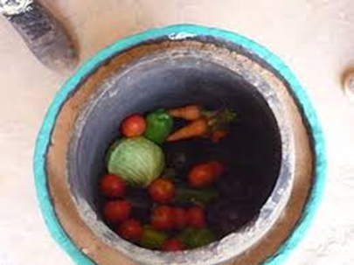
PORTABLE CLAY COOLER
Thepot-in-pot system isagoodwayto store foodwithoutusingelectricity.Theuserputswetsandbetweentwopots,onefittinginsidetheother.Thewaterevaporates2andkeepsfoodcool.Thathelpsfoodstayfreshlonger.Forexample,tomatoescanlastweeks,insteadofjustdays.Thatway,peoplecanbuymorefreshfruitsandvegetablesatthemarket,andfarmerscanmakemoremoney.
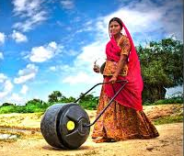
WATER CONTAINER
Inpoorareas,peopleoftenhavetowalkseveralmilestogetcleanwater.Usually,womenandchildrenhavetocarryheavy containers ofwaterhomeeveryday,anditisdifficultwork.TheQDrumholds13gallons(about50liters)inarollingcontainer.Withthisinnovation,peoplecaneasilyrollthewaterontheground.

SOLAR WI-FI LIGHT
TheStarSightsystemisaninnovationthatcan benefit millionsofpeoplearoundtheworld.Itabsorbssolarenergyduringthedaytopowerstreetlampsatnight.ThesolarpanelsalsopowerwirelessInternetaccess.Theresult: renewable electricityforbetterstreetlightingandfastercommunication.Thiscanbeextremely valuable inplaceswhereitisdifficulttogetelectricity.
HEALTH DETECTOR  ScientistHayatSindi’s device isthesizeofapostagestamp,anditcostsjustapenny.Butitcouldsavemillionsoflives.Inmanypartsoftheworld,doctorsandnursesworkwithnoelectricityorcleanwater.Theyhavetosendhealthteststolabsandwaitweeksforresults.Butthislittlepieceofpapercouldchangethat.Itcontainstinyholesthatarefilledwithchemicals.Thesechemicalscan detect healthproblems.Apersonplacesasingledropofbloodonthepaper.Thechemicalsinthepaperchangebecauseofthebloodand indicate whetherornotthepersonhasanillness. | 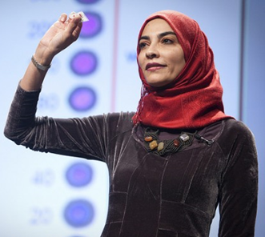  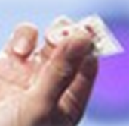
X. Read the following sentences about the reading on previous pages. For each sentence, circle T (true), F (false), or NG (the information is not given in the passage).
1.Theinfantwarmerwasinventedtohelplow-birthweightbabies.
2.Inpoorareas,menandteenageboysusuallycarrywaterhome.
3.Theportableclaycoolerwillcausefarmerstomakelessmoneybecausepeoplewon’thavetobuyvegetableseveryday.
4.HayatSindi’slow-techdiagnosticdeviceismadeofpaper.
5.EachsolarWi-Filightcanprovideelectricityfor10to20homesatatime.
XI. Find supporting details in the reading to answer each question below.
1.Whatisthereasonthatlow-birthweightbabiesneedinfantwarmers?
2.WhatcantheQDrumhold?
3.Howdoestheportableclaycoolerwork?
4.WhatisonereasonthatpeopleneedHayatSindi’sdiagnostictool?
5.WhatisanexampleofhowthesolarWi-Filightcanbenefitpeople?
XII. Ranking and Justifying. Which of the innovations from the previous pages do you think is the most important? Which is the least important? Rank them 1–5, with 1 as the most important. Then talk with a partner and explain your choices.
InfantWarmer………………………… PortableClay…………………………
CoolerSolar………………………… Wi-FiLight…………………………
WaterContainer………………………… HealthDetector…………………………
XIII. What do you consider to be the greatest / important / latest / accidental scientific discoveries of the last 500 years? Do you know more or less when the discoveries were made and who made them? Make a list on the board.
XIV. A) Connect the names with the correct invention, country and date.
Name | Invention | Origin | Date
1. John Walker | slinky | Scotland | 1968
2. Wilhelm Conrad Rontgen | pacemaker | USA | 1928
3. George Crum | Coca-Cola | NewYork | 1896
4. Sir Alexander Fleming | synthetic plastic – Bakelite | USA | in1940s
5. Richard James | Post-itNote | NewYork | 1895
6. Wilson Greatbatch | potatochips | England | 1956
7. Spencer Silver | ice-creamcone | USA | in1880s
8. ItaloMarchiony | penicillin | Germany | 1853
9. John Pemberton | X-rays | Belgium | 1907
10. Leo Baekeland | matches | USA | 1826
B) Read the text and check your answers.
WRITING:
XV. Write a short essay (100-250 words) about:
a) the positive and negative effects of 5 inventions named above;
b) the scientific discoveries of the last 500 years you consider to be the greatest (choose 5);
c) the inventions of the last 500 years you consider to be the most important (choose 5);
d) the accidental discoveries you consider to be the best (choose 5);
e) the latest discoveries you consider to be the best (choose 5).
Give arguments.

Література та джерела

1. 10 Compelling Reasons Why Money Can’t Buy Happiness [Електронний ресурс] / Frugal Budgeter / Режим доступу до ресурсу:https://www.frugalbudgeter.com/money-cant-buy-happiness/
2. 13 Examples of Good and Bad Manners Around the World [Електронний ресурс] / Publications International, Ltd. // Режим доступу до ресурсу:https://people.howstuffworks.com/13-examples-of-good-and-bad-manners-around-the-world.htm
3. Move. Eat. Learn. [Електронний ресурс] // Режим доступу до ресурсу:www.vimeo.com/27246366
4. Pathways: Listening, Speaking, and Critical Thinking 2 [Електронний ресурс] /National Geographic Learning // Режим доступу до ресурсу:https://ngl.cengage.com/ assets/downloads/pathways_pro0000000046/pathwaysrw_2_unit2.pdf
5. Pinola Melanie. The World Is a Book and Those Who Do Not Travel Read Only One Page [Електронний ресурс] / Lifehacker // Режим доступу до ресурсу: https://lifehacker.com/the-world-is-a-book-and-those-who-do-not-travel-read-o-5971748
6. Riseoftherocketgirls [Електронний ресурс] // Режим доступу до ресурсу:https://eltngl.com/sites/file/70439/download?token=Ug2-pI_F
7. Top 10 benefits of travelling – Learn why travelling is good for you [Електронний ресурс] // Режим доступу до ресурсу:https://eurama.hu/2017/02/08/benefits-of-travelling/
8. http://bucketlist.org/featured/
9. https://www.rong-chang.com/eslread/eslread/ss/s009.htm
10. https://www.onestopenglish.com
11. https://app.wizer.me

CONTENTS

Topic6.1.Travelling........................................................................................................4
Topic 6.2. Countries and Cultures................................................................................17
Topic 7.1. Health and Accidents....................................................................................24
Topic 7.2. Healthy Way of Life.....................................................................................38
Topic 8. Money doesn’t Bring Happiness....................................................................45
Topic 9. Ambitions and Dreams....................................................................................54
Topic 10. Discoveries and Inventions. The best and the worst discoveries and inventions of humanity...................................................................................................65
Література та джерела.................................................................................................76

УДК 378.091:811.111(07)

Методична розробка до курсу (частина IІ): Англійська мова для студентів 1 курсу. (Englishforgeneralpurposes) / укладачі: Шпеник С.З., Минда О.І. – Ужгород: «Шарк». 2021. – 76 с.

Гарнітура TimesNewRoman. Папір офсетний
Формат видання 6084/16
Ум.друк.арк.4,42. Замовлення № 19. Наклад 100.

Видруковано ПП «АУТДОР-ШАРК»
88000, м.Ужгород, пл.Жупанатська, 15/1, тел. 3-51-25

Свідоцтво про внесення суб’єкта видавничої справи
до державного реєстру видавців,
виготівників і розповсюджувачів
видавничої продукції
Серія 3т № 40 від 29 жовтня 2012 р.

